December 2023

**TOWARDS MORE EFFECTIVE SPATIO-TEMPORAL SCHEMES FOR REMEDIATION OF AGRICULTURAL SOILS**

IN RESPONSE TO LARGE-SCALE CONTAMINATION WITH RADIONUCLIDES

**Supervisor:**

Prof. dr. ir. Jos Van Orshoven, KU Leuven

**Co-supervisors:**

dr. ir. Lieve Sweeck, SCK CEN

**Members of the Examination Committee:**

Prof. dr. ir. Abram Aertsen (chair), KU Leuven

dr. Johan Camps, SCK CEN

Prof. dr. ir. Dirk Cattrysse, KU Leuven

Prof. dr. Gert Verstraeten, KU Leuven

dr. ir. Gerd Dercon, IAEA

Prof. dr. Kenneth Sörensen, Universiteit Antwerpen

Floris ABRAMS

Doctoraatsproefschrift nr. 1909 aan de faculteit Bio-ingenieurswetenschappen van de KU Leuven

© 2023 Floris Abrams

Uitgegeven in eigen beheer, Floris Abrams, Mechelen

Alle rechten voorbehouden. Niets uit deze uitgave mag worden vermenigvuldigd of openbaar gemaakt worden door middel van druk, fotokopie, microfilm, elektronisch of op welke andere wijze ook zonder voorafgaandelijke schriftelijke toestemming van de uitgever.

All rights reserved. No part of the publication may be reproduced in any form by print, photoprint, microfilm, electronic or any other means without written permission from the publisher.

# ACKNOWLEDGMENTS

Reflecting on the past four years, I am grateful for the incredible journey that has brought me to this moment. This book is a culmination of my efforts and a celebration of the remarkable individuals and experiences that shaped my path.

First and foremost, I want to thank SCK CEN for the funding that made this possible. To my colleagues at SCK CEN, your warm welcome and unwavering support have been instrumental. The challenges were met with enthusiasm, and I am sincerely thankful to everyone who took the time to guide me through both the intricacies of our work and the administrative landscape of SCK CEN. A special note of gratitude goes to Lieve, Johan, Fabricio, and Catrinel for their invaluable feedback, research ideas and guidance. To my colleagues at Tower Two, although I was not there regularly, every time was a pleasure.

Thanks to Gerd for the occasional motivational speech, showing me the importance of the work and encouraging me to keep going. A special thanks to Jos. Even as the Dean of our faculty, you made the time to discuss and help me unravel this topic. Your ability to summarize and bring clarity to my ideas still amazes me.

A special thanks to Ilié, Brecht, Isabelle and Margot for all the engaging discussions in our office or during conferences, with or without a beer. The challenges posed by the Covid pandemic were unprecedented. However, thanks to Tuur, Wannes, Lode, Eva, and Hanne, I only have good memories of that time.

Lastly, I want to express my deepest gratitude to Hanne. Your unwavering support, endless inquiries about my work, and willingness to listen as I navigated the complexities of my research have been invaluable. Your encouragement made this last year, filled with countless hours, days, and weekends spent behind my laptop writing this manuscript bearable. Thank you patatie for being there for me during this challenging time.

Cheers to all the incredible individuals who have been part of this journey with me.

With heartfelt gratitude,

Floris

# TABLE OF CONTENTS

ACKNOWLEDGMENTS I

TABLE OF CONTENTS III

LIST OF FIGURES V

LIST OF TABLES IX

LIST OF APPENDICES XIII

ABBREVIATIONS XV

SYMBOLS…….. XIX

SUMMARY…… XXI

SAMENVATTING XXIII

CHAPTER 1 Setting the Scene 1

1.1 Spatial planning for nuclear decontamination 2

1.2 The role of nuclear power in the global energy mix 2

1.3 Radiation 4

1.4 Large-scale releases of radionuclides in the biosphere 7

1.5 Environmental remediation of agricultural areas 10

1.6 sDSS for responding to nuclear emergencies. 13

1.7 Research objectives and outline of the thesis 13

1.8 Study areas 17

CHAPTER 2 Multi-criteria Decision Analysis to Support the Remediation of Polluted Soils: A Review of Case studies. 21

2.1 Summary 22

2.2 Introduction 22

2.3 Review Methodology 25

2.4 Results 27

2.5 Discussion 37

2.6 Conclusion 41

CHAPTER 3 Accounting for Uncertainty and Disagreement in Multi-criteria Decision Making Using Triangular Fuzzy Numbers and Monte Carlo Simulation: A Case Study About Selecting Measures for Remediation of Agricultural Land After Radioactive Contamination. 43

3.1 Summary 44

3.2 Introduction 44

3.3 Materials and methods 46

3.4 Case study: The application of fuzzy MCDM to choose the optimal remediation technology. 49

3.5 Results 53

3.6 Discussion 58

3.7 Conclusion 59

CHAPTER 4 Optimizing Remediation of Spatially Dispersed Contaminated Parcels under an Annual Budget Constraint. 61

4.1 Summary 62

4.2 Introduction 62

4.3 Materials and methods 64

4.4 Case Study 69

4.5 Discussion 78

4.6 Conclusions and future work 79

CHAPTER 5 A column generation approach to determine temporal trajectories of actions for optimizing the remediation of contaminated agricultural parcels 81

5.1 Summary 82

5.2 Introduction 82

5.3 Material and methods 84

5.4 Results 91

5.5 Discussion 100

5.6 Conclusions 102

CHAPTER 6 An iterative approach to identify the optimal spatial configuration of remedial actions to minimize export of radioactively contaminated sediments from agricultural catchments affected by a nuclear accident. 103

6.1 Summary 104

6.2 Introduction 104

6.3 Material and methods 105

6.4 Results 114

6.5 Discussion 118

6.6 Conclusion 119

CHAPTER 7 Accounting for on-site and off-site criteria for remediation of agricultural catchments affected by a nuclear accident. 121

7.1 Summary 122

7.2 Introduction 122

7.3 Materials and methods 123

7.4 Results 130

7.5 Discussion and conclusion 139

CHAPTER 8 Conclusions and outlook 141

8.1 General conclusions 142

8.2 Outlook 147

REFERENCES… 149

APPENDIX A. Methodology for calculating radioactive contamination in agricultural products and ingestion doses as result of accidental atmospheric releases 163

APPENDIX B. Evaluation Criteria found in site selection for supporting soil remediation 168

# LIST OF FIGURES

Figure 1‑1: The produced electricity of constructed reactor in GW from 1950 (Bars) for the OECD and non-OECD countries and the share of nuclear power in total electricity generation (line) globally, in the OECD countries and non-OECD countries (IEA, 2019). 3

Figure 1‑2: The cancer risk of an individual plotted against the cumulative radiation dose received by this individual (Ministry of the Environment government of Japan, 2023) 5

Figure 1‑3: Hypothesized models to determine excess cancer risk form low dose exposure (Canadian Nuclear Safety Commission, 2013). 6

Figure 1‑4: Exposure pathways to the human population after a nuclear emergency (from Ministry of the Environment government of Japan 2023). 8

Figure 1‑5: Schematic overview of the Absalom model to estimate TF illustrating the needed input parameters and relationships between variables from (Tarsitano et al., 2011). 10

Figure 1‑6: Application of topsoil removal in Japan (JAEA, 2015). 11

Figure 1‑7: Application of ploughing techniques in Japan (JAEA, 2015). 11

Figure 1‑8: Graphical overview of the manuscript chapters, divided based on the type of criteria (On – Off-site) and the use of time (Static – Dynamic). 16

Figure 1‑9: The location of the Maarkebeek catchment, with all the nuclear reactor in and surrounding Belgium. 17

Figure 1‑10: Crop classes (left), soil classes (middle) and simulated deposition level (right) for all parcels within the Maarkebeek catchment. 18

Figure 1‑11: The Niida catchment situated in the Fukushima prefecture in Japan (Left) and close up of the Niida catchment and Niida river with the Haramachi observatory (Right). 18

Figure 1‑12: The Niida River catchment (delineated with a black line). The blue circle indicates the outlet location, corresponding to Haramachi Observatory. Black Triangle is located at Fukushima Daichi Nuclear Power Plant (FDNPP). The Cs-137 contamination density (kBq/m2) is derived from 4th airborne monitoring survey by MEXT and interpolated by (Gonze et al., 2014) from (Delmas et al., 2017). 19

Figure 2‑1: Generalized MCDA structure, with the MCDA steps used as the reference for reviewing the case studies, with reference to the specific sections (adapted from Adem Esmail and Geneletti, 2018). 25

Figure 2‑2: Systematic literature survey methodology to identify case studies related to the MCDA framework applied to the management of polluted soils. Figure adapted from (Sitorus et al., 2019). 26

Figure 3‑1: Triangular fuzzy numbers with the membership functions on the interval 0 to 1. Linguistic values and equivalent integer designations are shown with each membership function. The centroids for the triangular functions evenly divide the interval into seven segments (Very Low = VL, Low = L, Medium Low = ML, Medium = M, Medium High = MH, High = H, Very High = VH). 46

Figure 3‑2: Triangular fuzzy number A: [a1, a2, a3]. Adapted from (Han et al., 2019). 47

Figure 3‑3: Example to illustrate the relationship between the opinions of decision makers and the merged TFN's. DM1 stands for the first decision maker and DM2 for the second one. 49

Figure 3‑4: The ranking of the alternatives based on the deterministic MCDM model, for skim & burial ploughing (S&B), deep ploughing (DP), addition of potassium fertilizer (PF), shallow ploughing (SP) and topsoil removal (TR). 53

Figure 3‑5: The rank acceptability index, based on the relative occurrence of the alternatives in that rank, when uncertainty is introduced on the criteria scores, for skim & burial ploughing (S&B), deep ploughing (DP), addition of potassium fertilizer (PF), shallow ploughing (SP) and topsoil removal (TR). 54

Figure 3‑6: The rank acceptability index, based on the relative occurrence of the alternatives in that rank, when uncertainty is introduced on the criteria preferences, for skim & burial ploughing (S&B), deep ploughing (DP), addition of potassium fertilizer (PF), shallow ploughing (SP) and topsoil removal (TR). 55

Figure 3‑7: The rank acceptability index, based on the relative occurrence of the alternatives in that rank, when uncertainty is introduced on both the criteria evaluations and weights. 55

Figure 3‑8: TFN’s of the weights given by the two hypothetical multiple decision maker scenarios, where scenario 1 (upper) resembles high agreement between DM’s and (bottom) low agreement. 56

Figure 3‑9: The rank acceptability index, based on the relative occurrence of the alternatives in that rank, when uncertainty is introduced on both the criteria evaluations and weights but disagreement between the 3 decision makers is limited, for skim & burial ploughing (S&B), deep ploughing (DP), addition of potassium fertilizer (PF), shallow ploughing (SP) and topsoil removal (TR). 57

Figure 3‑10: The rank acceptability index, based on the relative occurrence of the alternatives in that rank, when disagreement between 3 decision makers is large, for skim & burial ploughing (S&B), deep ploughing (DP), addition of potassium fertilizer (PF), shallow ploughing (SP) and topsoil removal (TR). 57

Figure 4‑1: The cluster growing procedure applied on 12 parcels, considering three possible actions, resulting in two clusters each with one action. 66

Figure 4‑2: Pseudo code of the spatio-temporal cluster approach, determining the remedial technique and timing of the clusters. 66

Figure 4‑3: Initial set of distributed parcels (a) and VP computed by the EMT, resulting in a partitioned coverage (b). 67

Figure 4‑4: Action Priority Score (APS) for the different candidate remedial actions on an agricultural parcel with cereal cultivation. 72

Figure 4‑5: Membership functions of the linguistic expert ratings used for quantifying the criteria weights, with abbreviations VL: very low, L: low, ML: medium low, M: medium, MH: medium high, H: high and VH: very high. 72

Figure 4‑6: Representation of a two-dimensional Compromise programming distance for three parcels (bottom) and its geographic representation (top). 73

Figure 4‑7: The parcel priority score (PPS) for agricultural parcels in need for remediation, displayed in 20% quantiles. The lower the PPS, the more urgent the remediation is. 74

Figure 4‑8: The remedial technologies based on the optimal remedial action for each parcel. 74

Figure 4‑9: The remedial technologies proposed by the spatio-temporal clustering algorithm with a similarity threshold of 0.025. 75

Figure 4‑10: The timing of remediation proposed by the spatio-temporal clustering algorithm when the similarity threshold is set to 0.025. 76

Figure 4‑11: The timing of remediation proposed by the spatio-temporal clustering algorithm when the similarity threshold is set to 0.01. 76

Figure 4‑12: PPS score for the 10 highest ranked clusters, which are equal to the 10 highest ranked seed parcels for a similarity threshold of 0. 77

Figure 4‑13: boxplots representing the variability of the PPS score within the 10 highest ranked clusters, when the similarity threshold is 0.025. 77

Figure 4‑14: boxplots representing the variability of the PPS score within the 10 highest ranked clusters, when the similarity threshold is 0.05. 78

Figure 5‑1: Column generation methodology adopted for finding the best trajectory of actions per parcel to minimize the overall remediation cost. 90

Figure 5‑2: The average year of remediation completion for specific crop types as a function of the type of farmer compensation (Table 5‑3). 94

Figure 5‑3: Proposed initial or generated remedial trajectories, named strategy here, for each parcel (n=1380) in the Maarkebeek catchment. 99

Figure 6‑1: Fragment of a flow direction grid, where cell 4 represents the outlet of the catchment, black arrows represent flow direction and gray arrows denote the branches of the corresponding tree representation in which the cells are considered as nodes connected by links, from Castillo-Reyes et al. (2022). 107

Figure 6‑2: Flowchart of the iterative optimization framework, iteratively assessing candidate cells in the candidate set based on sediment yield reduction at the outlet resulting from afforestation of the considered cell, adapted from (Gabriels et al., 2022). 109

Figure 6‑3: The Niida river catchment, with indication of the decontaminated zones and the Haramachi measurement station (red dot). 110

Figure 6‑4: The Cs-137 deposition on the Niida catchment as result of the Fukushima accident. 111

Figure 6‑5: The slope (middle) and LS-factor (right) determined from the elevation model (left) of the Niida catchment. 112

Figure 6‑6: Size and original land use of the area decontaminated in 2012, 2013 and 2014. 113

Figure 6‑7: The Niida catchment, with the decontaminated cells of 2014 (white) as the candidate cells for afforestation (left), zoom of a river branch, with a subset of the 1000 priority cells for afforestation (right). 115

Figure: 6‑8: Sediment reduction [ton y-1] at the outlet after afforestation on 1, 10, 100, 500 and 1000 cells using a spatially targeted approach compared to a random approach (for year 2014). 116

Figure 6‑9: Boxplots for elevation (m), slope (%), LS-factor (-), distance to the river (m), upslope contribution area (cells), sediment production (ton year-1), transport capacity (tonm-1 year-1) and sediment concentration (kBq/kg) of the 1000 cells ranked highest for sediment yield reduction (SYR) through afforestation. 117

Figure 7‑1: The Maarkebeek Catchment, with the digital elevation model (left) and the flow direction raster (right). A flow direction value of 7 represents flow to the north, 8 to the north-east, 1 to the east, 2 to the southeast, 3 to the south, 4 to the south-west, 5 to the west and 6 to the north-west. 124

Figure 7‑2: C factor (-) in the Maarkebeek catchment. 124

Figure 7‑3: K factor (ton h MJ-1 mm-1) in the Maarkebeek catchment. 125

Figure 7‑4: Sediment production per pixel [ton yr-1] (left) and the LS-factor [-] (right for the Maarkebeek for a R-factor of 1250. 125

Figure 7‑5: The iterative workflow for determining the parcel priority based on their off-site impact. 127

Figure 7‑6: Workflow for determining the parcel priority, composed of the off-site priority (black) or on and off-site criteria (red). 128

Figure 7‑7: Parcel priorities for decontamination based on the six on-site criteria in Table 7‑3 and the compromise programming approach as elaborated in section 4.3.1. The priority classes are based on the quantiles, where the Very high priority parcels represent the 20% most important parcels. 130

Figure 7‑8: Parcel priorities for decontamination based on one off-site criterion, i.c. the reduction of Cs-137 flux a the outlet, using the approach elaborated in section 7.3.4. The priority classes are based on the quantiles, where the Very high priority parcels represent the 20% most important parcels. 131

Figure 7‑9: Parcel priorities for decontamination based on the on and off-site criteria using the approach elaborated in section 7.3.5. The priority classes are based on the quantiles, where the Very high priority parcels represent the 20% most important parcels. 132

Figure 7‑10: Difference in per parcel priority ranking considering off-site criteria only on the one hand and on-site criteria only on the other hand. 133

Figure 7‑11: Difference in per parcel priority ranking considering on & off-site criteria on the one hand and on-site criteria only on the other hand. 133

Figure 7‑12: Difference in per parcel priority ranking considering on & off-site criteria on the one hand and off-site criteria only on the other hand. 133

Figure 7‑13: Timing of parcel remediation timing based on the on-site priority and an annual budget constraint of 3M€. 135

Figure 7‑14: Timing of parcel remediation timing based on the off-site priority and an annual budget constraint of 3M€, using from the approach elaborated in section 7.3.6. 136

Figure 7‑15: Timing of parcel remediation timing based on the on- and off-site priorities and an annual budget constraint of 3M€, using the approach elaborated in section 7.3.6. 137

Figure 7‑16: Timing of parcel remediation timing based on the on site priorities, the off-site priorities in the presence of multiple receptors (catchment outlet and already decontaminated parcels) and an annual budget constraint of 3M€, using the approach elaborated in section 7.3.6. 138

# LIST OF TABLES

Table 1‑1: The typical doses in millisieverts (mSv) due to natural and artificial sources of radiation (UNSCEAR, 2023). 6

Table 2‑1: Relative occurrence of criteria over the five criteria classes for all case studies (N=43). 28

Table 2‑2: Relative occurrence of specific economic criteria to evaluate the alternative remedial technologies compared to the total number of cases implementing economic criteria (N=42). 29

Table 2‑3: Relative occurrence of specific social criteria to evaluate alternative remedial technologies compared to the total number of cases implementing social criteria (N=24). 30

Table 2‑4: Relative occurrence of specific technical criteria to evaluate alternative remedial technologies compared to the cases implementing technical criteria (N=36). 31

Table 2‑5: Relative occurrence of specific human health effects criteria to evaluate the alternative remedial technologies compared to the total number of cases implementing human health criteria (N=32). 32

Table 2‑6: Relative occurrence of specific environmental criteria to evaluate the alternative remedial technologies compared to the total number of cases implementing environmental criteria (N=31). 33

Table 2‑7: Relative frequency of remedial technologies compared to the total number of studied cases (N=41). 34

Table 3‑1: Linguistic variables with the matching fuzzy number for the criterion evaluation scores for each alternative. 47

Table 3‑2: Linguistic variables with the matching fuzzy number for the criteria weight. 48

Table 3‑3: Applicable agricultural remedial counter measures for the region around Tihange, applicable on a cereal field. 50

Table 3‑4: Criteria used in the determination of the optimal remedial technology for a cereal field contaminated with Cs-137. 51

Table 3‑5: Alternative-criteria matrix with the criteria evaluations (L = Low, M = Medium, MH = Medium High, H = High, VH = Very High), with the best alternative score per criterion in bold (Hendrickx et al., 2021). 52

Table 3‑6: Criteria preferences for decision makers for a scenario with and without consensus: LI = Low importance, QLI = Quite low importance, MI = Medium importance, MHI = Medium High importance, HI = High importance, QHI = Quite High importance. 52

Table 3‑7: Summary table of descriptive indicators of the ranking, when uncertainty is additively introduced in both the criteria scores and the criteria weights. 58

Table 3‑8: Summary table of descriptive indicators of the ranking for a group decision-making process, two scenarios of disagreement between DMs. 59

Table 4‑1: The chosen remedial technique for the cluster in bold and corresponding composite score, during the growing procedure of a cluster for five iterations for a similarity threshold of 0.3, resulting in one cluster. 68

Table 4‑2: The chosen remedial technique for the cluster in bold and corresponding composite score, during the growing procedure of a cluster for five iterations for a similarity threshold of 0.15, resulting in two clusters with different remedial techniques. 68

Table 4‑3. Criteria used to determine the Action Priority Score (APS) of each remedial intervention, the weights are based on expert judgement. 70

Table 4‑4: Example of an alternative-criterion matrix for the five remedial alternatives, scoring them on six criteria (Hendrickx et al., 2021). 71

Table 4‑5: Criteria used to determine the Parcel Priority Scores (PPS), with the corresponding weights determined by experts. 73

Table 5‑1: The possible countermeasures used for the decontamination of agricultural areas contaminated with Cs-137 (Nisbet and Jones, 2009; Evrard et al., 2019). 85

Table 5‑2: Initial set of 12 remedial actions, where for a remediation scheme of 5 years, every year a remedial action from Table 5‑1 was allocated. 86

Table 5‑3: Compensation scenarios defined in terms of cost (€ ha-1) for each cultivation type to be paid to the farmer in years when the agriculture production is not allowed to be marketed due to excessive Cs-137 activity. 89

Table 5‑4: Total cost, number of production years lost, number of years to return to full production and sum of PPS for 500 fields, with a successive annual budget of 400k€, 400k€, 300k€, 200k€, 100k€ euro for different objective functions. 92

Table 5‑5: Results of frequency analysis of trajectories from the initial set in Table 5‑2 for different objective functions. 92

Table 5‑6: The impact of different compensation cost scenarios for farmers for objective function 5.1 (Minimizing the total cost). For scenario 4, insufficient resources are available for the remediation of the parcels. 93

Table 5‑7: Number of parcels with proposed remedial trajectory, selected from the initial set (Table 5‑2) for different farmer compensation scenarios for objective function 5.1 (Minimizing the total cost). 93

Table 5‑8: The impact of different compensation costs scenarios for farmers for objective function 5.6 (Total loss of production years). 95

Table 5‑9: Number of parcels with proposed remedial trajectory, selected from the initial set (Table 5‑2) as a function of farmer compensation scenario for objective function 5.6 (Minimize loss of production years). 95

Table 5‑10: Total cost, number of production years lost and sum of PPS for the Maarkebeek catchment (n =1380), with an annual budget of 800k€ over 5 years for different objective functions. 96

Table 5‑11: Number of parcels with proposed remedial trajectory, selected from the initial set (Table 5‑2) as a function of three objective functions (5.1, 5.6, 5.7). 96

Table 5‑12: Impact of the number of iterations in the 5.3.6 Column generation methodology. 97

Table 5‑13: Number of parcels with proposed remedial trajectory, selected from the initial set for objective function 5.7. 97

Table 5‑14: Number of parcels with proposed remedial trajectory, selected from the extended set created during the from the column generation methodology, for objective function 5.7. 97

Table 5‑15: Extended set of remedial trajectories from column growing methodology for the complete Maarkebeek catchment. 98

Table 5‑16: The trajectories by crop type proposed by the column generation with 1000 iterations. Newly generated trajectories are shown in bold. 98

Table 6‑1: The annual river discharge (Q, m3 yr-1), annual suspended sediment load (L, Gg yr-1) and annual 137Cs flux (LCs, TBq yr-1) measured in the Haramachi monitoring station (Bin et al., 2022). 110

Table 6‑2: Parameters for temporal trends of Sc from (Wakiyama et al., 2019). 111

Table 6‑3: Rainfall erosivity factor (Mj mm h-1 ha-1 y-1) measured in Haramchi (Bin et al., 2022). 111

Table 6‑4: C-factor values[-] by land cover type for the Niida catchment. 112

Table 6‑5: Simulated and observed yearly sediment yields (Gg yr-1) at the outlet for 2013 – 2018, after calibration (KTClow =25 m and KTChigh = 115 m). 114

Table 6‑6: Yearly observed and simulated aggregated Cs-137 flux at the Haramachi measurement station for 2013-2018 using equation 6 and 7 for the predicted values and with KTClow = 25 m and KTChigh = 115 m. 114

Table 6‑7: Sediment yield reduction (SYR) in ton yr-1 at the outlet after afforestation of the 1, 10, 100, 500 and 1000 highest ranked cells from the sites that underwent remediation in the year 2014 for an R-factor of 2191 MJ mm ha-1 h-1 year-1. 115

Table 6‑8: Cs-137 flux reduction in MBq y-1 at the outlet after afforestation of the 1, 10, 100, 500 and 1000 highest ranked cells from the sites that underwent remediation in the year 2014 for an R-factor of 2191 MJ mm ha-1 h-1 year-1. 116

Table 7‑1: Land use classes and their corresponding C value in the Maarkebeek catchment. 124

Table 7‑2: Texture classes and their corresponding K value in the Maarkebeek catchment. 125

Table 7‑3: The criteria to determine the on-site priority score (PPS) of agricultural parcels contaminated with Cs-137. 126

Table 7‑4: Annual reduction in Cs-137 flux [kBq] and in sediment quantity [ton] resulting from the execution of the 5 year topsoil removal plan for Maarkebeek elaborated considering the on-site criterion only. The baseline SY for Maarkebeek catchment is 16 857 tons year-1 and the Cs-137 flux in the year after contamination is 9 876 kBq. 134

Table 7‑5: Annual reduction in Cs-137 flux [kBq] and in sediment quantity [ton] resulting from the execution of the 5 year topsoil removal plan for Maarkebeek elaborated considering the off-site criterion only. The baseline SY for Maarkebeek catchment is 16 857 tons year-1 and the Cs-137 flux in the year after contamination is 9 876 kBq. 136

Table 7‑6: Reduction in Cs-137 flux [kBq] and sediment quantity [ton] on annual basis because of the remedial efforts based on priorities from the on & off-site criteria. 137

# LIST OF APPENDICES

**APPENDIX A**

Table A 1: Best estimate values for the soil-to-plant transfer factors for Cs-137 (IAEA, 2010; ONDRAF/NIRAS, 2010). Values in bold are best overall estimates, due to missing data for organic specifically. 164

Table A 2: model parameters (bulk density of the root zone soil, (solid-liquid distribution coefficient, net infiltration rate, volumetric water content) used for different soil types. 164

Table A 3: Crop-specific dry weight content of crops DWv [kgdw/kgfw]. 165

Table A 4: Animal-specific parameters (Sweeck and Hakimi, 2022) 166

Table A 5: Ingestion dose factor DFing, Cs-137 for adults, children and infants [Sv/Bq] (Sweeck and Hakimi, 2022). 167

Table A 6: Food intake of the population [kg fw y-1] (Sweeck and Hakimi, 2022). 167

**APPENDIX B**

Table B 1: Papers used in the review of criteria for site selection support for soil poluttion. 168

Table B 2: Distribution of the criteria over the five classes and the sub-division for the “Site location selection”. 169

Table B 3: The relative occurrence of specific economic criteria to evaluate the alternative remediation sites (where) compared to the total number of cases for the ‘where problem statement’ (n = 13). 169

Table B 4: The relative occurrence of specific social criteria to evaluate the alternative remediation sites (where) compared to the total number of cases for the ‘where problem statement’ (n = 13). 169

Table B 5: The relative occurrence of specific technical criteria to evaluate the remediation sites (where) compared to the total number of cases for the ‘where problem statement’ (n = 13). 170

Table B 6: The relative occurrence of specific human health effects criteria to evaluate the remediation sites (Where) compared to the total number of cases for the ‘where problem statement’ (n = 13). 171

Table B 7: The relative occurrence of specific environmental criteria to evaluate the remediation sites (Where) compared to the total number of cases for the ‘where problem statement’ (n = 13). 171

# ABBREVIATIONS

|  |  |
| --- | --- |
| AFCF | Ammonium-Ferric Hexacyano-Ferrate |
| AHP | Analytical Hierarchy Process |
| ALARA | As Low As Reasonable Achievable |
| ANP | Analytical Network Process |
| APS | Action priority score |
| CAMF | Cellular Automata based heuristic for Minimizing Flow |
| CBA | Cost-Benefit Analysis |
| CBRN | Chemical, Biological, Radiological and Nuclear |
| CEA | Cost-Effectiveness Analysis |
| CF | Concentration Factor |
| CF | Clean Feeding |
| COA | Centre Of Area |
| CP | Compromise Programming |
| CG | Column Generation |
| DCA | Direct Cost of remediation Action |
| DEM | Digital Elevation Model |
| DEMATEL | DEcision MAking Trial and Evaluation Laboratory |
| DM(s) | Decision Maker(s) |
| DP | Deep Ploughing |
| ELECTREE | ÉLimination Et Choix Traduisant la REalité |
| EMT | Enhanced Morphological Tessellation |
| ER | Environmental Remediation |
| F | Feasibility |
| FDNPP | Fukushima Daiichi Nuclear Power Plant |
| GIS | Geographical Information System |
| H | High |
| HI | High Importance |
| IAEA | International Atomic Energy Agency |
| ICRP | International Commission on Radioprotection |
| INES | International Nuclear Event Scale |
| IP | Integer Programming |
| L | Low |
| LC | Land Cover |
| LI | Local Impact |
| LI | Low Importance |
| LNT | Linear No-Threshold model |
| LP | Linear Programming |
| M | Medium |
| MADM | Multi-attribute Decision Making |
| MAUT | Multi-Attribute Utility Theory |
| MAVT | Multi-Attribute Value Theory |
| MAX | Maxima-Method |
| MCDA | Multi-Criteria Decision Aiding |
| MCDM | Multi-Criteria Decision Making |
| MCS | Monte Carlo Simulation |
| MH | Medium-High |
| MHI | Medium High importance |
| MI | Medium importance |
| MOM | Mean of Maxima |
| MT | Morphologic Tessellation |
| NPP | Nuclear power plant |
| NS | Nash–Sutcliffe model efficiency coefficient |
| OECD | Organization for Economic Cooperation and Development |
| PF | Application of Potassium Fertilizers |
| PPS | Parcel Priority Score |
| PROMETHEE | Preference Ranking Organization METHod for Enrichment Evaluation |
| QHI | Quite High Importance |
| QLI | Quite Low Importance |
| RC | Radiocaesium |
| RE | Reduction Efficiency |
| RN | Radionuclides |
| RUSLE | Revised Universal Soil Loss Equation |
| S&B | Skim & burial ploughing |
| SCM | Sediment Concentration Model |
| sDSS | spatial Decision Support System |
| SF | Sediment Flux |
| SFD | Single Flow Direction |
| SFR | Sediment Flux Reduction |
| SMAA-2 | Stochastic Multi-criteria Acceptability Analysis |
| SMART | Simple Multi Attribute Rating Technique |
| SP | Shallow Ploughing |
| SPTM | Sediment Production and Transportation Model |
| SuRF | Sustainable Remediation Forum |
| SY | Sediment Yield at the outlet |
| SYR | Sediment Yield reduction |
| TF | Transfer Factor |
| TFN | Triangular Fuzzy Number |
| TR | Topsoil Removal |
| UNEA | United Nations Environmental Assembly |
| US EPA | The United States Environmental Protection Agency |
| VH | Very High |
| VP | Voronoi Polygons |
| VT | Voronoi Tessellation |
| WLC | Weighted Linear Combination |

# 

# SYMBOLS

|  |  |
| --- | --- |
| **A** | Mean annual soil loss [ton ha-1 year-1] |
| **A(0)** | The activity at time zero [Bq] |
| **A(t)** | The activity at time t [Bq] |
| **Acs-137** | Deposition of Cs-137 [Bq m-2] |
| **aijt** | The cost of the remedial action within the trajectory j when applied to parcel i in the year t [€] |
| **Bq** | Becquerel [Bq] |
| **bt** | The monetary budget available for year t [€] |
| **C** | Cover factor [-] |
| **Ccs-137** | Concentration of Cs-137 in the sediments [Bq kg-1] |
| **Csoil** | RCs concentration in the solid phase [Bq kg-1] |
| **Csolution** | RCs concentration in the soil solution [Bq/L-1] |
| **f+i** | The optimal value for performance criterion i |
| **f-i** | The anti-ideal value for performance criterion i |
| **fi(x)** | The value of the performance criterion i, expressed as a function of the decision variables x |
| **GW** | Gigawatt |
| **K** | Soil erodibility factor [ton h MJ-1 mm-1] |
| **KD** | Solid and liquid phase distribution coefficient [l kg-1] |
| **KTC** | Transport capacity coefficient [m] |
| **LS** | Two- dimensional slope and slope length factor [-] |
| **manSv** | Man sievert |
| **P** | Erosion control practice factor [-] |
| **PPSijt** | The PPS score for parcel i with trajectory j on time t |
| **R** | The rainfall erosivity factor [MJ mm ha-1 h-1 year-1] |
| **SA** | Accumulated sediments at the cell [ton] |
| **Sc** | The solid entrainment coefficient [m2 kg-1] |
| **Sc0** | Solid entrainment coefficient at time 0 [(m2 kg−1] |
| **Sct** | Solid entrainment coefficient at time t [(m2 kg−1] |
| **Sg** | The local slope [m m-1] |
| **SO** | Outgoing sediments from cell [ton] |
| **Sv** | Sievert |
| **t** | Time [yr] |
| **TC** | Transport capacity [ton m-1 year-1] |
| **xij** | Allocation variable of the remedial trajectory j applied to parcel I [-] |
| **αi** | Dual variable associated with the master problem. |
| **βt** | Dual variable associated with the objective function of the subproblem. |
| **λ** | Decay constant [yr−1] |
| **µA** | Membership function of the fuzzy set |

# SUMMARY

Although nuclear energy can be categorized as a safe and low-carbon energy source, two major accidents (Chornobyl, 1986, and Fukushima, 2011) demonstrated the large-scale impact it may have. While immediate response plans to nuclear accidents are well established, the complex and resource-intensive recovery phase lacks adequate (inter)national guidance and tools. The recovery is especially important for agricultural areas, where food production needs to be returned to normalcy. This research contributes to the development of tools within a spatial decision support system (sDSS) to improve the post-accident decision-making process about where, how, and when to remediate agricultural land. This research illustrates the tools in two agricultural watersheds: the Maarkebeek, located in Flanders (Belgium), and the Niida watershed, located in the Fukushima prefecture (Japan). At the basis of the sDSS was a multi-criteria decision-aiding methodology (MCDA), which was found to be a good framework for supporting soil remediation on a local scale through optimal remedial technology selection for a specific site and on a regional scale through optimal site selection. However, we identified four major gaps in the reviewed case studies: (i) A lack of inclusion of social criteria, (ii) A lack of early stakeholder engagement, (iii) A mismatch between weighting and aggregation methodologies, and (iv) A lack of sensitivity analysis. To overcome (i) and (iv), a methodology to include linguistic scoring within ordinal qualitative scales as fuzzy numbers, for the evaluation of criteria or weight setting was proposed. The impact of an increasing amount of uncertainty within the triangular fuzzy numbers (TFN) was studied, and it became clear that the impact of uncertainty on decision-making power cannot be ignored. Proposing remedial plans using two compromise programming methodologies for site selection and action selection results in a very complex spatial pattern for remediation. The clustering of individual entities into larger, homogeneous, actionable units can improve feasibility and reduce the cost of remediation, especially when interventions are costly and technically challenging to perform. A spatio-temporal clustering approach under a budget constraint was presented to determine homogenous clusters of polygons and interventions to reduce the cost of intervention while still attaining near-optimal effectiveness.

When remedial actions are converted into remediation trajectories, a sequence of multiple remedial actions in time is explicitly considered within the decision-making. A column generation model was proposed that reconciles the economic and productive aspects of remediation for agricultural areas. The model’s main novelty is its ability to find optimal multi-period sequences or trajectories of remedial actions from a set of predefined remedial actions, where column generation is used to extend the candidate set of the remedial trajectories while keeping the computational complexity limited. It was found that the introduction of new trajectories with the column generation approach, after 4700 iterations, reduced the loss in productive years by 237 years and the accumulated productivity score by 20%.

An iterative framework called the CAMF approach (Cellular Automata-Based Heuristic for Minimizing Flow) was used to model and reduce the off-site impacts of soil remediation in the Niida watershed. Spatially targeted afforestation of the 1000 best cells reduces the sediment quantity resulting from the decontamination work by 15.4%, compared to 0.8% when the cells are selected randomly. Prioritizing topsoil removal interventions within the Maarkebeek watershed while accounting exclusively for off-site criteria results in a 267% increase in Cs-137 flux reduction efficiency in the first year when compared to remedial schemes based only on on-site criteria.

# 

# SAMENVATTING

Hoewel kernenergie kan worden gecategoriseerd als een veilige en koolstofarme energiebron, hebben twee nuclaire ongevallen (Tsjernobyl, 1986, en Fukushima, 2011) de grootschalige impact aangetoond die een ongeval kan hebben. Hoewel de onmiddellijke interventieplannen voor nucleaire ongevallen goed zijn opgesteld, ontbreekt voor de complexe en middelenintensieve herstelfase adequate (inter)nationale instrumenten. Het herstel is vooral belangrijk voor landbouwgebieden, waar de voedselproductie moet worden hersteld. Dit onderzoek draagt bij aan de ontwikkeling van instrumenten binnen een ruimtelijk beslissingsondersteunend systeem (sDSS) om het besluitvormingsproces na een ongeval over waar, hoe en wanneer te saneren te verbeteren. Dit onderzoek illustreert de tools in twee agrarische stroomgebieden: de Maarkebeek, gelegen in Vlaanderen (België), en de Niida, gelegen in de Fukushima prefectuur (Japan).

Aan de basis van het sDSS ligt een multi-criteria beslissingsondersteunende methodologie (MCDA), die een goed kader bleek te zijn voor de ondersteuning van bodemsanering op lokale schaal door optimale selectie van saneringstechnologie voor een specifieke locatie en op regionale schaal door een optimale locatieselectie. We hebben echter vier grote problemen geïdentificeerd in de onderzochte casestudies: (i) een gebrek aan gebruik van sociale criteria; (ii) een gebrek aan vroegtijdige betrokkenheid van stakeholders; (iii) een mismatch tussen wegings- en aggregatiemethoden; en (iv) een gebrek aan een onzekerheidsanalyse. Om (i) en (iv) te verhelpen, werd een methode voorgesteld om taalkundige scores op te nemen in ordinale kwalitatieve schalen als fuzzy numbers, voor de evaluatie van criteria of het bepalen van gewichten. De impact van het verhogen van de hoeveelheid onzekerheid via de triangular fuzzy numbers (TFN) werd bestudeerd en het werd duidelijk dat de impact van onzekerheid op de beslissingen niet genegeerd kan worden.

Het voorstellen van saneringsplannen met behulp van twee compromise programming methodes voor locatieselectie en saneringstechniek selectie resulteert in een zeer complex ruimtelijk patroon voor sanering. Het clusteren van individuele entiteiten in grotere, homogene eenheden kan de haalbaarheid verbeteren en de kosten van sanering verlagen, vooral wanneer interventies duur en technisch uitdagend zijn. Er werd een ruimtelijk-temporele clusteringaanpak onder een budgetbeperking gepresenteerd om homogene clusters van polygonen en interventies te bepalen om zo de kosten van interventie te verlagen en toch een bijna optimale efficiëntie te bereiken. Bij het omzetten van saneringsacties in saneringstrajecten, een opeenvolging van meerdere saneringsacties in de tijd, wordt de tijd expliciet mee genomen in het beslissings proces. Er werd een kolomgeneratiemodel voorgesteld dat de economische en productieve aspecten van sanering voor landbouwgebieden met elkaar verzoent. De belangrijkste nieuwigheid van het model is de mogelijkheid om optimale trajecten van saneringstechnieken te vinden in een reeks vooraf gedefinieerde trajecten, waarbij kolomgeneratie wordt gebruikt om de kandidaatset van trajecten uit te breiden terwijl de rekencomplexiteit beperkt blijft. De introductie van nieuwe trajecten met de kolomgeneratie aanpak zal, na 4700 iteraties, het verlies in productieve jaren verder verminderen met 237 jaar en 20% van de geaccumuleerde prioriteitsscore.

Een iteratief framework genaamd CAMF (Cellular Automata-Based Heuristic for Minimizing Flow) werd gebruikt om de externe effecten van bodemsanering in het Niida-stromgebied te verminderen. Ruimtelijk gerichte bebossing van de 1000 beste cellen vermindert de hoeveelheid sediment als gevolg van de sanering met 15,4%, in vergelijking, wanneer de cellen at random worden geselecteerd is dit slechts 0,8%. Het prioriteren van interventies voor het afgraven van de bovengrond, als saneringsactie, in het stroomgebied van Maarkebeek wanneer uitsluitend rekening wordt gehouden met off-site criteria, resulteert in een toename van 267% in Cs-137 fluxreductie-efficiëntie in het eerste jaar in vergelijking met saneringsschema's die uitsluitend gebaseerd zijn op on-site criteria.

# Setting the Scene

## Spatial planning for nuclear decontamination

Although nuclear energy production can be categorized as a safe way to produce energy, it can have severe and long-lasting consequences if an accident occurs (Brook et al., 2014). Therefore, a comprehensive remediation approach, balancing environmental benefits against economic costs without overlooking the technical and societal dimensions, is needed (Beinat et al., 1998; van Drunen et al., 2005). Due to the large spatial extent of the contamination, as observed in Chornobyl and Fukushima, there is a need for planning the remediation measures, which can only be achieved using (spatial) decision support systems (s)DSS. A (s)DSS combines spatial and non-spatial data to facilitate evaluating solution alternatives and assessing their trade-offs within the decision context (Keenan and Jankowski, 2019). A sDSS can be defined as an interactive, computer-based system designed to support a user or group of users in achieving higher effectiveness in decision-making while solving a semi-structured spatial decision problem (Malczewski, 1999). The (s)DSS can be used in many stages of the emergency, from the preparedness phase to the recovery phase. Experience from past nuclear and radiological accidents shows that preparedness plans for the immediate response to such accidents are generally well established (NEA, 2021, 2018). However, for the recovery phase, which encompass a long, complex and resource-intensive process, this has not been considered to the same extent by many countries and there is a lack of international and national guidance (OECD and NEA, 2022). Improving the decision-making process by enhancing the assessment capabilities of experts and offering manageable information to stakeholders using a DSS is highly desired (Pollard et al., 2004). The following paragraphs will describe the reason for existing and potential growth in nuclear facilities. Followed by an in-depth discussion on why and how remediation is needed in case of a nuclear accident. Further, an overview of current (s)DSS will be shown, followed by the research questions, objectives and research areas.

## The role of nuclear power in the global energy mix

Electricity has been critical to the human progress we have seen over the last few centuries. Although it brought us significant advantages, it was not without its downsides. The production of electricity from different energy sources can have negative impacts such as air pollution, greenhouse gas emissions contributing to climate change, land requirements, or accident-related impacts. All of them have short and long-term impacts. However, it is important to recognize that none of the energy sources is without impact, but their contribution to each environmental impact differs enormously. The world is attempting to transition its energy systems away from fossil fuels towards more low-carbon energy sources, like hydropower, wind, solar, and nuclear. When considering the complete life cycle, these technologies typically emit very little CO2 and cause limited pollution per unit of energy production (United Nations Economic Commission for Europe, 2021). Although low-carbon technologies have much lower impacts compared to fossil fuels, a mix between all these low-carbon energy sources must be found to transition our society as quickly as possible to a low-carbon future in energy production.

Currently, nuclear power makes a significant contribution to global electricity generation. It provided around 10% of the global electricity supply in 2018 and contributes even more within the advanced economies, making up 18% of the total electricity generation. For some developed countries such as France and Belgium, it provides over half of the electricity supply, (IEA, 2019). As of December 2022, 422 nuclear power reactors are in operation within 31 countries worldwide, with a combined capacity of about 378 gigawatts (GW) (IAEA, 2022). However, the share of nuclear power within the energy mix has fallen steadily, from a peak of around 18% in the mid-1990s to 10% in 2018 (Figure 1‑1). Construction of nuclear power plants peaked in the ’70ies, but globally, the world’s nuclear fleet is aging, with an average age of the nuclear reactors of 32 years. Nevertheless, 57 reactors are under construction with the potential to supply 58 GW, most of them in the developing economies (IAEA, 2022).

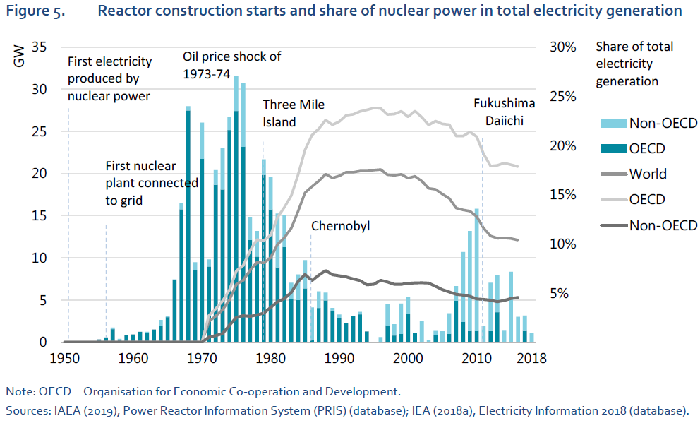

Figure 1‑1: The produced electricity of constructed reactor in GW from 1950 (Bars) for the OECD and non-OECD countries and the share of nuclear power in total electricity generation (line) globally, in the OECD countries and non-OECD countries (IEA, 2019).

Despite the impressive growth of low-carbon energy production, solar and wind power, the overall share of low-carbon energy sources in total electricity supply in 2018 was the same as 20 years earlier (IEA, 2019). Therefore, during the shift to a low-carbon energy supply, all forms of low-carbon energy sources will play a role in the future energy mix. With an increasing interest in reducing CO2 emissions within the climate agreements, and due to the global energy crisis in 2021 (IEA, 2022), nuclear energy has received a renewed interest from the developed economies. The reason is that nuclear power can contribute significantly to countries’ energy security while producing it in a low-carbon manner, especially for countries lacking domestic energy resources (IEA, 2019). Although the future of nuclear energy is unclear, many nuclear research centers and environmental agencies see the controlled expansion of nuclear plants as an environmentally friendly way of meeting growing energy demands (Nuttall, 2022). In addition, the lifetime of several NPPs is being prolonged, and even without the renewed interest in nuclear power, many of the operational reactors will be in use for the next decade(s). Following the future predictions of the nuclear capacity by 2050, the projection indicates a consistent global nuclear capacity in the low scenario and substantial growth in the high scenario (IAEA, 2021). This implies that the worldwide "nuclear" capacity will either stay constant or undergo an increase in absolute terms. This reinforces the necessity for future nuclear emergency planning.

## Radiation

Nuclear power plants produce electricity by converting the energy released during the fission of uranium fuel. Radiation is energy that moves from one place to another in a form that can be described as waves or particles. Each person is exposed to radiation in his everyday life; some of the most familiar sources of radiation include the sun or the microwave oven we use to heat our food. Radiation can be divided into two main categories, ionizing and non-ionizing radiation, based on its potential to interact with matter. The non-ionizing radiation can be found in the lower energy region of the electromagnetic spectrum, where it is not energetic enough to detach electrons from atoms or molecules in the irradiated material. In comparison, ionizing radiation has the capacity to detach electrons from atoms, which can cause changes at the atomic level of the matter, including biological tissue. Each person receives a level of ionizing radiation from a number of natural as well as man-made sources on a daily basis. These sources include cosmic rays from outer space or man-made sources, such as medical X-rays. In addition, radiation can occur from natural or man-made radionuclides (RN) found in the air, water, and food we consume or the building materials we use (Ojovan and Lee, 2013). Radionuclides are a specific type of atoms where the nucleus spontaneously emits energy. This emission of energy causes the unstable atomic nucleus to fall apart into more stable atoms, whereby it loses the excess energy by emission of electrons, helium nuclei, neutrons, or electromagnetic radiation (photons).

Radionuclides can be man-made or naturally occurring (Kirchmann and Van der Stricht, 2001). Some of the naturally occurring radioactive elements were already present in the earth’s crust at the time of formation and have very long decay times comparable with the earth’s age, while others are formed every day due to the interaction with the radiation from outer space. In contrast, man-made radionuclides are produced as products of nuclear fission during energy production or other processes. The release of energy from a radionuclide is termed radioactive decay. It can produce a stable daughter nuclide and/or will produce new unstable daughter radionuclides, which may undergo further decay. Radioactive decay is a random process at the level of single atoms; it is impossible to predict when one particular atom will decay. However, for a collection of a large number of the same radionuclides, the decay rate is proportional to the number of radioactive atoms in the radioactive source and the proportionality constant, called the decay constant. The decay constant is radionuclide specific. Consequently, the decay rate or activity follows an exponential decreasing function of time and can be determined using this exponential decay equation (equation 1.1). As a result, the half-life (*t*1/2) can be determined from equation 1.2. The decay rate is expressed as the number of decays per unit of time, known as Becquerel (Bq) (Kirchmann and Van der Stricht, 2001).

$$A\left(t\right)= A\left(0\right)* e^{-λt} (Equation 1.1)$$

With A(t) representing the activity at time t; A(0) the activity at time zero, and λ the decay constant.

$$t_{\frac{1}{2}}=\frac{\ln\left(2\right)}{λ} (Equation 1.2)$$

Where the half-life of a radionuclide can be determined from the decay constant (λ) using equation 1.2.

The dominant decay processes are alpha, beta, and gamma decay, in which respectively, alpha (particle), beta (particle), and gamma (wave) radiation are emitted. They differ in the magnitude of energy release and penetration depth (Kirchmann and Van der Stricht, 2001). Although all living organisms are exposed to radiation, it might not be without consequences. Ionizing radiation interacts with the biological tissues, potentially causing cell and/or DNA damage, which can result in health effects. The effects from exposure to ionizing radiation depend upon the absorbed dose, dose rate, quality of radiation, specifics of the tissue irradiated, and age of the receiving individual (Mettler, 2012). In many instances, the cells are able to (completely) repair the damage and function normally after receiving a dose of radiation, but when this is not the case, biological effects arise. The effects of radiation exposure on biological cells are classified into stochastic and non-stochastic or tissue reactions. Tissue reactions occur if the radiation dose is above a certain threshold (very high doses) and results in predominantly cell killing. This deterministic effect is commonly used in cancer treatments, where radiotherapy is deployed to specifically target tumour tissue and use radiation to kill the cancer cells. In lower dose scenarios, only stochastic effects will arise, where radiation-induced cancer risk is regarded as the principal health risk. The effects of radiation may be apparent immediately or in the near future (deterministic) or may take decades to manifest itself (stochastic). To describe the impact of both exposure types and related health risks of ionizing radiation, the Sievert unit (Sv) is used. It is determined based on the radiation dose and type as well as the tissue exposed (Kirchmann and Van der Stricht, 2001). By using Sv to express all types of exposure, it becomes possible to compare the effects of different radiation sources and exposure routes on the human body. The epidemiologic studies on survivors of the Hiroshima and Nagasaki nuclear bombs are the main information sources of the health effects of ionizing radiation on human health. When the incidence of disease (principally cancer) was plotted against radiation dose, the dose response was linear, meaning that as dose increased so did cancer risk. However, determining the health effects of low-dose radiation is very difficult. Low-dose radiation-induced cancers in humans depend on several different confounding factors, and it is impossible to correct for all these factors in epidemiologic studies (Prasad et al., 2004). The cancer risk is influenced in a strong way by the lifestyle of the individual, making the increased impact of radiation-induced cancer risk very difficult to measure, as visualized in Figure 1‑2.

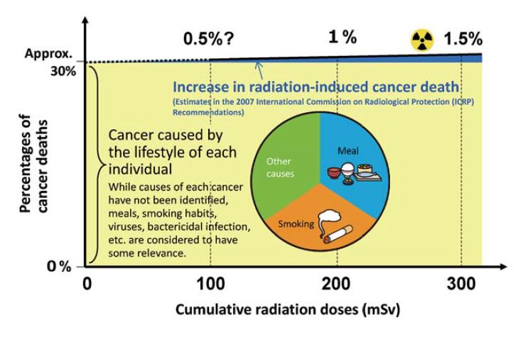

Figure 1‑2: The cancer risk of an individual plotted against the cumulative radiation dose received by this individual (Ministry of the Environment government of Japan, 2023)

Below the lowest data points of the epidemiologic studies on survivors of the Hiroshima and Nagasaki, the natural incidence of the disease masked any effects that may have been caused by radiation (Canadian Nuclear Safety Commission, 2013). When extrapolated to the lower end of the dose spectrum, the disputed linear no-threshold model (LNT) conservatively assumes that there is a direct relationship between radiation exposure and cancer rates for these low doses (Figure 1‑3). However, competing hypotheses exist in which the health dangers of low-dose radiation are reduced (Threshold model), greater (Hypersensitivity), or possibly beneficial (Hormesis). The ICRP stated that while evidence supports other models, the LNT model provides the best overall fit for radiation protection purposes (ICRP, 2005). Using the LNT model, one Sv results in a 5.5% probability of eventually developing fatal cancer (ICRP, 2007) for the lower range dose rates. To put these numbers in perspective, on average a person receives a dose of 2.4 mSv/year, with a typical range of 1–13mSvdue to exposure to naturally occurring radiation and an additional dose of 0.6 mSv/year due to artificial sources (UNSCEAR, 2008). Nevertheless, these numbers vary considerably depending on the development of the healthcare system. For example, Belgian citizens receive on average four mSv/year, with 1.5 mSv/year from medical applications (FANC, 2020). Further, it is important to differentiate between chronic (annual) and individual (single dose) radioactive dose rates to which a person may be exposed. For illustration, Table 1‑1 gives some reference doses.

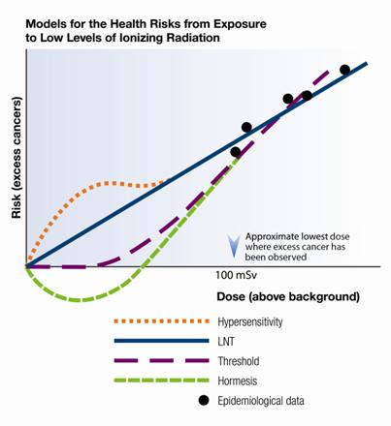

Figure 1‑3: Hypothesized models to determine excess cancer risk form low dose exposure (Canadian Nuclear Safety Commission, 2013).

Table 1‑1: The typical doses in millisieverts (mSv) due to natural and artificial sources of radiation (UNSCEAR, 2023).

|  |  |
| --- | --- |
| The doses received by persons from sources of radiation | Typical dose [mSv] |
| 10-hour aeroplane flight | 0.03 |
| Annual cosmic radiation at sea level | 0.4 |
| Annual cosmic radiation Mexico City (2 300m) | 0.8 |
| Annual dose from natural background | 2.4 |
| CT scan | 10 |

Specifically for radionuclides in food, legislators have translated these exposure doses (in Sieverts) into maximal permissible levels or quantity of radioactive substance (measured in becquerels) within food products. Within the EU, permissible levels for Cs-137 and Cs-134 for general food products are set to 1000 Bq/kg, while the standards in Japan are stricter and allow food till 100 Bq/kg. In comparison, permissible levels for food product used for infant foods, can only contain 50 Bq/kg (IAEA, 2016).

## Large-scale releases of radionuclides in the biosphere

The most large-scale accidents were the Chornobyl disaster in the Soviet Union (currently Ukraine) in 1986 and the nuclear accident in Fukushima, Japan, in 2011 (FDNPP). Both accidents are classified as “Major accident” (level 7) on the International Nuclear Event Scale (INES). A major accident implies a major release of radioactive material with widespread health and environmental effects requiring the implementation of planned and extended countermeasures (IAEA, 2014). Such emergencies affect large territories by deposition of radioactive substances such as iodine-131 (I-131) and caesium-137 (Cs-137). These radionuclides are the dominant volatile fission products from nuclear fission of uranium-235 in NPP. Due to the volatility and fast incorporation into biological systems and consequent transfer through the food chain, they pose a significant environmental risk (Kirchmann and Van der Stricht, 2001). Noble gas elements, such as Xe-133, are not deposited and have much shorter half-lives and, therefore, pose a lesser threat to human health in the long term. Radiocaesium, Cs-137, poses one of the most significant long-term threats because it has a relatively long half-life of 30.2 years and emits harmful beta and gamma radiation during the decay (Gupta and Walther, 2017).

Although both accidents score similarly on the INES scale, the accidents of Chornobyl and Fukushima exhibit some interesting differences (Steinhauser et al., 2014). For the Chornobyl accident, the radionuclide plume, with a total release of 157 to 181 PBq of radiocaesium isotopes, spread over the European continent and contaminated large areas of land and water bodies. In comparison, in the Fukushima accident, 20 to 83 PBq of radiocaesium was released, and due to the weather conditions, nearly 80% of radionuclides were transported offshore into the ocean (Steinhauser et al., 2014).

For reasons of comparison, the resulting radiation to a (sub)population can be expressed in manSv. This unit is the sum of all radiation (in Sv) given to all impacted persons. For example, one manSv can be represented by a person receiving 1 Sv of radiation or ten people receiving 0.1 Sv. When these metrics are determined for both accidents, the lifetime manSv for Chornobyl and Fukushima are respectively 400 103 and 48 103 manSv. Within the complete fuel cycle from uranium mining to the operation of an NPP 0.72 manSv/GW.y is produced, resulting in an equivalent of 200 manSv/y in 2010 for the produced 300 GW. When considering 100 years of nuclear electricity production with a capacity of 300 GW, this amounts to a dose of 0.18 µSv/y for the global population, which is negligible compared to the natural background radiation (UNSCEAR, 2008). Nevertheless, this metric could potentially hide some individuals receiving much higher doses. In an attempt to frame these numbers, the atmospheric weapons testing (1945 – 1963) resulted in 22 106 manSv, and the yearly medical exposure in Belgium gives a collective exposure of 22 103 manSv/year (UNSCEAR, 2013). From comparing the radiological impact of an accident against the complete ‘normal’ fuel cycle, it is clear that safe operation of the nuclear fuel cycle is of utmost importance.

### Radiocaesium exposure pathways

During a nuclear emergency, radioactive isotopes can leak or be released from the nuclear reactor's containment building. Different discharge routes to the environment are possible, such as atmospheric or liquid releases. In atmospheric releases, the leakage contains radioactive noble gases (Xe-133) and aerosols (I-131, Cs-137), which enter the atmosphere and travel away from the emergency site. The resulting radioactive plume can spread far and wide depending on wind conditions. Aerosols, such as Cs-137, will gradually migrate down and are deposited on the ground surface and plants; this process is called dry deposition. However, aerosols can also be washed down more rapidly from the atmosphere due to rain, called wet deposition. The interaction between these two types of deposition could potentially cause an inhomogeneous deposition pattern with hotspots. When outside during the passage of the radioactive plume or after deposition, a person will receive external exposure. However, when the aerosols are inhaled, internal exposure could occur.

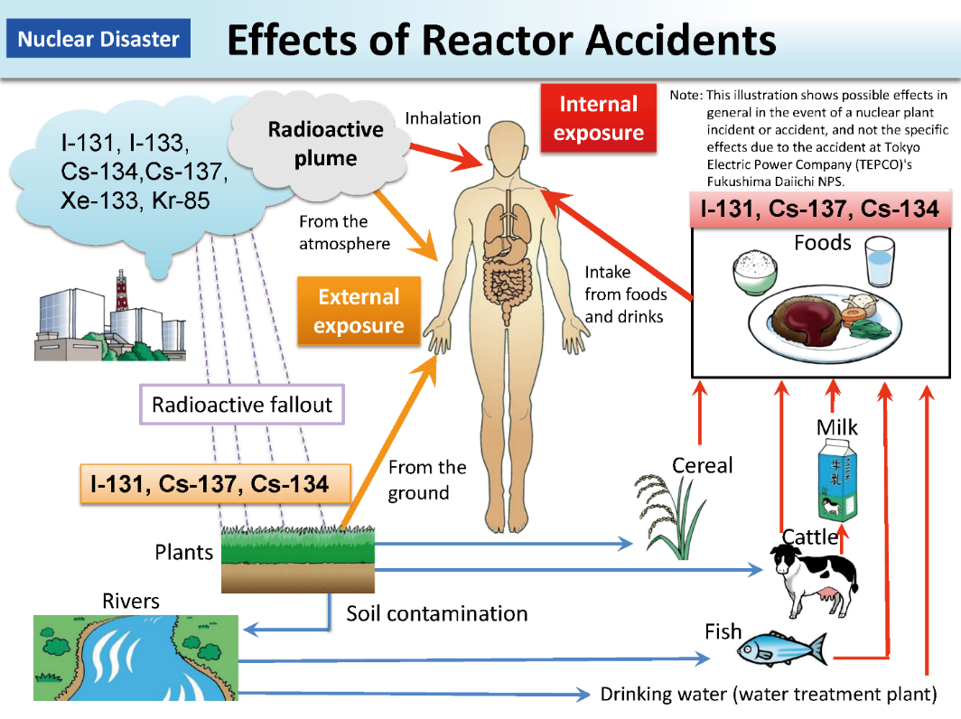

Figure 1‑4: Exposure pathways to the human population after a nuclear emergency (from Ministry of the Environment government of Japan 2023).

Radiocaesium (Cs-137, RC) is a radioactive isotope of caesium. Although radiocaesium is only one of the many RNs produced in a nuclear accident, Cs-137 is of particular interest to human health due to its high volatility, solubility, and long half-life. Due to these characteristics, radiocaesium becomes important in the long term because the ingestion of foodstuff contaminated with RC can cause internal exposure.

When the radiocaesium is deposited on the plant tissue, the radiocaesium can be taken up through the leaf stomata (foliar uptake) and further translocated to other plant tissues (Tanoi, 2013). This pathway can only occur for perennial crops or accidents within the growing season of feed or food crops. However, the radiocaesium deposited on the soil can travel through the multiphase soil system, following similar pathways as RC’s major analogue element, potassium (K). After the release in the soil system, a fraction of the radiocaesium is adsorbed on the soil particles (Söderlund et al., 2011), while another fraction is dissolved in the soil solution. The distribution of radiocaesium between the solid and liquid phases in the soils is expressed in terms of a distribution coefficient (KD).

(Equation 1.3)

With Csoil: the RCs concentration in the solid phase (Bq/kg) and Csolution, the RCs concentration in the soil solution (Bq/L).

The mechanism by which plants take up and incorporate radionuclides in their biological tissues is the same as how they obtain their nutrients (Kirchmann and Van der Stricht, 2001). The radiocaesium present in the terrestrial ecosystem can travel through the soil system, following similar pathways as potassium (K). This results in a competition between K and RC for influx to plant roots (White and Broadley, 2000). Radiocaesium uptake is controlled by the plants' nutritional status and soil solution composition around plant roots (Staunton et al., 2002). The plant-specific physiological mechanisms, defined by the uptake and transport systems in plant cells, determine to a large extent how much RC can potentially enter the plant (Staunton et al., 2002). The uptake processes can be quantified by the transfer factor (TF). For plant uptake, the TF (in units L kg-1) is the concentration ratio of radiocaesium in the plant (Bq kg-1 plant DW) to radiocaesium in the soil solution (Bq L-1) (Uematsu, 2017).

$$\underset{→}{RC_{soil solid phase} \overset{↔}{K_{D}} RC_{soil solution} \overset{→}{CF} RC_{plant}}$$

$$TF$$

The first part of the reaction above is a sorption-desorption reaction quantified by KD (Sanchez et al., 1999). The second reaction is the Cs-137 uptake process and is quantified by CF. The whole process can be quantitatively described by combining the previous two fundamental processes of KD and CF into the transfer Factor (TF) or concentration ratio (CR).

$$TF= \frac{C_{plant}}{C_{soil}}= \frac{\frac{C_{plant}}{C_{solution}}}{\frac{C_{soil}}{C_{solution}}} ≈ \frac{CF}{K_{D}} (Equation 1.4)$$

Cplant represents the concentration of RCs in plant material (Bq kg-1 plant DW) and Csoil is the concentration of RCs in soil solid phase (Bq kg-1 soil DW).

The TF value [kg kg-1] expresses the overall degree of incorporation of RCs into plant tissues from contaminated soils. The TF varies for different soil and plant combinations depending on a set of factors that control RCs sorption (Kirchmann and Van der Stricht, 2001). Semi mechanistic models (e.g., Absalom) can be used to estimate the TF factor depending on the specific soil conditions.

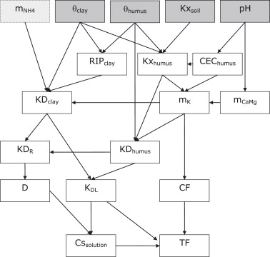

Figure 1‑5: Schematic overview of the Absalom model to estimate TF illustrating the needed input parameters and relationships between variables from (Tarsitano et al., 2011).

More details on RCs plant uptake can be found in Zhu and Smolders (2000) and Gupta et al. (2018). Because of the sorption of RC on the soil particles, a slow downward migration of Cs-137 is observed, resulting in potential uptake by crops for many years/decades (Onda et al., 2020). However, physical processes like erosion can create lateral movement of soil particles or aggregates with associated contamination (Taniguchi et al., 2019).

## **E**nvironmental remediation of agricultural areas

The IAEA defines environmental remediation (ER) as: “Any measures that may be carried out to reduce the radiation exposure due to existing contamination of land areas through actions applied to the contamination itself (the source) or to the exposure pathways to humans.” (IAEA, 2018). Remediation actions do not necessarily imply the complete removal of the contamination or the return to the condition of the site before the pollution. Consequently, remediation is much more than “dig it all up and put it somewhere else” (Mobbs et al., 2019). Further, a remediation strategy can be defined as a time-dependent sequence of remedial actions that are justified, optimized, and undertaken in a specified area and time. Although the main objective of the remediation strategy, with associated remediation actions, is clearly to reduce or to prevent radiation doses to humans, other actions should not be forgotten, like the provision of reassurance to the local population (Gupta and Walther, 2017). As stated in section 1.4.1, the soil acts as the primary long-term reservoir of radionuclides in terrestrial ecosystems. Therefore, many remediation options are applied to the soil to reduce the uptake of RCs into edible crops. However, due to the presence of animal products within the common diet of most human communities, agricultural countermeasures should also be applied to reduce the accumulation of radionuclides within animal products, such as meat and milk.

### Soil-based remediation practices

In the case of agricultural countermeasures, the soil-based remediation options can be divided into those that alter the soil structure (Mechanical) and those that directly modify the chemical characteristics of the soil (Chemical). Mechanical treatment uses two different techniques to reduce radionuclide uptake into the crop: (i) removal of the source or (ii) dilution of the source.

|  |  |
| --- | --- |
| Figure 1‑6: Application of topsoil removal in Japan (JAEA, 2015). | Figure 1‑7: Application of ploughing techniques in Japan (JAEA, 2015). |

Topsoil removal (Figure 1‑6) relies on the slow downward migration of radiocaesium, to effectively remove most of the radionuclides by scrapping and collecting the upper soil horizon [0-5 cm] in the initial years after the accident. The collected contaminated soil is stored and/or treated in a central storage facility. In contrast, different ploughing systems exist, where the upper layer of the soil is mixed with the deeper soil layers, resulting in a dilution of the contamination concentration in the root zone (Figure 1‑7). Farmers can easily perform the latter measures, as they are comparable with common ploughing practices in European farming systems. More specialized systems like “skim and burial ploughing” were developed in the aftermath of the Chornobyl accidents, which bury the upper layer beneath a 30 cm of subsoil. For the chemical countermeasures, it is important to remind that the radionuclide activity concentration in plants depends on the concentration of radionuclides in the soil solution and its potential uptake. Improving the sorption capacity of the soil for radiocaesium or improving the competition for uptake into the plant will lower the radionuclide concentration in the plant. Common practice is the use of K-fertilizer, to enhance competition between potassium cations and RCs, resulting in a lower uptake of RC depending on the initial concentrations. Otherwise, the addition of zeolite components to the soil, with high sorption capacity, will lower the concentration of RCs in the soil solution resulting in a lower RCs uptake by the plant (Hardie and McKinley, 2014; Perepelyatnikov et al., 2007).

### Animal-based remediation practices

Animals just as humans incorporate RCs in their tissues from consuming contaminated feed so that RCs can accumulate in body tissue or produced milk. Similarly, as the soil-based techniques, some animal-based techniques attempt to remove the source of RCs such as providing clean feed to the animals. However, the uptake of RCs into the animal can be lowered by addition of Hexacyanoferrate compounds, known as Prussian blue, to the animal feed. These are radiocaesium binders, which may be added to the diet of livestock to reduce radiocaesium transfer to milk, meat and other animal products by reducing the absorption in the gut. Countermeasures should be maintained during a sufficiently long period before slaughter and during the lactation period (Fesenko and Howard, 2012).

### The role of optimization in environmental remediation

The environmental remediation of nuclear contaminated sites is guided by the principles underlying (inter)national environmental law and the principles of radiation protection. Two main principles on which the radiation safety system, recommended by the ICRP, is based are justification and optimization (ICRP, 2009). The justification principle ensures that any decision that alters the radiation exposure situation should do more good than harm. In addition, justification of remediation strategies goes far beyond the scope of solely radiological protection, as the actions will have far-reaching consequences in various economic, political, environmental, social, and psychological domains (ICRP, 2009). Many technical and non-technical factors need to be considered as part of preparing an adequately justified remediation strategy (Fesenko and Howard, 2012). Identifying and evaluating these non-radiological factors will require expertise supplementary to radiological protection and could potentially dominate decisions on protection strategies (NEA, 2006).

According to the ICRP, optimization involves keeping exposure as low as reasonably achievable, considering economic and societal factors. The process of optimization of protection is intended for protection strategies that have been justified. Within radioprotection, this can be translated by the concept of ALARA (As Low As Reasonably Achievable). Further, the ICRP has introduced the concept of constrained optimization to reduce inequity in the distribution of individual doses, meaning that a remediation action should not result in a higher burden to other individuals. However, optimization should only occur when basic safety needs are met. Consequently, specific reference levels are set. These reference levels represent the dose above which it is judged inappropriate to optimize and allow exposures to occur and below which optimization of protection should be implemented. The key aspect that needs to be determined to allow for optimization is the end state, which should include details on the remaining contamination and possible end uses for the site. Only when these aspects are determined can optimization play a role in finding the most optimal way to attain these goals (Mobbs et al., 2019).

These two principles, optimization and justification, altogether would provide the basis for fair and optimal decisions on how to approach the remediation of a contaminated territory (Fesenko and Howard, 2012). Specifically for the context of radioactively contaminated agricultural areas, remediation practices face a multitude of societal challenges. The decision related to the optimization of the remediation efforts are of a complex nature. The choice of the optimum option must consider cost, sustainability, social acceptability, distribution of doses over space and time, psychosocial effects such as stigma, and environmental impacts. We can state that a ‘sustainable remediation’ represents the best solution considering environmental, social and economic factors as agreed by the stakeholders (NICOLE, 2013). In Fukushima and Chornobyl a risk-based approach based on the ground deposition after the accident was used to determine the remediation need and type (IAEA, 2013). As an example for the need to optimize remediation the remediation efforts, the costs related to the damage and remediation of the Fukushima Daichi accident is currently estimated for the decontamination of contaminated land are between $60-300 billion (Behling et al., 2019). However, when including compensation schemes (e.g., farmers) $60 billion in compensation losses can be assumed. These enormous budgets showcase the need for optimal use of the efforts, from an economical point of view.

## sDSS for responding to nuclear emergencies.

In the aftermath of the Chornobyl accident, projects such as “STRATEGY” looked at decision tools to aid sustainable restoration and long-term management of contaminated agricultural ecosystems. Other tools, such as DECERNS (Yatsalo et al., 2016) and ResCa (Ulanovsky et al., 2011), were used to determine how to reduce the long-term effects of the Chornobyl accident. In 2004, the EURANOS project (European Approach to Nuclear and Radiological Emergency Management and Rehabilitation Strategies) (Nisbet and Jones, 2009), a collaboration between 23 EU member states, was established to improve EU preparedness for the next radiological emergency. During the project, the DSS RODOS (Real-time On-line Decision support) system was improved, and knowledge of emergency actions and countermeasures was shared. Additionally, many countries with NPPs research nationally applicable tools and frameworks (e.g., PRIME in France). Lastly, commercial tools (e.g., ARGOS) are developed to optimize decisions for incidents involving atmospheric dispersion of hazardous CBRN-materials (Raskob et al., 2011). The initial period after deposition is always characterized by high degrees of uncertainty, leading to a need for precautionary emergency measures with less margin for optimization (Yumashev and Johnson, 2017). However, in the later stages, when information is more certain, DSS tools can help to find optimal strategies for dealing with recovery and rehabilitation of affected areas. Therefore, investing in emergency and recovery preparedness frameworks and tools before the accident is important because it is usually more cost-effective than the post-accident implementation of unprepared emergency and recovery actions (OECD and NEA, 2022).

To address these complex multi-criteria decision problems, multi-criteria decision aiding (MCDA) is generally needed. MCDA encompasses a framework that has the ability to consider a broad range of potentially conflicting economic, technical, environmental, and social aspects simultaneously. In addition, the need for intensive interactions with stakeholders in this decision-making context favours methodologies such as MCDA. Within this manuscript, the concept of MADM (Multi-attribute Decision-Making) stated by Malczewski (1999) will be used as the primary MCDA methodology. In MADM a finite number of explicitly stated alternatives are used, while the criteria used to evaluate the alternatives are referred to as attributes of these alternatives. Because MCDA allows for a structured, transparent, and sound decision process. In order to integrate spatially referenced data into the decision context, GIS-based MCDA (GIS-MCDA) is useful. At its most simple level, GIS-MCDA is a procedure that combines geographic data (input maps) to define a set of alternatives and criteria and the decision maker’s preferences into a decision map (Malczewski and Rinner, 2015). It requires a number of criteria to evaluate geographically defined decision alternatives so that recommendations can be formulated. Spatial decisions can come in the form of “where to act?”, where the alternatives are potential locations for intervention. On the other hand, for questions like “How to act?”, alternatives are defined as potential interventions for that specific location. GIS-MCDA can be seen as a particular class of spatial Decision Support Systems.

## Research objectives and outline of the thesis

Experience from past nuclear and radiological accidents shows that preparedness plans for the immediate response to such accidents are generally well established (NEA, 2021, 2018). However, the recovery phase, which encompasses long, complex and resource-intensive processes, has not been considered to the same extent in many countries. Moreover, there is a lack of international and national guidance (OECD and NEA, 2022). This PhD research project was set up to contribute to developing a framework and tools that improve post-accident decision-making about where, how and when to remediate to facilitate the return of the agricultural sector to normalcy as rapidly as possible. The research was meant to contribute to the state-of-the-art by delivering a proof-of-concept for various aspects of an sDSS, capable of combining on- and off-site criteria into spatio-temporal remediation schemes that facilitate the remediation of agricultural areas contaminated with Cs-137 whereby the agricultural parcel is the unit of remediation. In this context, ‘remediation’ was defined as the application of some measure that reduces the internal radiation dose resulting from the ingestion of food products contaminated with RC. The internal dose remains important for many years after the accident, when the external dose (the level of soil contamination) is already reduced significantly.

### Research questions

Numerous facets influence the decision on where, how and when to remediate agricultural land contaminated with RC. Four of these dimensions shape the research questions of this PhD-project.

#### The spatial dimension

The spatial dimension of soil remediation strategies refers to the “where to act?” question and encompasses the georeferenced agricultural parcels in the contaminated territory on the one hand and the parcel-specific remediation technologies (“how to act?” question) on the other hand as the alternatives that require a selection decision. For efficiency of the remediation, it is wise to consider not just the combination of each individual parcel and each possible technology but rather spatial clusters of parcels as pseudo-homogenous remediation units to which a compromise remediation technology is assigned.

#### The temporal Dimension

The temporal dimension of soil remediation refers to the “when to act?” question. As a result of the combination of thresholds separating harmful from less harmful contamination levels with natural radioactive decay, the question is not a trivial ‘the sooner, the better’ one. In this research, we either do not take time into account (all parcels are remediated simultaneously) or we address time implicitly by introducing annual budget constraints leading to not all parcels being remediated in the same year. However, time can also be more explicitly incorporated by considering a remedial trajectory for each parcel i.e. a sequence of remedial actions distributed through time.

#### The decision criteria types

The criteria utilized in the MADM process may originate from on-site parcel attributes, capturing the parcel-specific characteristics (e.g. distance to river, contamination of the parcel). However, off-site attributes may also be considered as criteria. They encompass characteristics of parcels or of locations that are not the parcel to be remediated (e.g., sediment accumulated downstream through erosion).

#### Uncertainty

The uncertainty dimension relates to the inherent presence of uncertainty in the input parameters used in the MADM. Both the criteria scores for the considered alternatives and the preferences (or criteria weights) expressed by the decision-makers typically exhibit uncertainty. Moreover, disagreement between decision-makers may add uncertainty to their preferences.

Considering these four facets, six research questions (RQ) were put forward:

1. What is the current state of the art regarding multi-criteria decision-making systems used for optimizing the remediation of polluted soils?
2. What is the individual and combined effect of (i) uncertain criteria weights, (ii) uncertain criteria scores, and (iii) disagreement between decision makers on the ranking of alternative soil remediation technologies and, hence, on the decision power of that ranking?
3. How to spatially cluster contaminated parcels to increase remediation efficiency without and with a given annual financial budget?
4. How to optimally design temporal sequences of elementary remediation actions considering on-site criteria and a given annual budget?
5. How to address off-site criteria in the design of remediation plans? Can the CAMF approach (Cellular Automata based heuristic for Minimizing Flow, Vanegas et al., 2008) be used to incorporate sediment loss and flow after decontamination in the where- and how-to-act questions?
6. How to take account of both on- and off-site criteria and an annual budget constraint in the design of spatio-temporal schemes for remediation, considering also the risk of re-contamination due to sediment flows?

### Outline of the dissertation

Figure 1‑8 links the six research questions to a specific manuscript chapter. They are positioned according to two of the four select dimensions: time and decision criteria types. In line with Figure 1-8, the dissertation continues in chapter 2, investigating RQ 1, with a review of multi-attribute decision-making (MADM) implementations to support the remediation of polluted soils on a regional (Where to act?) and local scale (How to act?). In Chapter 3, RQ 2 is examined using an uncertainty analysis protocol, in which linguistic scorings, as fuzzy numbers, are used for more simple quantification of difficult-to-quantify criteria. A Monte Carlo approach was used to determine the impact of increasing uncertainty on the decision power. A spatio-temporal clustering algorithm was designed to address RQ 3 in Chapter 4 using the on-site characteristics governing the local and regional decisions. By introducing an annual budget constraint, time is implicitly considered. Indeed, the combination of regional and local decisions regarding where and how to remediate results in a spatially complex pattern for action, which is optimal but, at the same time, challenging to execute. Chapter 5 introduces the concept of remediation strategy to address RQ 4. A remedial strategy encompasses the expansion of a single remedial action into a sequence of remedial actions through time. The strategies are identified using a column generation approach that is applicable for addressing large-scale contaminations with long time horizons. In Chapter 6, RQ 5 is addressed in a case study of the off-site effects due to erosion and consequent movement of contaminated sediments resulting from the removal of contaminated topsoil in the Niida catchment in Japan. The case study uses the CAMF (Cellular Automata-based heuristic for Minimizing Flow) methodology and extends it to include the Cs-137 concentration of the sediments. In Chapter 7 (RQ 6), the integration of on- (chapter 4) and off-site criteria (chapter 6) in the decision framework is consolidated, resulting in an extended spatio-temporal approach that is capable of generating remediation plans. Finally, the concluding chapter highlights the main findings of this research and identifies the avenues for future work.

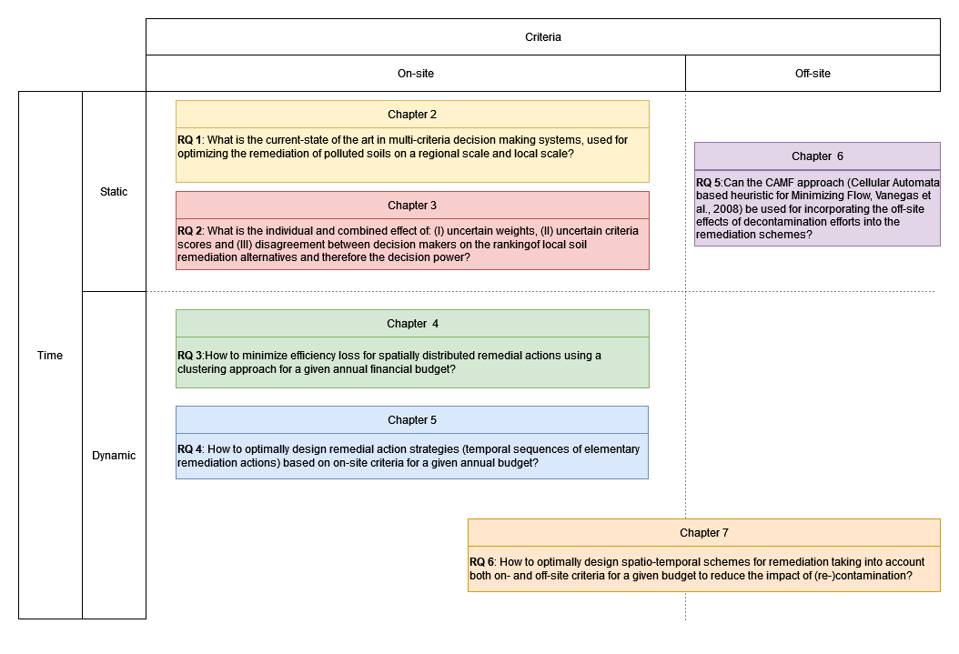

Figure 1‑8: Graphical overview of the manuscript chapters, divided based on the type of criteria (On – Off-site) and the use of time (Static – Dynamic).

## Study areas

Within the manuscript 2 different catchment are used for showcasing the models. First, an agricultural catchment within Flanders, Belgium was used. The catchment has no radionuclide contaminations but was hypothetically contaminated by a radionuclide release from the NPP in Thiange. Second, the Niida catchment in the Fukushima prefecture in Japan. The catchment received radionuclide deposition from the accident at the Fukushima Daichi nuclear accident.

### The Maarkebeek catchment (Belgium)

The Maarkebeek catchment situated in Flanders is used in chapters 4, 5 and 7. The Maarkebeek subbasin, is situated in the Upper Scheldt river basin and has an area of approximately 52 km². The catchment has an altitude that ranges between 18m and 147m, with gentle slopes. The area is characterised by a landcover dominated by arable land and pasture. As shown in Figure 1-9, within and surrounding the Belgium territory many nuclear reactors are situated. Therefore, a catchment within Flanders should be prepared for potential nuclear emergencies.

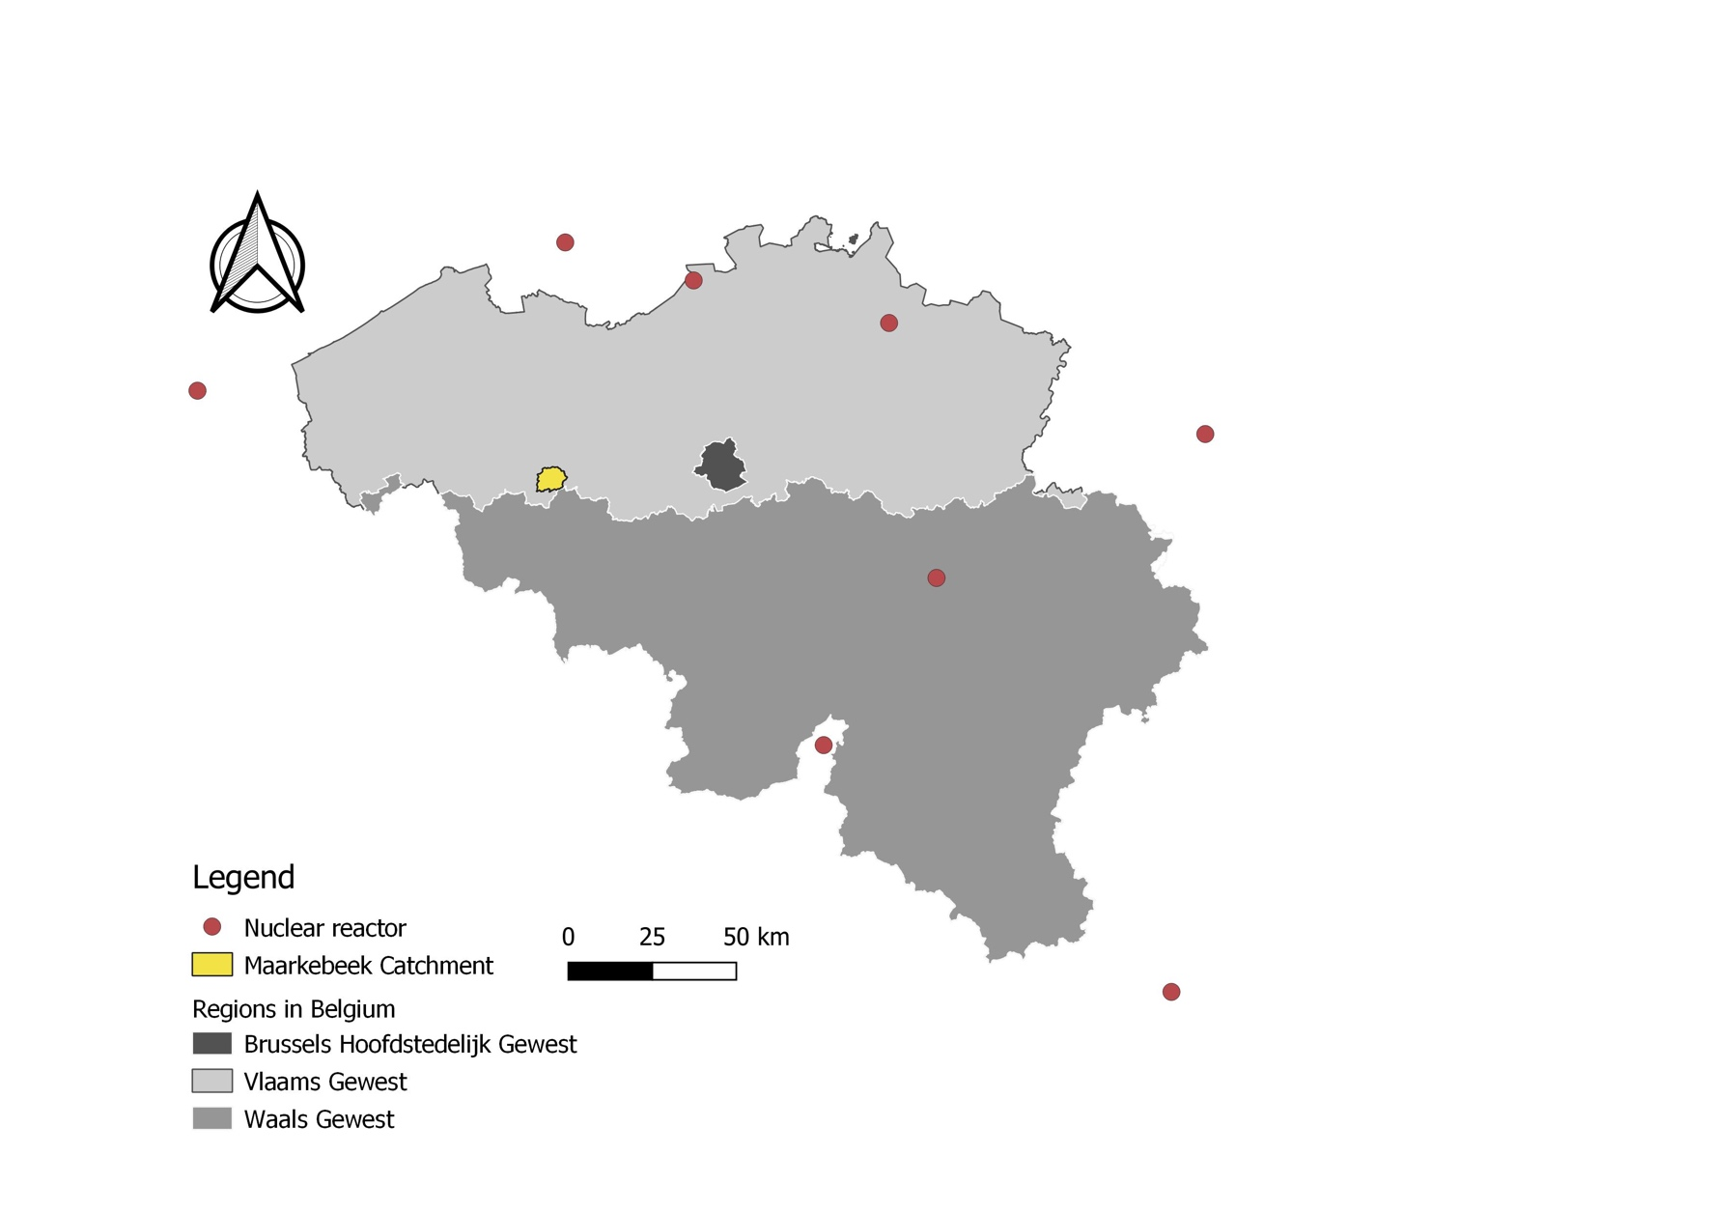

Figure 1‑9: The location of the Maarkebeek catchment, with all the nuclear reactor in and surrounding Belgium.

A variety of crop types may be found within the watershed, with the majority of the fields are cultivated as pasture (46%), cereals (41%), Tubers (8%) and root crops (4%). The most common soil types found in the catchment are loam and silt loam (Figure 7-1 & 7-2)). The crop type, soil type and hypothetical deposition per parcel can be found in Figure 1-9. The spatially variable Cs-137 contamination is assumed to be caused by a Cs-137 deposition from a hypothetical accident in a nearby nuclear power plant. The contamination from the atmospheric deposition has a non-uniform distribution over the catchment ranging between 6.5 and 9.5 MBq/m2. To determine the parcels in need for remediation, only parcels producing food with Cs-137 activity above the intervention level will be further considered. The methodology for calculating radioactive contamination in agricultural products as result of accidental atmospheric releases can be found in APPENDIX A. Within the catchment, 1380 parcels are in need for remediation and will be used further.

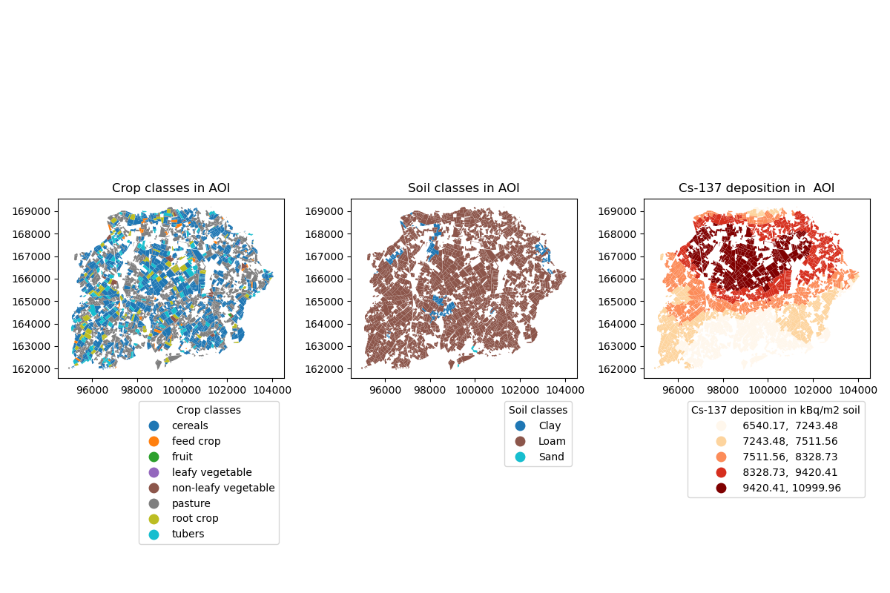

Figure 1‑10: Crop classes (left), soil classes (middle) and simulated deposition level (right) for all parcels within the Maarkebeek catchment.

### The Niida catchment (Japan)

The Niida River is a 78 km-long river that flows in the eastern part of the Fukushima Prefecture. The river flows from the coastal mountain range (>900 m) to the Pacific Ocean, located 25 km north from the FDNPP.



Figure 1‑11: The Niida catchment situated in the Fukushima prefecture in Japan (Left) and close up of the Niida catchment and Niida river with the Haramachi observatory (Right).

The upper plateaus of these catchments were highly contaminated (>1000 kBq/m2) and were evacuated in 2011 as Cs-137 activities in soils ranged from 20 to 75 kBq·kg−1. In contrast, the coastal plain contamination did not exceed 20 kBq·kg−1 (Delmas et al., 2017; Evrard et al., 2020).

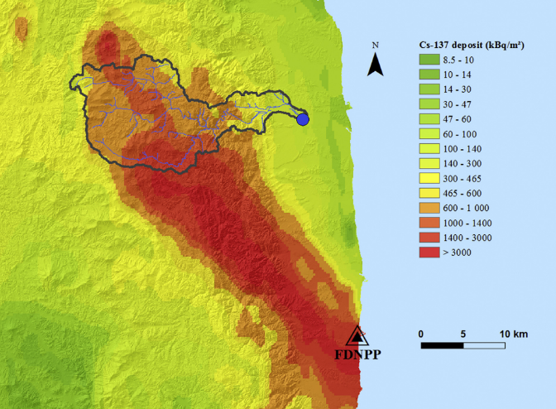

Figure 1‑12: The Niida River catchment (delineated with a black line). The blue circle indicates the outlet location, corresponding to Haramachi Observatory. Black Triangle is located at Fukushima Daichi Nuclear Power Plant (FDNPP). The Cs-137 contamination density (kBq/m2) is derived from 4th airborne monitoring survey by MEXT and interpolated by (Gonze et al., 2014) from (Delmas et al., 2017).

# Multi-criteria Decision Analysis to Support the Remediation of Polluted Soils: A Review of Case studies.

Submitted to Journal of Environmental Planning and Management

## Summary

For the successful remediation of polluted sites, priority setting among the possible remediation technologies is of major importance. The related decisions are typically conditioned by a limited set of alternative remediation techniques and multiple, often contradicting criteria. These characteristics make the decision problem suitable for the application of a formalized discrete multi-criteria decision analysis (MCDA). This chapter reports on the outcome of a systematic review of articles published between 1995 and 2020 encompassing 43 MCDA applications to support the selection of the remediation technique for polluted soils. It focuses on the comparison between implementations of the MCDA methodology. The review identifies four gaps where progress can be made to mobilize the full strength of the MCDA methodology to support the remediation of polluted soils: (i) early stakeholder engagement, (ii) inclusion of social criteria, (iii) an informed choice of the weighting and aggregation method, (iv) and sensitivity analysis.

## Introduction

Pollution is one of the main threats affecting soils and the ecosystem services they provide. Soil pollution can be local or diffuse and originate from a variety of natural and artificial sources. Globally, anthropogenic pollution of soils has become a widespread problem that continues growing (FAO and ITPS, 2015). In 2017, the United Nations Environmental Assembly (UNEA-3) adopted a resolution calling for accelerated action and cooperation to address soil pollution (Rodríguez Eugenio et al., 2018). This initiative, along with numerous other regional and national endeavours, reflects the increased concern regarding polluted soils around the world.

In many cases (e.g., heavy metals or long-lived radioactive contaminants), soil pollution is persistent and requires intensive and active management to be reduced in a reasonable time span. Historically, soil remediation projects have focused on the single objective of reducing contaminant concentrations below regulatory standards in the shortest possible time (van Drunen et al., 2005). Therefore, in most cases, the direct costs, time, and achievable risk reduction are the only criteria involved in the choice of the remediation approach (Sorvari et al., 2009). However, this may not be the most cost-effective or socially acceptable solution. In recent years, there has been a paradigm shift towards a more comprehensive approach, balancing environmental benefits against economic costs without overlooking the technical and social dimensions (Beinat et al., 1998; van Drunen et al., 2005). This reflects the growing attention towards green and sustainable remediation (Hou and Al-Tabbaa, 2014; NICOLE, 2012; SuRF U.K, 2010; US EPA, 2008). It is now recognized that the environmental management of projects dealing with polluted soils commonly faces a range of complex and multidisciplinary problems for which there is no one-size-fits-all solution (European Commission, 2006). To optimize decisions on remediation actions, a broad range of potentially conflicting economic, technical, environmental, and social aspects must be considered simultaneously. As a result, inherent trade-offs must be considered to ensure socially responsible solutions and the sustainability of the remediation outcome (Cappuyns, 2016).

Furthermore, researchers and practitioners increasingly highlight the need to have more intensive interactions with stakeholders in environmental remediation decision-making, who argue that environmental decisions are scientific as well as political (Beierle, 2002). One-way provision of information to stakeholders and potentially affected people, commonly referred to as the decide-announce-defend strategy, is not only questionable from an ethical point of view but has also been proven ineffective and inadequate to address the uncertainty and controversy surrounding contamination issues (Briggs, 2009). Today, a more collaborative process with various stakeholders is advocated, as this not only enhances *“the legitimacy of decisions and reduce[s] the level of conflict”* (Coenen 2009) but also increases the quality of decisions in various ways, not in the least by improving the projects’ outcome (Beierle, 2002; Muro et al., 2012). Balasubramaniam et al. (2007) and others advocated the involvement of a diverse set of actors ranging from civil society to regulators, decision-makers, implementers, and scientific and technical experts. But when a variety of stakeholders with conflicting beliefs, interests, perceptions, and concerns are involved, obviously, the remediation project becomes more challenging to define and manage (Guillevic et al., 2018).

To tackle these challenges, it is recommended to use a formal decision analysis framework to allow for a structured, transparent, and sound decision process. Furthermore, if the decision-makers are challenged to convert expert assessments, stakeholder perceptions, and the inevitable degree of uncertainty into a robust commitment to remediation, such reproducible methodologies become a requirement. Different decision analysis frameworks exist, with Multi-Criteria Decision Analysis (MCDA) being among the most prominent frameworks for environmental decision-making. MCDA supports a structured and inclusive decision process, addressing a plurality of preferences and socio-technical dimensions that cannot always be brought to a common scale (e.g., monetary) (Gamper and Turcanu, 2015; Linkov et al., 2004a). Initially developed in the field of operations research, MCDA is an umbrella term for a variety of decision-aid methods that support the decision-maker by describing and evaluating decision options with respect to multiple criteria, representing several points of view. Each method applies specific procedures to involve stakeholders, elicit and evaluate inputs, aggregate information, and formalize recommendations. These different approaches have distinct information requirements and computational complexity that depend heavily on the assumptions about the decision-making process, the level of stakeholder engagement, the time pressure, and the data requirements (Belton and Stewart, 2002; Greco et al., 2016; Huang et al., 2011). If MCDA is used in an inclusive manner, as shown, for instance by Linkov (2006), it can offer a scientifically sound as well as inclusive decision framework for the management of contaminated sites, addressing the previously mentioned challenges. MCDA is deemed to overcome the limitations of two prominent approaches: Cost-Benefit Analysis (CBA) and Cost-Effectiveness Analysis (CEA). CBA is rooted in the field of economics and aims at finding the alternative that will achieve the greatest overall societal welfare.

Consequently, it involves monetizing all socio-economic costs and benefits attributed to every alternative (Marleau Donais et al., 2019). Within CEA, the cost is measured per unit of effect, which enables comparison of alternatives with respect to the costs of achieving the same outcome. Munda (2019) argues that MCDA is the most comprehensive framework since it can incorporate a more diverse set of quantitative and qualitative information. Furthermore, criteria with different dimensions, such as social and environmental impacts, cannot be easily condensed into simple monetary expressions as required by CBA and CEA (Gamper and Turcanu, 2015).

Although many variants of the MCDA framework exist, it could be argued that most approaches involve three main stages: (1) Description of the decision context and structuring of the problem, (2) Analysis of the alternatives with respect to a number of criteria and (3) Selection of the preferred alternative among the candidate ones. The first stage aims at establishing a shared understanding of the decision problem among the stakeholders. The problem is structured by identifying all possible alternative solutions and related evaluation criteria. The subsequent analysis stage includes assessing preferences among criteria (e.g., by weighting of the criteria) and comparison of alternatives based on the aggregation of preferences and scorings into an overall performance for each alternative. This second stage may encompass an analysis of the sensitivity and robustness of the outcome with respect to the set model parameters and the related criteria scores. In the final selection stage of the MCDA, information from the previous stages is combined to formulate recommendations, preferably leading to an actual commitment to action (Adem Esmail and Geneletti, 2018).

In MCDA, various terms are used by different authors to refer to similar concepts. In this chapter, we adhere to the terminology of Malczewski (1999), whereby the set of possible remediation options is a finite number of explicitly stated alternatives, while the aspects used to evaluate the alternatives are referred to as attributes. Hereby, a criterion is an attribute together with a direction of preference (e.g., to be minimized or maximised). So, the term MCDA will be used in the following sections to represent the previously defined framework.

The application of MCDA frameworks has been the subject of reviews in many different fields, such as nature conservation (Adem Esmail and Geneletti, 2018), mining and processing of mined minerals (Sitorus et al., 2019), sustainable development (Kandakoglu et al., 2019)) and management of contaminated sites (Linkov et al., 2004b). More recently, reviews of MCDA applications to environmental problems were carried out by Huang et al. (2011), and a follow-up study was done by Cegan et al. (2017). These showed an increased interest in using multi-criteria decision aiding approaches for the remediation of contaminated soils. While these review papers contain valuable information on the decision context and the MCDA frameworks, they lack a more detailed description of the studied cases. Also, Huysegoms and Cappuyns (2017) provided an extensive review of the available decision support tools and their characteristics to support sustainable remediation of contaminated sites. Although the latter review addresses the potential use of these tools, it does not directly describe whether and how these tools were implemented to support environmental remediation projects.

This chapter reports on a systematic review of literature showcasing the role of MCDA as a framework to support the remediation and management of polluted soils. In contrast to previous studies, it aims to provide an analysis of how and where MCDA was used in practice to address the remediation of polluted soils and report on its specific implementation using a generalized reporting structure. In Figure 2‑1, the applied MCDA framework is shown. It encompasses six steps, each labelled with a code referring to the corresponding section number in the chapter.

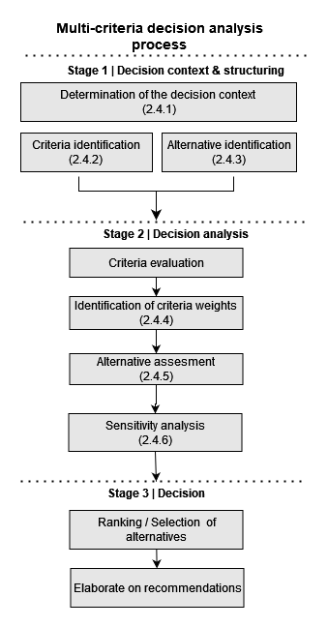

Figure 2‑1: Generalized MCDA structure, with the MCDA steps used as the reference for reviewing the case studies, with reference to the specific sections (adapted from Adem Esmail and Geneletti, 2018).

Section 2.3 describes the protocol that was applied to include or exclude case studies for this review. Section 2.4 shows the results of the literature review, and Sections 2.5 and 2.6 provide a discussion and conclusions about our findings.

## Review Methodology

To ensure the objectivity and reproducibility of the review, a systematic approach in line with Sitorus (2019) was used to select case studies. It encompasses the application of a search string to three literature databases and three sequential exclusion steps, as shown in Figure 2‑2 and described in the following paragraphs. The search was conducted for peer-reviewed literature between 1985 and 2020.

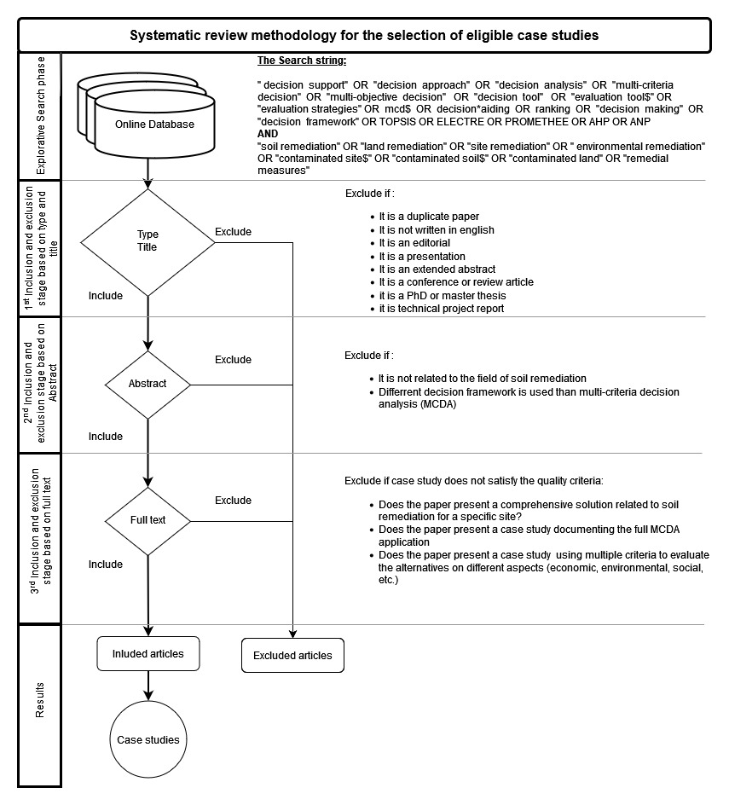

Figure 2‑2: Systematic literature survey methodology to identify case studies related to the MCDA framework applied to the management of polluted soils. Figure adapted from (Sitorus et al., 2019).

The search string was composed of two sets of search terms, each linked by the OR operator including keywords capturing decision-making and MCDA and keywords specifically addressing remediation of polluted soil. To determine the performance of the search string, a set of target papers was created based on the authors’ best available initial knowledge. The set consists of papers judged as particularly relevant from the first explorative search phase. The validity of the search string was determined based on the share of papers from the target paper list that were returned. The final search string consisted of the two sets combined by the AND operator, as illustrated in Figure 2‑2. The three electronic academic databases that were searched based on title and keywords were Web of Science Core Collection (http://www.webofknowledge.com), Science Direct (http://www.sciencedirect.com/), and Scopus (http://www.scopus.com/). Combining the search results from all three, the complete set of preselected target papers was retrieved. Inclusion and exclusion are important in any systematic literature review. Figure 2‑2 shows the hierarchy of the three steps performed. After completing this three-step selection procedure, out of 835 initial papers, 56 independent case studies were retained. This review focused on scientific peer-reviewed publications in English. Papers addressing the same polluted site with multiple sets of weights and/or different MCDA techniques were considered as one single independent case study.

## Results

56 case studies were identified to support the remediation of polluted soils, of which 43 cases were specifically about the choice among remedial techniques addressing soil pollution on a local scale. While the other 13 cases were about the priority setting among different polluted sites, targeting the regional scale. This chapter is about the 43 case studies, addressing the decisions regarding the remedial technique only. The 43 cases were assessed against the six steps of the generalized MCDA framework displayed in Figure 2‑1. While not fully exhaustive, this set of 43 case studies was considered sufficiently large to gain valuable insights for supporting and optimizing the use of MCDA in soil remediation. The complete list of 43 selected case studies can be found in the supplementary materials.

### Decision context

#### Type of Decision Problem

The first stage in the MCDA methodology consists of framing and structuring the decision problem. In the scope of environmental remediation, according to Roy (1996) and later elaborated by Belton and Stewart (2002), MCDA is fit to tackle five types of decision problems: (i) the choice of the best (set of) alternatives, (ii) the ranking of alternatives, (iii) the classification of alternatives, (iv) the establishment of a portfolio of alternatives satisfying certain constraints and (v) the description of alternatives. For each case study, we therefore clarified which type of recommendations are provided to support decisions in managing polluted soils. All papers, except for two, focused on ranking the decision alternatives. Solving this type of problem has the advantage that it can easily help to address the choice problem (select the best alternative) in a well-advised manner. The problem type addressed in two remaining case studies (Bage et al., 2003; Jackson et al., 2017) was the portfolio problem. For a portfolio of remedial actions, i.e., the optimal sequence/combination of remediation actions in time, different aspects of the remedial technology can become more significant. Due to future data acquisition, progressive insights in the contamination could change/reverse the direction of remediation management in the future. Therefore, the use of irreversible techniques can become less favoured, when dealing with portfolios compared to single actions.

#### Inclusion of Stakeholders in the Evaluation of the Problem Framework

The case studies were analysed to understand which stakeholders were involved from what stage onwards to contribute to determining the decision context and defining the decision criteria and alternatives. Stakeholders can be defined as all parties being affected by, having an interest in, or being involved in the remediation decision-making or the remediation works (Coenen, 2009). Despite the potential advantages of involving a broad set of stakeholders from the beginning of the decision-making process, it was observed that early involvement of non-technical stakeholders in the reported remediation projects was limited. Only in six of the 43 examined cases a broad range of stakeholders was involved from the beginning (Alvarez-Guerra et al., 2010; Bates et al., 2016; Bonano et al., 2000a; Chen et al., 2017; Søndergaard et al., 2018; Sparrevik et al., 2011). However, the engagement of stakeholders from an early stage of the project could help to determine the site’s future use, specify the remediation goals, the feasible remediation alternatives, and the evaluation criteria and their importance (Muro et al., 2012). For instance, in Sparrevik et al. (2017), three stakeholder groups were engaged: residents, local interest groups, and non-resident sediment experts. Stakeholders are consulted using various approaches, such as focus groups, surveys, citizen panels, or workshops.

### Evaluation Criteria

For the MCDA approach to evaluate alternatives with respect to a broad scope of aspects, a diverse set of evaluation criteria should be determined. These evaluation criteria are the fundamental building blocks for describing, choosing among, ranking, or sorting the decision alternatives. Each criterion should be clear, measurable, and relevant to the underlying goal, while the criteria should be minimal, complete, non-decomposable, non-redundant, and independent (Malczewski and Rinner, 2015). Criteria should be determined by all actors involved from the beginning in the decision process (stakeholders, experts) and are to be based on specific field knowledge, literature, or experience.

For our review, evaluation criteria were grouped into five general classes, allowing analysing of their prevalence in the case studies (Table 2‑1). The human health criteria were separated from the social criteria to stress the difference between direct health effects from exposure to a contaminant and other social aspects affecting the community. Furthermore, a more in-depth assessment of the identified criteria was done for each general class.

The class counter was increased when at least one criterion from that class was included in the case study. The exact criteria used to evaluate alternatives can differ between projects, as they are very case-specific depending on the contamination type, social context, and available data. The review showed that the number of criteria used in the case studies varied from two to 16, with a median of six. In 37 cases, criteria from at least three different classes were considered; in 28 cases, criteria from four different classes were present.

Table 2‑1: Relative occurrence of criteria over the five criteria classes for all case studies (N=43).

|  |  |  |
| --- | --- | --- |
| General Criteria Class | Description | Relative occurrence of the class [%] |
| Economic | The costs and benefits that can be monetized from the alternatives. | 98 % |
| Human health risk | The human health risk or effect on human health of the alternative. | 74 % |
| Social | The social impact that the alternative has on the surrounding communities. | 56 % |
| Technical | The technical needs and impacts of the alternative. | 84 % |
| Environmental | The effect of the alternative on the local and regional environment in physical, chemical and/or biological terms. | 72 % |

Table 2‑1 shows that each of the five criteria classes is present in more than half of the case studies, albeit to various extents. Economic criteria are nearly always present, followed by technical, human health and environmental criteria. In contrast, social criteria were observed the least. Most case studies did not justify why the used criteria were selected. Nine of them reported that criteria selection was inspired by a sustainable remediation framework (Anderson et al., 2018; Søndergaard et al., 2018) or by national or regional regulations or guidance (Betrie et al., 2013; Linkov et al., 2011). The framework most referred to in the case studies was the Sustainable Remediation Forum (SuRF) (Bardos et al., 2020; SuRF U.K, 2011). Other frameworks considering positive and negative environmental, economic, and social effects were the USEPA Green Remediation programme (US EPA, 2012), the Network for Industrially Contaminated Land in Europe (NICOLE, 2012), the Comprehensive Environmental Response, Compensation, and Liability Act (CERCLA) and the five year US superfund review (US EPA, 1988). To analyse the distribution of criteria within the five classes, the relative occurrence of criteria with respect to the total number of cases in the general class was assessed.

#### Economic Criteria

Table 2‑2: Relative occurrence of specific economic criteria to evaluate the alternative remedial technologies compared to the total number of cases implementing economic criteria (N=42).

|  |  |  |  |
| --- | --- | --- | --- |
| Economic criteria | Description | Example indicator | Relative occurrence of the criterion [%] |
| Direct cost of alternative | The cost of complete implementation of the remediation technique from site investigation up until waste management. [Minimize | Remedial cost [$/m2] | 95% |
| Direct benefits of alternative | The potential economic benefits directly attributed to the use of this technique. [Maximize] | Improved agricultural yield after contaminant removal [ton/h] | 19% |
| Indirect costs of alternative | The indirect cost or the potential negative influence caused by the remediation alternative. The public opinion of the site after remediation can have indirect financial effects on other sectors (e.g., tourism). [Minimize] | Decreased provision of other ecosystem services [$] | 7% |
| Indirect benefits of alternative | The indirect benefit or the potential positive influence caused by the remediation alternative. The public opinion of the site after remediation can have indirect financial effects on other sectors (e.g., tourism). [Maximize] | Increased property value of the surroundings after remediation [$] | 7% |

From Table 2‑2, it is clear that the direct cost of the remedial technology is the dominant economic criterion used for evaluating the alternative technologies. Moreover, direct cost and benefit criteria are generally used more often than their indirect counterparts. Interestingly, the review found one case study, where a complete CBA framework was used as an economic criterion in the MCDA (Rosen et al., 2015). The CBA was used to quantify the overall economic benefit of the considered alternatives.

#### Social Criteria

Table 2‑3: Relative occurrence of specific social criteria to evaluate alternative remedial technologies compared to the total number of cases implementing social criteria (N=24).

|  |  |  |  |
| --- | --- | --- | --- |
| Social Criteria | Description | Example indicator | Relative occurrence of the criterion [%] |
| Local acceptance | How acceptable is the alternative for the local communities? [Maximize] | Rated by community members [Qualitative scale] | 71% |
| Local impact | What is the local impact of the remediation alternative on the neighbouring communities? [Minimize] | Nuisance from noise (dB) | 46% |
| Local participation | What are the effects on the local community regarding local job opportunities, resources and other local activities? [Maximize] | Number of people possibly employed from local community [n] | 8% |
| Cultural heritage | What impact does the remediation alternative have on cultural heritage both on-site and off-site of the project, due to destruction, preservation or restoration? Does the alternative impact cultural practices of the local communities in any way? [Minimize] | Rated by community members [Qualitative scale] | 8% |
| Equity | Does the remediation alternative provide fair chances (equity) for all community members? Are there effects on vulnerable groups in the society? [Maximize] | Rated by community members [Qualitative scale] | 8% |

The most frequently used social criteria are local acceptance (N=17) and local impact considerations (N=11) (Table 2‑3). Social criteria scores for each alternative were predominantly determined by means of pairwise comparison of the alternatives. In other cases, the alternatives were assigned a rating by experts or stakeholder representatives using a scale ranging for instance from “unacceptable” to “acceptable”. The importance of local acceptance was stated by Salt and Dunsmore (2000), who argue that, if the remedial activity is not compatible with current management practices, for example in agriculture, the community will be reluctant to support the new practices. It has been shown that the local acceptance can be improved by a collaborative stakeholder engagement process, in which the local community gains knowledge about the remediation techniques and has the possibility to suggest adaptations. The regular use of ‘impact on the local community’ is not surprising since many remedial activities make use of heavy machinery and require large scale storage of polluted soil, which can have large impacts on the everyday life of the surrounding communities (e.g., noise, dust, traffic). Additionally, many case studies dealt with sites situated close to or even in the urban environment, thus enlarging the impact of remedial activities on the population. The ‘Local participation’ criterion is used less frequently in the case studies and does not take into account stakeholder engagement, but rather the explicit demand to the surrounding communities for labour and materials (Bezama et al., 2007).

#### Technical Criteria

Table 2‑4: Relative occurrence of specific technical criteria to evaluate alternative remedial technologies compared to the cases implementing technical criteria (N=36).

|  |  |  |  |
| --- | --- | --- | --- |
| Technical Criteria | Description | Example indicator | Relative occurrence of the criterion [%] |
| Technology performance | The performance (contamination level reduction) of the remediation technique. [Maximize] | Reduction efficiency [%] | 50% |
| Waste management | Does the remediation technology produce waste? [Minimize] | Amount of waste produced [tons/ha] | 44% |
| Feasibility | The feasibility of the remediation technique for this particular site. This criterion can be quantified by the number of successful use cases of the technique, and the success rate of previous implementations. [Maximize] | Number of demonstration projects using the selected technology for the addressed pollutants with success [/] | 44% |
| Time | Time to reach an acceptable contamination level for the site. [Minimize] | Time to reach acceptable contaminant level [year] | 42% |
| Contaminant mobility | Does the remedial action optimally retain the contamination? [Minimize] | Number of pathways to receptors [/] | 17% |
| Area | The size of the contaminated area or region affected by the remedial action. [Minimize] | Size of the region affected by the remedial action [ha] | 8% |
| Future use | What is the effect of the remediation technique on the future use or aesthetic of the site? [Maximize] | Does the alternative increase or decrease the future uses of the site? [Qualitative scale] | 6% |

Technology performance (N=18), feasibility (N=16) and waste management (N=16) are the most used technical criteria (Table 2‑4). The management of waste is a very important aspect and should not be overlooked, since ineffective waste management would only relocate the problem instead of solving it. The time criterion may be related to contamination reduction efficiency, as some case studies use the time to reach a reasonable contaminant concentration as a measure of the technological efficiency of the alternatives.

#### Human Health Effects

Table 2‑5: Relative occurrence of specific human health effects criteria to evaluate the alternative remedial technologies compared to the total number of cases implementing human health criteria (N=32).

|  |  |  |  |
| --- | --- | --- | --- |
| Human health effects Criteria | Description | Example indicator | Relative occurrence of the criterion  [%] |
| Long-term risk | The effects on human health and safety of the surrounding communities due to exposure to the remediation actions and residual contamination on the site. [Cost] | Toxicity indicators: Soil Carcinogenic Risk Index | 97% |
| Short-term risk | The effects on human health and safety of the workers and users of the site due to exposure and spreading resulting from the remediation technique. [Cost] | Collective dose to workers and population [man Sv] | 34% |

Long-term exposure of the population is considered in more case studies than short-term exposure for determining the impact of a remedial technology (Table 2‑5). Long-term exposure is related to the accumulation/decrease of contaminants over time and therefore better reflects the sustainability of the remediation actions. Both the short and long-term risks related to specific contaminants are in many cases determined by transport and receptor sensitivity models. For many pollutants, the short and long-term health risk thresholds are strictly regulated. For example, the REC methodology (Risk reduction, Environmental merit and Costs) does not explicitly consider exposure of workers as an evaluation criterion, because there are already very stringent legal limits on working conditions (Beinat et al., 1998).

#### Environmental Criteria

The eco-toxicity of the contaminant is an important criterion (N=22) (Table 2‑6). A smaller number of cases (N=12) have taken the exposure of living organisms (e.g., earthworms) into account. The use of non-renewable energy sources, carbon emissions and production of non-recyclable waste is used to evaluate the sustainability of the remedial technology. In a few cases only, the contaminant concentration (N=4) and land use type (N=1) of the site have been used to assess the feasibility and impact of the remediation.

Table 2‑6: Relative occurrence of specific environmental criteria to evaluate the alternative remedial technologies compared to the total number of cases implementing environmental criteria (N=31).

|  |  |  |  |
| --- | --- | --- | --- |
| Environmental Criteria | Description | Example indicator | Relative occurrence of the criterion  [%] |
| Exposure of living organisms | The effect of the remediation on the exposure to the contaminant of living organisms and the residual contamination of the site after remediation (The ecological toxicity and risk to fauna and flora). [Maximize] | Bio-concentration Index [/] | 71% |
| Primary non-living exposure | The effect of the remediation on the exposure to the contaminant of the abiotic environment and the residual contamination of the site after remediation. [Minimize] | Toxicity Index [/] | 39% |
| The use of non-renewable energy sources and production of non-recyclable waste | Unsustainable use of resources and production of non-recyclable waste during the remediation process. [Minimize] | Use of non-renewable energy sources such as diesel [L] | 35% |
| Secondary exposure | The effect of the remediation on the contaminant pathways to the air. [Minimize] | Volatilization of the contaminant [Qualitative scales] | 26% |
| Contaminant concentration | The effect of the contaminant concentration on the remedial technology selection. Could the remedial technology deal with concentrations found on the site or is residual contamination expected? [Minimize] | Contaminant concentration [mg/l] | 13% |
| Land use | Are the remedial technologies suitable for the different specific land use types? [Maximize] | Suitable land use types [/] | 3% |

### Remedial Alternatives

In Table 2‑7, the remedial technologies found in the case studies are categorized in groups, to represent the relative frequency of the disparate alternatives with respect to the total number of case studies. As a baseline, many case studies (N=33) compared the remedial alternatives to a “Do nothing” or natural attenuation scenario. In this scenario, the site is actively monitored to follow-up reductions in contaminant concentrations brought about by naturally occurring mechanisms (e.g., bioturbation or biodegradation). To ensure public safety, land use restrictions and information campaigns are often launched to inform the communities about the current level and danger of the contamination. From Table 2‑7, it is clear that the treatment of polluted soils (on- or off-site) is more regularly considered than disposal without treatment.

Table 2‑7: Relative frequency of remedial technologies compared to the total number of studied cases (N=41).

|  |  |
| --- | --- |
| Remedial alternative | Relative frequency [%] |
| Excavation and on-site disposal of the contaminated soil | 14% |
| Excavation and off-site disposal of the contaminated soil | 35% |
| Excavation and transport of contaminated soil + off site treatment (thermal treatment or soil washing) | 49% |
| In situ treatment of the contaminated soil (e.g., vapour extraction, pumping treatment, skim & burial or bioremediation) | 58% |
| Physical containment of the source area, through stabilization or containment of the pollutant on the site. | 37% |

The impact of the remedial alternatives can be significantly different, when a different time horizon is taken into account. Therefore the allowed duration of the project should be determined carefully; decision makers should consider the effect of varying time horizons as was, for instance, investigated by He et al (2020).

### Criteria Weights

Throughout the case studies, different types of actors were involved in the determination of the criteria weights. In nearly half of the case studies (N=20) weights were determined by experts and in 15 case studies groups of stakeholders were consulted. The remaining eight case studies used hypothetical weights, designed to explore different views (e.g., the economical, green, conservative view and an equal-weights view) and assessed their impact on the resulting recommendations. Alvarez-Guerra et al (2010) explained the necessity for hypothetical scenarios (like equal-weights) because information on the weight distribution is often lacking. However, it should be noted that the assumption of equal weights is not compatible with the use of aggregation techniques (e.g., weighted sum) where weights have the meaning of trade-offs. Overall, seven different algorithms for eliciting criteria preference information were reported with pairwise comparison (N=19) as the most popular. All cases in which a form of direct rating method was applied are categorized as value judgement (N=8). In these cases, different rating scales were applied, for example: a Likert scale (1 – 9) or an ordinal, linguistic scale (good – bad) (Promentilla et al., 2008). More complex weighting methods (e.g., SWING (van Drunen et al., 2005), SMART (Bezama et al., 2007) and DEMATEL (Naseri-Rad et al., 2020)) were applied when the determination of weights was performed by experts (N=20). Another method used by experts was trade-off analysis, which uses a ratio between the scores of quantitative criteria to determine their weights (Zeevaert et al., 2001). Finally, in the Best-Worst case method, stakeholders must state their preference for the most important criterion) over the others and for all criteria over the least important criterion. From these preferences, the weights are determined mathematically.

### Criteria Aggregation Methods

In the aggregation step all the partial criterion assessments are converted into an overall assessment for each alternative. In general, no alternative is characterised by the optimal value for all criteria at the same time (a dominating solution). Consequently, a compromise solution, that finds a balance between all the criteria, must be found. According to Greco et al (2016), techniques for assessment of alternatives can be divided into two types: (1) the synthesising preference relational system or outranking approach and (2) the synthesising criterion approach.

The latter approach is based on the assumption that the preferences of the decision-maker are consistent with an overall synthesising criterion v. For each alternative *a*, all the individual scores $g_{1}\left(a\right), …, g_{n}\left(a\right)$ for the corresponding n evaluation criteria are aggregated into one all-encompassing value (v). Subsequently, a comparison between two alternatives is then determined by their aggregated values $v\left(a\right)=V\left[g_{1}\left(a\right), …, g_{n}(a)\right]$ (Greco et al., 2016). An important effect of using a synthesising criterion approach is the compensatory nature of the technique, as it allows high scores for specific criteria to compensate for lower scores for other criteria. Therefore, the problem becomes a trade-off problem as stated by Keeney and Raiffa (1976). In comparison, the synthesising preference relational system does not assess each potential alternative separately from the others, but it successively compares it to the others (Greco et al., 2016). The underlying assumption of these methods, among which the most known ones are ELECTRE and PROMETHEE, is that the decision makers’ preference structure can be represented by an outranking relation (Roy, 1968). For the outranking methods, the meaning of weights is the relative importance of each criterion. The values assigned to these weights depend upon the specific project context and on the judgements and belief structures of the actors. Depending on the number of actors, their background and the consensus level, different weighting methods can be used.

In some of the 43 case studies, multiple aggregation techniques were used. Hence, we report on the 47 cases (and not on the 43) in this section. In 40 (85%) of the cases the synthesising approach was used. Seven cases (15%) were addressed with the synthesising preference relational system or outranking approach.

The most commonly used technique for synthesising criteria (N=11) is the weighted linear combination (WLC) of weights and criteria scores. WLC is a simple approach similar to the multi-attribute value theory (MAVT), but instead of a stakeholder-based value function, a simpler normalization function is used to make the criteria commensurate. The multi-attribute value theory (MAVT) and the multi-attribute utility theory (MAUT), was applied in nine cases. MAVT is a special case of MAUT, which assumes that the decision maker is relatively “ risk neutral” or that the attributes are known with certainty (Keeney, 1980). Value theory is based on the hypothesis that for every decision maker in a specific decision context, a preference structure or value function exists to assess the alternatives on a criterion. Further, the aggregated score of all criteria for an alternative is determined, where a higher value represents a better alternative (Keeney and Raiffa, 1976). A linear aggregation function is most commonly used although other functions with different mathematical properties are also used (e.g., multiplicative aggregation (Jarjies et al., 2013) or a Choquet integral (Li et al., 2014; Pizzol et al., 2011; Zabeo et al., 2011). The Choquet integral aggregation allows to include expert judgements for the elicitation of synergistic and antagonistic effects between the criteria (Zabeo et al., 2011).

In seven study cases the Analytical Hierarchy Process (AHP) was used and in three the Analytical Network Process (ANP) framework. ANP is an elaboration of AHP where the hierarchical structure is transformed into a network that represents the interconnections and feedback loops among criteria (Promentilla et al., 2006).

Ideal point aggregation methods were applied in five out of the 47 cases, specifically Technique for Order of Preference by Similarity to Ideal Solution (TOPSIS) (Bai et al., 2015; Tian et al., 2019; Yang et al., 2012) (N=4) and Compromise Programming (CP) (Salt and Dunsmore, 2000) (N=1). Ideal point aggregations compare the alternatives in terms of their distance to an optimal solution in the normalised n-dimensional criterion space. The most observed distance metric was the Euclidean distance, but a variety of distance measures have been proposed. TOPSIS not only considers a distance to the ideal point (best alternative) but uses a closeness metric which also takes into account the distance to the anti-ideal point (worst alternative). The best-worst multi-criteria decision-making method (BWM MCDM) and the stochastic multi-criteria acceptability analysis (SMAA-2) are aggregation methods that inherently take uncertainty into account. They are further discussed in Section 2.4.6.

Within the group of cases in which an outranking aggregation method was applied, PROMETHEE II was the method most frequently found with four cases out of seven. The interval-based methodologies (N=2) use a similar procedure as PROMETHEE II with the calculation of leaving (or positive) and entering (or negative) flows. In only one out of the 47 cases use was made of ELECTRE III, and in one case a TOPSIS-PROMETHEE combination was used to determine the ranking. The two cases tackling the portfolio problem used a dynamic programming approach (Bage et al., 2003; Jackson et al., 2017).

### Sensitivity Analysis

Finally, uncertainty follows from imperfect knowledge of the world and is inherently present in decision-making. The uncertainty in the decision framework arises from different sources: scarcity of or uncertainty in the base data, measurement errors, conflicting information, uncertainty associated with the criteria scoring or the MCDA model parameters, and ambiguity in stakeholders’ opinions about criterion importance. Many of these sources of uncertainty are inherently present in all scientific investigations. However, specifically in MCDA, determining the weights is often considered the most subjective or uncertain step (Liland et al., 2019). To gain insights in the impact of these uncertainties and investigate the stability of the outcome of the MCDA, a sensitivity analysis can be performed. A stable decision alternative implies that a similar rank is maintained when minor perturbations are introduced to the data and/or model parameters.

In 23 of the 43 studied cases, a sensitivity analysis of the outcome to changes in the MCDA parameters was reported. In all these cases the effect of uncertainty on the weights through a stochastic sensitivity analysis was studied. The most frequently used technique (N=13) was the Monte Carlo simulation approach (MCS). In MCS, the weight of each criterion is represented by a probability distribution function (PDF) rather than by a unique value. The function is defined by both the range and a likelihood of the weight. Then, a random sampling technique selects a weight from each probability density function, with enforcement that the sum of weights equals one. This procedure is repeated several times. For each combination of sampled weights, the aggregation technique is applied and the output ranks become a rank probability. In some cases, the approach is further linked with the computation of a rank correlation measure such as the Spearman rank correlation to determine the robustness (Betrie et al., 2013). Techniques such as the Latin hyper cube sampling are similar but use specific random sampling approaches (Zeevaert et al., 2001). The second most used technique (N=4) was a combination of procedures that assess the utilities for decision options with the related probabilities in the data. In two of the cases, uncertainty was already taken into account in the aggregation process, i.e. by Stochastic Multi-criteria Acceptability Analysis for Group Decision Making (SMAA-2) (Alvarez-Guerra et al., 2010; Hokkanen et al., 2000) and by the Best-Worst method (BWM) MCDA (Kujlu et al., 2020). SMAA-2 uses the central weight vector analysis to assess the sensitivity of the alternative preference order to changes in the weights. BWM is simpler: it determines the best and worst solutions.

Analysis of uncertainty can also be integrated in the weighting (2.4.4) and criteria evaluation (2.4.2) steps. A common approach to integrate uncertainty in the MCDA is based on fuzzy set theory. Fuzzy logic and fuzzy set theory were introduced by Zadeh in 1965 and have been extensively used in ambiguity and uncertainty modelling in the context of decision making. The different views and ambiguities in stakeholder opinions or between stakeholders can be handled using linguistic scales and fuzzy approaches (Stewart and Durbach, 2016). Weight determination using linguistic scales and fuzzy set theory is deemed more similar to human thinking than numerical scaling. Therefore, it is less cognitive demanding for stakeholders to represent the importance of criteria on an intuitive linguistic scale (Teigen, 1988; Zimmer, 1983). Linguistic scales are also argued to be less prone to errors and more robust leading to fuzzy logic to be the preferred method when the information sources are qualitative or uncertain (Malczewski and Rinner, 2015). In five out of the 43 cases, fuzzy numbers instead of fixed/crisp values were used in the weighting procedure to represent uncertainty (Zhang et al., 2009). Fuzzy numbers can also be used as the basis for a probability distribution function in a Monte Carlo simulation (Bonano et al., 2000a).

## Discussion

The purpose of this study was to review and synthesise findings from published cases in which use was made of MCDA to support the selection of remedial technologies for polluted soils. The review provided evidence that MCDA is a useful and flexible framework: It can accommodate several types of (i) contexts, (ii) criteria, (iii) alternatives, (iv) weighing and (v) aggregations techniques. However, the review identified four major gaps: (i) a lack of early stakeholder engagement; (ii) a lack of inclusion of social criteria, (iii) a mismatch between weighting and aggregation methodologies; and (iv) a lack of sensitivity analysis. The four gaps will be discussed in depth the following paragraphs.

### Early stakeholder engagement

Stakeholder involvement in projects targeting the remediation of contaminated soils has been recognized by both the scientific community and the governmental organizations as beneficial to the decision process as well as the project outcome (Beierle, 2002; NEA, 2016). The engagement of stakeholders creates a form of ‘Buy-in’ into the project and is imperative for the eventual implementation of the MCDA-outcome by these stakeholders. If consulted early in the decision making process, stakeholders’ specific knowledge and insights can be mobilised to find innovative solutions aligned with the community’s needs, to increase the credibility of the decision process and to enhance the acceptability of the project outcome (Beierle, 2002; Bonano et al., 2000a; Osterwalder et al., 2014). In addition, including the local community in the decision processes is also justified from an ethical point-of-view since the decisions will affect their lives in the first place (Oughton, 2013). However, from our review it becomes clear that there is still a gap between the literature describing the advantage of decision-making with strong stakeholder involvement and the adoption in practice. This finding confirms the observation by Bonano et al. (2000), further the proportion of cases involving stakeholders that we found (14%) is in line with the 31% reported by Hammond et al. (2021). In the latter study, particularly the views of the local communities were lacking.

Institutional reports on stakeholder engagement (NEA, 2016; Pölzl-Viol et al., 2018) and previous studies on the application of MCDA (e.g., Gamper and Turcanu, 2015) point to multiple reasons for the low engagement of stakeholders in MCDA, a major one being the reluctance to share the decision power. The reports agree that no “one-size-fits all” methodology exist, therefore, for each specific remediation project an appropriate methodology needs to be chosen or designed. Inevitably, this makes the engagement with stakeholders more challenging and potentially more time-consuming. Furthermore, not all actors have the specific technical knowledge to participate effectively in the stakeholder consultation process, while other actors may not be as knowledgeable about the local social cultural context. Hence, good knowledge-sharing mechanisms need to be set up. The increased complexity, due to stakeholder engagement, is a major reason why MCDA is often limited to technocratic support of decision-making, missing out on the sustainability of the decision process outcome. In addition, in the field of health care, Thokala and Madhavan (2018) discussed that MCDA renders the process to be objective, explicit and transparent, while decision makers may not want to reveal their priorities, as they are concerned that they may be challenged if priorities shift over time. As environmental remediation has a great link with health, such consideration could also be applicable to remediation projects. Within the reviewed cases, where multiple stakeholders are used, the technical implementation of finding consensus between multiple possible contrasting views was not explained.

### Lack of social aspects within the set of criteria

On average, each of the 43 MCDA case studies considered six criteria and more than half of them used criteria from four (economic, human health related, technical, and environmental) out of five (four previous ones + social) criteria classes. It can therefore be stated that decision makers use MCDA to address the remediation problem in a more holistic way, as compared to CBA and CEA. In general, technical, environmental and economic criteria were the most frequently used. This can be explained by the fact that they are relatively easy to score in quantitative terms for the considered alternative technologies and are most related to the more common CBA and CEA approaches for decision making. In addition, this review highlights a case were the CBA framework was incorporated into MCDA to quantify the economic attributes of the considered alternatives (Rosen et al., 2015). Therefore, MCDA can be seen as an extension of other decision frameworks, to include difficult to monetize criteria. However, within the case studies an underrepresentation of criteria like “indirect cost”, “indirect benefit” and “future use” show that even within the economic and technical classes, important aspects of the soil remediation are not always taken into account.

Within the reviewed case studies a low adoption of social criteria was observed, confirming the findings of Cappuyns (2016) and Hammond et al. (2021). Still, in several of the case studies where social criteria were included, it was stated that the MCDA methodology is convenient to incorporate difficult to quantify criteria such as those related to social impacts. While MCDA offers the ability to incorporate social criteria, it is not straightforward to operationalise them. However, it is important to stress that, if not all dimensions of the remediation project are taken in account, the decisions will be sub-optimal (Oughton, 2013). As stated by NICOLE (2013), a sustainable remediation project is one that represents the best solution considering environmental, social and economic factors, as agreed by the relevant stakeholders.

### Informed choice of weighting and aggregation methodologies.

In the studied cases, the most frequently applied techniques to determine the criterion weights were the pairwise comparison and the value judgement methods. Each of these techniques has its own strengths and weaknesses. Nevertheless, it was observed that in the majority of the cases, the weighting was done by experts, and that the variation in weighting methods was larger when expert groups were involved. This preference for experts may be due to the specific knowledge and skills required by some of the weight determination methodologies, which is lacking or would cause a significant cognitive overburden to non-experts. However, even with weights assessed by experts, variations in weights may have large impacts. Li et al. (2018) developed a modified AHP with an expert competence classification to reduce the impact of outliers regarding the weights. Although the inclusion of various stakeholder groups in determining priorities is important, as demonstrated in Section 2.5.1, some of the studies reviewed by Hammond et al. (2021) argue for the application of professional judgement in the determination of weights for the MCDA.

It is important to note that the meaning of criteria weights differs between the two main aggregation approaches. While for the outranking approaches, the concept of relative importance is valid, for the synthesising criterion approach weights should be viewed as trade-off values. The combination of weighting and aggregation methods should be matched carefully to prevent inconsistencies in the meaning of the used weights (Belton and Stewart, 2002; Greco et al., 2016). A difference in meaning could potentially influence the weight given by the stakeholders to specific criteria. Our review identified several cases with such a mismatch, where value judgement techniques were used to assess the weight of a criterion, but these values were used as trade-off values in a compensatory aggregation rule.

An abundant use of the pairwise comparison method for assessing the weights was noted, possibly due to the long-standing tradition of AHP in MCDA since its introduction by Saaty (1980), as well as to the intuitive nature of expressing relative importance by direct pairwise comparison. Nevertheless, it is important to note that this method can lead to a high number of comparisons to be made, resulting in cognitive burden for the decision maker (Zardari et al., 2015). On the other hand, the frequent use of value judgement methods as a weighting procedure can be attributed to its ease of implementation although the decision analyst must be careful to avoid inconsistent rating (Belton and Stewart, 2002). Moreover, value judgement requires the decision maker to be able to express, either directly or indirectly, the strengths of his or her preferences in a numeric way, which is not a natural cognitive task (Greco et al., 2016). Methods like SWING or SMART allow working around this shortcoming; however, a low adoption rate of these techniques was observed in the case studies analysed.

The frequent use of synthesising criterion approaches can be explained by their simpler mathematical implementation and the relatively easier way to communicate results. Nevertheless, the compensatory behaviour of such methods can be undesirable for applications where social or environmental aspects are considered. For example, a remediation technology that has a negative impact on the environment and the community can still be ranked high because of a very favourable economic impact. In the case of environmental remediation, Sorvari and Seppälä (2010) highlighted the risk of a trade-off between risk reduction and costs in remediation. However, the aim of remediation is to eliminate or significantly lower the risk of the contamination (Alexandrescu et al., 2014). Consequently, by allowing for these kinds of compensation, sustainability principles may not be fulfilled (Munda, 2004). Therefore, it can be beneficial to only rank alternatives, which meet a given threshold for one or more key criteria or groups of criteria. As an example, Rosen et al. (2015) evaluate the remediation alternatives with respect to both “strong and weak sustainability” (Pearce et al., 2006), as strong sustainability does not allow for the substitution of natural capital with human capital.

### Sensitivity analysis

While efforts to reduce the uncertainty are important, the recognition of inherent sources of uncertainty and the application of sensitivity analysis to assess the uncertainties’ impacts on the decision process outcome are essential. Two main sources of uncertainty occur in MCDA. First, the measurement uncertainty, which relates to the methods used to score the criteria for the alternatives. Second, the uncertainty on the MCDA model parameters. Particularly the weights assigned to the criteria are characterised by several uncertainties resulting from individual bias, lack of shared problem understanding or value pluralism. The importance of dealing with uncertainties in the decision-making process has been the topic of many papers and projects. One recent example is the EC Confidence project “Coping with uncertainties in improved modelling and decision making in nuclear emergencies*”* (Raskob et al., 2020). Even though it is seen as an important step in MCDA, in only half of the reviewed case studies uncertainty was taken into account. This converges with the findings of Hammond et al. (2021) where, on average half of the tools they reviewed included some sort of uncertainty analysis. While sensitivity analysis can challenge the interpretation of results by decision makers, it is important to account for the uncertainty and communicate its impacts on MCDA results, in order to increase transparency, provide a more complete assessment and allow for post-MCDA negotiations.

### Limitations

The major limitation of this review is that it considered publications in international peer reviewed journals for the period 1995 – 2020 only. It can be expected that a considerable number of valuable MCDA case studies are reported in institutional and non-governmental reports and in grey scientific literature. Expansion of the literature search base and extension of the covered period to the early phase of the digital revolution in earth and environmental sciences (1980-1994) or 2021 to 2022 will undoubtedly allow to further substantiate the findings of this review. What is not covered by any of the reviewed cases are the eventual implementation (ex. consensus building hen multiple stakeholders are used) and post-implementation phases of the selected alternative. More information on the extent to which the MCDA-recommendations were effectively implemented and on the effective economic, human health related, social, technical and environmental impacts is obviously of high interest. The review highlighted, which criteria where used within the cases studies, it did not attempt to improve implementation of MCDA in supporting soil remediation or suggest what the optimal criteria are.

## Conclusion

The review of 43 cases confirms the value of the MCDA framework to provide holistic support to the selection of a remediation approach for polluted soils. It also identified four opportunities to strengthen the practical applications of MCDA for soil remediation: Better inclusion of social indicators; Early and continuous stakeholder involvement; Attention to potential methodological pitfalls; the inclusion of sensitivity analysis.

The review highlighted that economic and technical criteria were predominantly present in the MCDA applications. However, within these classes a more holistic view should be adapted to take into account all facets, for example indirect cost. In addition, social criteria should be included to a greater extent in order to move towards a fully holistic decision process, taking full benefit of the capacity of the MCDA framework to integrate difficult to quantify indicators especially from the social and environmental domains. In a number of cases, the importance of engaging the stakeholders from an early phase was recognized to create a form of ‘buy-in‘, which would increase credibility and enhance the acceptability of the MCDA outcome. Nevertheless, a significant number of case studies do not put this principle of early involvement of stakeholders into practice. With respect to criteria weights, a variety of techniques exists, each of them with their own strengths and limitations. A careful selection and combination of weighting and aggregation methods is needed to prevent a mismatch between the meaning of weights and the logic of the subsequent technique for aggregation of the weighted criteria scores. Currently the most frequently used techniques for aggregation of criterion scores are of the synthesising nature, whereby the possible compensation of social and environmental criteria by economic criteria should be carefully monitored and where possible prevented. Finally, the case studies should pay more attention to uncertainty and sensitivity analysis, as this allows to assess the impact of uncertainty and improve transparency of the decision.

# Accounting for Uncertainty and Disagreement in Multi-criteria Decision Making Using Triangular Fuzzy Numbers and Monte Carlo Simulation: A Case Study About Selecting Measures for Remediation of Agricultural Land After Radioactive Contamination.

Based on Abrams, F., Hendrickx, L., Sweeck, L., Camps, J., Cattrysse, D., Van Orshoven, J., 2022. Accounting for Uncertainty and Disagreement in Multi criteria Decision Making Using Triangular Fuzzy Numbers and Monte Carlo Simulation: A Case Study About Selecting Measures for Remediation of Agricultural Land After Radioactive Contamination. In: Real Life Applications of Multiple Criteria Decision Making Techniques in Fuzzy Domain. Springer Nature. https://doi.org/10.1007/978-981-19-4929-6_6.

## Summary

In many MCDM applications linguistic evaluation scales are becoming used more often to replace quantitative inputs because, words are more natural than numbers to represent the preferences of people (García-Lapresta and González del Pozo, 2019). Most real-world decision making takes place in a complex environment, therefore, the use of these linguistic scorings can become a tool for dealing with vagueness, imprecision and uncertainty. Both criteria scores for the considered alternatives and criteria weights can be expressed using fuzzy set theory in fuzzy numbers. In addition, when the MCDM is conducted by a group of decision makers, the impact of disagreement among them can be further characterized using these fuzzy numbers. One way of accounting for the uncertainties, related to the fuzziness in the MCDM-inputs, is the substitution of the ordinal linguistic scores by triangular fuzzy numbers (TFN) followed by a set of Monte Carlo runs of the MCDM. In this chapter, we report on a case study of which the goal is to select the most appropriate of five candidate countermeasures to remediate an agricultural parcel contaminated with the radionuclide Cs-137. The linguistic evaluation scales, according to which two of the criteria and the criteria weights are scored, were converted in TFN and then sampled using a Monte Carlo procedure to generate 10.000 rankings of the alternative countermeasures. We demonstrate that the ranking resulting from the deterministic approach is increasingly challenged when the uncertainties resulting from (1) the linguistic criteria scores, (2) the linguistic criteria weights and (3) the disagreement between decision makers are additively considered. The outcome is a fuzzy ranking of alternatives that should make decision makers think twice about the apparent superiority or inferiority of alternatives.

## Introduction

Every decision we ever take requires the balancing of multiple factors, therefore, a significant part of the problems we address in our daily live can be considered as multi-criteria decision-making (MCDM) problems (Belton and Stewart, 2002). More specifically in the field of operation research, decision problems can be defined as “problems, where a group of experts or stakeholders assess alternatives regarding multiple often conflicting criteria for obtaining the best alternative(s) or a ranking of them, are investigated” (Greco et al., 2016). Furthermore, when a variety of stakeholders with conflicting beliefs, interests, perceptions and concerns are involved in the decision, it will become difficult to determine a (strict) consensus on the decision characteristics. Hence, these decisions require a (collaborative) group decision making (group MCDM) approach. The stakeholders included in the decision process can range from a small number of field experts up to representatives of all affected groups. For the purpose of this chapter, all representatives that are included in the process will be referred to as decision makers (DMs). The influence of DMs on the decision process is important in all stages of the MCDM process, nevertheless, in two stages the DMs will generally be asked to provide inputs for the MCDM process.

First, the DMs are asked to express their judgements for a specific criterion on a predefined set of alternatives. The DMs evaluate the alternatives based on a predefined evaluation scheme, which can be quantitative or qualitative. It is not uncommon that the evaluations or ratings cannot be assessed precisely, because the information may be unquantifiable due to its nature or a lack of precise measurements (Bordogna et al., 1997). To enable the experts to formulate their judgements in a natural way, a limited set of ordinal linguistic labels can be supplied in the form of an evaluation scale (e.g. “low”, “medium”, “high”). The number of labels must be small enough to not impose useless precision while, it must be rich enough in order to allow a discrimination of the performances in a limited number of grades (Bordogna et al., 1997).

Second, to take into account the stakeholders importance weights in the MCDM methodology, the stakeholders are asked to define their belief structures explicitly. A simple but very effective way to retrieve the stakeholders’ preferences for a criterion in MCDM is by asking them to directly state the relative importance (weight) of each criteria (Zardari et al., 2015). However, an important opposition to utilise the direct estimation technique is that stakeholders are not able to quantitatively state their preference (Danielson and Ekenberg, 2019). Therefore, in many of these decision-making problems, ordinal qualitative scales formed by linguistic terms are used, these scales are popular since words are more natural than numbers to represent the preferences of people (Teigen, 1988; Zimmer, 1983).

These linguistic scorings are an appropriate tool for dealing with the inherent vagueness, imprecision and uncertainty in human thinking and input data (Fasolo and Bana e Costa, 2014). By allowing the DMs to express their opinions in a linguistic form, for both the criterion evaluations and the importance of criteria, the system-expert interaction is simplified. In general, the scales used in these decision-making problems are characterized by ordered response categories with a numerical value assigned to each category, referred to as a Likert scale (Likert, 1932). From these linguistic evaluation scales, a relation to quantitative values can be determined, using methods from fuzzy set theory. Fuzzy logic and fuzzy set theory was introduced by Zadeh in 1965 (Zadeh, 1965) and has been extensively used in ambiguity and uncertainty modeling in decision-making. Although, the recognition and impact of the inherent uncertainty in the MCDM process is considered important and necessary, in practice, it is not implemented on a regular basis (Scholten et al., 2015).

In addition, for group MCDM an extra source of uncertainty is present when multiple DMs do not find common ground or have diverging opinions even after a participatory and consensus seeking process. The objective of such participatory MCDM is to encourage experts and stakeholders to work together, learn from each other and come to a consensus regarding the criteria to be considered, their scores and relative importance for use in the MCDM (Oltra et al., 2019). However, achieving consensus between all the decision-making groups might not be possible, especially in complex decision-making problems such as remediation after a nuclear disaster. This is a widely discussed problem described by Nordström et al.(2010) as follows: “In a group decision-making context, individual preferences must be brought together in some way in order to obtain a group preference. How this is done is both a practical and a philosophical issue. As stated before, in real situations humans rarely come to an unanimous agreement, therefore it is often needed to synthesize the opinions of the decision makers into one representative view, using a aggregation procedure (Fedrizzi and Pasi, 2008).

This chapter proposes a way to account for these uncertainties, related to the fuzziness in the MCDM-inputs, by substitution of the ordinal linguistic scores by triangular fuzzy numbers (TFN), and followed by a Monte Carlo simulation of the model. The objective of this process is to allow us to gain better insights in the impact of the uncertainty and investigate the stability of the outcome. Although the application of a sensitivity analysis is not new to the field of nuclear emergencies and emergency preparedness, the stepwise process used in this chapter shows a much more detailed impact of each source of uncertainty than currently found in literature. The impact of uncertainties on the decision will be demonstrated based on a case study, concerning the selection of the most appropriate of five candidate countermeasures to remediate a contaminated agricultural parcel.

In section 3.3, the theoretical background of the MCDM and fuzzy set theory is shown followed by a detailed description of the case study in section 3.4. Lastly, in section 3.5 to 3.7, the results of the case study are discussed and compared to literature.

## Materials and methods

In this section, we briefly review the concepts relating to the MCDM framework, linguistic evaluation scales and fuzzy sets, triangular fuzzy numbers, and consensus in group decision making.

### MCDM framework

In MCDM-literature, a variety of terms is used interchangeably to refer to similar concepts. For the MCDM methodology that is adhered to in this chapter, Malczewski (1999) uses the term multi-attribute decision making (MADM), in this chapter we will further refer to it as MCDM. Although many variants on the framework exist, it can be argued that most approaches involve three main stages: (1) Description of the decision context and structuring of the problem (criteria & alternatives), (2) Analysis of the decision alternatives and (3) The selection of the preferred alternative among the candidate alternatives (Adem Esmail and Geneletti, 2018). The framework as shown in Figure 2‑1 is used to structure the application of MCDM to the remedial technology selection. In this chapter, only the uncertainty related to the introduction of fuzziness for two of the stages: the criteria evaluation and the identification of criteria weights are addressed by the introduction of fuzziness.

### Linguistic evaluation scales and fuzzy set theory

A linguistic evaluation scale used in a MCDM application should be a finite and totally ordered discrete scale, with a linguistic labels set $S= \left\{S_{α}\left|α=0, 1, 2,…, τ\right.\right\}$ where $S_{α}$ represents the value for a linguistic label (Martínez et al., 2005). The introduction of these linguistic labels should be interpreted as a multi-valued logic where the semantic labels allow values in the entire interval [0,1] (French, 2002). Therefore, there is a need to define the relation between a given label and the numerical scale associated to the label. The label is converted into a fuzzy set, where the fuzzy set represents a membership function to the quantitative scale [0, 1] (Figure 3‑1). In a finite universe $X=\left\{x_{1},x_{2}, …, x_{n}\right\}$, a fuzzy set Ã in X is represented as $Ã= \left\{(x_{i}, μ_{Ã}(x_{i}))\left|x_{i}∈X\right.\right\}$ where $μ_{Ã}$ is the membership function of the fuzzy set, which denotes the degree of membership of an element $x_{i}$ belonging to Ã, with $μ_{Ã}\left(x_{i}\right)∈\left[0,1\right]$ (Zadeh, 1965).

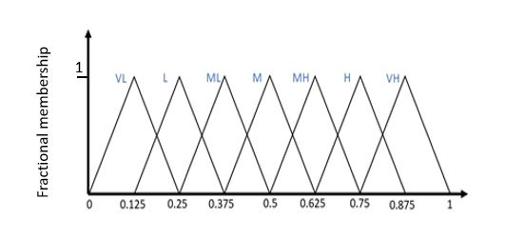

Figure 3‑1: Triangular fuzzy numbers with the membership functions on the interval 0 to 1. Linguistic values and equivalent integer designations are shown with each membership function. The centroids for the triangular functions evenly divide the interval into seven segments (Very Low = VL, Low = L, Medium Low = ML, Medium = M, Medium High = MH, High = H, Very High = VH).

A commonly used fuzzy set is the triangular fuzzy number, defined by three points [a1, a2, a3], respectively the lower bound, the mode and the upper bound(Kwang, 2019). The mathematical representation of the membership from the triangular fuzzy number (TFN) is shown in equation 3.1 and Figure 3‑2. Zardari et al., (2015) showed that fuzzy sets are often used to implement vague linguistic scores of experts and stakeholders into the MCDM structure.

$µ_{Ã}\sim (x) =\left\{\begin{aligned}0 for x < a_{1 } \\ \frac{x-a_{1}}{a_{2}-a_{1}} for a_{1} ≤ x < a_{2} \\ \frac{a_{3}-x}{a_{3}-a_{2}} for a_{2} ≤ x ≤ a_{3} \\ 0 for x > a_{3 }\end{aligned}\right.$ (Equation 3.1)

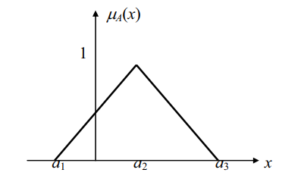

Figure 3‑2: Triangular fuzzy number A: [a1, a2, a3]. Adapted from (Han et al., 2019).

The fuzzy linguistic sets are introduced in two different stages: (i) on the evaluation of the qualitative criteria and (ii) for the weight preferences to the criteria. Both stages use a similar linguistic evaluation scale but with different labels as shown in tables Table 3‑1 and Table 3‑2. The values are chosen to evenly divide the interval in equal segments when a 7 point Likert scale is used, the scales are comparable to distributions found in literature (Moradpour et al., 2011; Ozsahin et al., 2020).

Table 3‑1: Linguistic variables with the matching fuzzy number for the criterion evaluation scores for each alternative.

|  |  |  |  |  |
| --- | --- | --- | --- | --- |
| Linguistic variable | Abbreviation | a1 | a2 | a3 |
| Very Low | VL | 0 | 0.125 | 0.25 |
| Low | L | 0.125 | 0.25 | 0.375 |
| Medium Low | ML | 0.25 | 0.375 | 0.5 |
| Medium | M | 0.375 | 0.5 | 0.625 |
| Medium High | MH | 0.5 | 0.625 | 0.75 |
| High | H | 0.625 | 0.75 | 0.875 |
| Very High | VH | 0.75 | 0.875 | 1 |

Table 3‑2: Linguistic variables with the matching fuzzy number for the criteria weight.

|  |  |  |  |  |
| --- | --- | --- | --- | --- |
| Linguistic variable (Importance) | Abbreviation | a1 | a2 | a3 |
| Low | LI | 0 | 0.125 | 0.25 |
| Quite low | QLI | 0.125 | 0.25 | 0.375 |
| Medium low | MLI | 0.25 | 0.375 | 0.5 |
| Medium | MI | 0.375 | 0.5 | 0.625 |
| Medium High | MHI | 0.5 | 0.625 | 0.75 |
| Quite High | QHI | 0.625 | 0.75 | 0.875 |
| High | HI | 0.75 | 0.875 | 1 |

### Group decision making

After all stakeholders of the project are determined, it is important to use participatory techniques to align the different stakeholders’ perspectives and build consensus on the MCDM parameters. Consensus in the traditional sense is a strict and unanimous agreement, however, in a complex situation this is unrealistic unattainable goal. Therefore, a softer and human perception of consensus is used, where people are willing to accept that a consensus has been reached when most or the more predominant actors agree on the preferences associated with the most relevant alternatives (Fedrizzi and Pasi, 2008). A technical solution to finding consensus between stakeholders, consists of aggregating the different individual views into one generic view, determined from the majority (Pasi and Yager, 2006) or average view (Yager and Filev, 1999). For a more detailed explanation on aggregation procedures we recommend Fedrizzi and Pasi (2008).

In this chapter, we propose an approach, in which the information on the initial disagreement is preserved and can therefore be used to account for uncertainties caused by disagreement between DMs. For each criterion weight, the different TFNs, one per stakeholder, are converted into one TFN, where the width of the resulting TFN is dependent on the degree of (dis)agreement between the decision makers. The peak of the TFN is the average of the initial TFNs and the upper and lower boundary values are determined by the lowest lower and highest upper boundary values found in the initial TFNs. The width of these TFN’s is therefore altered, resulting in a change in its membership, resulting in a wider or more uncertain scoring. An example of the TFN resulting from two disagreeing DMs can be found in Figure 3‑3.

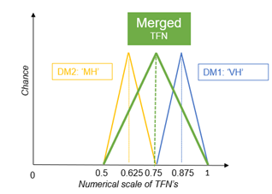

Figure 3‑3: Example to illustrate the relationship between the opinions of decision makers and the merged TFN's. DM1 stands for the first decision maker and DM2 for the second one.

### Monte Carlo simulation

Monte Carlo Simulation (MCS) is widely used to propagate (probabilistic) uncertainties from the model inputs to the model outputs (Urso, 2019). MCS is used to tackle uncertainties that can be described by probability distribution functions (PDFs). A MCS consists of a large number of repeated runs of the model, where each time the input values are randomly sampled from each probabilistic density function (PDF). The sampling of the criteria evaluation values is independent from each other, while the values of the criteria weights should sum to one. Therefore, after all the weights values are independently sampled the criteria weights are normalised so that, they sum up to one. The distribution of the output variables can then be examined further using statistical methods (Qin et al., 2008). As mentioned earlier, the triangular distributions based on the linguistic scorings are used as the PDFs, defining both the range of values and the likelihood that the weight has a value in specific interval (Aral, 2010). When this procedure is repeated a large number of times, the MCDM output can be seen as rank acceptability indices, that describes the chance of any alternative to be assigned a certain rank (Lahdelma and Salminen, 2008). Therefore, the higher the rank acceptability index of an alternative for a specific rank, the more this alternative was ranked at that specific rank during the MCS.

## Case study: The application of fuzzy MCDM to choose the optimal remediation technology.

### Materials and methods

In line with the generalized MCDM structure presented in Figure 2‑1, the components of the decision problem are the following:

#### Determination of the decision context:

Following a large-scale accidental release of radioactivity into the environment, large areas are likely to be contaminated by volatile radionuclides (RN) (e.g., I-131, Cs-137). Due to the persistence and the possible uptake of some long-lived RN (Cs-137) in the environment and food chain, the impact on the food production systems can last for many years (Merz et al., 2013). The need for long-term management plans after such a release can be seen in the Fukushima region, where 10 years after the DAIICHI nuclear accident, the remedial activities are still ongoing (Evrard et al., 2019).

The management of the contaminated areas focusses on the restoration of a normal lifestyle for all affected populations. Nevertheless, the recovery strategy to be adopted has to be justified and optimised (ICRP, 2007). The justification principle of a recovery strategy goes far beyond the radiological protection alone, as the implementation of recovery options may also have various economic, environmental, social and psychological impacts (Nisbet and Jones, 2009). Further, the optimisation principle ensures the selection of the best possible strategy and actions under the prevailing circumstances. Considering these principles, it is clear that for the successful remediation of sites contaminated with variable levels of long-lived RN, priority setting among adequate remediation technologies is of major importance. The selection of the remediation technology is typically conditioned by multiple and often contradicting criteria of an economic, social, technical, environmental and radiological nature. There are inherent trade-offs to be made between these possibly conflicting criteria to ensure a responsible and sustainable remediation process. As a case study, the optimal remedial agricultural measure is sought for a hypothetical contaminated cereal field, contaminated with Cs-137.

#### Alternative identification:

The possible agricultural countermeasures for the stated problem are listed in Table 3‑3. They are retrieved from the “Generic handbook for assisting in the management of contaminated food productions systems in Europe following a radiological emergency” (Nisbet and Jones, 2009) and expert knowledge.

Table 3‑3: Applicable agricultural remedial counter measures for the region around Tihange, applicable on a cereal field.

|  |  |
| --- | --- |
| Agricultural countermeasure | Description |
| Skim & burial ploughing (S&B) | Skimming of the top 5 cm of soil and burry it at 45 cm depth. Lifting the deeper soil layer up without inversion. |
| Deep ploughing (DP) | Inversion of the top 45 cm of soil to decrease Cs-137 root availability due to burial of the most contaminated top layer. |
| Application of potassium fertilizers (PF) | Reduce plant uptake of radio caesium by adding potassium to the soil due to increased competition for plant uptake. |
| Shallow ploughing (SP) | Use of ordinary plough to mix the top 20-30 cm of soil. Resulting in a deeper burial and dilution of the most contaminated top layer. |
| Topsoil removal (TR) | Removal and external waste management of the top 2-5 cm of soil. |

#### Criteria identification:

To ensure the selection of the most appropriate remediation measure, a divers set of criteria are to be considered. The combination of the criteria should encompass all dimensions of the decision problem without being redundant. Criteria are either of the benefit or the cost type. Whereas for benefit criteria the higher the score is the better, for cost criteria the opposite is true: lower scores are preferred. For this case study, four criteria are selected and they are listed in Table 3‑4.

Table 3‑4: Criteria used in the determination of the optimal remedial technology for a cereal field contaminated with Cs-137.

|  |  |  |
| --- | --- | --- |
| Criterion | Description | Benefit or cost |
| Reduction efficiency (RE) | Reduction in radioactivity of agricultural product (compared to doing nothing). [%] | Benefit |
| Direct cost of remediation technique (DCA) | The total implementation cost. It includes the full remediation cycle, from investigation to monitoring and waste treatment. [€/ha] | Cost |
| Local impact (LI) | The severity by which the local population is affected due to the implementation of the technique. The impact is based on expert assessment. [Linguistic scale] | Cost |
| Feasibility (F) | The probability that the remediation strategy is successful. If the successful implementation of a technique is not certain, it highly influences the preference for such technique. The impact is based on expert assessment and experiences. [Linguistic scale] | Benefit |

#### Criteria evaluation:

The score of each of the four criteria for each of the five alternatives are shown in Table 3-5. The criteria scores of ‘Reduction efficiency’ and ‘Direct cost’ are expressed on a continuous quantitative scale. ‘Local impact’ and ‘Feasibility’ are scored qualitatively by experts using a linguistic evaluation score, following the scale in Table 3‑1.

Table 3‑5: Alternative-criteria matrix with the criteria evaluations (L = Low, M = Medium, MH = Medium High, H = High, VH = Very High), with the best alternative score per criterion in bold (Hendrickx et al., 2021).

|  |  |  |  |  |
| --- | --- | --- | --- | --- |
|  | Criteria | | | |
| Alternatives | Reduction efficiency | Direct cost of remediation technique | Local impact | Feasibility |
| S&B | 80 | 2500 | MH | L |
| DP | 70 | 2000 | MH | M |
| PF | 50 | 265 | **L** | H |
| SP | 35 | **39** | **L** | **VH** |
| TR | **90** | 7600 | VH | L |

#### Criteria Preferences:

The criteria weights assigned by three individual decision makers to the four criteria are shown in Table 3‑6. They are expressed using the linguistic scorings from Table 3‑2. Two distinct scenarios are represented to show the impact of reaching a better consensus within the group.

Table 3‑6: Criteria preferences for decision makers for a scenario with and without consensus: LI = Low importance, QLI = Quite low importance, MI = Medium importance, MHI = Medium High importance, HI = High importance, QHI = Quite High importance.

|  |  |  |  |  |  |  |
| --- | --- | --- | --- | --- | --- | --- |
|  | Scenario 1 (consensus) | | | Scenario 2 (less consensus) | | |
|  | Decision makers | | | Decision makers | | |
| Criterion | DM 1 | DM 2 | DM 3 | DM 1 | DM 2 | DM 3 | |
| RE | HI | HI | HI | QHI | HI | MHI | |
| DCA | QHI | HI | HI | HI | QHI | MHI | |
| LI | MLI | QLI | LI | LI | QLI | MI | |
| F | MI | MI | MHI | QLI | MLI | MHI | |

#### MCDM method:

For the aggregation of the criteria scores, TOPSIS (Technique of Order Preference Similarity to the Ideal Solution) was utilised. TOPSIS is a distance-based MCDM method, where the rank of an alternative is based on the distance to the ideal and anti-ideal point (Behzadian et al., 2012).

#### Uncertainty analysis:

To estimate the impact of uncertainty on the ranking of the alternative countermeasures a Monte Carlo approach was used, sampling the TFN for 10 000 times.

## Results

For each of the different scenarios, the output is given as rank acceptability indices; this index describes the probability of any alternative to be assigned a certain rank. The results are structured so that the uncertainty, related to the imprecision on the input variables, is gradually increased. First, a deterministic run will be performed to set a baseline ranking of the actions. Next, both the uncertainties on the criteria scores and the weights are considered separate and thereafter combined. Then, the impact of a group of stakeholders on the results is considered using two scenarios (low and high consensus).

### Deterministic approach

In the deterministic approach, the methodology is applied without considering uncertainty from the fuzzy inputs. Different methods exist for the defuzzification of fuzzy numbers into crisp values, such as the Centre of Area (COA), Mean of Maxima (MOM) and Maxima-Method (MAX). However, for the specific case of a TFN the defuzzification result always equals the peak value: a2 (Geldermann et al., 2000). By using one of the above defuzzification methods, instead of a random sample, the input values will be constant over all the runs.

From Table 3-5, it became clear that skim and burial ploughing (S&B) is ranked highest for this specific decision context (contamination level, parcel size, crop type). The use of topsoil removal is ranked lowest and hence to be considered as the least optimal alternative. This can be explained by its high cost of implementation and the very high local impact. This deterministic approach is used as a baseline ranking, to compare the effect of introducing uncertainty in the fuzzy parameters.

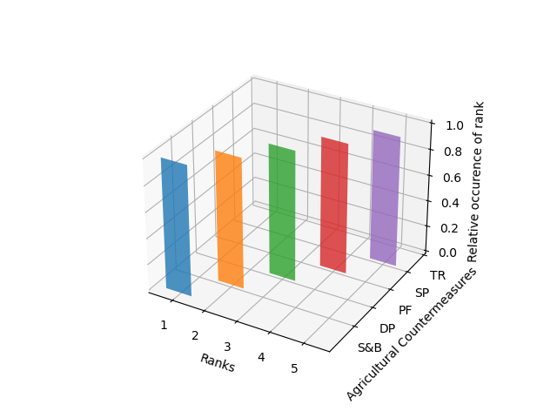

Figure 3‑4: The ranking of the alternatives based on the deterministic MCDM model, for skim & burial ploughing (S&B), deep ploughing (DP), addition of potassium fertilizer (PF), shallow ploughing (SP) and topsoil removal (TR).

### Introduction of uncertainty on the criteria scores (I)

The introduction of uncertainty on the criteria scores, compared to the deterministic case, shows multiple different rankings for S&B, DP and PF. In 2 % of the 10.000 runs, DP becomes the preferred alternative and in 3 % of the runs, PF is the alternative to be preferred. Further, the distinct difference in ranking between PF and DP as shown in the deterministic scenario becomes less straightforward.

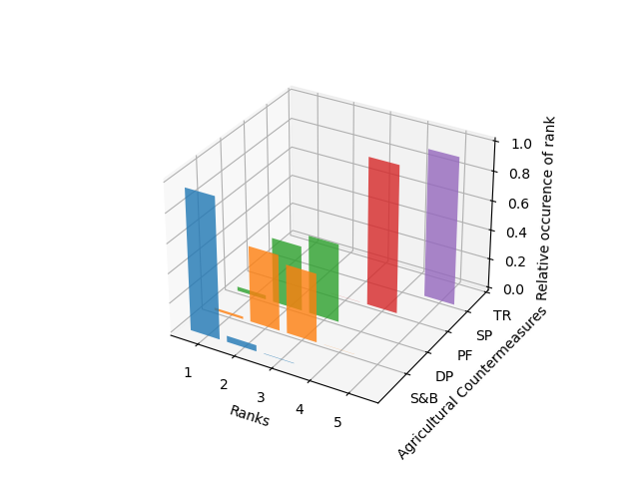

Figure 3‑5: The rank acceptability index, based on the relative occurrence of the alternatives in that rank, when uncertainty is introduced on the criteria scores, for skim & burial ploughing (S&B), deep ploughing (DP), addition of potassium fertilizer (PF), shallow ploughing (SP) and topsoil removal (TR).

### Introduction of uncertainty on the criteria preferences/weights (II)

When the uncertainty on the criteria preferences is introduced, it is observed that, even with uncertain criterion weights, the S&B alternative was ranked first in all cases. Further, in 3% of the runs, the TR alternative outranks alternative SP. This inversion could be a result of a Monte Carlo sample in which the importance for the cost criterion is low and the importance for the reduction efficiency criterion is high.

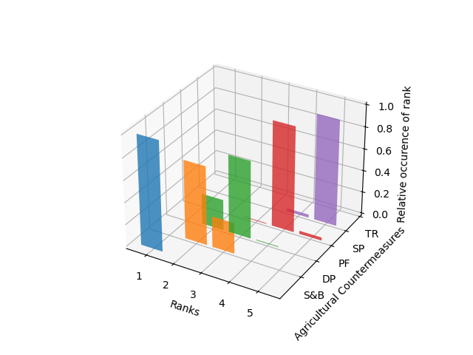

Figure 3‑6: The rank acceptability index, based on the relative occurrence of the alternatives in that rank, when uncertainty is introduced on the criteria preferences, for skim & burial ploughing (S&B), deep ploughing (DP), addition of potassium fertilizer (PF), shallow ploughing (SP) and topsoil removal (TR).

### Uncertainty on the criteria scores and criteria preferences combined (I + II)

Combination of both sources of uncertainty clearly affects discrimination between alternatives DP and PF. The best performing alternative S&B was ranked second in 7 % of the runs and even third in 1 % of the runs. The alternatives on rank 1, 4 and 5 can be determined with high confidence, while this is not the case for alternatives on rank 2 and 3 anymore.

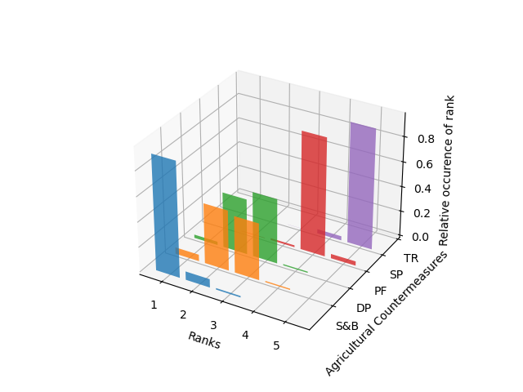

Figure 3‑7: The rank acceptability index, based on the relative occurrence of the alternatives in that rank, when uncertainty is introduced on both the criteria evaluations and weights.

### Group decision making with uncertainty (I +II + III)

Two scenarios are considered, differing in the amount of (dis)agreement between DMs. The introduction of disagreement between DMs further increases the number of different ranking options for all alternatives.

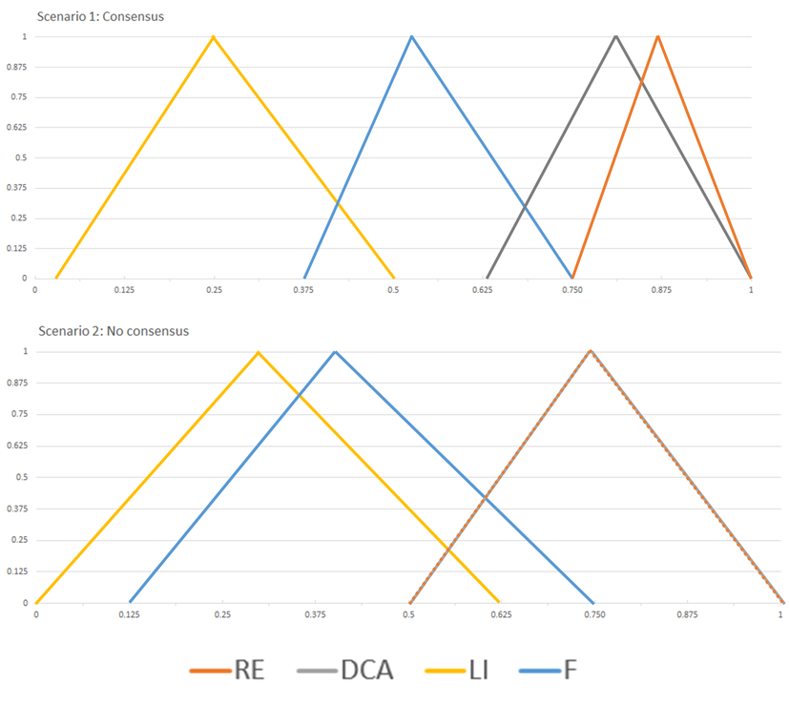

Figure 3‑8: TFN’s of the weights given by the two hypothetical multiple decision maker scenarios, where scenario 1 (upper) resembles high agreement between DM’s and (bottom) low agreement.

All alternatives were distributed over at least four different ranks over the 10.000 runs, and PF was even distributed over all five possible ranks. The impact of limited disagreement between multiple decision makers is rather small. However, when disagreement is larger the distribution of the alternatives over the different ranks also becomes larger. The difference between the ranking of SP and TR become smaller so that discriminating between them becomes less clear.

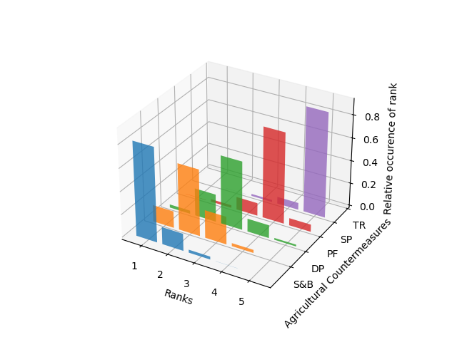

Figure 3‑9: The rank acceptability index, based on the relative occurrence of the alternatives in that rank, when uncertainty is introduced on both the criteria evaluations and weights but disagreement between the 3 decision makers is limited, for skim & burial ploughing (S&B), deep ploughing (DP), addition of potassium fertilizer (PF), shallow ploughing (SP) and topsoil removal (TR).

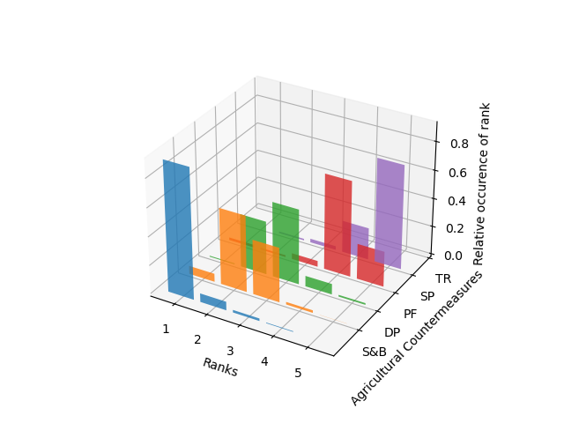

Figure 3‑10: The rank acceptability index, based on the relative occurrence of the alternatives in that rank, when disagreement between 3 decision makers is large, for skim & burial ploughing (S&B), deep ploughing (DP), addition of potassium fertilizer (PF), shallow ploughing (SP) and topsoil removal (TR).

## Discussion

From the graphs and the summary tables (Table 3‑7 and Table 3‑8), it became clear that the impact of uncertainty on the decision power cannot be ignored. When using a deterministic method without uncertainty, the user is given a false feeling of confidence in the MCDM. The increased complexity by introducing uncertainty, compared to a deterministic result, should not be seen as a disadvantage since the results are more reasonable and realistic in nature (Scheffler et al., 2014). The increasing uncertainty from introducing multiple uncertainty sources is as expected from literature and in line with other research performing stochastic uncertainty analysis of a MCDM approach to optimize remedial actions have reported similar trends in the rank acceptability indices (Alvarez-Guerra et al., 2010; Bonano et al., 2000b; Hokkanen et al., 2000).

From introducing uncertainty on the criteria evaluations, it became clear that in some cases the optimal alternative changes. This shows the importance for an accurate criterion evaluation. Nevertheless, it is important to acknowledge the inherent uncertainty of these criteria in the context of large-scale remedial actions. The criteria evaluations should be adapted to each agro-ecological zone to optimally describe and estimate the impacts of each alternative. This can for example be done by setting in-situ monitoring schemes can help improve our understanding of the alternatives in the field with time and adapt the decision matrix for consequent decisions.

Differences in criteria weights can have similar impacts on the decisions, this implicates that DM should be trained and prepared to use MCDM, to accurately represent their perspectives through these weights. The introduction of both sources of uncertainties on the criteria scores and weights clearly shows that decisions are less straightforward for rank 2 and 3, while rank 1, 4 and 5 could still be determined with high confidence, as can be seen in Table 3‑7 and Table 3‑8. These results highlight the robustness of the MCDM technique to robustly predict the best and worst remedial options, even under uncertain conditions.

Table 3‑7: Summary table of descriptive indicators of the ranking, when uncertainty is additively introduced in both the criteria scores and the criteria weights.

|  |  |  |  |  |  |  |  |  |  |
| --- | --- | --- | --- | --- | --- | --- | --- | --- | --- |
|  | Decision-making | | | | | | | | |
| Fuzzy criteria scores | | | Fuzzy criteria weights | | | Fuzzy criteria weights and scores | | |
| Min rank | Max rank | Median rank | Min rank | Max rank | Median rank | Min rank | Max rank | Median rank |
| **Skim and burial ploughing (S&B)** | 1 | 3 | 1 | 1 | 1 | 1 | 1 | 3 | 1 |
| **Deep ploughing (DP)** | 1 | 4 | 2 | 2 | 3 | 2 | 1 | 4 | 3 |
| **Potassium fertilization (PF)** | 1 | 3 | 3 | 2 | 4 | 3 | 1 | 4 | 3 |
| **Shallow ploughing (SP)** | 3 | 4 | 4 | 3 | 5 | 4 | 2 | 5 | 4 |
| **Topsoil removal (TR)** | 5 | 5 | 5 | 4 | 5 | 5 | 3 | 5 | 5 |

Table 3‑8: Summary table of descriptive indicators of the ranking for a group decision-making process, two scenarios of disagreement between DMs.

|  |  |  |  |  |  |  |
| --- | --- | --- | --- | --- | --- | --- |
|  | Group decision-making | | | | | |
| Consensus (Scenario 1) | | | No Consensus (Scenario 2) | | |
| Min rank | Max rank | Median rank | Min rank | Max rank | Median rank |
| **Skim and burial ploughing (S&B)** | 1 | 3 | 1 | 1 | 4 | 1 |
| **Deep ploughing (DP)** | 1 | 4 | 2 | 1 | 4 | 2 |
| **Potassium fertilization (PF)** | 1 | 5 | 3 | 1 | 5 | 3 |
| **Shallow ploughing (SP)** | 2 | 5 | 4 | 1 | 5 | 4 |
| **Topsoil removal (TR)** | 3 | 5 | 5 | 2 | 5 | 5 |

When consensus between the stakeholders is reached in a group decision-making problem, then the impact on the rankings is rather small. In comparison, if stakeholders do not agree on the criteria weights the decision can become less clear. This affects the model’s ability to determine the best option between several proposed options.

The introduction of uncertainty and the resulting impact on the rankings should be clearly communicated to the DMs, so that a better-informed decision can be made. The proposed technique to use linguistic evaluation scales and corresponding fuzzy numbers to quantify the vagueness and uncertainty of expert assessments could help with a clear communication of the impact of uncertainty. The resistance of stakeholders to give criteria preferences, because of the large influence on the ranking results, could be reduced with the applied method. The methodology is easy to understand, and it can be implemented with a variety of different MCDM aggregation techniques (e.g., PROMETHEE, ELECTRE, WLC, and VIKOR). Because of the increase in processing capacity, the use of MCS with even larger number of runs becomes feasible and less time consuming.

## Conclusion

The case study clearly showed the impact of uncertainty on the decision-making power, to support the remediation of agricultural land. As expected, the higher the number of sources of uncertainty considered and/or the larger the magnitude of the uncertainty the later will be the impact of the uncertainty on the ranks.

Although considering the uncertainties in the decision-making process has some disadvantages, such as a less clear ranking of the alternatives, the DMs receive a much more realistic information and advice compared to a deterministic model. It can be concluded, that using linguistic evaluation scales and corresponding fuzzy numbers, to incorporate vagueness and uncertainty in the decision process is helpful. Furthermore, it highlights the need for accurate criteria evaluations and weight settings. The application of fuzzy elements in MCDM could address some issues of DMs to MCDM and help them not to fear uncertainty but embrace its presence in every decision. It can be concluded that the application of fuzzy logic in MCDM to account for the uncertain nature of complex decision problems (e.g., soil pollution remediation projects) is further to be promoted. Future research should include more sources of uncertainty, combined with a careful investigation of possible interactions between them and the effect on the robustness of the MCDM process.

# Optimizing Remediation of Spatially Dispersed Contaminated Parcels under an Annual Budget Constraint.

Based on: Abrams, F., Sweeck, L., Camps, J., Cattrysse, D., Van Orshoven, J., 2022. Optimizing Remediation of Spatially Dispersed Contaminated Parcels under an Annual Budget Constraint. International Journal On Advances in Software, 15, 188–199.

## Summary

In environmental disaster management, due to the large impacted area or limited availability of labor and financial resources, setting priorities of where, how and when to act are indispensable. When prioritized interventions on spatially dispersed entities are costly and technically challenging to perform, clustering of individual entities in larger homogeneous actionable units can improve feasibility and reduce cost of the remediation. In this chapter, a spatio-temporal clustering approach under a budget constraint is presented to determine homogenous clusters of polygons and interventions to reduce cost while still attaining an overall optimal distribution of interventions. We demonstrate the effectiveness of this clustering algorithm with a hypothetical case study of contaminated agricultural land in Belgium. Finally, we demonstrate the capabilities of the proposed cluster algorithm to provide decision makers with a multi-period action plan, reducing the cost of intervention while still prioritizing resources for the most important sites.

## Introduction

When dealing with large natural or man-made disasters, decision makers are confronted with setting priorities of where, how and when to act because of the limited availability of labour and financial resources. This priority setting is particularly applicable when the impact of remedial actions is costly and has long-lasting influences. For spatially distributed sites with variable characteristics, priority setting among the sites and the determination of the most adequate remedial action per site are of major importance. The United States Environmental Protection Agency (US EPA) identified the following benefits of these optimization efforts: more cost-effective expenditure, lower energy use, reduced carbon footprint, improved remedy protectiveness, improved project and site decision making, and acceleration of project and site completion (US EPA, 2020).

Addressing the questions of where and how to act consecutively results in a nested ranking of sites and interventions per site. From those rankings, a spatio-temporal action plan can be determined.

To assist decision makers in setting such priorities, spatial Decision Support Systems (sDSS) become of importance (Malczewski and Rinner, 2015). The effectiveness of related decisions is typically conditioned by multiple and often contradicting criteria of economic, social, technical, environmental, and human health-related nature (Anderson et al., 2018). These characteristics of the decision problem make it suitable for the application of a spatially discrete Multi-Attribute Decision Making (GIS-MADM) approach (Malczewski, 1999). ‘GIS’ points to the spatial aspect of the decision problem, while MADM encompasses a subset of Multi-Criteria Decision Analysis (MCDA) methods. MADM supports the decision-maker by describing and evaluating the performance of a finite number of decision alternatives with respect to multiple criteria expressed as attributes of the alternatives, representing several points of view. The MADM results in a ranking of the alternatives based on the selected criteria and their relative importance (Malczewski and Rinner, 2015). The MADM framework is often applied because it supports a structured and inclusive decision process, addressing a plurality of preferences and socio-technical dimensions that cannot always be brought to a common monetary scale (Gamper and Turcanu, 2015).

This chapter presents a GIS-MADM approach that provides actionable support to decision makers by proposing a coherent action plan in space and time for decontamination of the agricultural domain in a region affected by the deposition of radionuclides. It uses a spatio-temporal approach to deal with the clustering of spatially scattered polygon-based parcels, whereby a budget constraint limits the extent and/or type of interventions that can be performed in each time step, i.e., in one year. The chapter elaborates on the classic region-growing principles, adapted to polygon-based data structures, and explicitly takes into account the attributes of the individual polygons to find the optimal compromise attribute for the whole cluster. Because a spatial and temporal clustering of sites and actions is likely to create “economies of scale” (Kingscott and Weisman, 2002), the cost of remediation interventions will be lowered, resulting in an overall cheaper and faster remediation process.

The use of MADM approaches for supporting remediation on a regional scale by prioritization contaminated sites for decontamination (‘Where to act?’) was reported by several authors (Lin et al., 2020; Polat et al., 2015; Zhang et al., 2010). In addition, the support on a local scale by prioritization of the remedial technologies for a given site (‘How to act?’) was also addressed in several publications (Linkov et al., 2004b; Promentilla et al., 2006; Rosen et al., 2015). However, no reports were found, where MADM was used for simultaneously prioritizing of where and how to act decisions into a coherent spatio-temporal action plan. When both prioritizations are done separately, the procedure typically yields a geographically distributed set of priority sites as well as neighbouring sites with different interventions. Different propositions were made to improve MADM on a regional scale, to reduce the scattered priorities. For example, by incorporating a compactness measure to ensure sites were big enough to ensure a feasible intervention (Vanegas et al., 2010).

MADM approaches have been used with raster as well as polygon-based datasets. For this application, it was chosen to use polygon-based data because they provide a natural representation for many types of geospatial entities, such as agricultural parcels, buildings, or polluted sites. In addition, these entities form the smallest units used in real-world decision making. Therefore, it is interesting to provide actionable support to decision makers based on polygon-based representations. By addressing the problem with polygon-based data, the adaptations using compactness measures and clustering of entities are more complicated compared to raster-based datasets. Because the topology of spatially dispersed polygons is less straightforward when dealing with unlinked features (Fleischmann, 2019).

Further, due to the limited availability of resources, a budget constraint limits the extent of interventions possible for each period; thus, a multiple-period action plan is required. A multi-period decision problem requires a Dynamic Multi-Attribute Decision Making (dMADM) methodology (Chen and Li, 2011; Dong and Guo, 2013; Karatas, 2017). However, the majority of documented MADM applications only address a decision problem for a specific time period (Xu, 2008). In contrast, dMADM determines the criteria scores and relative relevance for each period to accurately reflect the decision variables at that time.

Some spatial DSS tools were developed for supporting decisions with similar spatio-temporal aspects. These authors included a temporal dimension in their approach to determine how a set of land use types should be distributed over space and time in order to optimize the multi-dimensional land performance of a region over a period of 30 years (Estrella et al., 2016). However, they found that their approach, which was based on integer programming (IP), resulted in land use plans that were too spatially and temporally fragmented for real-world application and recommended that a clustering strategy could be a suitable next step.

The rest of this chapter is organized as follows: Section 4.3 provides an in-depth explanation of the spatio-temporal cluster approach. In Section 4.4, the approach is illustrated with a case study for an agricultural region in Belgium, contaminated after a hypothetical accidental release of Caesium-137 from a nuclear power plant. Section 4.5 discusses the applicability of the algorithm to help improve decision making, while Section 4.6 draws the most pertinent conclusions.

## Materials and methods

The spatio-temporal clustering approach combines a site priority score (PPS) and an action priority score (APS), as discussed in Section 4.3.1. The iterative and dynamic cluster growing algorithm is discussed in Sections 4.3.2 and 4.3.3.

### Distance based priority scores

Different implementations of MADM exist, each with their own strengths and weaknesses. We opted for a distance-based MADM, called Compromise Programming (CP), to rank the considered set of feasible alternatives (Bai et al., 2015; Salt and Dunsmore, 2000; Tian et al., 2019; Yang et al., 2012). CP uses the distance in the feature space to the so-called ideal point of each alternative to rank them. The feature space is constructed from independent, operational, non-redundant, and continuous attributes (Belton and Stewart, 2002). The criteria used vary significantly between different case studies, depending on the problem, the site characteristics and the available data. For each criterion, a weight reflecting the importance of the criterion is set by the stakeholders, preferably through a collaborative process (Zardari et al., 2015). This weight takes into account the relative importance of the criterion, where its value can be understood as a trade-off value between criteria. For this set of criteria and corresponding weights, the CP methodology determines the optimal point, a vector of performance attribute values corresponding to an alternative with the best observed performance on each criterion separately. This ideal point is mostly hypothetical, because multi-criteria decision problems involve conflicting criteria. The ideal point allows for determining a ranking of the alternatives based on each alternative’s distance to the ideal point, whereby the alternative that comes ‘closest’ to the ideal point is the most preferred. The definition of ‘closeness’ requires the formulation of a distance metric (Equation 4.1), where a larger distance equals a less optimal alternative (Malczewski and Rinner, 2015). For this application a Euclidean distance was chosen (Equation 4.1) and fall within the range [0-1], with a distance of zero being the best alternative that requires no compromise because it outperforms all other alternatives on all criteria. In contrast, a distance of one reflects an alternative that scores the lowest on all criteria.

$$L= {\left[\sum_{i}^{n}{w_{i}^{p}{\left[\frac{f_{i}^{+}- f_{i}(x)}{f_{i}^{+}- f_{i}^{-}}\right]}^{p}}\right]}^{1/p} (Equation 4.1)$$

* n is the number of criteria under consideration;
* $w_{i}$ is the relative importance (weight) assigned to performance attribute i;
* p is a parameter that determines the type of distance function, where 2 represents the Euclidian distance;
* $f_{i}^{+}$ is the optimal value for performance criterion i;
* $f_{i}\left(x\right)$ is the value of the ith performance criterion expressed as a function of the decision variables x;
* $f_{i}^{-}$ is the anti-ideal corresponding to the ith criterion that is the “worst” value for this criterion.

To determine the optimal remediation plan for a territory of interest two important questions need to be answered. The first question is “Where are the sites situated for which intervention is most urgent?”. The CP methodology returns a distance score for each polygon, representing the priority/urgency of a polygon to be intervened on. From these scores a ranking of the polygons from high priority (small distance) to low priority (large distance) can be made. For the case study in this chapter, this score is referred to as Parcel Priority Score (PPS). The second question is “What is the most optimal action for each site?”. Therefore, for each polygon, the feasible intervention actions need to be ranked. In our proposed approach, the ranking of the alternative interventions is similarly based on a distance score, computed by CP. In the following case study, for each alternative intervention on a specific site, the Action Priority Score (APS) is calculated. The further clustering of parcels is based on the combination of PPS and APS.

### Temporal dynamics in MADM

When actions are postponed in time, the initial decision variables (criteria scores for the alternatives and criteria weights) may alter, and the decision problem needs to be redefined, resulting in a multi-period MADM. The number and extent of polygons that can be acted on in each period depends on the budget available in each period, which is set to one year in our case study. While performing actions on the most urgent polygons first, each of the actions comes at a cost. For each intervention, the cost can be calculated based on the cost per unit of area and the size of the polygon. Interventions can be done in one period until the total cost of remediation exceeds the period’s budget. When the budget is reached, the remaining polygons become candidates for the next period, where changes in the criteria scores and weights may occur and should be taken into account.

### Spatio-temporal clustering algorithm

The algorithm operates in a similar fashion as a region-growing algorithm, where it consecutively checks whether one of the neighbouring polygons can be added to the cluster, taking the similarity between the priority scores of the seed polygon and the neighbouring candidate into account. The clustering algorithm is iterative and consists of two phases: The cluster initialization phase is followed by the cluster-growing phase, which ends as soon as one of the stopping criteria is met. The procedure is illustrated in Figure 4‑1 and the pseudo code is given in Figure 4‑2.

#### Cluster initialisation

To optimally allocate resources, the most urgent sites should be treated first. Therefore, the seed parcel is the one with the lowest PPS (smallest distance to the ideal point).

#### Cluster growing procedure

After the seed parcel has been determined, the cluster-growing procedure attempts to find neighbouring parcels that can be added to the seed parcel or the growing cluster, where parcels in a cluster have the same intervention action to be performed in the same period.

Adding more parcels to the cluster enlarges the cluster, therefore creating larger actionable units, which are preferred from the perspective of reducing the complexity and operational cost of the intervention. However, since the parcels added to the cluster potentially have a different optimal action, it is important to find a compromise remediation action that minimizes the deviation in performance with the parcels considered individually. The cluster growing can be subdivided into three consecutive steps that are repeated until the constraints for the end of cluster growth are met.

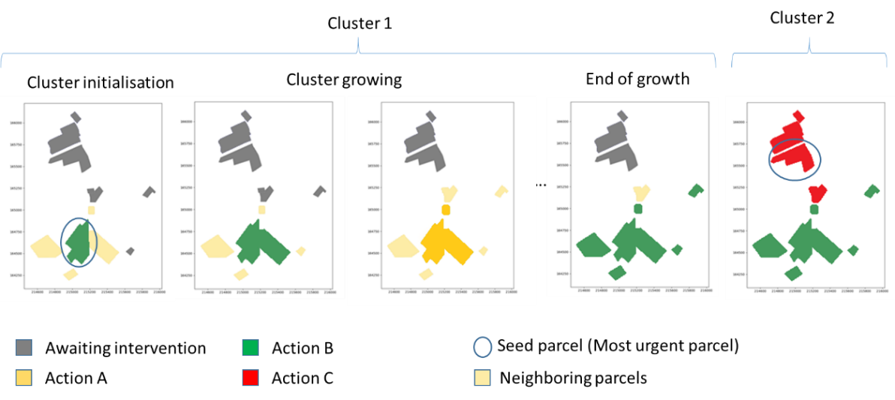

Figure 4‑1: The cluster growing procedure applied on 12 parcels, considering three possible actions, resulting in two clusters each with one action.

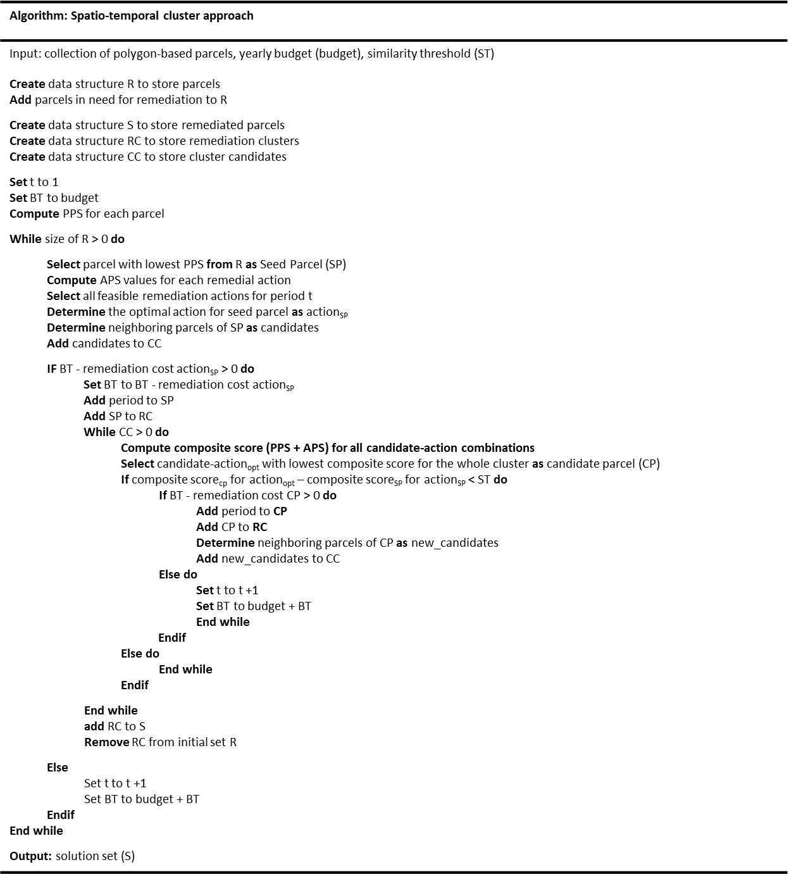

Figure 4‑2: Pseudo code of the spatio-temporal cluster approach, determining the remedial technique and timing of the clusters.

#### Determination of the parcel neighbours

Compared to a raster dataset, where cells are spatially arranged in a systematic way and neighbours are easily defined, in a data set of spatially distributed polygons, determining the neighbours is more challenging. To define neighbouring polygons, which are not necessarily sharing a border but are rather separated by irrelevant space, a technique called morphologic tessellation (MT) is used. At the core of MT is the Voronoi tessellation (VT), a method of geometric partitioning of the 2D space, where a planar set of “seed points” generates a series of polygons known as Voronoi polygons (VP). Each VP encloses the portion of the plane that is closer to its seed than to any other polygon (Fleischmann et al., 2020). From the partitioned space, the neighbours of a VP can be determined by examining the VPs sharing borders. An example of the portioning by VPs is given in Figure 4‑3.



Figure 4‑3: Initial set of distributed parcels (a) and VP computed by the EMT, resulting in a partitioned coverage (b).

To deal with the distributed nature of the polygons, use is made of an enclosed tessellation based on the enhanced morphological tessellation algorithm (EMT). EMT allows for setting limits to the expansion of the MT, limiting the allowed distance between polygons that can be considered neighbours. Furthermore, it allows for the establishment of break lines (e.g., rivers or administrative boundaries) beyond which the VPs are not permitted to trespass. The VP constructed by the EMT algorithm captures the spatial configuration of all parcels, from which the neighbouring parcels of each parcel can be determined. The EMT algorithm is accessible from an open-source Python package (http://docs.momepy.org). Fleischmann et al. (2019, 2020) provides more information regarding the EMT methodology.

#### Determining the optimal neighbour

To determine the neighbouring polygon that is best suited for growing the cluster, the sum of the PPS and APS scores of each neighbour is considered. Whereby the neighbour leading to the lowest increase in the composite score of the cluster is added. From this, it follows that adding a parcel to the cluster can change the remediation action to be applied to all the parcels in the cluster. Moreover, when the best candidate is found, it is verified whether the candidate neighbour is similar enough to the seed pixel to be added. If the similarity threshold is not exceeded, the parcel is added to the cluster, and this procedure is repeated; otherwise, the end of the cluster-growing phase is reached. To highlight the process of finding a compromise between all parcels on the cluster level, five iterations of the growing procedure are shown in Table 4‑1 and Table 4‑2. The similarity threshold applied is 0.31 for Table 4‑1 and 0.15 for Table 4‑2. The cells with the same colour show the current parcels in the cluster, and the remedial action of the cluster is shown with a subscript on the APS. The APS values in bold show the optimal action per parcel. Table 4‑1 illustrates that while a cluster grows iteratively, the optimal remediation action for all parcels combined within the cluster changes. In iteration III, the optimal remediation on the cluster level is the worst performing action for the seed parcel (A) and the second-best action for parcel B. Nevertheless, from the perspective of the cluster, action 3 is the best compromise solution. In addition, Table 4‑2 shows the impact of the similarity threshold: In iteration V, parcel E is not added to the growing cluster due to a difference larger than the similarity threshold between it and the seed parcel (parcel A). Parcel E will then be selected as the next seed parcel. The different cluster configuration (1 vs. 2) in iteration V for both tables highlights that a lower similarity threshold will result in an overall lower (better) composite score for the solution.

Table 4‑1: The chosen remedial technique for the cluster in bold and corresponding composite score, during the growing procedure of a cluster for five iterations for a similarity threshold of 0.3, resulting in one cluster.

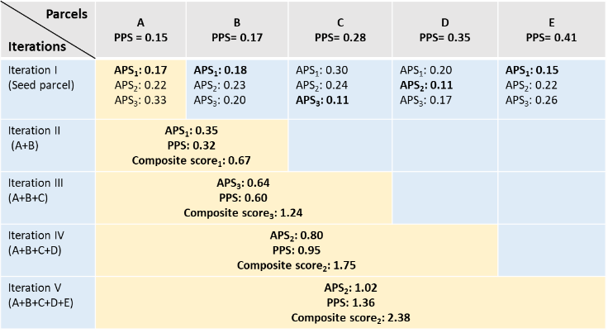

Table 4‑2: The chosen remedial technique for the cluster in bold and corresponding composite score, during the growing procedure of a cluster for five iterations for a similarity threshold of 0.15, resulting in two clusters with different remedial techniques.

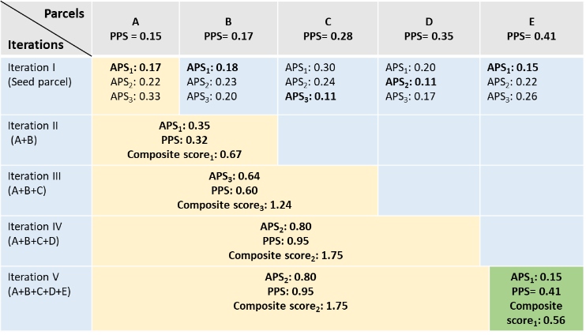

#### Cost calculation

Every intervention has a corresponding cost, determined by the intervention type and size of the parcel. Discounts can be taken into account when a cluster reaches a certain size (e.g., a 20% cost reduction for the whole cluster if a cluster reaches a size of five ha). Before a parcel is added to the cluster, it is confirmed if there is still enough budget left for performing the intervention. If the budget constraint is exceeded when the parcel would be added to the cluster, the cluster growing is stopped, and the remaining budget is transferred to the next year’s budget.

#### End of growth

The end of growth phase is reached when one of the two constraints is not met.

#### Similarity threshold

The similarity threshold determines the variability of parcels that is allowed within the cluster. By lowering the threshold, only parcels with a similar composite score will be allowed to enter the cluster, resulting in a more homogenous cluster. Consequently, the growth of clusters is more rapidly stopped, and the clusters tend to remain smaller, possibly not achieving a large enough size to be entitled to a discounted remedial cost. Therefore, the threshold should be chosen according to a trade-off between the homogeneity of the clusters on the one hand and the ease and cost of implementing the remediation strategy on the other. The reasoning behind the threshold setting is that when the difference in performance between seed and candidate parcels is large, resources will be used for less urgent parcels or for suboptimal intervention. When the similarity threshold is not met, the cluster growing is stopped and a new seed polygon is found for building the next cluster.

#### Budget constraint

The budget constraint limits the amount of resources that can be allocated to interventions in each period. The implementation of a budget constraint in the spatial clustering algorithm ensures that cluster growth cannot lead to exceeding the budget for the given period. Once the budget is reached, the attributes of the remaining (unclustered) polygons are adapted to reflect their status for the new period. Next, the clustering can be started for the new period.

## Case Study

To demonstrate the capabilities of the proposed spatio-temporal clustering model, it is applied to the Maarkebeek case study as discussed in section 1.8.1. A remediation plan for these parcels must be designed for a budget of 500 000 euros per year to ensure that all parcels are remediated so that food can be produced in accordance with the legally set contamination limits. In this case study, five possible remedial interventions are considered: potassium fertilizers, shallow ploughing, deep ploughing, skim and burial ploughing and topsoil removal (Table 3‑3).

### Optimizing remediation on a local scale by determination of the Action Priority Score (APS)

For the determination of the remedial intervention among the five potential remedial actions, six criteria have been selected (Table 4‑3). The applicability of the intervention depends on the parcel’s contamination level and the crop type, because some remedial actions are unsuitable for specific agricultural crops or inadequate to reduce the contamination levels below the legal permissible levels. For example, ploughing actions are unfeasible for parcels with perennial crops. The criteria to assess remedial actions can vary largely based on the geographical region, contamination type, stakeholders, and data availability (see Chapter 2).

Table 4‑3. Criteria used to determine the Action Priority Score (APS) of each remedial intervention, the weights are based on expert judgement.

|  |  |  |
| --- | --- | --- |
| **Criteria** | **Description** | **Weight** |
| Feasibility | The probability that the remediation strategy is implemented successfully. | MH |
| Incremental Dose | Exposure dose to the workers that need to implement the remediation technique. | MH |
| Environmental Impact | Risk or actual impact on the living and or non-living environment due to the remediation. | M |
| Local Impact | Changes to the landscape/ way of life of the population. | MH |
| The cost of remediation | The total implementation cost of remediation minus the otherwise paid compensation to the farmer. The full remediation cycle is included from investigation to monitoring and waste treatment. [€/ha] | H |
| Reduction Effectivity | Reduction in activity of agricultural product (compared to doing nothing). [%] | VH |

The five remedial alternatives are scored on the six criteria that produce the alternative-criterion matrix Table 4‑4,which is the basis for the distance calculations by the CP. For each of the parcels the alternative-criterion matrix will be different based on the location of the parcel, Cs-137 deposition level, crop and soil class.

Table 4‑4: Example of an alternative-criterion matrix for the five remedial alternatives, scoring them on six criteria (Hendrickx et al., 2021).

|  |  |  |  |  |  |  |
| --- | --- | --- | --- | --- | --- | --- |
|  | Feasibility | Incremental dose | Environmental impact | Local impact | Cost of application [€ ha-1] | Reduction efficiency  [%] |
| Potassium fertilizer | H | L | H | L | 66  (repeated) | 69 |
| Shallow ploughing | VH | MH | VL | L | 39  (single time) | 50 |
| Deep ploughing | M | H | M | MH | 53  (single time) | 70 |
| Skim and burial ploughing | L | H | M | MH | 95  (single time) | 87.5 |
| Topsoil removal | L | H | VH | VH | 24 499 (single time) | 93.5 |

The incorporation of the temporal dynamics in this case study is necessary since the values of certain decision variables change through time. Because of natural attenuation, which causes the mass, toxicity, volume or concentration of contaminants in the soil or groundwater to reduce over time. This implies that the contamination decreases over time without the interference of specific remedial actions. For radioactive contaminations the reduction of the contaminant is strongly determined by the radioactive decay, the radionuclide’s half-live. For a remedial action to be considered feasible, it should be able to reduce the contamination levels below the legally allowed limits. From the dynamic nature of the contamination, it follows that, after a certain period of time other remedial options can become effective enough and outperform the previously selected option. Consequently, the remedial actions for each parcel should be revised to ensure they are still optimal for each time period. For this case study, the weights are not considered to change between periods. For each individual parcel, an APS score for each of the feasible remediation technique can be calculated. This is illustrated for a cereal parcel (Figure 4‑4). For this specific parcel, four remedial actions are feasible, because shallow ploughing is not able to reduce the contamination level below the needed threshold. Deep ploughing is considered the most optimal since it has the lowest APS value and topsoil removal is the second-most optimal remedial technology.



Figure 4‑4: Action Priority Score (APS) for the different candidate remedial actions on an agricultural parcel with cereal cultivation.

### Optimizing remediation on a regional scale by determination of the Parcel Priority Score

A parcel is characterized by a set of attributes such as geographic location, environmental characteristics, and agricultural practices. These attributes form the basis for the decision criteria used for determining the PPS (Table 4‑5). The criteria for assessing the priority for remediation of sites with polluted soils were determined based on the prevalence of used criteria in 13 case studies; an overview of all the reviewed criteria can be found in APPENDIX B. Furthermore, each of the criteria was assigned a relative weight based on expert assessment of its importance. The weight is expressed by a linguistic score, which corresponds to a triangular fuzzy number (TFN). TFN are then converted to a quantitative value using the centre of gravity method, where the center of gravity from the triangle is taken to determine the quantitative value (Wang and Luoh, 2000).



Figure 4‑5: Membership functions of the linguistic expert ratings used for quantifying the criteria weights, with abbreviations VL: very low, L: low, ML: medium low, M: medium, MH: medium high, H: high and VH: very high.

Table 4‑5: Criteria used to determine the Parcel Priority Scores (PPS), with the corresponding weights determined by experts.

|  |  |  |
| --- | --- | --- |
| **Criterion** | **Description** | **Weight** |
| Activity in the food products | The activity of Cs-137 found in the crop after harvest from this field [Bq/kg] | VH |
| Importance of the food in the local diet | The amount consumed of this product on yearly basis [kg/year] | M |
| Distance to the urban infrastructure | Distance to the closest urban infrastructure (houses and gardens) [meter] | H |
| Distance to nature reserves | Distance to the closest nature reserve [meter] | L |
| Distance to surface water | Distance to the closest surface water (lake/river) [meter] | M |
| Population density | Population density of the municipality [pp/km2] | H |
| Erodibility of the parcel | The erosion sensitivity of the field [scale (0: None - 0.5: medium - 1: very high)] | L |

The seven criteria and corresponding weights, shown in Table 4‑5, are then used by the CP methodology to determine the feature distance of each parcel to the hypothetical parcel with the highest societal priority and therefore the need for remediation. In Figure 4‑6, the CP methodology, limited to three alternatives and two criteria, is illustrated. The priorities based on the CP methodology for each parcel are shown in figure 4-7.

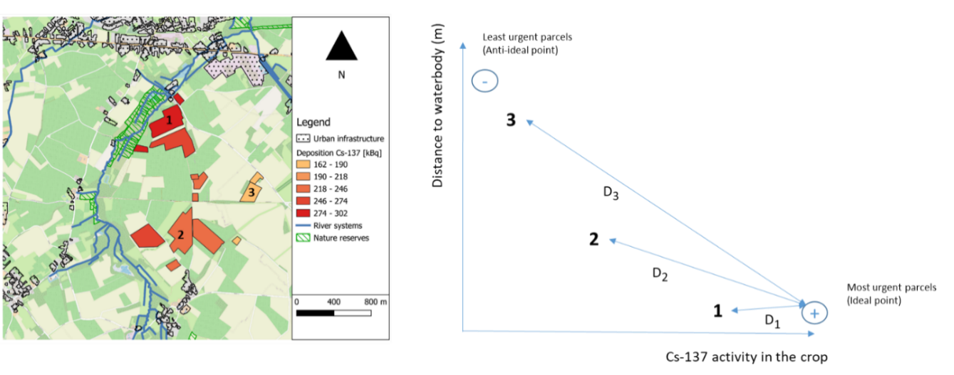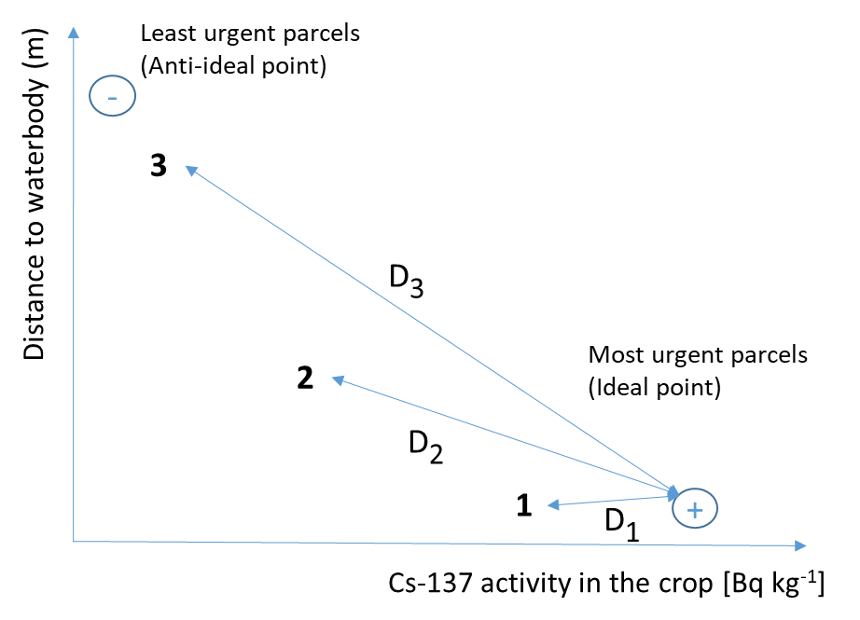

Figure 4‑6: Representation of a two-dimensional Compromise programming distance for three parcels (bottom) and its geographic representation (top).

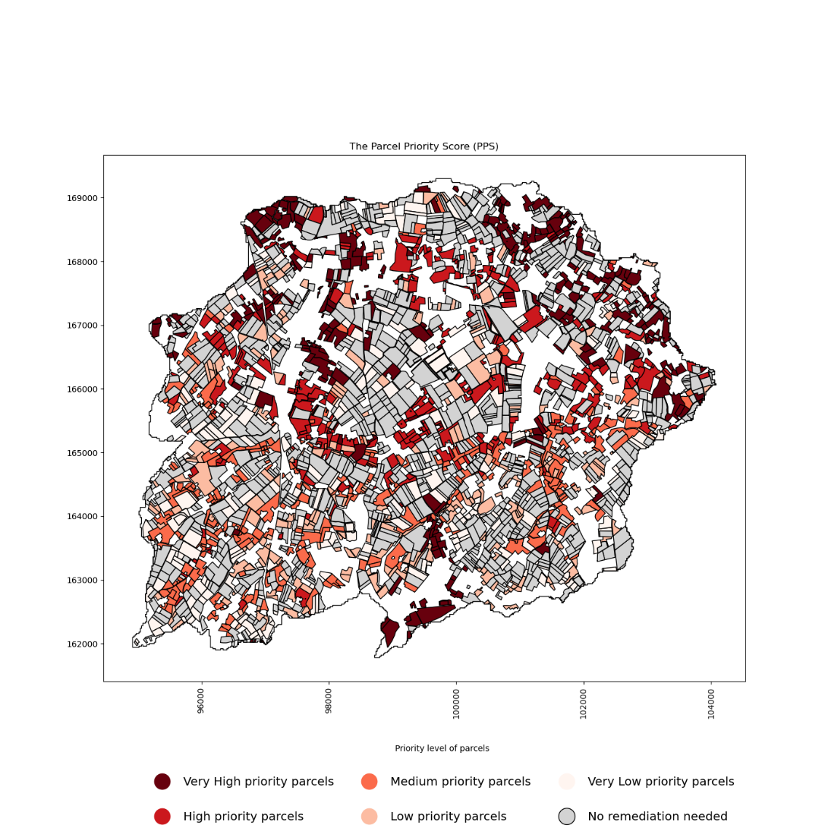

Figure 4‑7: The parcel priority score (PPS) for agricultural parcels in need for remediation, displayed in 20% quantiles. The lower the PPS, the more urgent the remediation is.

### Remedial solution per parcel

In

Figure 4‑8, the optimal remediation technique for each parcel, based on the technique with the lowest APS, is shown.

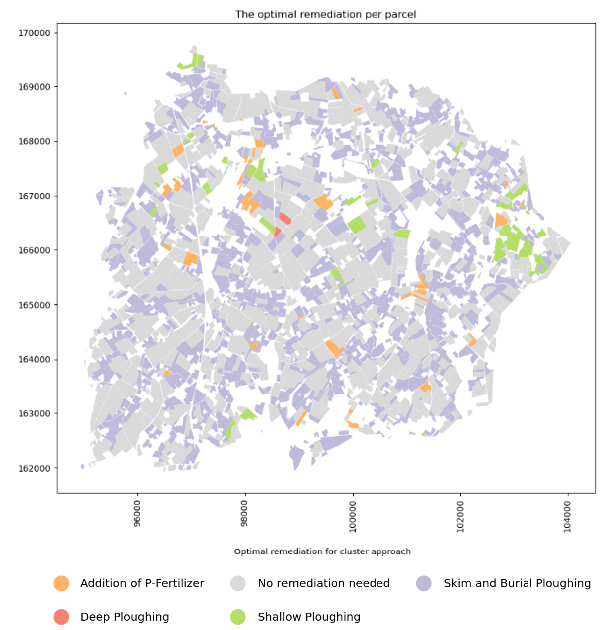

Figure 4‑8: The remedial technologies based on the optimal remedial action for each parcel.

### Spatio-temporal cluster solution for the affected region

With the spatio-temporal cluster approach, a multi-period action plan can be designed, taking into account when and how to remediate the parcels. For the same area, the spatio-temporal cluster model proposes a remedial technique and timing. Both can be found in Figure 4‑9 and Figure 4‑10, respectively. The difference in remedial technologies between

Figure 4‑8 and Figure 4‑9 can be explained by the clustering of parcels and the changing of some of the parcel characteristics due to the delayed remediation. The remedial action “food restriction” found in Figure 4‑9 is for agricultural parcels where, due to the physical decay process, the food crops can be produced after some time with activity level below the permissible levels without the need for a remedial action. The model will seek optimal homogenous clusters, where the solution is optimal overall and not for each individual parcel.

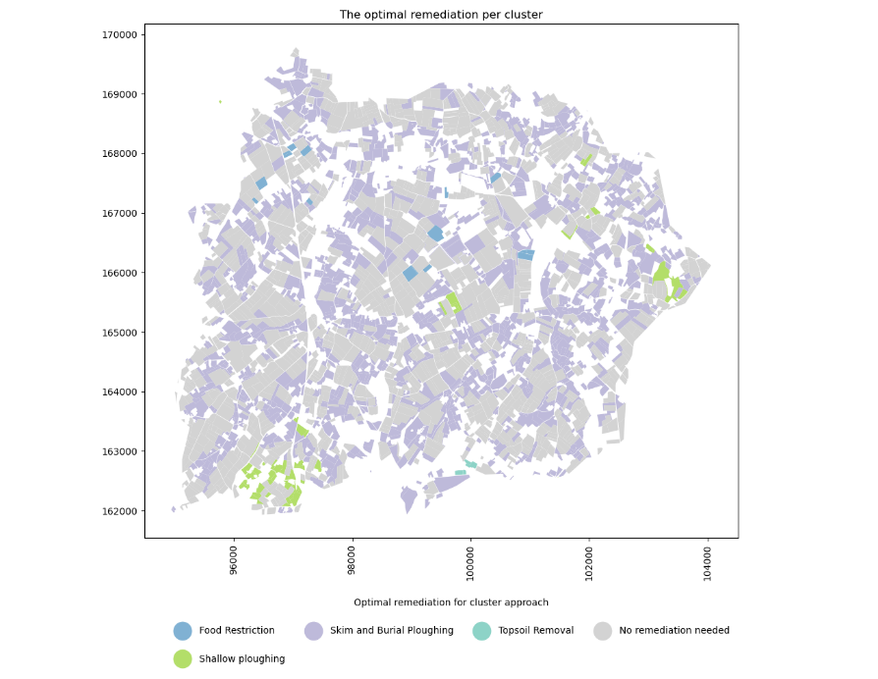

Figure 4‑9: The remedial technologies proposed by the spatio-temporal clustering algorithm with a similarity threshold of 0.025.

A higher similarity threshold results in more resources going to less important parcels, but on the other hand, it results in larger clusters and therefore lower operational costs. When lowering the similarity threshold for more optimal decision making, the overall cost of remediation will increase, resulting in more time needed for the remediation of the affected region. This effect can be seen in Figure 4-11, where the remediation will take nine years instead of seven, increasing the budget by around 1 million euros compared to Figure 4-10.

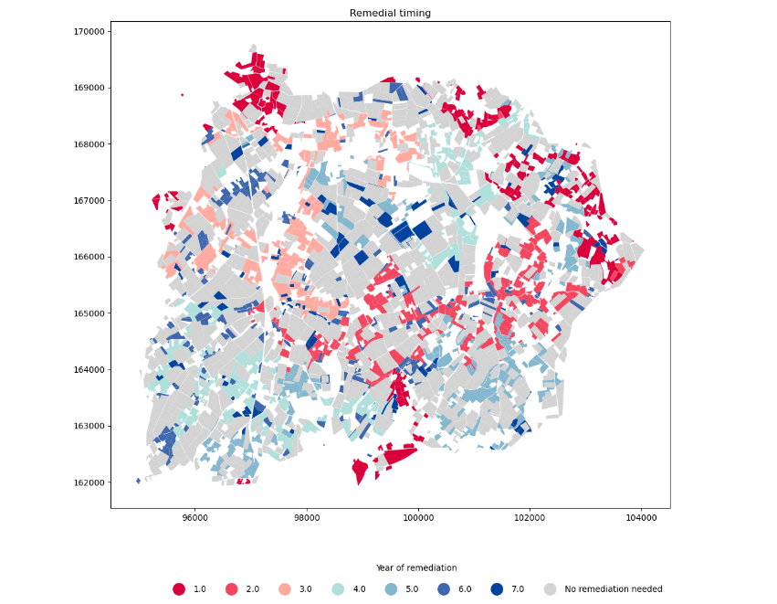

Figure 4‑10: The timing of remediation proposed by the spatio-temporal clustering algorithm when the similarity threshold is set to 0.025.

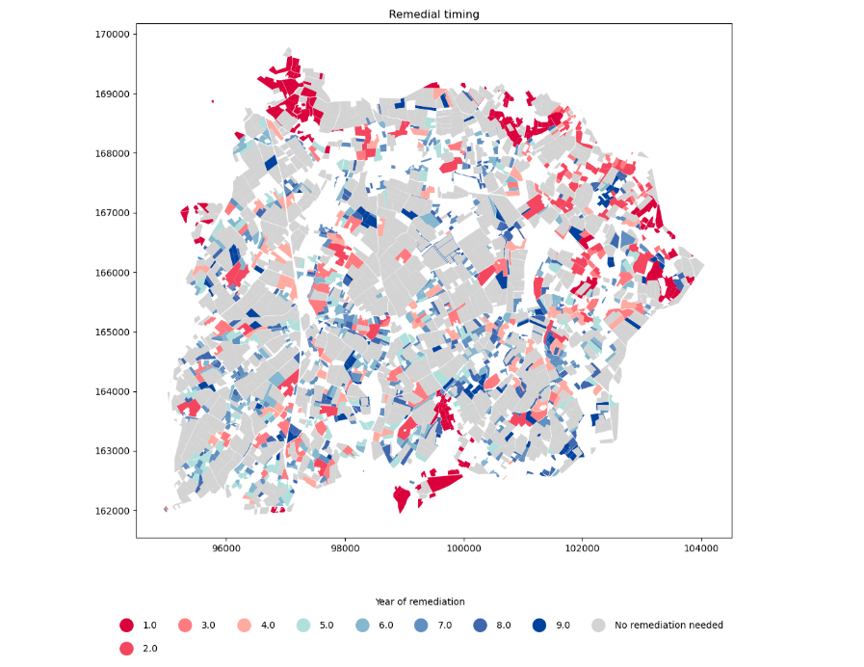

Figure 4‑11: The timing of remediation proposed by the spatio-temporal clustering algorithm when the similarity threshold is set to 0.01.

### Intracluster variability

The variability of the PPS score within the cluster should be as low as possible to make sure that resources are used for the most urgent parcels. When the similarity threshold is set to 0, as in Figure 4‑12, the clusters consist of only the seed parcel. As the cluster rank increases, so does the value of the cluster’s PPS score, demonstrating the prioritization of resources for the most important parcels.

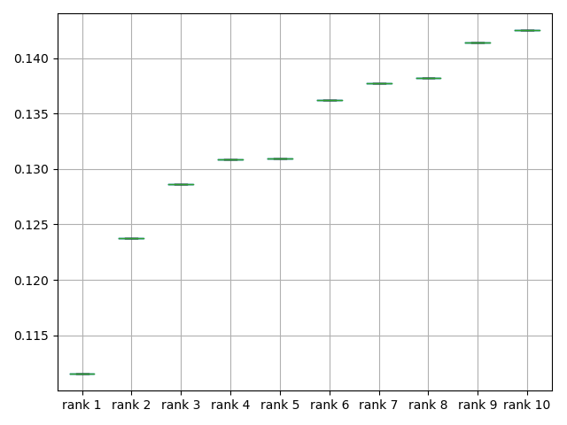

Figure 4‑12: PPS score for the 10 highest ranked clusters, which are equal to the 10 highest ranked seed parcels for a similarity threshold of 0.

With an increasing similarity threshold (see Figure 4‑13 and Figure 4‑14), the variability of the PPS within the cluster is allowed to increase. Furthermore, it is important to observe the increased presence of outliers due to the higher similarity threshold. This can be important when the seed parcel is the outlier, because then resources are potentially used on a less important site first.

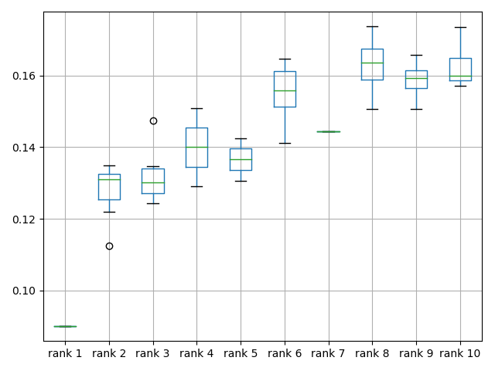

Figure 4‑13: boxplots representing the variability of the PPS score within the 10 highest ranked clusters, when the similarity threshold is 0.025.

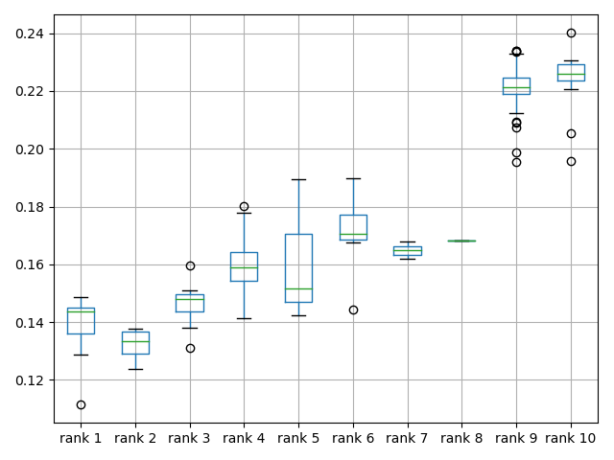

Figure 4‑14: boxplots representing the variability of the PPS score within the 10 highest ranked clusters, when the similarity threshold is 0.05.

## Discussion

This case study shows the complexity of designing spatio-temporal remedial schemes. Therefore, the use of a GIS-MADM based DSS, as proposed in this chapter, could help decision makers find clarity and see the impacts of certain decisions. A major benefit of these tools is the ability to do scenario analysis and uncertainty analysis. The impact of varying degrees of uncertainty in this decision context is described in (Abrams et al., 2022b) and chapter 3. Further the use of these dynamic MADM approaches allows for a shift to a more adaptive management paradigm (Linkov et al., 2006).

The spatio-temporal MADM relies heavily on the PPS and APS of a parcel; therefore, the determination of these scores should be done with great care. The determination of the specific applicable criteria and weights is not only the work of experts, but it is highly suggested to take into account all stakeholders to ensure a solution supported by society is proposed.

For the purpose of this research, CP was used with a Euclidean distance measure. Different distance functions can be used but will have an impact on the ranking (Kizielewicz et al., 2021). The use of two distance-based metrics with similar range, the composite distance score still has a physical meaning (distance to the ideal or anti-ideal situation).

Figure 4‑12 to Figure 4‑14 show the effect of the increasing similarity threshold on the variability of PSS scores within clusters. A larger similarity threshold allows more variation within the cluster; therefore, less optimal clusters are formed and more deviation from the optimal per-parcel-solution is allowed. However, larger clusters give rise to lower operational costs, resulting in cheaper and faster remediation due to economies of scale. This effect can be seen in Figure 4-11, where the remediation will take nine years instead of seven, due to an increasing budget.

Decision makers can decide on the used threshold, depending on the specific case, but a rule of thumb to determine the initial similarity threshold is half of the range of the APS values. The budget constraint limits the number of interventions per year; therefore, a lower budget will spread the remediation over more years. This increase in remediation time could potentially change the remedial actions for parcels because of delayed remediation.

The reduced cost of remediation for larger units is the main driver for the introduction of remedial management clusters. For this specific case study, expert-based estimations for the discounts were used because empirical data for these large-scale remedial actions is not widely available. Nevertheless, they should be determined with great care and potentially adapted during the remedial process to improve the model estimations.

The proposed technical implementation of the budget constraint stops the remediation if the most optimal neighbour of the cluster with the specific remedial action exceeds the available budget, whereby the remaining budget is transferred to the next year. This method has a low impact on the timing of remediation, when the yearly budget largely exceeds the remediation cost of a single cluster.

When working with polygon-based datasets, topological errors, such as gaps, may occur. Relying solely on these topological relationships can have major impacts on determining the neighbor parcels. Our EMT approach is less impacted by these errors.

Other cases could benefit from a similar approach. For example, when afforesting a large region, not all sites can be afforested at the same time because it is a very costly and labor-intensive intervention. Additionally, every plot has a certain suitability and urgency to be afforested. In addition, afforesting connected parcels with a similar tree composition would severely reduce the cost of planting and improve the ecological connectivity of the landscape. Therefore, finding optimal clusters of parcels to be afforested with similar tree compositions could be facilitated with our approach. A similar approach for raster datasets was already reported by (Vanegas et al., 2010).

## Conclusions and future work

With the proposed spatio-temporal clustering approach, dispersed polygons can be clustered in space and time and be assigned the most optimal intervention type under a budget constraint. This allows decision makers to form multi-period remedial schemes to address the environmental disaster. The approach also gives decision makers the possibility to do scenario analysis and uncertainty analysis to better understand the impact of the different parameters in the model. In addition, the approach shows promise for other fields of application. More research on the impact of the similarity threshold is needed. In addition, the introduction of off-site impacts (e.g., transport and re-deposition of contaminated sediment) should be incorporated in the MADM criteria (Estrella et al., 2014) to better mimic the contamination behaviour. Future research should consider multiple consecutive remedial actions rather than single ones (Estrella et al., 2016), to be more in line with the reality of remediation.

# A column generation approach to determine temporal trajectories of actions for optimizing the remediation of contaminated agricultural parcels

In preparation for submission to Journal of Environmental Management

## Summary

Acknowledging the complexity of setting priorities about where, how and when to allocate resources for the remediation of a large-scale contamination of soils, this chapter introduces and illustrates the potential of a column generation (CR) model that reconciles the economic and productive aspects of remediation of agricultural areas. The model’s main novelty is its ability to find optimal multi-period sequences of remedial actions from a set of predefined remedial actions, where column generation is used to extend the candidate set of sequences or trajectories while keeping the computational complexity limited. The latter is especially important when dealing with a large number of contaminated parcels and long planning horizons. The column generation methodology improves the usability of remedial trajectories for large-scale areas, where conventional IP optimization models would become intractable. In a case study with 1380 parcels to be remediated within a period of maximum 5 years with 19 trajectories in the initial candidate set, remediation can be performed at 3 811 546€ with a loss of 2598 production years and an accumulated priority score of 10 129. Reducing the societal burden, via the accumulated priority score, will increase the cost with 155k €, but reduce the loss of production years to 1190 with an accumulated priority score of 4586. The introduction of new trajectories with the column generation approach will after 4700 iterations further reduce the loss in productive years with 237 years (20%) and 20% of the accumulated priority score while increasing the cost with only 34k. The potential to minimize the cost, the loss of production years, the number of years until full production or the accumulated societal burden and the possibility to introduce a compensation to farmers, gives freedom to the user to explore alternative remediation schemes based on their own preferences.

## Introduction

When dealing with large natural or man-made disasters, decision makers are confronted with setting priorities regarding where, how and when to allocate resources. This priority setting is particularly applicable for large-scale remediation projects of polluted soils with a long-term planning horizon and costly actions, like the remediation of radioactively contaminated land after a nuclear accident. The remediation of the Fukushima Daichi accident is currently estimated to cost $60 billion for decontaminating the land and is still ongoing. Furthermore, the compensation for economic losses is estimated to exceed $80 billion (Behling et al., 2019).

Therefore, in the pursuit of effective and sustainable soil remediation practices, it is crucial to consider optimization models to allocate resources over space and time. We hypothesize that a comprehensive inclusion of the temporal perspective is beneficial for decisions about remediation and is likely to lead to improved resource allocation. Integer Programming (IP), a mathematical optimization method, is an established framework for solving optimization problems with discrete decision variables. Its ability to handle combinatorial optimization problems makes it particularly suitable for proposing discrete remediation actions in space and time. Further, there is an increasing level of attention for using this optimisation technique in a land management planning context (Nazari et al., 2015; Türk and Zwick, 2019). The use of optimization methods for planning remedial efforts after a large scale nuclear disaster was already reported in literature, mostly geared towards finding cost-effective ways for remediation (Munro, 2013; Yumashev et al., 2017; Yumashev and Johnson, 2017). In this context, remediation actions need to be assigned to individual parcels within each period, considering the specific requirements for each period and the overall objectives. Balancing the constraints, while ensuring the optimal use of resources, poses significant challenges.

Effectively allocating resources for individual remedial decisions on a regional scale demands numerous decisions in space and time. However, the complexity of these decisions escalates exponentially as the scale of the affected area and the planning horizon increases, making traditional optimization approaches computationally infeasible. To address this complexity, a “decomposition” approach becomes essential. Decomposition techniques allow us to break down the problem into smaller, interconnected subproblems, enabling efficient and iterative solutions to obtain an overall optimal resource allocation strategy. One effective method of decomposition that aligns well with this resource allocation problem is the Dantzig-Wolfe decomposition technique (Dantzig, 1963). The main idea behind Dantzig-Wolfe decomposition is to iteratively solve the master problem with only a meaningful subset of variables, while simultaneously solving the subproblems to generate new feasible solutions (columns) for the restricted master problem (Desrosiers and Lübbecke, 2005).

The columns represent the remedial trajectories, which are a comprehensive portfolio of successive decisions over time, streamlining the decision-making process and reducing the combinatorial complexity. The process continues iteratively, adding relevant columns to the master problem until a predefined number of iterations is met or an optimal solution is obtained, providing the best resource allocation plan for the entire remedial planning horizon. Moreover, the use of predefined rule-based system to create remedial trajectories adds a layer of efficiency to the resource allocation process. The rule-based system is implemented to ensure that only feasible and reasonable trajectories are considered. This methodology will be referred to as column generation (CG) in the rest of the chapter. The concept of allocating individual trajectories for optimizing overall performance in a landscape was proposed by Estrella et al., (2016), where a trajectory of land use types, i.e. temporal succession of land use changes, was introduced for land units (LU) to optimize ecosystem service delivery for both individual LUs and on a regional scale.

In this study we address the question which temporal trajectories of measures are most fit to reclaim a set of agricultural parcels contaminated with Cs-137 located in the Maarkebeek catchment, in Belgium. First, a subset of the problem is used to design the optimal IP approach, where different objective functions and farmer compensation schemes are compared. Next, a column generation model is applied to the complete catchment to extend the set of candidate trajectories without making the computational cost excessive. The chapter has the following structure: Section 5.3 relates the material and methods, where the impact of different objective functions and potential compensation schemes for farmers on a simplified IP model is described. Further the methodology for decomposition and the column generation framework is explained, to deal with larger problems. In Sections 5.4 and 5.5 respectively, the obtained results are presented and discussed. In Section 5.6 the conclusions are presented.

## Material and methods

In this study we once again address a set of agricultural parcels contaminated with Cs-137 located in the Maarkebeek catchment as was discussed in section 1.8.1. It is assumed, that the crops cultivated do change over the remediation period.

In paragraph 5.3.1, the remedial trajectories are described. Further, in paragraph 5.3.2 to 5.3.4, the initial IP model is introduced and the different objective functions and compensation schemes to farmers are described. The IP-model was implemented in the python-based PYOMO framework (Hart et al., 2012) and made use of the GUROBI solver (Gurobi Optimization, 2020). Lastly, in paragraph 5.3.5 the column generation methodology is presented.

### Initial remedial trajectories

To reduce the number of possible successions of remedial actions, also called countermeasures, the concept of a remedial trajectory was introduced. The trajectory consists of a sequence of remedial actions on a yearly basis. Each of the remedial actions are assumed to be performed before the growing season of the crops, therefore performed actions have immediate impact on the agricultural production of the year they are performed at. However, this implies that all remedial actions should be performed before the start of the growing season.

Different potential actions are feasible for the remediation of agricultural areas after contamination with Cs-137 (Nisbet and Jones, 2009). We consider six remedial actions as the potential building blocks of the remedial trajectories. Comparable to the food monitoring system set in place after the Fukushima Daichi nuclear powerplant, a large-scale monitoring network will be stablished to monitor food crops (Nihei, N., 2016). Therefore, we assume that each year the Cs-137 concentration in the cultivated crop is monitored, to verify if the Cs-137-activity of the food product is lower than the legally set threshold (FAO and WHO, 2019). Consequently, monitoring of the Cs-137 activity level of the food product is the baseline action with no added cost. Hence, for years where none of the countermeasures (Table 5‑1) are used within the trajectory, “Food monitoring” is shown.

It has been shown for the remedial actions, that the time of their application as well as the order in which they are applied can have a severe impact on the results (Hiete et al. 2010). Therefore, the remedial trajectories, composed of a sequence of remedial actions, are predefined and based on expert knowledge. The following rules are used to define a remedial trajectory:

* Topsoil removal cannot be performed after ploughing;
* Multiple ploughing techniques cannot be performed consecutively;
* The addition of potassium fertilizers will have a temporary effect of 1 year and will need to be repeated for the next year(s);
* For perennial crops (e.g., fruit trees), ploughing techniques are not possible. The proposed remedial actions in the trajectory need to be feasible from an agro-technical point of view;
* The parcel should produce agricultural products, with a Cs-137 activity below the legal thresholds, in the years after the remedial trajectory has come to an end.

Based on these rules, for each parcel a variable number of the initial remedial trajectories is allowed. The complete set of possible remedial trajectories is listed inTable 5‑2. The initial set is deliberately kept small. Within the initial set, in a trajectory there are no combinations of different actions in order to keep the computational cost of the problem limited.

Table 5‑1: The possible countermeasures used for the decontamination of agricultural areas contaminated with Cs-137 (Nisbet and Jones, 2009; Evrard et al., 2019).

|  |  |  |  |  |
| --- | --- | --- | --- | --- |
|  | Description | Reduction efficiency | Cost (€/ha) | Application |
| Application of potassium fertilizers | Temporarily reduce the uptake of radiocaesium by the plant, by adding potassium to the soil that enters in competition with Cs-137 for uptake. | 0.5 | 265 | Repeated |
| Deep ploughing | Inversion of the top 45 cm of soil to decrease 137Cs availability for the plant roots due to the burial and dilution of the most contaminated top layer. | 0.70 | 2000 | One-time |
| Skim and burial ploughing | Skimming of the top 5 cm of soil to bury it at 45 cm depth. Lifting the deeper soil layer up without inversion. | 0.875 | 2500 | One-time |
| Topsoil removal | Removal (and external waste management) of top 5 cm of the soil | 0.9 | 7600 | One-time |
| Addition of AFCF | The addition of ammonium-ferric hexacyano-ferrate (AFCF), a radiocaesium binder, to the animal feed. To reduce concentrations of the radionuclide in meat and milk. | 0.5 | 207 | Repeated |
| Clean Feeding | Feeding livestock with (partially) uncontaminated feedstuff. To reduce concentrations of the radionuclide in meat and milk. | 0.90 | 913 | Repeated |
| Baseline action / Do nothing scenario | | | | |
| Food monitoring | The agricultural parcel is cultivated and the produce is tested for Cs-137. If the activity concentration of the product is below the legal threshold, it will go to market, otherwise it is destroyed. | 0 | 0 |  |

Table 5‑2: Initial set of 12 remedial actions, where for a remediation scheme of 5 years, every year a remedial action from Table 5‑1 was allocated.

|  |  |  |  |  |  |  |  |
| --- | --- | --- | --- | --- | --- | --- | --- |
|  |  | Remedial trajectories | | | | | |
|  |  | **1** | **2** | **3** | **4** | **5** | **6** |
| **Years** | **1** | **Potassium fertilization** | **Deep ploughing** | Food Monitoring | Food Monitoring | Food Monitoring | Food Monitoring |
| **2** | **Potassium fertilization** | Food Monitoring | **Deep ploughing** | Food Monitoring | Food Monitoring | Food Monitoring |
| **3** | **Potassium fertilization** | Food Monitoring | Food Monitoring | **Deep ploughing** | Food Monitoring | Food Monitoring |
| **4** | **Potassium fertilization** | Food Monitoring | Food Monitoring | Food Monitoring | **Deep ploughing** | Food Monitoring |
| **5** | **Potassium fertilization** | Food Monitoring | Food Monitoring | Food Monitoring | Food Monitoring | **Deep ploughing** |
|  |  | **7** | **8** | **9** | **10** | **11** | **12** |
| **Years** | **1** | **Skim and burial ploughing** | Food Monitoring | Food Monitoring | Food Monitoring | Food Monitoring | **Topsoil removal** |
| **2** | Food Monitoring | **Skim and burial ploughing** | Food Monitoring | Food Monitoring | Food Monitoring | Food Monitoring |
| **3** | Food Monitoring | Food Monitoring | **Skim and burial ploughing** | Food Monitoring | Food Monitoring | Food Monitoring |
| **4** | Food Monitoring | Food Monitoring | Food Monitoring | **Skim and burial ploughing** | Food Monitoring | Food Monitoring |
| **5** | Food Monitoring | Food Monitoring | Food Monitoring | Food Monitoring | **Skim and burial ploughing** | Food Monitoring |

Table 5-2 (continued)

|  |  |  |  |  |  |  |  |  |
| --- | --- | --- | --- | --- | --- | --- | --- | --- |
|  |  | Remedial trajectories | | | | | | |
|  |  | **13** | **14** | **15** | **16** | **17** | **18** | **19** |
| **Years** | **1** | Food Monitoring | Food Monitoring | Food Monitoring | Food Monitoring | **AFCF** | **Clean Feeding** | Food Monitoring |
| **2** | **Topsoil removal** | Food Monitoring | Food Monitoring | Food Monitoring | **AFCF** | **Clean Feeding** | Food Monitoring |
| **3** | Food Monitoring | **Topsoil removal** | Food Monitoring | Food Monitoring | **AFCF** | **Clean Feeding** | Food Monitoring |
| **4** | Food Monitoring | Food Monitoring | **Topsoil removal** | Food Monitoring | **AFCF** | **Clean Feeding** | Food Monitoring |
| **5** | Food Monitoring | Food Monitoring | Food Monitoring | **Topsoil removal** | **AFCF** | **Clean Feeding** | Food Monitoring |

### IP model

The initial objective of the IP model is to find a cost-effective way to bring down the Cs-137 concentration of agricultural produces below the legal threshold, within the considered number of years without exceeding the annual budget. The IP model searches for the optimal configuration of remediation strategies for each of the individual parcels, to minimize the monetary cost of the remediation of agricultural parcels on a regional scale.

The fundamental equations of the mathematical programming model are 5.1 – 5.4.

$$Min \sum_{i}^{m}{\sum_{j}^{n}{\sum_{t}^{T}{a_{ijt}}x_{ij}}} (Equation 5.1)$$

Subject to:

$$\sum_{i}^{m}{\sum_{j}^{n}{a_{ijt}x_{ij}}} ≤b_{t} ∀ t (Equation 5.2)$$

$$\sum_{j}^{n}{x_{ij}=1} ∀ i (Equation 5.3)$$

$$x_{ij}∈ \left\{0,1\right\} ∀ i,j (Equation 5.4)$$

Where:

* i is the specific parcel within the set of m number of parcels;
* j is a specific trajectory within the set of n remediation trajectories for a specific parcel;
* t is the year within the set of T years in which the remediation can be performed;
* xij are the decision variables. They indicate whether the remedial trajectory j should (xij = 1) or should not (xij = 0) be applied to parcel i;
* aijt indicates the cost of the remedial action within the trajectory j when applied to parcel i in the year t;
* bt is the monetary budget available for year t.

Equation 5.1 expresses the objective function of the model, i.c. the minimisation of the cost of remediation for all 1380 parcels. Equations (5.2)–(5.4) encompass the constraints of the minimisation. Constraint 5.2 makes sure that the yearly budget is not exceeded and constraint 5.3 and 5.4 ensure that only one remedial trajectory is chosen per parcel. Thus, constraint 5.4 restricts the solution to integer allocations.

### Alternative objective functions

The initial objective function (equation 5.1) is to minimize the cost of the remediation, and is similar to other models like the one of Yumashev et al., (2017). However, decision makers may have different objectives for the remediation. In objective function 5.5, the aim is to have the complete area remediated and start agricultural production as soon as possible. Equation 5.5 minimizes the year of return to agricultural production on all parcels in the study area.

$$Min Max_{ij} (c_{ij} x_{ij}) \left(Equation 5.5\right)$$

* cij indicates the first year of food production where the produce has an activity below the legal limits when the remedial trajectory j is applied to parcel i. (i.e., cij = 2 for a parcel that produces marketable food after 2 years without production)

When the objective of the model is to minimize the total loss in production years due to excessive Cs-137 concentrations in the agricultural products, objective function 5.6 can be used.

$$Min \sum_{i}^{m}{\sum_{j}^{n}{c_{ij}x_{ij}}} \left(Equation 5.6\right)$$

As discussed in chapter 2, remediation should be approached in a holistic way, taking into account more than solely technical or economic measures. To this end, a multi-objective measure, the parcel priority score (PPS), to determine the priority for remediation of a parcel was introduced in chapter 4. Equation 5.7 will minimize this multi-objective measure. For each year that a parcel is too heavily contaminated for food production, the parcel will receive the inverse of the PPS (PPS-1) score, otherwise it will get a score of zero. The inverse of the PPS is needed, because the PPS score reflects the distance to the optimal point (highest need for remediation) and therefore a low PPS score reflects a high priority. The sum of these PPS-1 score for a trajectory will resemble the accumulated need for remediation of that parcel under the trajectory, where a trajectory with a low accumulated PPS score is considered the better trajectory.

$$Min \sum_{i}^{n}{\sum_{j}^{m}{\sum_{t}^{T}{\frac{1}{{PPS}_{ijt}}}x_{ij}}}(Equation 5.7)$$

* PPSijt indicates the parcel priority score of parcel i for trajectory j at time t (Abrams et al., 2022b).

### Farmer’s compensation cost

Introducing an opportunity cost or compensation for farmers, for each year that agricultural production is not allowed, is likely to affect the proposed solution. The aijt component in equation 5.2, indicating the cost of the remedial trajectory j when applied to parcel i for year t, can be adapted according to two potential cases. It represents the remedial cost of the action (Table 5‑1) if the agricultural produce can enter the market or it is the sum of the action cost and the compensation cost (Table 5‑3) if the agricultural produce cannot enter the market.

The impact of a compensation cost to farmers on the model solution is investigated in four different scenarios. The compensation cost is initially set to 0 for all parcels in scenario 1, followed by a fixed 100 Euro per ha independent of the cultivated crop in scenario 2. Further, a low and a high crop specific compensation scenario are considered. The compensation in the crop specific scenarios are not based on potential yields of individual parcels, but simply on the produced crop type.

Table 5‑3: Compensation scenarios defined in terms of cost (€ ha-1) for each cultivation type to be paid to the farmer in years when the agriculture production is not allowed to be marketed due to excessive Cs-137 activity.

|  |  |  |  |  |
| --- | --- | --- | --- | --- |
|  | Scenario 1: No compensation | Scenario 2: Homogeneous compensation | Scenario 3: Low cultivation specific compensation | Scenario 4: High cultivation specific compensation |
| Cereals | 0 | 100 | 100 | 200 |
| Non-leafy vegetable | 0 | 100 | 200 | 400 |
| Leafy vegetable | 0 | 100 | 200 | 400 |
| Pasture | 0 | 100 | 100 | 200 |
| Feed crop | 0 | 100 | 100 | 200 |
| Root crop | 0 | 100 | 125 | 250 |
| Tubers | 0 | 100 | 125 | 250 |
| Fruit | 0 | 100 | 300 | 600 |

### Column generation methodology

The IP model, introduced in 5.3.2, is designed to allocate the optimal remedial trajectory from a set of predefined trajectories to each parcel. However, the current predefined set of trajectories is rather small. Enlarging the initial set with all possible trajectories would make traditional optimization approaches computationally infeasible, due to the large number of parcels and the high number of alternative remedial trajectories. Therefore, a column generation is proposed to solve the problem. By using this approach columns, remedial trajectories, can be added to the initial set, at a minimal computational cost (Desrosiers and Lübbecke, 2005). In each iteration the optimal column (= trajectory) for the optimization problem is added to the set of candidate remedial trajectories. The new columns consist of a new combination of remedial actions, not in the initial set. The requirements and expert-based rules, detailed in 5.3.1, are still under consideration, while constructing the new trajectories. By adding only, the best newly proposed column per iteration, the system systematically adds columns which improve the overall solution, while keeping the size of the problem small.

The column generation works as follows: First, the original problem is split into two problems: the primal problem (restricted master problem) formulated in equations 5.2, 5.3, 5.6, 5.7 and the dual problem (pricing problem), formulated in equations 5.8, 5.9 and 5.10.

$$Max \sum_{t}^{T}{β_{t}b_{t}+ \sum_{i}^{m}{α_{i} (Equation 5.8)}}$$

$$\sum_{t}^{T}{a_{ijt} β_{t}+α_{i}≤c_{ij} ∀i,j (Equation 5.9)}$$

$$β_{t}≤0, α_{i} urs ∀ t, i (Equation 5.10)$$

The primal problem is the original column-wise (one column at a time) formulation of the problem. While the dual problem is a newly created to identify new promising columns. The objective function of the dual problem encompasses the minimisation of the cost of the new restricted variable with respect to the current dual variables α, β (Desrosiers and Lübbecke, 2005). The Column generation approach, is a Linear Programming method (LP), as expressed in equation 5.10. After the column generation is ended, the model with the new set of trajectories is revisited as an IP problem, using equation 5.4, to find the final solution as visualised in Figure 5‑1.

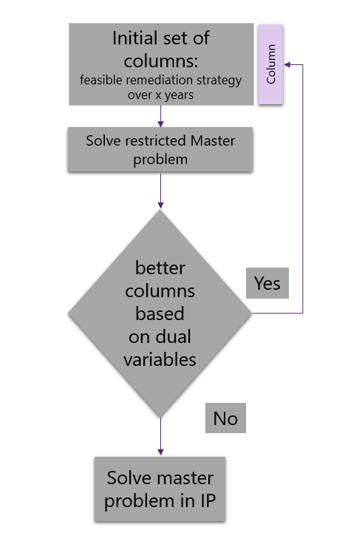

Figure 5‑1: Column generation methodology adopted for finding the best trajectory of actions per parcel to minimize the overall remediation cost.

## Results

First, the IP model, with the different objective functions, was applied to a specific case encompassing 500 parcels. Since the natural half-life of Cs-137 is 30 years, due to radioactive decay remediation will not be needed anymore and parcels will become when enough time passes. For the agricultural production in this region it will take 90 years to reduce the contamination below the permissible levels on all fields , if no remediation intervention was. This highlights the persistent nature of Cs-137 pollution and the requirement for intensive and active management to reduce the contamination in a reasonable time span. Second, for the same case, the impact of several farmer compensation scenarios for two objective functions were investigated. Third, the IP model is presented for the whole Maarkebeek region for different objective functions. Lastly, the column generation model is tested on a set of 1380 parcels, i.e., those in the Maarkebeek catchment (1.8.1).

### IP model

The case of a remediation project of 500 parcels to be remediated in a maximum of 5 years with an annual budget of respectively 400 k, 400 k, 300 k, 200 k and 100 k€ is used to illustrate the model. The resulting spatio-temporal remediation schemes are evaluated by means of four metrics. The first one is the total cost of all remedial trajectories for all parcels. Here, the cost of compensation of the farmers is added to the yearly cost of the remediation if the agricultural production is not marketable. The second metric is the number of years to return to marketable agricultural production on each parcel reflecting the year in which the last parcel is remediated. The third metric is the total loss of production years, determined as the sum over all parcels of the years within the considered 5 years that parcels produce non-marketable food. The last metric is the accumulated inverse of the PPS, which is based on the priority score of a parcel for remediation, where each parcel, that cannot produce food receives a PPS score for that year (Abrams et al., 2022b).

#### Alternative objective functions

The value of the metrics for the considered objective functions is given in Table 5‑4. The optimal allocation of remediation efforts, within the annual budget constraint, results in a remedial scheme costing 1 261 619euro over 5 years where full production is restored after 5 years. However, Table 5‑4 shows that focusing on a minimal cost will result in delayed return to normalcy, with a production loss of 936 years. Minimizing the years to full production, will result in full production still to be met in 4 years and total loss of 904 production years but the total cost raises to 1.304 456 €. Similarly, when the total amount of production years lost is minimized, full production is resumed at 5 years and only 212 production years are lost. However, total cost is raised to 1 326 281 €. Minimizing the accumulated priority scores, will result in 213 years of production loss, but with the lowest accumulated priority score of 821.

Table 5‑4: Total cost, number of production years lost, number of years to return to full production and sum of PPS for 500 fields, with a successive annual budget of 400k€, 400k€, 300k€, 200k€, 100k€ euro for different objective functions.

|  |  |  |  |  |
| --- | --- | --- | --- | --- |
| Objective function | Total cost (Euro) | Years to return to full agricultural production (y) | Total loss of production years (y) | Accumulated PPS-1 (-) |
| Min. Total cost | **1 261 619** | 5 | 936 | 3630 |
| Min years for return to full production | 1 304 456 | **4** | 904 | 3494 |
| Min. total loss of production years | 1 326 281 | 4 | **212** | 828 |
| Accumulated priority score | 1 326 281 | 4 | 213 | **821** |

The variety of proposed remedial trajectories highlights the impact of the objective function on the allocation of resources in space and time for the region. Table 5‑5, shows a frequency analysis of allocated trajectories per objective function, expressed as the number of parcels allocated for the trajectory. Since there are 500 parcels to be remediated, the number of parcels per trajectory adds up to 500 in a row. From Table 5‑5, it is clear that deep ploughing is proposed more than the other remedial actions, as it is cheap and has a relatively high reduction efficiency. A clear opposite pattern, between trajectory 1 and 17 can be observed for minimization of the cost and the years to return to full production, compared to the total loss in production years and accumulated PPS. This can be explained by parcels that would naturally become clean after within the remediation horizon, without intervention. However, to reduce the years of production loss the model acted on these parcels with the cheapest remedial action, i.e., the addition of K-fertilizer.

Table 5‑5: Results of frequency analysis of trajectories from the initial set in Table 5‑2 for different objective functions.

|  |  |  |  |  |  |  |  |  |  |  |  |  |  |  |  |  |  |  |  |
| --- | --- | --- | --- | --- | --- | --- | --- | --- | --- | --- | --- | --- | --- | --- | --- | --- | --- | --- | --- |
|  | Proposed remedial trajectories | | | | | | | | | | | | | | | | | | |
| Objective function | **1** | **2** | **3** | **4** | **5** | **6** | **7** | **8** | **9** | **10** | **11** | **12** | **13** | **14** | **15** | **16** | **17** | **18** | **19** |
| Min. Total cost | 6 | 98 | 102 | 97 | 90 | 67 | 0 | 0 | 1 | 0 | 0 | 2 | 2 | 2 | 3 | 1 | 29 | 0 | 0 |
| Min years for return to full production | 7 | 81 | 103 | 95 | 187 | 0 | 1 | 0 | 0 | 0 | 0 | 2 | 2 | 4 | 2 | 0 | 16 | 0 | 0 |
| Min. # non-producing years | 35 | 313 | 99 | 35 | 7 | 0 | 0 | 1 | 0 | 0 | 0 | 1 | 2 | 3 | 3 | 1 | 0 | 0 | 0 |
| Accumulated priority score | 35 | 310 | 102 | 35 | 7 | 1 | 1 | 0 | 0 | 0 | 0 | 2 | 1 | 3 | 4 | 0 | 0 | 0 | 0 |

#### Cost of compensation to farmers

For the same remediation project, the four farmer compensation scenarios given in Table 5‑3 are illustrated for two different objective functions, minimizing the cost and minimizing the loss in production years. If no remedial actions were performed, the agricultural production would return to normalcy in 90 years with a cost of: 0, 2 317 076, 2 635 624 and 5 271 249 euro for respectively scenario 1, 2, 3 and 4. When introducing the compensation cost to farmers, it is clear that the budget available for remediation is lower so that less parcels can be remediated per year. This results in delayed actions, because the budget does not allow for more actions in the period.

#### Impact of compensation for objective function 5.1: Minimizing total cost

Table 5‑6 highlights the impact of the compensation scenarios for objective function 5.1 (minimizing total cost). The introduction of a compensation for farmers causes an increase in the cost for remediation and a reduction in the loss of production years for parcels. The addition of a compensation cost puts a monetary value on delayed remediation; resulting in an incentive to minimize of the loss of production years. When compensation is high, like scenario 4, the proposed annual budgets become insufficient to create a feasible region-wide remediation plan.

Table 5‑6: The impact of different compensation cost scenarios for farmers for objective function 5.1 (Minimizing the total cost). For scenario 4, insufficient resources are available for the remediation of the parcels.

|  |  |  |  |  |
| --- | --- | --- | --- | --- |
|  | Scenario 1 | Scenario 2 | Scenario 3 | Scenario 4 |
| Total cost (from which compensation) | **1 261 619**  **(0)** | **1 346 146**  **(84 526)** | 1 357 207  **(95 587)** | / |
| Production years lost | 963 | 514 | 603 | / |
| Years to return to full production | 5 | 4 | 4 | / |
| Accumulated priority score | 3630 | 1994 | 2353 | / |

When considering the compensation costs, deep ploughing is the preferred method, however, a switch to trajectories where the remediation action is performed in year 1 & 2 in the 5 year period can be observed (i.e. trajectory 2 and 3) in Table 5‑7.

Table 5‑7: Number of parcels with proposed remedial trajectory, selected from the initial set (Table 5‑2) for different farmer compensation scenarios for objective function 5.1 (Minimizing the total cost).

|  |  |  |  |  |  |  |  |  |  |  |  |  |  |  |  |  |  |  |  |
| --- | --- | --- | --- | --- | --- | --- | --- | --- | --- | --- | --- | --- | --- | --- | --- | --- | --- | --- | --- |
|  | Remedial trajectories | | | | | | | | | | | | | | | | | | |
|  | 1 | 2 | 3 | 4 | 5 | 6 | 7 | 8 | 9 | 10 | 11 | 12 | 13 | 14 | 15 | 16 | 17 | 18 | 19 |
| Scenario 1 | 6 | 98 | 102 | 97 | 90 | 67 | 0 | 0 | 1 | 0 | 0 | 2 | 2 | 2 | 3 | 1 | 29 | 0 | 0 |
| Scenario 2 | 6 | 136 | 251 | 53 | 14 | 0 | 0 | 0 | 0 | 1 | 0 | 0 | 0 | 1 | 7 | 2 | 29 | 0 | 0 |
| Scenario 3 | 6 | 119 | 226 | 67 | 40 | 2 | 0 | 1 | 0 | 0 | 0 | 0 | 0 | 0 | 7 | 3 | 29 | 0 | 0 |
| Scenario 4 | - | - | - | - | - | - | - | - | - | - | - | - | - | - | - | - | - | - | - |

The introduction of different compensation schemes can shift the remediation timing (faster or slower) for different crop types. From Figure 5-2, it becomes clear that some crops, such as tubers, root crops and leafy vegetables, are acted on faster in the specific crop type compensation scenario, due to the increasing compensation cost per ha that the farmer receives for this cultivation. The delay in remediation for fruit orchards can be explained by the restrictions in possible remediation actions for this cultivation. Highly contaminated fruit orchards can only be remediated with topsoil removal, the costliest procedure, therefore possibly a trade-off occur between remediating one fruit orchard on the one hand and multiple other fields on the other hand.

Figure 5‑2: The average year of remediation completion for specific crop types as a function of the type of farmer compensation (Table 5‑3).

#### Impact of compensation for objective function 5.6: Minimizing loss of production years

The objective of the model used in Table 5‑8, is minimizing the loss of production years. The introduction of a compensation for farmers causes an increase in the remediation cost as well as an increase in the loss of production years. This is in contrast with the case presented in Table 5‑6, where the loss in production years decreased, when introducing the compensation cost.

Table 5‑8: The impact of different compensation costs scenarios for farmers for objective function 5.6 (Total loss of production years).

|  |  |  |  |  |
| --- | --- | --- | --- | --- |
|  | Scenario 1 | Scenario 2 | Scenario 3 | Scenario 4 |
| Total cost  (from which compensation) | 1 326 281  (0) | 1 399 093  (72 811) | 1 398 465  (91 668) | / |
| Production years lost | **212** | **251** | **258** | / |
| years to return to full production | 4 | 5 | 5 | / |
| Accumulated priority score | 828 | 985 | 1005 | / |

Whereas the difference in chosen trajectories between the scenarios addressed in Table 5‑7 is large, this is less the case when optimizing for total number of production years lost. There is a small increase in the allocation of trajectory 3 and 4 for scenario 2 and 3 compared to 1, potentially caused by the increased cost, due to the need for compensation payments.

Table 5‑9: Number of parcels with proposed remedial trajectory, selected from the initial set (Table 5‑2) as a function of farmer compensation scenario for objective function 5.6 (Minimize loss of production years).

|  |  |  |  |  |  |  |  |  |  |  |  |  |  |  |  |  |  |  |  |
| --- | --- | --- | --- | --- | --- | --- | --- | --- | --- | --- | --- | --- | --- | --- | --- | --- | --- | --- | --- |
|  | Remedial trajectories | | | | | | | | | | | | | | | | | | |
|  | 1 | 2 | 3 | 4 | 5 | 6 | 7 | 8 | 9 | 10 | 11 | 12 | 13 | 14 | 15 | 16 | 17 | 18 | 19 |
| Scenario 1 | 35 | 305 | 103 | 35 | 6 | 0 | 1 | 0 | 0 | 0 | 0 | 1 | 1 | 4 | 4 | 0 | 0 | 0 | 5 |
| Scenario 2 | 35 | 296 | 107 | 39 | 12 | 0 | 0 | 0 | 1 | 0 | 0 | 1 | 0 | 2 | 4 | 3 | 0 | 0 | 0 |
| Scenario 3 | 32 | 295 | 106 | 40 | 12 | 1 | 0 | 1 | 0 | 0 | 0 | 1 | 1 | 2 | 4 | 2 | 0 | 0 | 3 |
| Scenario 4 | - | - | - | - | - | - | - | - | - | - | - | - | - | - | - | - | - | - | - |

### Maarkebeek case study

The capabilities of the column generation framework is illustrated for the Maarkebeek catchment encompassing 1380 parcels in need of remediation (N=1380) after a hypothetical nuclear accident that lead to spatially variable levels of Cs-137 deposition (Abrams et al., 2022b). The decontamination, without intervention, would take 97 years and cost 3 715 980 € in compensation cost, when using a crop specific compensation (scenario 3). The compensation cost of the first year would be 192 326 €.

For the Maarkebeek region three remediation plans are determined, based on three different objective functions (5.1, 5.6, 5.7). Further, the column generation framework is used to improve the IP for minimizing the accumulated PPS score (objective function 5.7).

Table 5‑10: Total cost, number of production years lost and sum of PPS for the Maarkebeek catchment (n =1380), with an annual budget of 800k€ over 5 years for different objective functions.

|  |  |  |  |
| --- | --- | --- | --- |
| Objective function | Total cost (Euro) | Total loss of production years (y) | Accumulated PPS-1 (-) |
| Min. Total cost | **3 811 546** | 2 598 | 10 129 |
| Min. total loss of production years | 3 977 937 | **1190** | 4619 |
| Accumulated priority score | 3 966 238 | 1190 | **4586** |

Depending on the objective function, the initial problem solution shows a remedial scheme where between 3 811 546 and 3 977 937€ is needed. When the cost is minimized a total compensation of 364 671€ is paid to farmers. Minimizing the cost of the remediation will result in a production loss of 2598 years, in contrast, an increase in budget of 154 692 will decrease the loss in production years with 54%. Minimizing the accumulated priority score will result in a similar loss in production years but with a lower accumulated PPS-1 (<1%).

Table 5‑11: Number of parcels with proposed remedial trajectory, selected from the initial set (Table 5‑2) as a function of three objective functions (5.1, 5.6, 5.7).

|  |  |  |  |  |  |  |  |  |  |  |  |  |  |  |  |  |  |  |  |
| --- | --- | --- | --- | --- | --- | --- | --- | --- | --- | --- | --- | --- | --- | --- | --- | --- | --- | --- | --- |
|  | Proposed remedial trajectories | | | | | | | | | | | | | | | | | | |
| Objective function | **1** | **2** | **3** | **4** | **5** | **6** | **7** | **8** | **9** | **10** | **11** | **12** | **13** | **14** | **15** | **16** | **17** | **18** | **19** | |
| Min. Total cost | 7 | 181 | 373 | 313 | 287 | 102 | - | - | - | 1 | - | - | - | - | - | 26 | - | - | 86 | |
| Min. # non-producing years | 90 | 652 | 282 | 178 | 109 | 35 | - | - | 1 | - | - | 4 | 1 | 1 | 3 | 17 | - | - | 3 | |
| Accumulated priority score | 89 | 652 | 280 | 180 | 106 | 34 | - | 1 | 4 | 4 | 2 | - | 6 | 13 | 4 | 89 | 652 | 280 | 180 | |

#### Column generation framework for objective function 5.7: Minimizing the accumulated priority score

The initial problem solution suggests a remedial scheme that would cost 3 966 238 €, from which the compensation paid to farmers is 357 295 € (9%). The execution of the resulting remediation plan takes 5 years and leads to a loss 1190 production years, but all fields by used in production at the fifth year. The proposed remedial scheme will result in an accumulated PPS-1 of 4586. However, using 1000 iterations in the column generation methodology, the PPS-objective is improved 3936 (13.6%). After 4700 iterations, the methodology does not find any columns to add based on the restricted master problem. The final solution reduces the accumulated PPS-1 with 904 (19.7%) compared to the initial problem solution. It is clear that the column generation technique allows the system to generate more favourable combinations of remedial actions than those in the initial set of trajectories. Compared to the initial problem solution, the system will use more of the budget, this can be seen as the model trying to fit the best columns within the available budget.

Table 5‑12: Impact of the number of iterations in the 5.3.6 Column generation methodology.

|  |  |  |  |
| --- | --- | --- | --- |
| Iterations in CR | Total cost (Euro) | Total loss of production years (y) | Accumulated PPS-1 (-) |
| Initial problem solution | 3 966 238 | 1190 | **4586** |
| 500 | 3 999 759 | 1145 | **4415** |
| 1000 | 3 999 915 | 1029 | **3963** |
| 4700 | 3 999 983 | 953 | **3682** |

Table 5‑13: Number of parcels with proposed remedial trajectory, selected from the initial set for objective function 5.7.

|  |  |  |  |  |  |  |  |  |  |  |  |  |  |  |  |  |  |
| --- | --- | --- | --- | --- | --- | --- | --- | --- | --- | --- | --- | --- | --- | --- | --- | --- | --- |
|  |  |  | Initial Trajectories | | | | | | | | | | | | | | |
|  | 1 | 2 | 3 | 4 | 5 | 6 | 7 | 8 | 11 | 12 | 13 | 14 | 15 | 16 | 17 | 18 | 19 |
| **IP** | 89 | 657 | 280 | 180 | 106 | 35 | - | 1 | 3 | 4 | 2 | - | 6 | 13 | - | - | 4 |
| **500** | 81 | 530 | 268 | 173 | 105 | 32 | - | 1 | - | 2 | 2 | 1 | 4 | 15 | - | - | 8 |
| **1000** | 39 | 420 | 243 | 159 | 91 | 23 | 1 | - | - | 2 | 2 | - | 8 | 12 | - | - | 10 |
| **4700** | 6 | 509 | 224 | 147 | 88 | 11 | 1 | - | - | 2 | 1 | - | - | 19 | - | - | 18 |

Table 5‑14: Number of parcels with proposed remedial trajectory, selected from the extended set created during the from the column generation methodology, for objective function 5.7.

|  |  |  |  |  |  |  |  |  |  |  |
| --- | --- | --- | --- | --- | --- | --- | --- | --- | --- | --- |
|  | Extended Trajectories | | | | | | | | | |
|  | 21 | 23 | 25 | 26 | 27 | 35 | 43 | 44 | 47 | 84 |
| **IP** | - | - | - | - | - | - | - | - | - | - |
| **500** | 2 | 1 | - | - | 1 | - | - | 152 | - | 2 |
| **1000** | 19 | 14 | 5 | - | 6 | - | 3 | 316 | 5 | 2 |
| **4700** | 17 | 15 | 17 | 1 | 19 | 1 | - | 280 | - | 4 |

It is clear that by introducing new trajectories, the overall solution is improved. Increasing the number of iterations (hence evaluating more new trajectories) leads to better solutions but leads to a more complex remedial approach. Eventually 10 new trajectories were allocated to 353 of the 1380 parcels. Most of the different crop types (except non-leafy vegetables) have used one of more of the extended trajectories. Although Tubers are only 186 parcels, 13 different trajectories are allocated for it (Table 5‑16).

Table 5‑15: Extended set of remedial trajectories from column growing methodology for the complete Maarkebeek catchment.

|  |  |  |  |  |  |  |
| --- | --- | --- | --- | --- | --- | --- |
|  | | 21 | 23 | 25 | 26 | 27 |
| **year** | 1 | **Potassium fertilization** | **Potassium fertilisation** | **Potassium fertilisation** | **Potassium fertilisation** | **Potassium fertilisation** |
| 2 | Food Monitoring | **Potassium fertilisation** | **Potassium fertilisation** | **Potassium fertilisation** | **Potassium fertilisation** |
| 3 | Food Monitoring | Food Monitoring | **Potassium fertilisation** | **Potassium fertilisation** | **Potassium fertilisation** |
| 4 | Food Monitoring | Food Monitoring | Food Monitoring | **Potassium fertilisation** | **Potassium fertilisation** |
| 5 | Food Monitoring | Food Monitoring | Food Monitoring | Food Monitoring | Food Monitoring |
|  |  | 35 | 43 | ~~44~~ | 47 | 84 |
| **Year** | 1 | **Potassium fertilisation** | **Potassium fertilisation** | **Potassium fertilisation** | Food Monitoring | **Potassium fertilisation** |
| 2 | **Deep ploughing** | **Potassium fertilisation** | **Potassium fertilisation** | **Potassium fertilisation** | **Potassium fertilisation** |
| 3 | **Potassium fertilisation** | **Potassium fertilisation** | **Potassium fertilisation** | **Potassium fertilisation** | **Potassium fertilisation** |
| 4 | **Potassium fertilisation** | **Deep ploughing** | **Potassium fertilisation** | **Potassium fertilisation** | **Potassium fertilisation** |
| 5 | Food Monitoring | **Potassium fertilisation** | **Deep ploughing** | **Deep ploughing** | **Topsoil removal** |

Table 5‑16: The trajectories by crop type proposed by the column generation with 1000 iterations. Newly generated trajectories are shown in bold.

|  |  |  |  |  |  |
| --- | --- | --- | --- | --- | --- |
| Crop type | Trajectory | Number of parcels | Crop type | Trajectory | Number of parcels |
| Pasture | 2 | 465 | Tubers | 1 | 5 |
| 3 | 180 | 2 | 22 |
| 4 | 100 | 3 | 25 |
| 5 | 67 | 4 | 17 |
| 6 | 11 | 5 | 7 |
| **44** | **253** | 7 | 1 |
| **35** | **1** | 19 | 18 |
| Root crop | 1 | 1 | **21** | **17** |
| 2 | 20 | **23** | **15** |
| 3 | 19 | **25** | **16** |
| 4 | 30 | **26** | **1** |
| 5 | 14 | **27** | **19** |
| **44** | **4** | **44** | **23** |
| Leafy vegetables | 2 | 2 | Non-leafy vegetables | 12 | 2 |
| Cereals | **25** | **1** | 13 | 1 |
| Fruit | **84** | **4** | 16 | 19 |

Figure 5‑3 visualises the spatial heterogeneity of the different remedial trajectories. Different remedial trajectories, are performed in adjacent fields, making it potentially difficult to perform from an executive and logistic perspective.

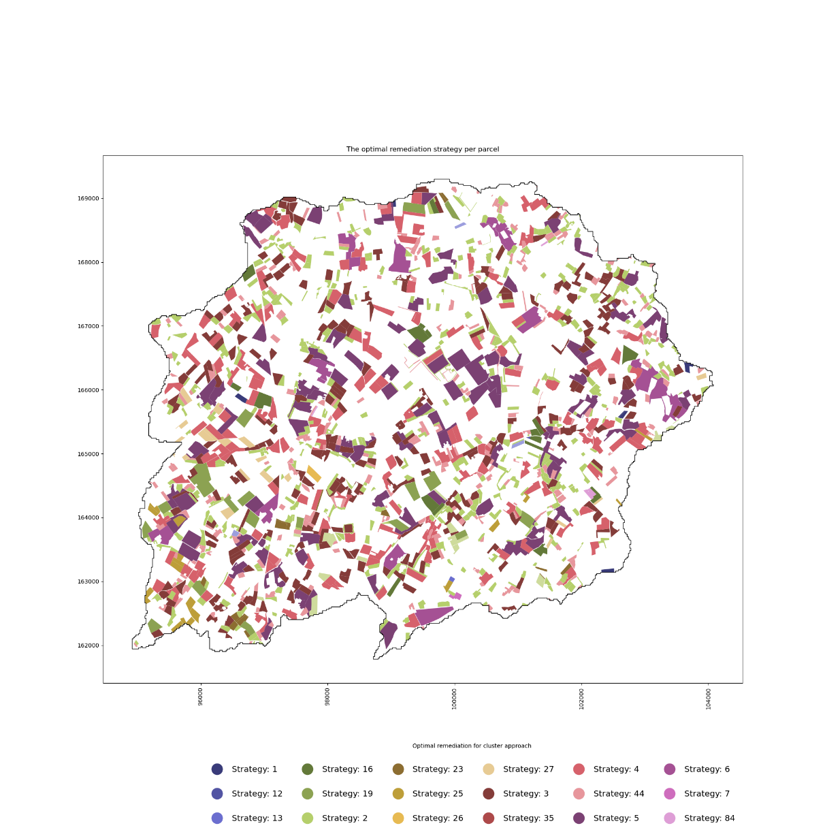

Figure 5‑3: Proposed initial or generated remedial trajectories, named strategy here, for each parcel (n=1380) in the Maarkebeek catchment.

## Discussion

The proposed optimization model is meant to help decision makers, compile spatio-temporal remediation schemes for a collection of agricultural parcels contaminated with variable levels of Cs-137. By explicitly taking into account the time, multi-period schemes can be determined, improving the transparency and overall allocation of resources for the remedial process. The optimal remediation efforts depend on the objectives that are pursued by the stakeholders. Table 5‑4 and Table 5‑5 show that the choice of objective function has a large impact on the proposed solution and the required budget. In the case of Cs-137 remediation, the most effective remedial actions are also the most expensive; therefore, if the objective is to minimize the cost, cheaper technologies that can be used later in the remediation process, when the contamination level is lower because of natural radioactive decay, are preferred. A consequence of this is the higher number of unproductive years when minimizing the total cost. There is a trade-off between lowering cost and minimizing the loss in production years, especially when farmers are not compensated for the non-productive years. When minimizing the loss of production years, without compensation, the model will propose to act on most parcels from the initial year onwards (trajectory 2), while, when the cost is minimized a more equal distribution of actions over time (trajectories 2-6) is proposed (Table 5‑5). Therefore, when compensation to farmers is accounted for, the proposed remedial trajectories between optimizing total cost and loss in production years becomes more similar. This is evident because a cost is attributed to a delay in remediation and so loss of a production year becomes part of the total cost. In Table 5‑9, it can be observed that the change in proposed trajectories is lower, when the objective function was the loss of production years.

From an ethical point of view, some form of compensation for farmers is important (ICRP, 2009). The introduction of the compensation cost puts a monetary value on delayed remediation, there for the objective functions become more aligned. The share of the compensation costs in the total cost can be large (e.g., 10%), potentially resulting in schemes that exceed the budget, as was seen in scenario 4. In addition, the crop specific compensation scheme could incentivise farmers to change cultivation, because, parcels with cultivations receiving higher compensation are designated for earlier remediation as was seen in Figure 5‑2. Therefore, decision makers should be careful to find a balance between the type and magnitude of the compensation. Currently, the proposed methodology assumes no rotation of crops on a parcel. This is a simplification of the reality, where multiple crops per year can be cultivated and farmers follow crop rotational schemes to change the cultivation on a parcel in consecutive years. In addition, the crop specific compensation schemes would incentivize farmers to change cultivation.

When dealing with these large-scale multi-period remediation projects, different annual provisions in the budgets with time should be compared to further reduce the loss in production years and or minimize the budget needs. Remediation efforts benefit from larger annual budgets in the initial period of the project, so reducing the compensation that needs to be paid to farmers. Due to the fact that all remedial actions need to be performed before the start of the growing season, other constraining factors like labour capacity should be considered as well in future research. Further, the choice of performing remediation within a 5 year timeframe will impact the allowed remediation techniques. Due to the relative short timeframe of 5 years the use of remedial actions with a temporary impact like K-fertilizer will be less favoured, because after the 5 years the field should be produce food with Cs-137 activity below the permissible levels without the intervention.

Using the column generation framework, the initial solution can be improved by increasing the number of iterations until no more columns can be added. In comparison with the initial problem solution, a 13.6% improvement of the accumulated PPS-score is achieved by testing 1000 new columns. If the column generation is continued until no more columns can be added to the master-problem a 19.7 % reduction in the objective was found. From the decreasing difference between allowed and used budgets, it became clear that the model was searching for columns to add, which make better use of the available budgets. The column generation approach offers rapid information for decision-makers, with potential for optimization through increased iteration cycles. It is assumed that, as the model undergoes more iterations, the discovery of novel columns saturates, leading to the idea that the optimal solution was found. It is critical to emphasize, however, that column generation’s applicability is inherently confined to the linear programming context. After the CG, the model is converted into an IP problem, caused by the need to represent the binary choices of applying or abstaining from trajectories to specific parcel. Regrettably, this transformation introduces the prospect of suboptimal solutions within the IP problem domain. Whereas the model was eventually used for optimizing the allocation of trajectories consisting of maximal five remedial actions on 1380 parcels within 5 years, the model is capable to accommodate much larger problem sizes, thanks to the column generation framework.

A potential for future research is the addition of variables and constraints to favour the same remedial technologies for adjacent parcels, therefore clustering parcels similar as in chapter 4. This could potentially improve the executive feasibility of the proposed remedial schemes, which are even more complex than in previous chapters. Acknowledging the need for an uncertainty analysis from chapter 2 and 3, further research on the sensitivity of the model to its input parameters (PPS, cost, etc..) could be beneficial. To this end, a similar framework as in chapter 3 can be used, where a Monte Carlo analysis is done to determine the frequency of a trajectory to be chosen for a specific parcel. Verstegen et al., (2012) used a similar framework to produce stochastic maps within their sDSS instead of deterministic maps. While to use of an IP framework is needed to for allocation of 1 trajectory per parcel, as a parcel is the smallest spatial unit of decision, the use of LP is beneficial from many perspectives (e.g., computational efficiency). A hybrid form where trajectories with remedial actions in the first year need to be allocated completely, while trajectories with actions in the future could only be partially allocated, could allow the model to have more freedom to find the best overall action plan. Then, the model is adjusted after each year with more certain data on remedial efficiencies and cost. This facilitates adaptive management approaches, where it becomes possible for continuous reassessing and adjusting of the portfolio of remedial actions based on evolving site characteristics, technical and scientific advancements, and changes in the regulatory framework (Linkov et al., 2006). Moreover, the model methodology, currently developed for parcels contaminated with Cs-137, can be adopted to facilitate remedial decisions for different areas, different soil-bound contaminants, through small adjustments in the model.

## Conclusions

Remediation of an agricultural parcel contaminated with Cs-137 may take several successive actions (a multi-period trajectory of actions) rather than one single action, leading to the need to incorporate time in the design and optimisation of regional remediation schemes. To accommodate this requirement in the elaboration of multi-parcel remediation schemes, we proposed and applied an IP model that assigns one of a set of predefined 5-year remediation trajectories to each of the considered parcels whereby four different objective functions, an annual budget constraint and four scenarios regarding financial compensation of farmers for the impossibility to market their produce, are considered. When the objective is to minimize total cost, delayed remediation takes place especially in situations where farmers are not compensated. When minimizing the loss in productive years is the objective, the remediation cost will rise, but the rise is smaller when a compensation to the farmers is accounted for. We demonstrated that the column growing methodology based on the Dantzig-Wolfe decomposition approach, is useful to extend the set of alternative trajectories, and hence improve the solution, without compromising the IP-model’s computational feasibility. The introduction of new trajectories with the column generation approach will after 4700 iterations further reduce the loss in productive years with 237 years (20%) and 20% of the accumulated priority score, while, increasing the cost with only 34k.

# An iterative approach to identify the optimal spatial configuration of remedial actions to minimize export of radioactively contaminated sediments from agricultural catchments affected by a nuclear accident.

In preparation for submission to Journal Science of The Total Environment

## Summary

The decontamination program in the Niida catchment in Fukushima led by the Japanese government in 2012-2014, lowered the Cs-137 concentration in the soil considerably. However, the decontamination works resulted in increased soil erosion and sediment delivery into the rivers. Our study demonstrates the capability of the iterative optimization framework CAMF (Vanegas et al., 2010), to identify locations within the decontaminated zones for which rapid afforestation would have led to the highest possible reduction of sediment export through the catchment outlet. The study confirms that CAMF ranks the candidate cells according to decreasing marginal gains in achieving the objective, i.c. sediment export reduction. This is illustrated by the finding that afforestation of the spatially targeted selection of the 1000 best cells (3.4% of candidate cells) would have resulted in a 15% decrease of sediment flux, compared to 0.8% when the cells are selected randomly. The 1000 cells selected for afforestation are situated in the riparian zones, 75 % are situated closer than 110 meters from a river branch, at an elevation around 450 m. We conclude that due to spatial variability and spatial interaction, the effectiveness and efficiency of afforestation as a post-decontamination intervention to reduce sediment and sediment bound pollutant export from catchments is highly location specific and can benefit from an optimisation framework like CAMF.

## Introduction

Due to the Fukushima Daiichi Nuclear power plant accident on 11 March 2011 more than 2.7 PBq of fallout Cs-137 was deposited on the surrounding terrestrial system (Onda et al., 2020). Cs-137, called Radiocaesium (RC), with a half-life of 30 years, is the most important radionuclide for long-term exposure, causing large-scale and long-lasting contamination in the Fukushima prefecture. The government-led decontamination program lowered the Cs-137 concentration in the topsoil considerably. However, due to the nature of the decontamination practices (e.g., mainly removal of the top soil), these efforts resulted in an increased share of bare or barely vegetated land and hence in increased soil erosion and sediment delivery into the rivers (Bin et al., 2022). RC firmly binds to soil particles and is transported downstream along with the sediments in the form of particulate Cs-137, causing increased radiological exposure for living organisms in the downstream areas and water bodies (Evrard et al., 2015). In addition, the use of river water for irrigation or deposition of sediments in the floodplains may induce contamination of other (agricultural) areas (Evrard et al., 2015). The behavior of Cs-137 within the soil and river system of the affected areas has been studied extensively (Golosov et al., 2022; Konoplev et al., 2021), and revealed that a considerable amount of particulate Cs-137 leaves the catchment and enters the Pacific Ocean (Chartin et al., 2017; Evrard et al., 2015; Liu et al., 2019; Ueda et al., 2013). For the Niida catchment, Bin et al. (2022) established a positive relationship between the increased suspended sediment loads in the rivers and the extent of the upstream decontamination works. Both the sediment production (by soil erosion) and sediment routing are highly spatially variable processes (Verstraeten et al., 2007), governed by many factors (e.g., the type and spatial connectivity of land forms, land cover and soil types and the height and intensity of precipitation). However, it is the extensive impact of the decontamination works on the vegetation cover in the landscape that explains the increased erosion and suspended sediment concentration in the rivers. These observations lead to our hypothesis that rapid afforestation of decontaminated sites is likely to decrease the magnitude and longevity of sediment losses.

Due to the massive scale of the decontamination works and the inefficiency of applying measures on areas that barely contribute sediment to river channels, afforestation efforts need to be spatially targeted for optimal impact (Verstraeten et al., 2007). To this end spatially distributed erosion and sediment transportation models are needed and not the frequently used non-spatially explicit lumped models (Van Rompaey et al., 2001). Since sediment transport shows spatial interaction behaviour (an intervention on a given location affects sediment accumulation and throughput at a downstream location) the correct assessment of the impact of site-specific afforestation requires an iterative modelling approach (section 6.3.3). However, the spatially distributed nature of the models makes them computationally demanding and hence unsuitable for iterative use.

To our knowledge, CAMF (Cellular Automata-based Heuristic for Minimizing Flow) is the only published framework meant for finding locations within a catchment for which intervention (e.g. afforestation) maximizes reduction of sediment export through the river catchment's outlet in an iterative way (Vanegas et al., 2008). CAMF combines a sediment production and transportation model (SPTM) with a Cs-137 sediment concentration model (SCM) within an iterative framework to rank cells with regard to intervention efficiency, safeguarding the spatial interaction between cells. Undeniably, upstream interventions potentially alter the downstream path and magnitude of flow, altering the next best cell or parcel to intervene on. Gabriels et al. (2021) applied CAMF for the maximal reduction of the total water discharge in river basins through either spatially targeted afforestation or winter cropping, as well as for the minimization of the total river discharge increase caused by spatially targeted urbanization. Castillo-Reyes et al. (2022) examined the computational efficiency of CAMF for maximizing sediment outflow reduction through spatially targeted afforestation, after substituting the single flow with a multiple flow direction algorithm in the SPTM.

With this chapter, we present a new application of CAMF meant to minimize the impact of decontamination works in the Cs-137 contaminated Niida catchment in the Fukushima area in Japan by optimally using post-decontamination measures, afforestation. The considered impact is the amount of Cs-137 contaminated sediment that leaves the catchment through the aquatic system while afforestation is the considered intervention that must be spatially targeted.

## Material and methods

CAMF uses a SPT-model (subsection 6.3.1) and a SC-model (subsection 6.3.2), within an iterative optimization framework (subsection 6.3.3) to rank candidate cells in a gridded representation of a catchment, based on the cells’ contribution to sediment export reduction after afforestation. The applicability of CAMF is evaluated using a case study for the Niida catchment in Japan, (subsection 6.3.4).

The original CAMF was conceived by Vanegas et al. (2010) whereby the SPTM was based on the per-cell sediment retention and saturation capacities and a single flow direction (SFD) algorithm. Estrella et al. (2015) substituted the SFD by a multiple flow direction algorithm. The resulting C++-code was revised and parallelized by Castillo-Reyes et al. (2022) for reduced computational time. For the purpose of this chapter, the SPTM was aligned with the RUSLE-concept (Renard et al., 1997) for the sediment production component. For the sediment transportation component, the concepts of sediment retention and saturation were substituted by the transport capacity approach (Van Rompaey et al., 2001). Finally, for both the sediment production and the sediment transport components, Cs-137 concentration was taken into account using the SCM.

### Sediment production and transport model (SPTM)

#### Sediment production

The mean annual sediment production in each cell of the raster-based representation of the catchment is calculated using the Revised Universal Soil Loss Equation (RUSLE) (Renard et. al, 1997), shown in equation 6.1:

A = R * K * LS * C * P (Equation 6.1)

where A is the mean annual soil loss (ton ha-1 year-1), R is the rainfall erosivity factor (MJ mm ha-1 h-1 year-1), K is the soil erodibility factor (ton h MJ-1 mm-1); LS is the two- dimensional slope and slope length factor (-) (Desmet and Govers, 1996), C the cover factor (-) and P is the erosion control practice factor (-).

#### Sediment transport

Sediment transport from a cell to its downslope neighboring cell(s) is modelled using the Transport Capacity (TC) approach proposed by Verstraeten et al. (2007). The logic is that in each time step (one year in this case) all available sediment in a cell below the TC is transported, while the amount of sediment above TC is retained in the cell. TC is calculated using equation 6.2:

TC = KTC * R * K * (LS – 4.12 * Sg0.8) (Equation 6.2)

where TC is the transport capacity (ton m-1 year-1), KTC is the transport capacity coefficient (m), R is the rainfall erosivity factor, (MJ mm ha-1 h-1 year-1), K is the soil erodibility factor (ton h MJ-1 mm-1), LS is the two-dimensional slope and slope length factor (-) and Sg is the local slope (m m-1). For the transport capacity coefficient (KTC), three levels are distinguished: KTClow, KTChigh and KTClimit. KTClimit is assigned to all sealed cells and is set to 9999, to force all sediment to be transported and have no accumulation on these cells. Both KTClow and KTChigh are catchment specific, where KTClow is the KTC value for cells with a low C-factor (≤ 0.001), and KTChigh is the KTC value for cells with a high C-factor (> 0.001). KTClow and KTChigh need to be calibrated for each catchment (subsection 6.3.4).

#### Direction of sediment transport

Based on the digital elevation model (DEM), the transport or flow direction of sediments can be determined for each of the cells. To accommodate DEMs of catchments with structural elements (e.g., bridges, dams) or containing other types of artefacts that could potentially obstruct the flow paths, the river network is burned into the DEM (Conrad et al., 2015).

Three flow direction models are implemented in CAMF: a single flow direction model (SFD), i.c. steepest descent and two multiple flow direction models (MFD): Fractional Deterministic Eight-Neighbor and D∞ algorithm (Castillo-Reyes et al. 2022). In this case study SFD was used, where the connectivity of the cells according to the steepest descent pathway, was represented as a tree (Figure 6‑1), with the root node corresponding to the outlet of the catchment and the child-parent relationship representing the sediment flow direction between cells.

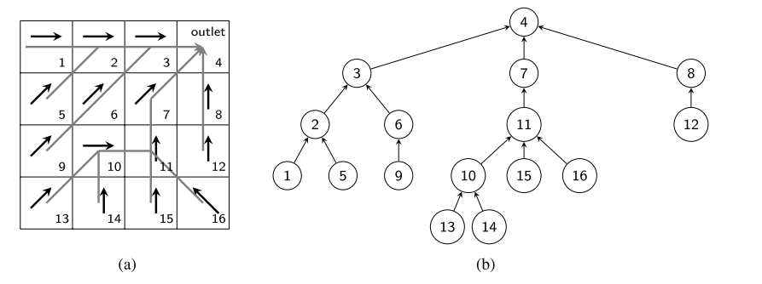

Figure 6‑1: Fragment of a flow direction grid, where cell 4 represents the outlet of the catchment, black arrows represent flow direction and gray arrows denote the branches of the corresponding tree representation in which the cells are considered as nodes connected by links, from Castillo-Reyes et al. (2022).

#### Sediment accumulation

The sediment accumulation model iterates over the graph (Figure 6‑1). At each iteration, the outgoing amount of sediment for every node is calculated. To this end, the total amount of sediment (SA) present in the node (incoming sediment (SI) + locally produced sediment) is compared with the transport capacity (TC) leading to one of two possible outcomes:

1. The transport capacity is larger or equal than the amount of accumulated sediment in the node. Therefore, the total amount of available sediment is transported to the downslope node. The outgoing sediment So equals the total available sediment SA.

Once the sediment reaches a river cell, the sediment is transferred completely to the next downstream river cell.

1. The transport capacity is smaller than the amount of accumulated sediment in the node meaning that the total available amount of sediment is higher than the amount of sediment that can be transported during the time step. The quantity of outgoing sediment equals the transport capacity so that net sediment deposition occurs in the cell equal to SA - TC.

$$S_{A}>TC→S_{o}=TC$$

### Sediment concentration model (SCM)

Within each cell the initial sediment concentration is determined using the solid entrainment coefficient (Sc) defined by Yoshimura et al (2015). For each land use types in the Fukushima area, the Sc relates the RC activity concentration (CCs-137) in the sediments to the initial RC deposition.

$Sc=\frac{C_{Cs-137}}{A_{Cs-137}}$ (Equation 6.4)

Where Sc (m2 kg-1) is the solid entrainment coefficient, CCs-137 the RC activity concentration in sediment (Bq kg−1) and ACs-137 the initial RC deposition (Bq m−2).

Wakiyama et al. (2019) incorporated the temporal variation in Sc, resulting in Sct:

(Equation 6.5)

where $Sc_{t}$ is Sc at time t (year). Sc0 is Sc at time of deposition (t=0) and k is the decrease rate constant (year−1). The constant k includes the decay constant of 0.023 yr−1 for RC. Using equation 6.5, the RC concentration can be determined using equation 6.6.

$C_{Cs-137}=A_{Cs-137}* Sc_{0}\exp\left(-kt\right)$ (Equation 6.6)

As Cs-137 mostly occurs in its particulate form (Bin et al., 2022), the amount of Cs-137 leaving the cell and ultimately the catchment is related to the amount of sediment and the concentration of Cs-137 in the sediment. To account for the sediment concertation within the transported sediments, CAMF was adapted to also track the sediment concentrations assuming homogenous mixture. In a single-flow direction situation, where node A drains into node B, the Cs-137-concentration of the sediments leaving node B, is determined as the sediment-weighted average of the Cs-137 concentration of the sediment produced by node B and of the Cs-137 concentration of the sediments coming in from node A.

$C_{B_{acc}}=\frac{A_{B}*C_{B}+{S(A)}_{out}*C_{A_{acc}}}{{S(B)}_{acc}}$ (Equation 6.7)

where $C_{B_{acc}}$ is the Cs-137 concentration (Bq kg-1) of the sediments leaving node B, AB is the annual sediment production in B, CB is the initial Cs-137 concentration of produced sediments in B, ${S(A)}_{out}$ is the amount of sediment leaving cell A to B, $C_{A_{acc}}$ is the concentration of Cs-137 of the accumulated sediments in A and ${S(B)}_{acc}$ is the total amount of sediment accumulated in B.

### Iterative optimization framework

The optimization framework CAMF (Figure 6‑2) iteratively runs the SPTM, ranking cells according to the change in accumulated sediment yield at the catchment outlet (SY) that the considered per cell intervention provokes. CAMF distinguishes between context cells and candidate cells, where the intervention of interest is considered only for the candidate cells. The context cells make up all other cells within the raster representation of the catchment and co-determine the amount of sediment and its flow path from the candidate cells to the outlet. For afforestation meant to reduce sediment export, candidate cells are typically the cells under land use types with high erosion potential, like agricultural or bare land. For each of the candidate cells (n), the intervention is considered separately. In the case that the intervention consists of afforestation the land use change results in a decrease of the local sediment production (A) and of the local sediment transport capacity (TC). From this follows a net decrease in sediment loss from the afforested cell to its parent cell (downslope neighbor), and this reduction is propagated from the afforested cell down to the outlet. The eventual sediment accumulation at the outlet, called the sediment yield (SY), is compared to the initial SY (without any candidate cell is afforested), and is a measure of the sediment yield reduction potential of the afforestation of the considered cell. This process is repeated for every candidate cell in the catchment. Cells are then ranked in descending order according to their sediment yield decrease and the cell leading to the highest SY reduction is set to be afforested. In the next iteration, all remaining candidate cells (n-1) are again one-by-one tentatively afforested to determine their SY reduction potential, accounting for the previously afforested cell. Cells are once again ranked based on the SY reduction potential, and the best cell is afforested. This procedure is repeated until a fixed number of candidate cells are afforested or a minimum cumulative amount of SY reduction is achieved. This iterative process allows for explicit accounting of the spatial interaction between the cells.

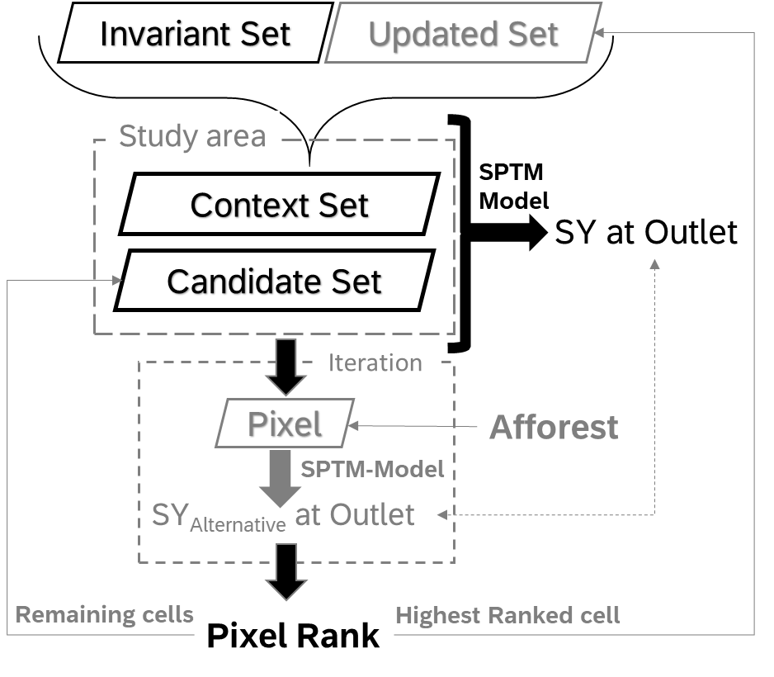

Figure 6‑2: Flowchart of the iterative optimization framework, iteratively assessing candidate cells in the candidate set based on sediment yield reduction at the outlet resulting from afforestation of the considered cell, adapted from (Gabriels et al., 2022).

### Case study: Niida catchment

#### Geography and contamination

The study area, 198 km2, is the catchment of the Niida river upstream of the Haramachi hydrographic measurement station, as shown with the red dot in Figure 6‑3. The digital elevation model (DEM) with an original resolution of 10 m x 10 m (Geospatial Information Authority of Japan) was resampled to a 20 m x 20 m resolution for computational reasons.

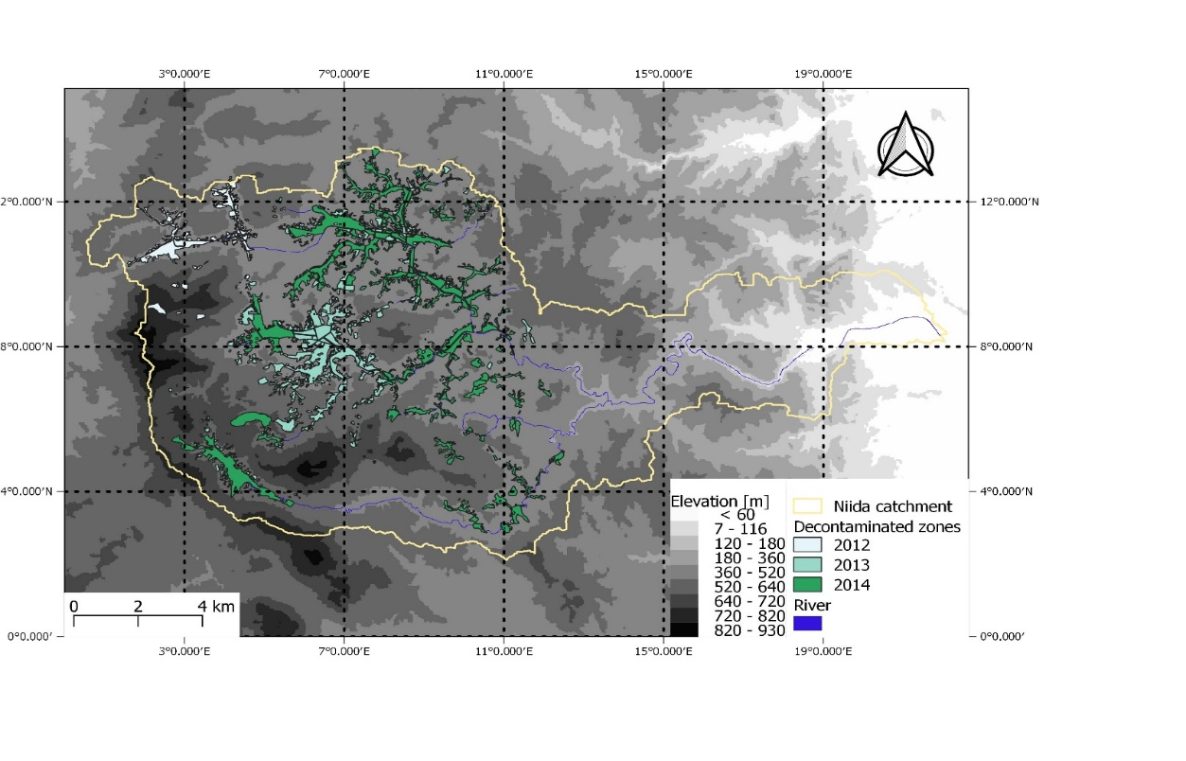

Figure 6‑3: The Niida river catchment, with indication of the decontaminated zones and the Haramachi measurement station (red dot).

The water discharge, sediment load and particulate RC data measured at the Haramchi outlet for 2013-2018 were obtained from (Bin et al., 2022). The total area of decontaminated zones for 2012, 2013 and 2014 was, respectively, 2.23 (1.1%), 9.11 (4.6%) and 12.12 (6.1%) km2.

Table 6‑1: The annual river discharge (Q, m3 yr-1), annual suspended sediment load (L, Gg yr-1) and annual 137Cs flux (LCs, TBq yr-1) measured in the Haramachi monitoring station (Bin et al., 2022).

|  |  |  |  |
| --- | --- | --- | --- |
| Year | River discharge (m3 yr-1) | Suspended Sediment load (Gg yr-1) | 137Cs flux (TBq yr-1) |
| 2013 | 1.09×108 | 6.75±0.01 | 0.16 |
| 2014 | 2.56×108 | 17.12±0.04 | 0.32 |
| 2015 | 2.54×108 | 126.71±0.31 | 1.24 |
| 2016 | 2.55×108 | 52.80±0.10 | 0.37 |
| 2017 | 3.53×108 | 49.37±0.03 | 0.37 |
| 2018 | 1.84×108 | 40.27±0.16 | 0.23 |

The Fukushima Daichi Nuclear Power Plant (FDNPP) accident in March 2011 resulted in the contamination of Niida catchment with radioactive fallout, mainly Cs-137 (Evrard et al., 2019). Due to the atmospheric and topographic conditions, following deposition pattern was formed.

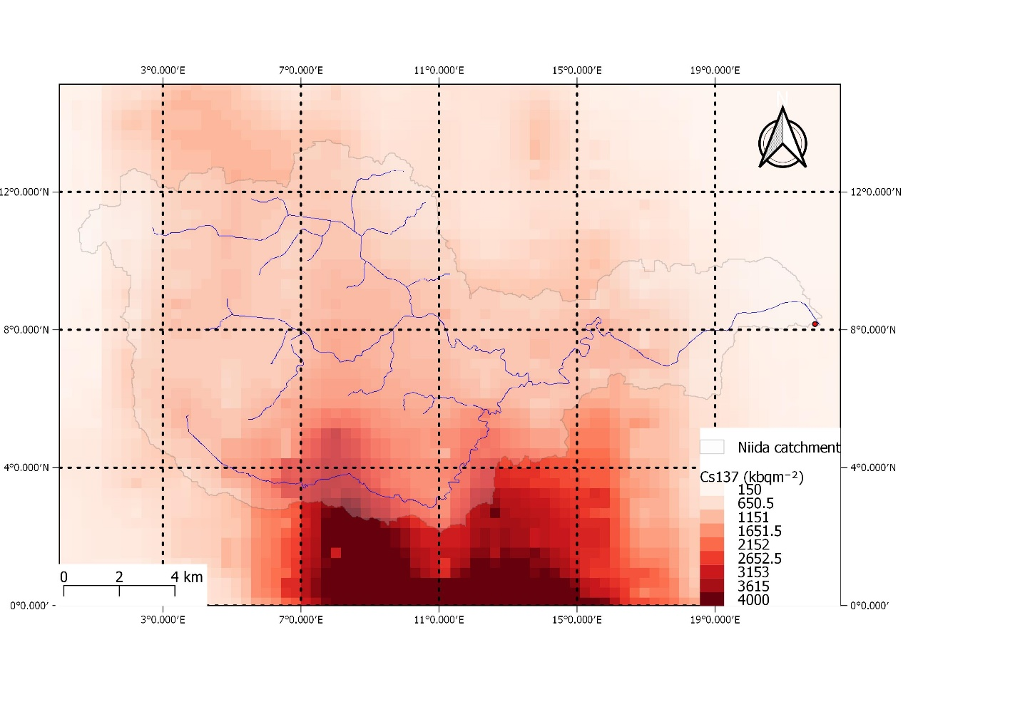

Figure 6‑4: The Cs-137 deposition on the Niida catchment as result of the Fukushima accident.

Equation 6.5 by Wakiyama et al. (2019) was used to estimate the CCs-137 in the produced sediments for each cell, based on the land use type, in the consecutive years after the Fukushima Daiichi nuclear accident. The Sc0 and k values in Table 6‑2 were used in this study, whereby ‘bare land’ was set equal to the ‘Agriculture’ land use type.

Table 6‑2: Parameters for temporal trends of Sc from (Wakiyama et al., 2019).

|  |  |  |
| --- | --- | --- |
| Land use | Sc0 | k |
| Forest | 0.084 | -0.090 |
| Agriculture | 0.0023 | -0.66 |
| Pasture | 0.012 | 0.048 |

#### Inputs for the sediment production model (RUSLE)

#### Rainfall erosivity R

The rainfall erosivity factor values given in the table below reported in Bin et al, 2022, were applied.

Table 6‑3: Rainfall erosivity factor (Mj mm h-1 ha-1 y-1) measured in Haramchi (Bin et al., 2022).

|  |  |  |  |  |  |  |
| --- | --- | --- | --- | --- | --- | --- |
|  | 2013 | 2014 | 2015 | 2016 | 2017 | 2018 |
| R-factor | 2153.00 | 1946.11 | 3893.37 | 2399.021 | 1551.17 | 1208.04 |

#### Soil erodibility K

The K-factor was assumed to be homogenous over the whole catchment and was set to 0.039 ton h MJ-1 mm-1 (Wakiyama et al., 2019).

#### Cover factor C

The Cover factor (C-factor) in the RUSLE equation accounts for the effects of plants and other soil cover, and soil disturbing activities on the soil erosion process (Wischmeier and Smith, 1978). The cover factor was originally developed for agricultural crops and needs to be adapted to be applicable to other land cover types, such as forest (Kitahara et al., 2000). To this end, the C-factor values were assigned to each cell using the high resolution (10 m x 10 m) land cover map for 2020 from ESA WorldCover 2020 (Zanaga et al., 2021). The actual C-factor values for the different land cover types, were retrieved from previous studies for the region (Chartin et al., 2013; Kitahara et al., 2000). The C-factor value for bare land was set to 0.5 because it is assumed that within a year, bare land is spontaneously partially revegetated, so a value of 1 would overestimate the actual sediment production (Kitahara et al., 2000).

Table 6‑4: C-factor values[-] by land cover type for the Niida catchment.

|  |  |
| --- | --- |
| Land cover | C-factor |
| Forest | 0.001 |
| Sealed | 0 |
| Water | 0 |
| Pasture | 0.02 |
| agriculture | 0.04 |
| Bare land | 0.5 |

#### Erosion control practice factor P

The P-factor of all cells was set to 1. There are no specific erosion control practices implemented in the study area.

#### LS factor

In RUSLE the effect of topography on sediment production is quantified by the LS-factor, which is a combination of the slope length factor (L) and the slope steepness factor (S). The LS-factor was computed according to the two-dimensional stream flow algorithm of Desmet and Govers (1996). The LS-factor and sediment production increase with an increasing slope length as well as with an increasing slope steepness. The maximum slope angle for which the LS-factor can be estimated is 50% (Panagos et al., 2015a). Therefore, the slope angle values were cut off at 50% for 4.3 % of the cells.

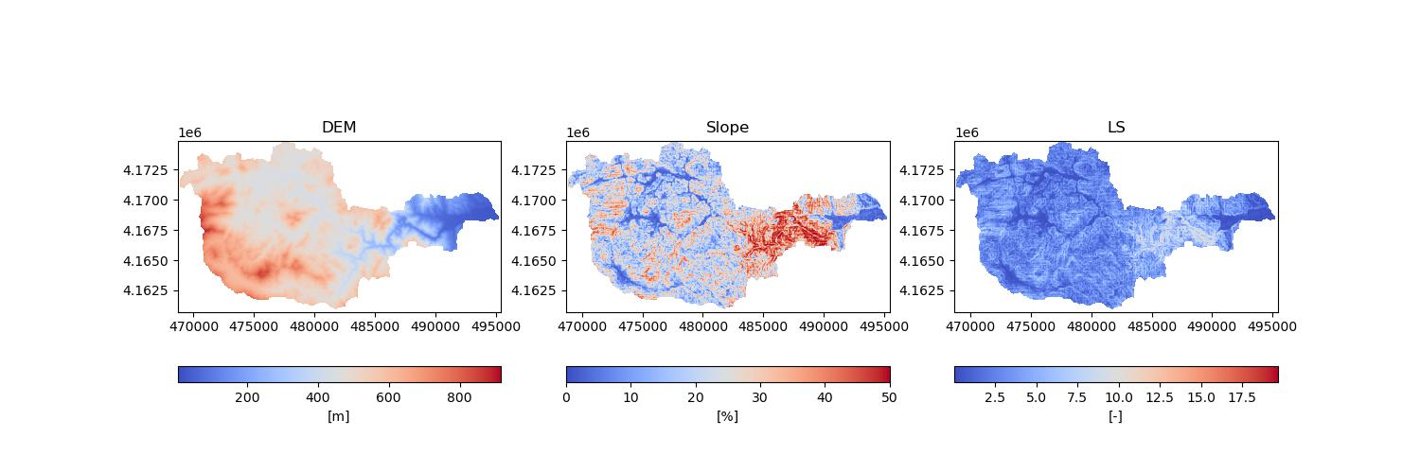

Figure 6‑5: The slope (middle) and LS-factor (right) determined from the elevation model (left) of the Niida catchment.

#### Impact of the decontamination works

Bin et al. (2022) found a clear positive relationship between the amount of sediment exported by and the Cs-137 concentration of the river water on the one hand and the extent of the land cover changes inflicted by the decontamination works on the other hand. The relationships highlight that the bare soil left after the decontamination works is very prone to erosion. Most of the decontamination works in 2012-2014 (Figure 6‑3) were done on agricultural land (Figure 6‑6).

Figure 6‑6: Size and original land use of the area decontaminated in 2012, 2013 and 2014.

The actual decontamination works consisted of the removal of vegetation and the top soil layer (± 5 cm). For the SPTM, the land cover (LC) type of the decontaminated zones was adapted from its original type to ‘bare land’, encompassing a change in the C-factor. After 3 years, the cover factor was reset back to the original C-factor values as it is assumed that by that time the cell was fully restored to its original LC. A similar approach was adopted by Kitahara et al. (2000) for forest disturbances after fire or clear cutting. Since air dose rate measurements (Bq m-2) after the decontamination showed a decrease of 20-70% of the original contamination (Onda et al., 2020), it was assumed that the decontamination reduced the initial concentration of Cs-137 by 50%.

#### Inputs for the sediment transport model and calibration

To calibrate the KTClow and KTChigh parameters, the suspended sediment load measurements for 2013 - 2018 (Table 6‑1) were used. The Nash–Sutcliffe model efficiency coefficient (equation 6.8), commonly used for assessing the goodness of fit of non-linear models in hydrology (McCuen et al., 2006), was used for assessing the STM-results (Quijano et al., 2016).

$NS=1- \frac{\sum_{i=1}^{n}{{\left(O_{i}-P_{i}\right)}^{2}}}{\sum_{i=1}^{n}{{\left(O_{i}-O_{mean}\right)}^{2}}}$ (Equation 6.8)

Where Oi and Pi are the observed and simulated sediment export (ton yr-1), Omean the mean observed value (ton yr-1) and n is the number of observations. The Nash–Sutcliffe model efficiency coefficient ranges from −∞ to 1. The closer the value of NS is to 1, the more efficient the model is and NS ≤ 0 indicates that the observed mean is a better predictor than the model. For calibration the KTC values were varied between 5 and 120 m for both KTClow and KTChigh, with the restriction that KTChigh should be higher than KTClow. The highest NS (0.75) was found for KTClow = 25 m and KTChigh = 115 m. From the R-values in Table 6‑3, it is clear that the catchment experienced extreme rainfall in 2015. Due to this extreme rainfall observed in 2015, the model has difficulties to predict the observed SY. Future work could identify the impact of not including 2015 in the calibration process, however, for this chapter 2015 was included.

Table 6‑5: Simulated and observed yearly sediment yields (Gg yr-1) at the outlet for 2013 – 2018, after calibration (KTClow =25 m and KTChigh = 115 m).

|  |  |  |
| --- | --- | --- |
| Year | Observed SY [Gg yr-1] | Simulated SY [Gg yr-1] |
| 2013 | 6.75 | 11.56 |
| 2014 | 17.12 | 26.35 |
| 2015 | 126.71 | 89.42 |
| 2016 | 52.8 | 55.10 |
| 2017 | 49.37 | 34.00 |
| 2018 | 40.27 | 17.27 |

Table 6‑6: Yearly observed and simulated aggregated Cs-137 flux at the Haramachi measurement station for 2013-2018 using equation 6 and 7 for the predicted values and with KTClow = 25 m and KTChigh = 115 m.

|  |  |  |
| --- | --- | --- |
| Year | Observed Cs-137 flux [TBq yr-1] | Simulated Cs-137 flux [TBq yr-1] |
| 2013 | 0.16 | 0.23 |
| 2014 | 0.32 | 0.18 |
| 2015 | 1.24 | 0.31 |
| 2016 | 0.37 | 0.17 |
| 2017 | 0.37 | 0.10 |
| 2018 | 0.23 | 0.07 |

## Results

CAMF was used to find those cells in the decontaminated zones within the Niida catchment of which afforestation leads to maximal reduction of the sediment export at the outlet. The candidate cells are restricted to those that were decontaminated in 2014. The cells decontaminated in 2012 and 2013 were considered to be still bare (not covered with vegetation) with a C-factor of 0.5. The R factor is 2191 MJ mm ha-1 h-1 year-1,the average for 2012-2018 calculated from Table 6‑3. The total modelled sediment yield for 2014 at the outlet before afforestation is 43 044 tons, with a Cs-137 flux of 0.169 PBq. For the simulations a Xeon E5-2697 v3 CPU (2.6 GHz) with 28 cores and 128 GB of RAM, with Ubuntu Bionic Linux as Operating System was used. The computational time to find the optimal 1000 sites within the Niida catchment using full parallelization is 1 688 79 seconds.

### Sediment yield reduction

In general, the most optimal cells for afforestation are situated close to a river branch, as seen in Figure 6‑7. This can be explained because afforestation leads not only to a reduction in local sediment production, but also to the halting of sediment moving downward from cells in the upper flow path.

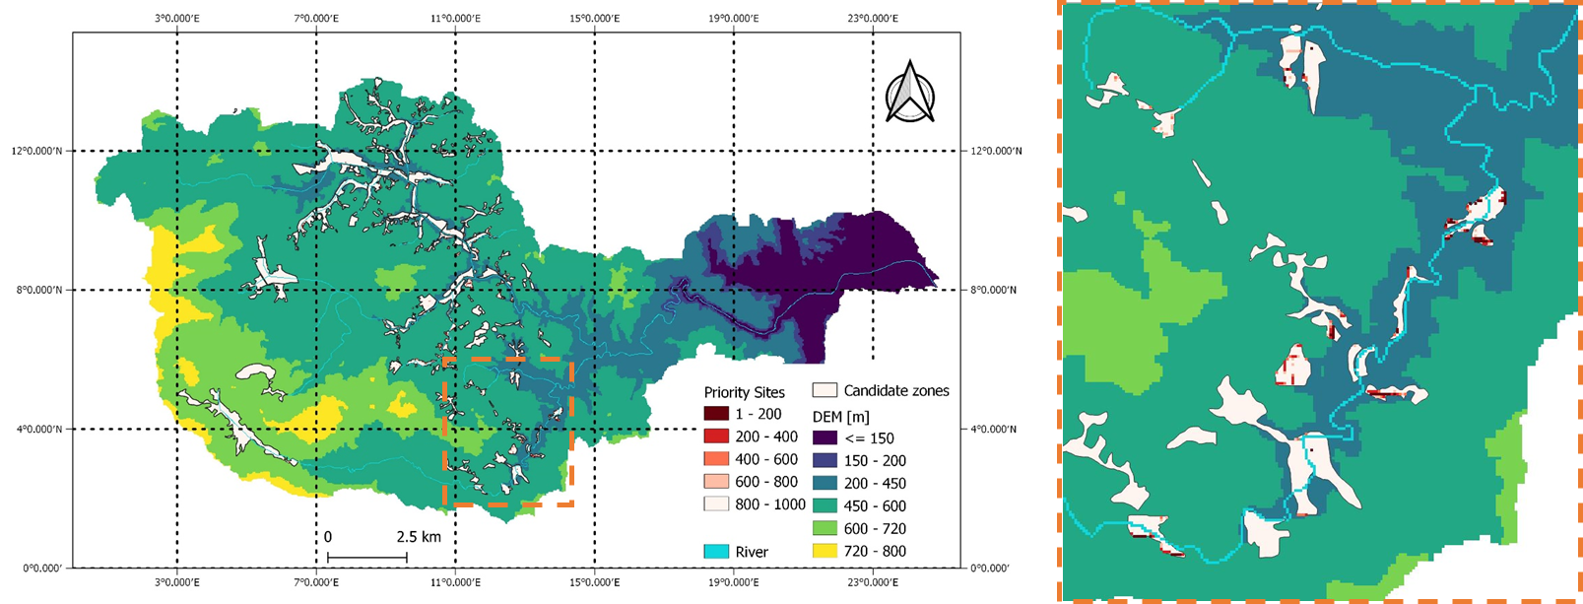

Figure 6‑7: The Niida catchment, with the decontaminated cells of 2014 (white) as the candidate cells for afforestation (left), zoom of a river branch, with a subset of the 1000 priority cells for afforestation (right).

Afforestation of the highest ranked first 100, 500 and 1000 cells reduces the sediment yield at the outlet with respectively 2.6%, 9.5% and 15.4% compared to the non-afforested situation. The absolute values for sediment yield reduction are given in Table 6‑7.

Afforestation of the 1, 10, 100, 500 and 1000 highest ranked cells results in a reduction of sediment yield per afforested m2. The sediment yield was reduced by 0.045 ton m2 for the highest ranked cell, 0.038 ton m2 for the 10 highest ranked cellsand 0.028 ton m2 for the 100 highest ranked cells confirming the importance of some key cells.

Table 6‑7: Sediment yield reduction (SYR) in ton yr-1 at the outlet after afforestation of the 1, 10, 100, 500 and 1000 highest ranked cells from the sites that underwent remediation in the year 2014 for an R-factor of 2191 MJ mm ha-1 h-1 year-1.

|  |  |  |  |  |  |  |
| --- | --- | --- | --- | --- | --- | --- |
|  | Number of candidate cells and area decontaminated [km2] | SYR resulting from afforestation of highest ranked cell [ton y-1] | SYR resulting from afforestation of 10 highest ranked cells [ton y-1] | SYR resulting from afforestation of 100 highest ranked cells [ton y-1] | SYR resulting from afforestation of 500 highest ranked cells [ton y-1] | SYR resulting from afforestation of 1000 highest ranked cells [ton y-1] |
| 2014 | 29056 cells [11.6 km2] | 18 (0.04%) | 152 (0.35%) | 1130 (2.6%) | 4079 (9.5%) | 6631 (15.4%) |

Although afforestation does not reduce the Cs-137 contamination, due to its reduction in sediment delivery downstream it impacts the RC flux at the outlet. The reduction in sediment at the outlet, is related to the CS-137 flux reduction (CSFR) at the outlet. In Table 6‑8, the corresponding CSFR after afforestation of 1, 10, 100, 500 and 1000 cells is presented.

Table 6‑8: Cs-137 flux reduction in MBq y-1 at the outlet after afforestation of the 1, 10, 100, 500 and 1000 highest ranked cells from the sites that underwent remediation in the year 2014 for an R-factor of 2191 MJ mm ha-1 h-1 year-1.

|  |  |  |  |  |  |  |
| --- | --- | --- | --- | --- | --- | --- |
|  | Number of candidate cells and area decontaminated [km2] | CSFR resulting from afforestation of highest ranked cell [MBq y-1] | CSFR resulting from afforestation of 10 highest ranked cells [MBq y-1] | CSFR resulting from afforestation of 100 highest ranked cells [MBq y-1] | CSFR resulting from afforestation of 500 highest ranked cells [MBq y-1] | CSFR resulting from afforestation of 1000 highest ranked cells [MBq y-1] |
| 2014 | 29056 cells [11.6 km2] | 1164  (6.9 10-4 %) | 25 103  (0.01%) | 160 103  (0.1%) | 514 103 (0.3%) | 816 103 (0.5%) |

The amount of sediment leaving the catchment after afforestation of the cells ranked highest by CAMF was not only compared with the sediment loss in the initial non-afforested situation. Another comparison was done with the sediment lost after afforestation of a random set of 1, 10, 100, 500 and 1000 cells. The random afforestation for 1, 10, 500 and 1000 cells was done 10 times each. The difference in sediment reduction is shown in Figure: 6‑8. It becomes clear that afforestation of the random cells leads to minor reduction, whereby the reduction increases linearly with the number of afforested cells. In comparison, spatially targeted afforestation as supported by CAMF leads to much greater reduction and to decreasing marginal gains with increasing number of cells. The afforestation of 1000 random cells is 16 times less effective than the afforestation of the 1000 CAMF-cells (Figure: 6‑8).

Figure: 6‑8: Sediment reduction [ton y-1] at the outlet after afforestation on 1, 10, 100, 500 and 1000 cells using a spatially targeted approach compared to a random approach (for year 2014).

### Characteristics of the priority cells for afforestation

A cumulative frequency analysis of the characteristics of the 1000 cells ranked highest for their contribution to the reduction of sediment export reveals that 75 % are situated closer than 110 meters from a river branch and half of the cells are located at an elevation around 450 m. On average, priority cells have an LS factor of 3.5 and a slope of 25%. However, the highest ranked cells are not the steepest cells which can be explained by the forest cover that is present on most cells on very steep slopes. Those cells are not among the candidate cells. The cells chosen for intervention have a sediment production between 4 and 18 ton/year, with an average of 6 and have a contamination level between 40 and 210 kBq. Within the catchment, the highest sediment-producing cell produces 20.89 tons per year. However, this cell is not selected among the 1000 top-ranked cells for afforestation. This is a clear example that it is not, per definition, the highest sediment-producing cells that need to be afforested and that sediment flow is important. Further, this flow is subject to spatial interaction between cells, so the iterative approach is important.

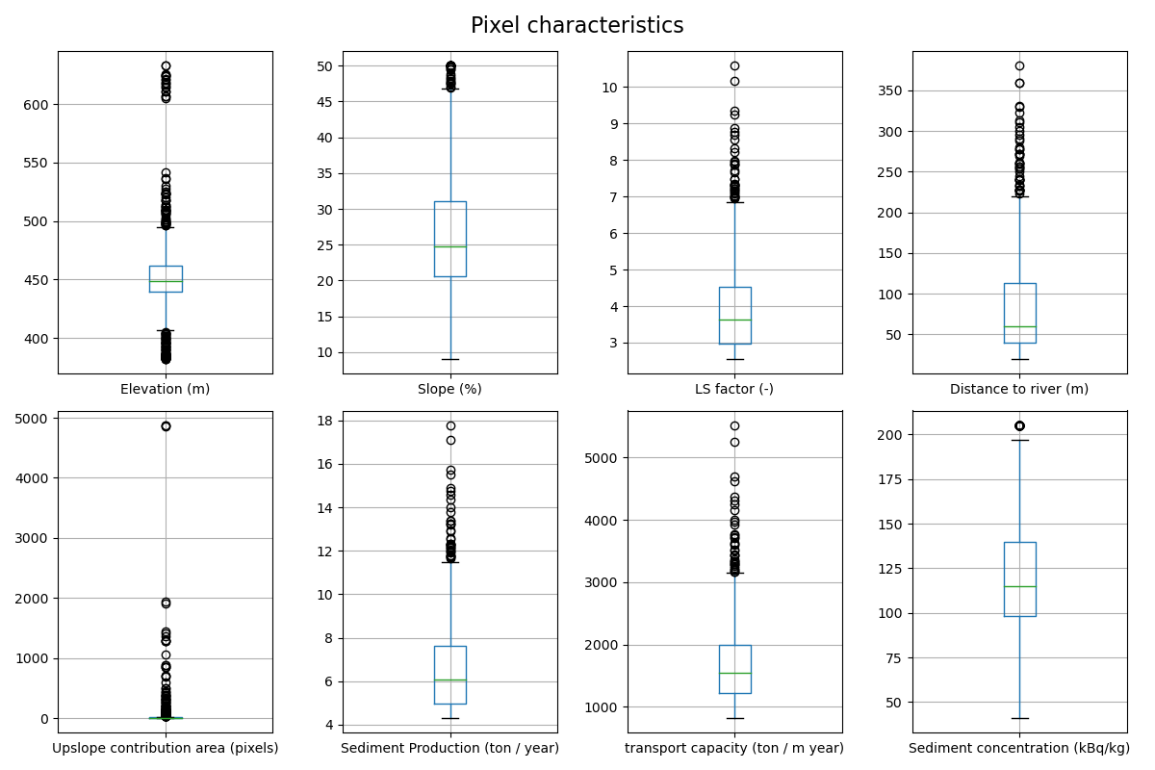

Figure 6‑9: Boxplots for elevation (m), slope (%), LS-factor (-), distance to the river (m), upslope contribution area (cells), sediment production (ton year-1), transport capacity (tonm-1 year-1) and sediment concentration (kBq/kg) of the 1000 cells ranked highest for sediment yield reduction (SYR) through afforestation.

## Discussion

This study confirms that land use and land management planners must be aware of and take into account the possible off-site effects of interventions in the landscape aiming at one or multiple on-site objectives. The remediation practices in the Niida catchment are a clear example of site-specific interventions where on-site impacts (reduction of the contamination) are associated with large off-site impacts (increased erosion and resulting sediment and Cs-137 yields at the outlet). Off-site effects are impacted, by the concept of spatial interaction between locations, meaning that an intervention at a given location affects not only the characteristics and properties of that location but also those of other, even distant, locations in the landscape. These spatial interactions are especially pertinent for flow phenomena in landscapes such as flow of water and sediments.

This chapter showed that for a gridded catchment, cells can be iteratively ranked from high impact cells to lower impact cells when the considered intervention is afforestation, and the objective is to maximally reduce the export of sediment from the catchment through the river system. By afforesting 40 ha of the more than 12 km2 decontaminated zones, a 15% reduction in sediment yield at the outlet can be obtained, when using CAMF. When afforestation is done randomly the expected reduction in sediment export is 16 times less. This proves that location does matter for the effectiveness of interventions, because it will modify the generation, transportation and accumulation of materials, not only in terms of the location-specific (on-site) characteristics but also regarding the off-site effects. It confirms the ideas stated by Verstraeten et al., (2007) that erosion control measures are very location specific and that measures to areas that hardly contribute water or sediment discharges to river channels is inefficient.

The highest sediment-producing cell is not selected for afforestation. This finding is in line with the notion that the connectivity between sites is more important than the soil erosion rate itself (Boardman et al., 2019). This is in accordance with Domingues et al. (2020), who showed that the ranking of cells is not dominated by the cells with the highest sediment production. The spatial distribution of the cells ranked highest for afforestation is in line with several studies, that found that the riparian zone is key for retaining sediments or surface runoff (Dosskey, 2001; Fennessy and Cronk, 1997; Gabriels et al., 2022).

By identifying the location and characteristics of highly contributing cells, a better understanding of the catchment dynamics is obtained. This knowledge can be further used to support land management decisions. The most important cells are found close to the river at a small elevation interval, this would result in a clear message to the decisionmakers on where to prioritize afforestation.

Within the SPTM, the per-cell sediment production estimation is based on the (R)USLE model. (R)USLE has been applied successfully especially for larger study areas across the globe, but for accurate predictions of erosion rates for variable land covers, the model parameters should be tested and calibrated for the specific area. Similarly, the use of a simple transport coefficient to describe the sediment flow between cells is a severe simplification of a complex process. Due to the range of different (stochastic) processes involved in sediment transport, it is unlikely that simple relationships will describe the process perfectly (Wainwright et al., 2015). In addition, no uncertainty analysis was performed to determine the impact of uncertainty on the input factors. Therefore, in the future an uncertainty analysis could give more insights into the impact of uncertainty. However, for planning of erosion and sedimentation mitigation measures, the understanding of patterns within the landscape is probably more important than obtaining the exact values (Domingues et al., 2020). Considering the reality of afforestation, clustering of afforestation sites and determining the most optimal patches with a minimal size would reduce the operational difficulty and costs.”

To improve the current predictions, the R-factor could be set to spatially vary across larger catchments. In addition, the K-factor currently set as homogenous over the whole catchment will in reality be spatially heterogeneous due to the diversity of soil types present in the catchment. Using higher resolution raster layers for the DEM could improve the modelling of the erosion flow (Van Rompaey et al., 2001), especially for catchments with many linear elements potentially obstructing or changing the erosion flow, like roads. However, this will result in an increase of the computational burden which is exacerbated by the iterative nature of CAMF.

Currently, the Cs-137 concentration in the sediments is estimated using a conversion factor of the deposition, which is rather simplistic. More complex Bayesian models as the ones proposed by Delmas et al. (2017) could return more accurate estimations of the RC concentration in the sediments. However, for the current implementation the methodology seems fit for purpose.

Chartin et al. (2013) and Golosov et al. (2022) identified a partial export of contaminated sediment from inland mountain ranges to the coastal plains in the Niida River basin. They stated that part of the sediment, with associated Cs-137, will be (temporarily) redeposited immediately after a sharp decline of channel gradients, these intermittent storage areas will be remobilized in the future by bank and bed erosion. In contrast, CAMF assumes that contaminated sediments that enter the river system are fully transported to the outlet of the catchment (TC = 9999). Hence, sedimentation in rivers or redeposition of sediment from floodings is not currently considered. In addition, CAMF assumes a direct reduction in sediment production after afforestation, which clearly is an overestimation of the initial impact. The assumption is more realistic though in case afforestation would be complemented with soil covering practices such as mulching. The findings in this chapter confirm the hypothesis that the incorporation of a CAMF-like methodology into decision making tools has the potential to design more effective and efficient schemes for spatially targeted interventions in the landscape, like remediation of polluted agricultural soil. Only by considering its on- and off-site impacts of a location-specific intervention, can remedial schemes be designed that assures the intervention’s sustainability, as was highlighted by Bin et al. (2022).

## Conclusion

This study confirmed that, due to spatial variability and spatial interaction, the effectiveness of afforestation as a post-decontamination intervention to reduce sediment and sediment bound pollutant export from catchments affected by deposition of Cs-137 is highly location specific. We demonstrated that the iterative optimization framework CAMF is suitable to identify those locations in the catchment for which the intervention has the highest desired impact. One finding is that in the Niida-catchment near Fukushima, Japan, a random selection of 1000 candidate cells for afforestation (3.4% of all candidate cells) results in a 0.8% decrease of sediment export whereas the 1000 cells ranked highest by CAMF lead to a sediment export reduction of 15%. Obviously, the optimality of the selected cells is conditioned by the reliability of the submodules for (i) sediment production, (ii) sediment transportation and accumulation, (iii) the spatial and temporal resolution, (iv) and the input parameter values. The incorporation of a CAMF-like methodology into decision making tools has the potential to design more effective and efficient schemes, considering the off-site impacts, for spatially targeted interventions in the landscape.

# Accounting for on-site and off-site criteria for remediation of agricultural catchments affected by a nuclear accident.

## Summary

Spatial and spatio-temporal remediation schemes meant to restore agricultural production in a landscape affected by deposition of radionuclides originating from a nuclear disaster, must not only consider the on-site behavior of the nuclides but also their transportation through the landscape. Such transportation is the result of soil erosion, which may be exacerbated by the applied decontamination technique. In this study we proposed a procedure to account for multiple on-site criteria and for flow of contaminated sediment as a single off-site criterion, to generate optimized spatial remediation schemes that express each parcel’s priority for remediation. In addition, we extend the procedure to account for annual budget constraints leading to multi-year, hence spatio-temporal, remediation schemes. We applied the procedure to a case study encompassing the Maarkebeek catchment in Belgium subject to a hypothetical spatially variable Cs-137 deposition pattern with topsoil removal as the remediation technique. The building blocks of the toolbox developed to generate the spatial and spatio-temporal schemes for parcel remediation were GIS, MADM (Compromise Programming and Weighted Linear Combination), a Sediment Production and Transport Model and Sediment Concentration Model for Cs-137 (CAMF). We found that the sole consideration of on-site criteria of both the cost and benefit type, inc. the benefit criterion ‘level of contamination’, resulted in the severest contaminated parcels to receive the highest priority. When modelled export of particulate Cs-137 through the outlet of the catchment was taken as the only (off-site cost) criterion, parcels close to the river system were ranked higher. We showed that on-site and off-site priority rankings can be weighted and combined to yield a spatial remediation scheme that considers both types of criteria. Next, we considered an annual budget constraint so that the remediation scheme extended over multiple years and became spatio-temporal. Due to the natural decay of the Cs-137 in the contamination and due to the spatial interaction, that characterizes the flow of (contaminated) sediment towards the outlet of the catchment, the final timing of remediation can be different from the initially expected from the priority given to parcels. Finally, we showed that we can build the off-site priority ranking of parcels considering not only the outlet of the catchment as the receptor of interest but also the already decontaminated parcels. In this way more parcels away from the river system received higher priority for decontamination as by decontaminating these the source of recontamination of the more downstream parcels is taken away. We acknowledge that the proposed procedure can be further extended to account for alternative remediation techniques, uncertainties in the on-site, off-site and combined priority calculations and for the need to spatially and temporally cluster parcels and associated remediation technique for economic and pragmatic efficiency reasons.

## Introduction

Spatial explicit remediation schemes meant for remediating agricultural parcels, contaminated by deposition of radionuclides, must not only consider the on-site behavior of the nuclides but also their transportation through the landscape. On a global scale, soil loss caused by water erosion in agricultural areas ranges from 23.7 to 120 Pg y-1, where rill and inter-rill processes are estimated to detach 17 Pg y-1 (Borrelli et al., 2018). Further, the mean soil loss rate in the erosion-prone lands (agricultural, semi-natural areas, etc.) in the EU, was estimated to be 2.46 ton ha−1 y−1, resulting in a total soil loss of 970 Mton annually (Panagos et al., 2015b). Once, the sediments are transferred through the landscape, they cause off-site impacts to downstream regions. Such transportation can be exacerbated by the applied decontamination technique. Off-site impacts of soil erosion are of great social and economic concern in Western Europe, even more than the on-site impacts (Boardman et al., 2019). The severity of these impacts are increased, when associated pollutants are transported (Evrard et al., 2015).

Critical to these off-site impacts is the connectedness between elements in the landscape leading to spatial interaction, which is potentially even more important than the on-site soil loss rate (Boardman et al., 2019).

Many so-called opportunity mapping tools (Gabriels, 2021) have been developed to identify the locations in the landscape where intervention would lead to the most significant soil loss reduction on-site. However, from Chapter 6 it became clear that interventions, as afforestation, can reduce the sediments at the outlet far more than the initial production of the site. Resulting in the idea that site with high erosion rates is not by definition the most important from an off-site perspective. Due to the strong adhesion of RC to soil particles in RC-contaminated landscapes, soil loss and sediment transport cannot be disconnected from the associated contamination. Therefore, in the scope of remediation of agricultural parcels in RC-contaminated watershed, parcels with a large contribution to the Cs-137 flux at the outlet should be prioritized for remediation. However, remediation of a particular parcel will inevitably change the sediment quantity and so RC-contribution to the watershed outlet of other parcels due to the phenomenon of spatial interaction (chapter 6). Therefore, optimizing remediation efforts solely based on on-site characteristics (e.g., contamination level) or off-site criteria but without considering the need for an iterative approach could result in sub-optimal remedial decisions. In addition, due to natural decay the decision context for remediation changes through time, for example, in multiple period remedial schemes attention needs to be given to the avoidance of recontamination of parcels.

This chapter introduces an iterative framework to integrate both on and off-site impacts in the elaboration of spatio-temporal remediation plans for agricultural landscapes. For the off-site component it makes use of the CAMF-approach in which parcels rather than cells are the objects to be ranked and in which the maximization of the reduction of the Cs-137 flux (CsFR) at the catchment outlet is the objective. In the chapter the priority for intervention for on- & off-site and a combination of criteria are compared. The introduction of a budget constraint will result in multi-period decision making scheme, where spatial interaction could impact the ranking of parcels in successive years. Within the multi-period remediation scheme, the concept of minimizing the recontamination of other parcels will be studied. The results will be based on a case study for the optimal use of topsoil removal as remedial action for contaminated agricultural parcels, within Maarkebeek catchment in Flanders, Belgium.

## Materials and methods

### Maarkebeek Catchment and intervention

To develop and demonstrate the framework to integrate on and off-site criteria into spatio-temporal remediation plans for agricultural parcels contaminated with Cs-137, the Maarkebeek catchment is used (see section 1.8.1.). Further, the intervention used as remedial action is topsoil removal. It is assumed to cause a reduction in Cs-137 concentration of 90%, but it also leads to an increase in sediment production and transportation due to the removal of vegetation and therefore an increase in the C-factor to 0.5. Within the catchment, it is assumed that after topsoil removal, the parcel is taken back into agricultural production and returns to a C-factor according to its agricultural cultivation.

### Production of sediment and flow of Cs-137-contaminated sediment

Per cell sediment production was computed using the RUSLE (equation 6.1) and a Digital Elevation Model (DEM), with a spatial resolution of 20m x 20m. The original DEM has a resolution of 5m x 5m and is derived from a LIDAR data collection campaign conducted between 2013 and 2015 (Agentschap Digitaal Vlaanderen, 2014). The resampling to a 20m x 20m resolution was done for performance reasons.

|  |  |
| --- | --- |
|  |  |

Figure 7‑1: The Maarkebeek Catchment, with the digital elevation model (left) and the flow direction raster (right). A flow direction value of 7 represents flow to the north, 8 to the north-east, 1 to the east, 2 to the southeast, 3 to the south, 4 to the south-west, 5 to the west and 6 to the north-west.

The cover factor (C) is derived from the land use map of Flanders for 2018 (Van der linden and Van Valckenborgh, 2018). Bare and agricultural land have the highest vulnerability for sediment production and have the lowest resistance against sediment transportation. The assignment of a C-factor to each land cover type was based on the recommendation by Deproost et al., (2018) (Figure 7‑2 & Table 7‑1).

Table 7‑1: Land use classes and their corresponding C value in the Maarkebeek catchment.

|  |  |  |
| --- | --- | --- |
| Land use class | C value (-) |  |
| Buildings | 0 |
| Highways | 0 |
| Other covered | 0 |
| Railroads | 0 |
| Water | 0 |
| Arable land | 0.37 |
| Grass and shrubs | 0.003 |
| Forest | 0.001 |
| Meadow/pasture | 0.01 |

Figure 7‑2: C factor (-) in the Maarkebeek catchment.

The texture classes are obtained from the Belgian soil map (Databank Ondergrond Vlaanderen, 2017). The soil texture classes were assigned the corresponding soil erodibility factor K-values following according to Deproost et al., (2018).

Table 7‑2: Texture classes and their corresponding K value in the Maarkebeek catchment.

|  |  |  |
| --- | --- | --- |
| Texture classes | K factor  [ton h MJ-1 mm-1] |  |
| loam (A) | 0.0420 |
| silt loam (L) | 0.0400 |
| clay (E) | 0.0275 |
| sandy loam (P) | 0.0250 |
| heavy clay (U) | 0.0225 |
| loamy sand (S) | 0.0200 |
| sand (Z) | 0.0120 |
| well (B) | 0.0040 |
| stoney (G) | 0.0040 |
| sealed soil (OB) | 0 |

Figure 7‑3: K factor (ton h MJ-1 mm-1) in the Maarkebeek catchment.

The average rainfall erosivity factor for Flanders of 1250 MJ mm ha-1 h-1 year-1 (Gobeyn et al., 2021), was assumed to be valid for Maarkebeek. In Figure 7‑4, the sediment production, based on the RUSLE equation, and the used LS-factor for the Maarkebeek catchment are shown.

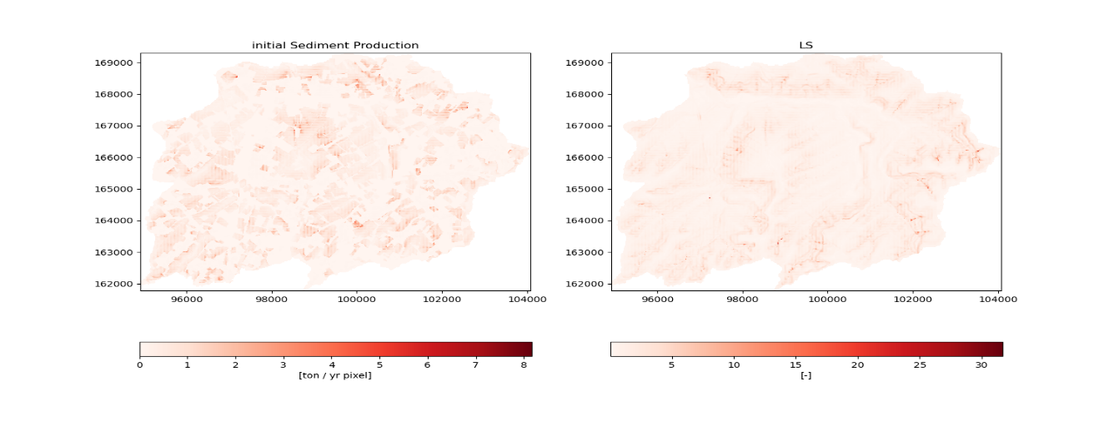

Figure 7‑4: Sediment production per pixel [ton yr-1] (left) and the LS-factor [-] (right for the Maarkebeek for a R-factor of 1250.

By means of the SPTM (section 6.3) the total sediment yield at the outlet for the first year after the Cs-137 deposition was estimated to be 16 857 tons with a Cs-137 flux of 9 876 kBq. The to be calibrated KTChigh and KTClow parameters were set to 12 and 3 respectively as proposed for Flanders by Deproost et al., (2018).

### On-site priority

The priority ranking of parcels for intervention based on on-site criteria only was determined by the parcel priority score (PPS) as elaborated in chapter 4 and Abrams et al., (2022b). Each agricultural parcel is assigned a PPS score, using a compromise programming methodology with the on-site criteria listed in Table 7‑3. The PPS score is used to rank all the parcels, where a low score represents a high importance/ranking.

Table 7‑3: The criteria to determine the on-site priority score (PPS) of agricultural parcels contaminated with Cs-137.

|  |  |  |
| --- | --- | --- |
| Criteria | Description | Weight |
| Activity in the food products | The activity of Cs-137 found in the crop after harvest from this field [Bq/kg] | VH |
| Importance of the food in the local diet | The amount consumed of this product on yearly basis [kg/year] | M |
| Population density | Population density of the municipality [pp/km2] | H |
| Distance to the urban infrastructure | Distance to the closest urban infrastructure (houses and gardens) [meter] | H |
| Erosion level of the field | The erosion sensitivity of the field [scale (0 : None - 0.5: medium - 1: very high)] | L |
| Distance to surface water | Distance to the closest surface water (lake/river) [meter] | M |

### Off-site priority

The off-site impact of a parcel was assessed as the parcel’s contribution of Cs-137 contaminated sediments to a specific receptor (e.g., the catchment outlet, cleaned agricultural parcels). Hence, the larger that contribution is to the reduction of the Cs-137 flux at the receptor after remediation of the parcel, the higher the off-site priority score of the parcel. The CsFR was determined using CAMF (Castillo-Reyes et al., 2022; Vanegas et al., 2012) as described in chapter 6. In comparison with chapter 6, there are two main differences in how CAMF is operated. First, the considered intervention for this application was not afforestation but topsoil removal, which is assumed to cause a reduction in Cs-137 concentration of 90%, and which leads to an increase of the sediment production, due to an increase of the C-factor to 0.5. Second, the polygon-based parcels are the unit of decision, not the elementary 20 m x 20 m cells. Thus, the Cs-137 flux reduction after intervention was determined after simultaneous topsoil removal on all the cells within a parcel. This approach resulted in a ranking of the parcels, according to the reduction in Cs-137 flux at the catchment’s outlet which the topsoil removal generates.

The iterative procedure, similar to the procedure in Figure 6‑2, is used (Figure 7‑5). To determine the ranking of the parcels. For each parcel the CsFR is determined, by intervening on all cells within the parcel, independent from the other parcels. The CsFR ranking is than used to intervene on the most important parcel(s). To completely take into account the potential spatial interaction, one parcel is selected for intervention in each iteration. However, to reduce the computational burden multiple parcels can be selected in each iteration, for this chapter 20% of the parcels were selected in each iteration. The intervened parcel(s), in period t, become part of the context set in period t+1, while the remaining parcels are returned to the parcel candidate set. The procedure was repeated until all parcels are intervened on.

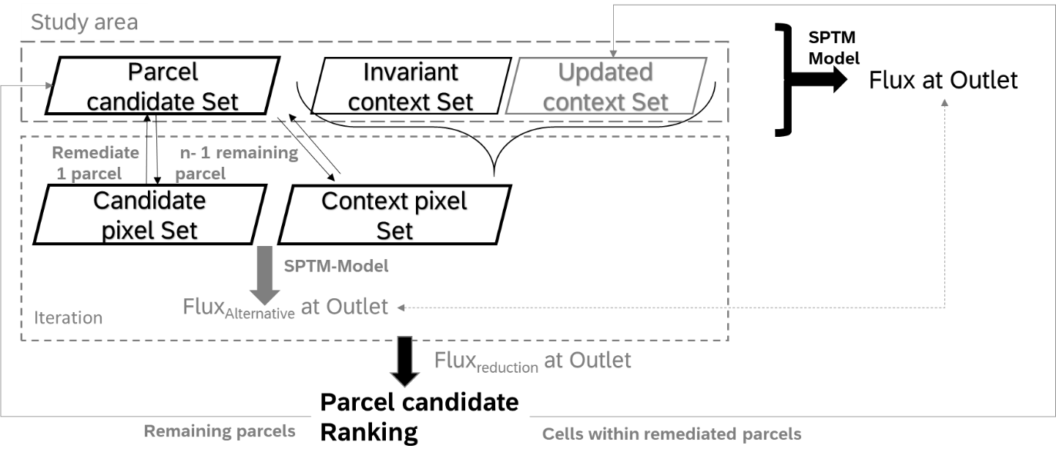

Figure 7‑5: The iterative workflow for determining the parcel priority based on their off-site impact.

Due to the lack of spatial interaction, this iterative structure was not required for the establishment of rankings based on on-site criteria.

### Integrated on & off-site priority

From the on-site perspective, a low PPS score relates to a parcel with a high priority for remediation (Abrams et al., 2022b), whereas from the off-site perspective a high potential reduction of the Cs-137 flux by remediation reflects a high priority. Therefore, both scores are normalized between 0 (low priority) and 1 (high priority) and are combined using a weighted linear combination with equal weights. Based on the combined score (on & off-site) parcels are ranked and the procedure as described in the previous section is continued (Figure 7‑6).

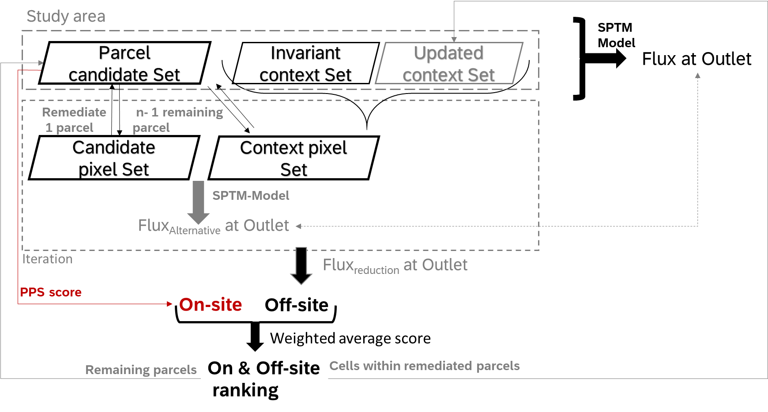

Figure 7‑6: Workflow for determining the parcel priority, composed of the off-site priority (black) or on and off-site criteria (red).

### Spatio-temporal decision-making

By introducing a budget constraint, for example an annual budget (3 M€ in this study), to be spend on topsoil removal efforts (7600 € ha-1). Due to the budget constraint only the highest ranked parcels can be remediated as long as the budget allows. The remaining parcels are then candidates for remediation in the next year.

This implies a spatial redistribution of the contaminated sediment. After one year not all sediments reach the river system. Sediments can be halted in the landscape, because of topographic features or land use types with low transport capacity. Hence, the amounts of sediment deposited in year t must be added to the newly formed amounts in year t+1, increasing the sediment quantity at that cell for period t+1. Also, the occurrence of natural decay which lead to a decrease of the Cs-137 contamination must be considered. Alike in chapter 6 a homogenous mixing of the sediments detached in years, and the sediments newly formed in year t+1 is assumed.

$$C_{t+1}=\frac{S_{deposited} *\left(C_{deposited, t}*exp\left(-λ\right)\right) +S_{t+1}*C_{t+1}}{S_{deposited}+S_{t+1}} (Equation 7.1)$$

where $λ$ equals 0.02297 and expresses the rate according to which the Cs-137 activity in the sediments is reduced due to radioactive decay. Sdeposited andCdeposited represents the amount (ton) and concentration (Bq/kg) of the sediments halted at the cell in period t. St+1 and Ct+1 are the newly produced sediments and its concentration for period t+1.

### Receptors

The receptor is the location at which the off-site impacts are considered. Because sediments flow to the river system and retention of sediment in the river is limited a common receptor is the outlet of the catchment. However, when addressing remediation in a multi-period scheme, parcels cleaned in a previous period can become (re)contaminated by posterior sediment flows so that they may be meaningful receptors as well. In case minimization of recontamination is at stake, the cells belonging to the decontaminated parcels must be considered as receptors as well for period t+1. This means that the off-site priority score of a parcel reflects both the sediment flux reduction at the catchment outlet and the sediment yield reduction at the previously decontaminated parcels. As a result, candidate parcels which in the absence of intervention would contribute to the recontamination of already decontaminated parcels obtain a higher priority score for remediation.

## Results

This section is structured as follows: First, the priority scores for parcels based on the on-site criteria and off-site criteria separately as well as the integrated priority scores are presented whereby the Maarkebeek outlet is the only receptor. Difference maps show the priority differences between these three different scenarios. Second, the timing of remediation of the parcels in the presence of a budget constraints is addressed. Lastly, the effect of already decontaminated parcels as additional receptors on the timing of remediation is given.

### Priority ranking of parcels

#### On-site priority ranking

The on-site parcel priority scores resulting from the integration of the six on-site criteria (Table 7‑3) exhibit a spatial pattern with multiple hotspots (

Figure 7‑7). The parcels in the north of the catchment tend to receive higher priority for remediation, due to the higher deposition (Figure 1-10). However, other high priority parcels are found in the southern part. It is clear, that combination of multiple potentially contradicting criteria leads to a complex priority pattern.

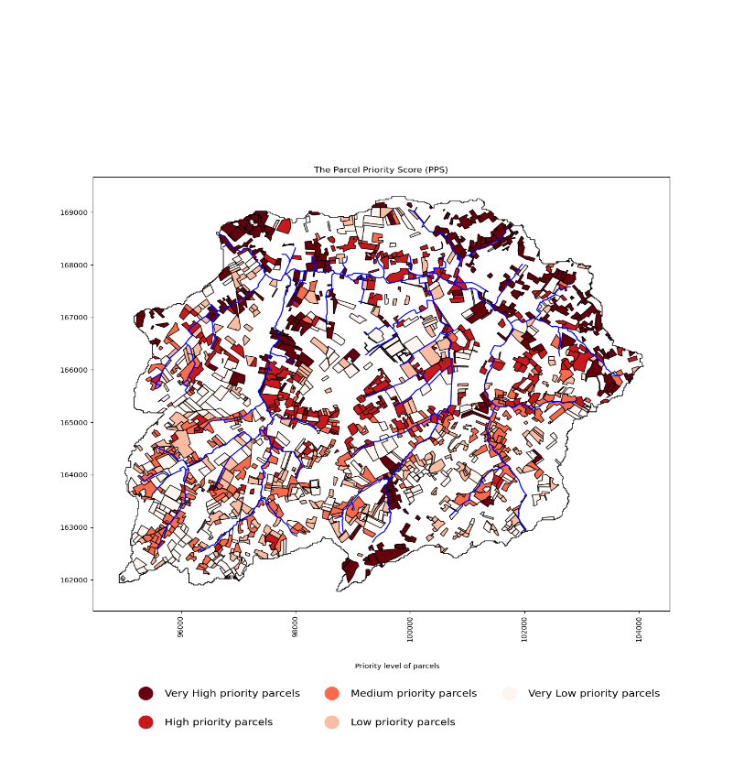

Figure 7‑7: Parcel priorities for decontamination based on the six on-site criteria in Table 7‑3 and the compromise programming approach as elaborated in section 4.3.1. The priority classes are based on the quantiles, where the Very high priority parcels represent the 20% most important parcels.

#### Off-site priority ranking

The ranking of the 1380 parcels according to the Cs-137 flux reduction (CsFR) which their decontamination would cause at the outlet, shows a pattern where most of the high priority parcels are situated close to the river (Figure 7‑8). Moreover, larger parcels are prioritized more than smaller ones because, obviously, remediation of larger parcels reduces the Cs-137 flux at the outlet more than remediation of smaller ones. Given the iterative framework and the order of decontamination based on the established ranking, decontamination of some parcels will have a lower impact on the Cs-137 flux at the outlet than the un-intervened situation.

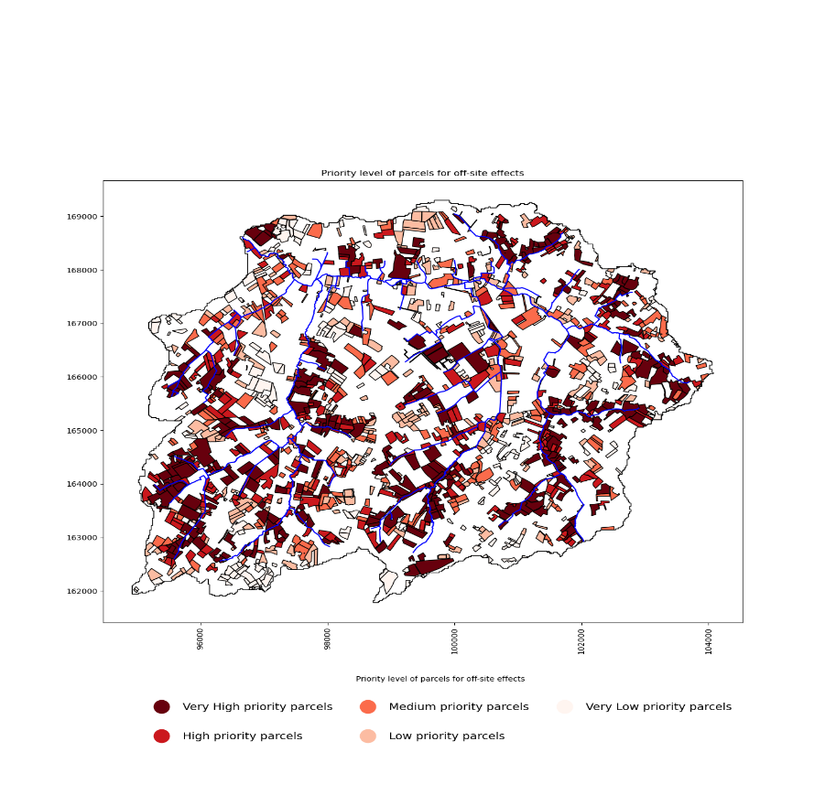

Figure 7‑8: Parcel priorities for decontamination based on one off-site criterion, i.c. the reduction of Cs-137 flux a the outlet, using the approach elaborated in section 7.3.4. The priority classes are based on the quantiles, where the Very high priority parcels represent the 20% most important parcels.

#### Integrated on & off-site criteria priority ranking

The on-site and off-site priorities for decontamination show different pattern compared to using only on or off-site criteria (

Figure 7‑7 and Figure 7‑8). Combining both priorities with equal importance, as described in 7.3.5, results in the priority pattern in Figure 7‑9. Many but not all parcels close to the river system belong to the high priority classes.

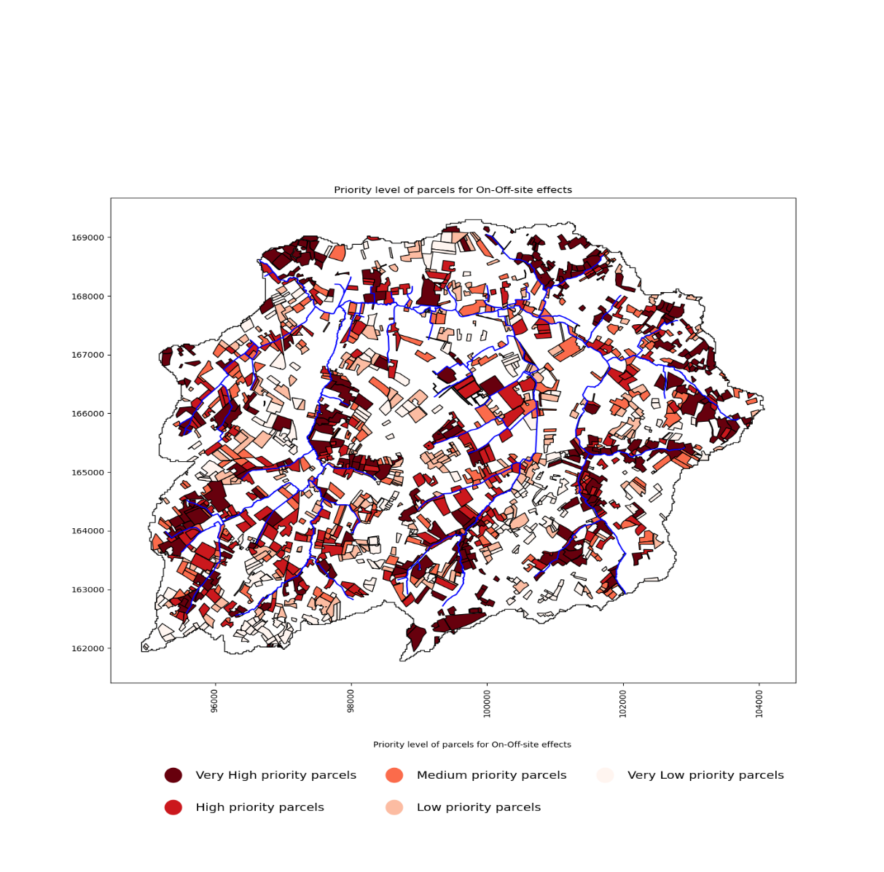

Figure 7‑9: Parcel priorities for decontamination based on the on and off-site criteria using the approach elaborated in section 7.3.5. The priority classes are based on the quantiles, where the Very high priority parcels represent the 20% most important parcels.

### Comparison of the priorities using difference maps between the three priority scenarios

The difference maps in Figures 7-11 – 7-13 show the increased or delayed priority class (20% quantile) for a parcel based on the used criteria. If a value is positive, the parcel receives a lower priority compared with the initial ranking, a negative value points to an increased priority. In Figure 7-11, positive values resemble parcels that are more important when considering on-site criteria in comparison with off-criteria. Different patterns can be noticed from Figure 7-11, parcels close to the river tend to have negative values and larger parcels in the south receive positive values. Figure 7-12, tend to have more zero values, however, similar pattern as Figure 7-11 can be noticed. Figure 7-13, shows even more low values, meaning that there is relative less difference between the on & off-site criteria and the off-site criteria.

Figure 7‑10: Difference in per parcel priority ranking considering off-site criteria only on the one hand and on-site criteria only on the other hand.

Figure 7‑12: Difference in per parcel priority ranking considering on & off-site criteria on the one hand and off-site criteria only on the other hand.

Figure 7‑11: Difference in per parcel priority ranking considering on & off-site criteria on the one hand and on-site criteria only on the other hand.

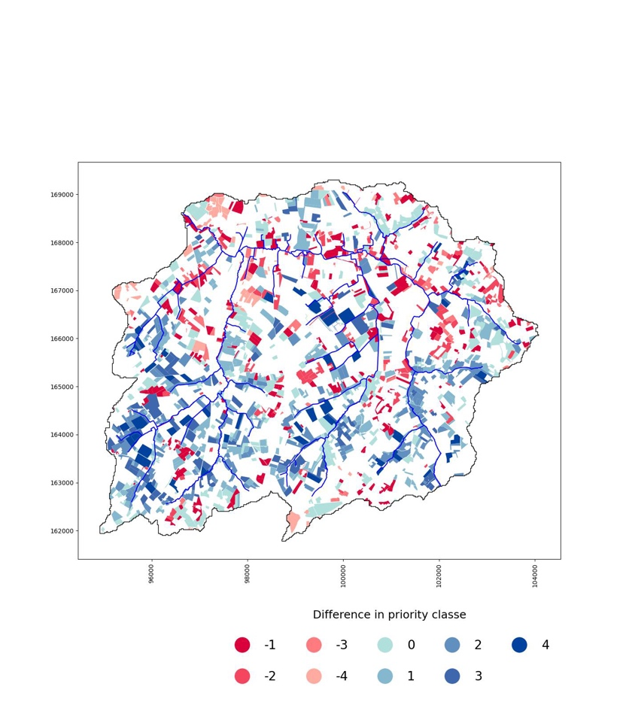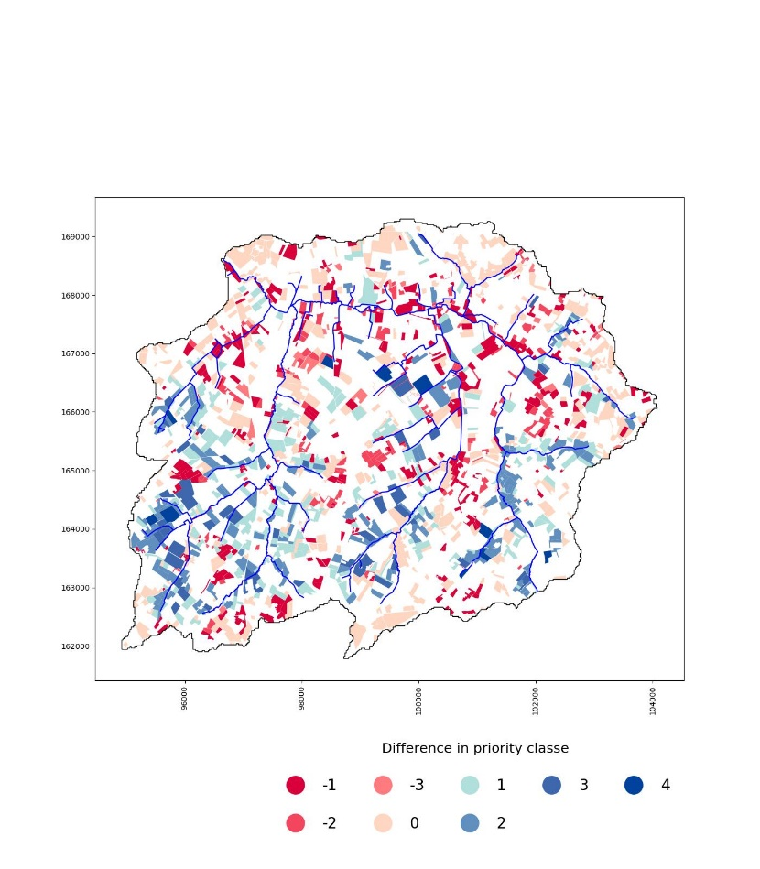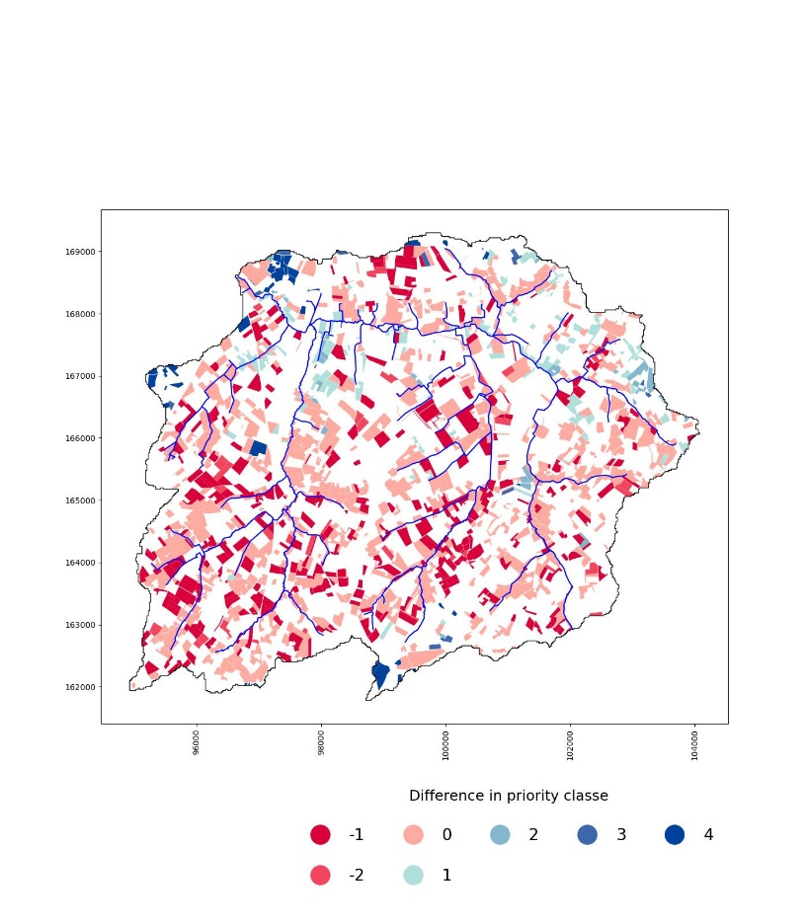

### Timing of remediation in the presence of an annual budget constraint

#### Timing of parcel remediation based on on-site ranking

Using the parcel priority score, based on the on-site criteria, a 5 year remediation scheme constrained by an annual budget of 3 million euro was created. Figure 7‑11 shows that there is a tendency to remediate parcels in the north of the catchment first. Account was taken of the fact that topsoil removal does not only lower the contamination but also increases the sediment production due to the removal of the vegetation. To illustrate these coupled impacts, both the results in terms of the annual Cs-137 flux reduction as well as of the annual sediment increase are provided in Table 7‑4. The remedial efforts result in a decrease of the Cs-137 flux of 71% after the 5 years. Topsoil removal on all 1380 parcels within the catchment is predicted to increase the sediment quantity at the outlet to increase with 111% (18 643 ton). The first year a 27% increase of sediment flux at the outlet is predicted, rapid afforestation after the remediation can mitigate this increase (see Chapter 6). During the remediation process 4695 kBq will not reach the outlet due to the remedial efforts.

Table 7‑4: Annual reduction in Cs-137 flux [kBq] and in sediment quantity [ton] resulting from the execution of the 5 year topsoil removal plan for Maarkebeek elaborated considering the on-site criterion only. The baseline SY for Maarkebeek catchment is 16 857 tons year-1 and the Cs-137 flux in the year after contamination is 9 876 kBq.

|  |  |  |  |  |  |
| --- | --- | --- | --- | --- | --- |
|  | Year 1 | Year 2 | Year 3 | Year 4 | Year 5 |
| Cs-137 flux reduction [kBq] | 1452 | 1750 | 1107 | 320 | 66 |
| Sediment quantity reduction [ton] | -4586 | -5561 | -6055 | -2000 | -441 |

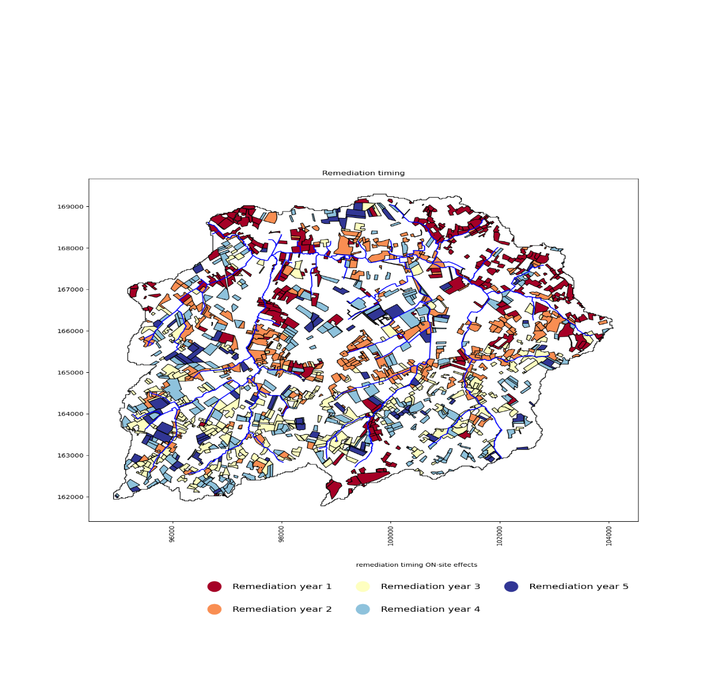

Figure 7‑11: Timing of parcel remediation timing based on the on-site priority and an annual budget constraint of 3M€.

#### Timing of parcel remediation based on off-site ranking

Using the priority scores based on the off-site criterion, a 5 year remediation scheme constrained by an annual budget of 3 million euro was created (Figure 7‑12). It shows that there is a tendency to remediate larger fields close to the river in the first years while in year 5 parcels positioned remotely from the rivers are to be decontaminated.

Compared to the on-site based timing from Table 7‑4, the CsFR in the first year is increased with 149%. Simultaneously a decrease of the Cs-137 flux reduction over the years is found, supporting the fact the most contributing parcels are decontaminated first and the presence of natural radioactive decay. However, an increase of 5880 ton of sediments can be expected to enter the river system in the first year compared to the remedial efforts based on the on-site criteria. Consequently, the first year a 62% increase of sediment flux at the outlet is predicted compared to the initial situation. During the remediation process 5034 kBq will not reach the outlet due to the remedial efforts, the prioritization of off-site criteria reduces the total amount of Cs-137 flux to the outlet.

Table 7‑5: Annual reduction in Cs-137 flux [kBq] and in sediment quantity [ton] resulting from the execution of the 5 year topsoil removal plan for Maarkebeek elaborated considering the off-site criterion only. The baseline SY for Maarkebeek catchment is 16 857 tons year-1 and the Cs-137 flux in the year after contamination is 9 876 kBq.

|  |  |  |  |  |  |
| --- | --- | --- | --- | --- | --- |
|  | Year 1 | Year 2 | Year 3 | Year 4 | Year 5 |
| Cs-137 flux reduction  [kBq] | 3619 | 1110 | 273 | 32 | 0 |
| Sediment quantity reduction [ton] | -10 466 | -5 574 | -2 162 | -432 | -9 |

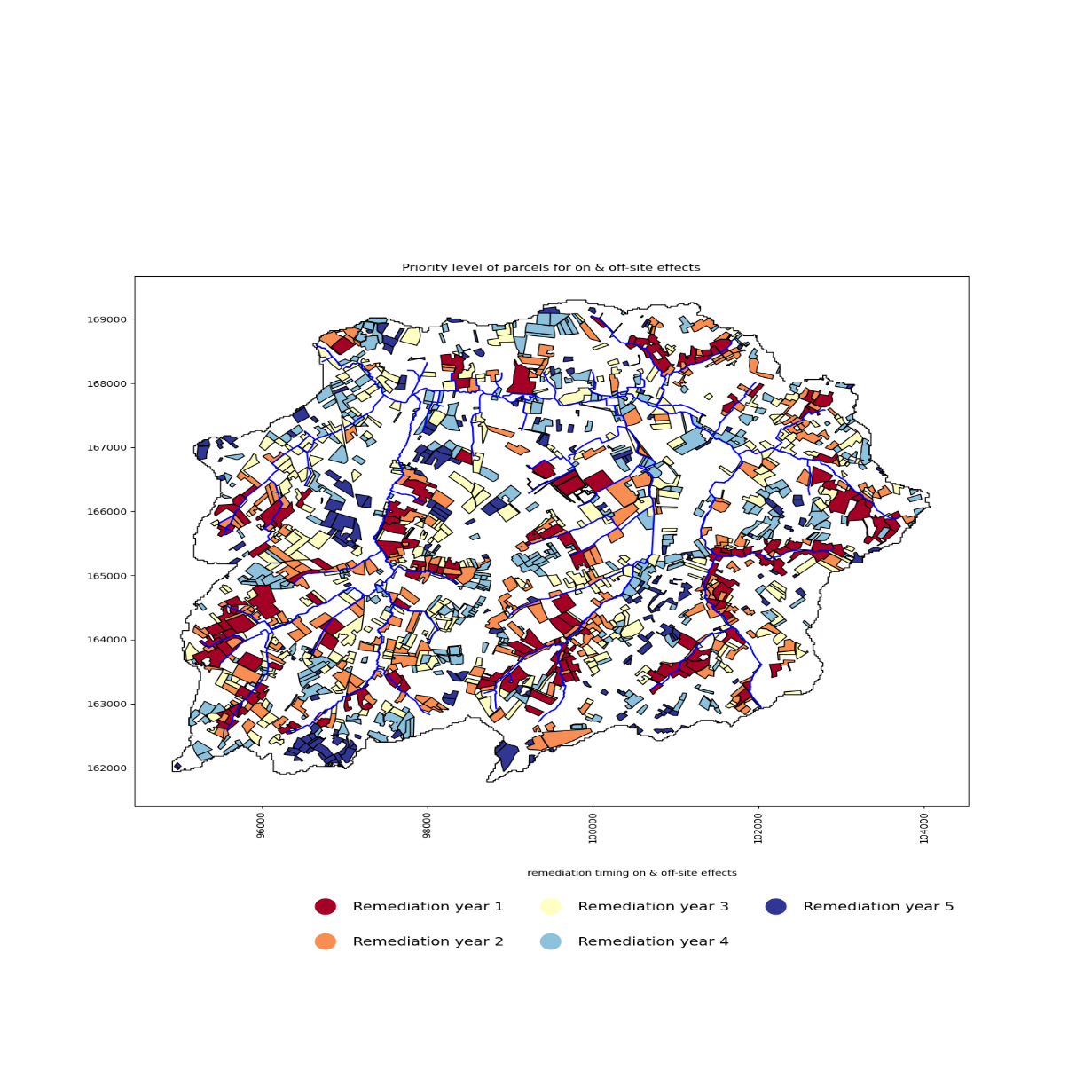

Figure 7‑12: Timing of parcel remediation timing based on the off-site priority and an annual budget constraint of 3M€, using from the approach elaborated in section 7.3.6.

#### Timing of parcel remediation based on integrated on & off-site ranking

Using the combined priority scores for the on and off-site criteria, a 5 year remediation scheme for an annual budget of 3 M€ was created (Figure 7‑13). With equal weights between on and off-site priority scores. The annual impacts of the remediation guided by on & off-site criteria are shown in Table 7‑6. Compared to the ranking based on solely on-site criteria or off-site criteria, the Cs-137 flux is respectively increased with 108% and reduced with 17% for the first year.

Table 7‑6: Reduction in Cs-137 flux [kBq] and sediment quantity [ton] on annual basis because of the remedial efforts based on priorities from the on & off-site criteria.

|  |  |  |  |  |  |
| --- | --- | --- | --- | --- | --- |
|  | Year 1 | Year 2 | Year 3 | Year 4 | Year 5 |
| Cs-137 flux reduction  [kBq] | 3014 | 2437 | 600 | 97 | 6 |
| Sediment quantity reduction [ton] | -9370 | -6214 | -2515 | -507 | -38 |

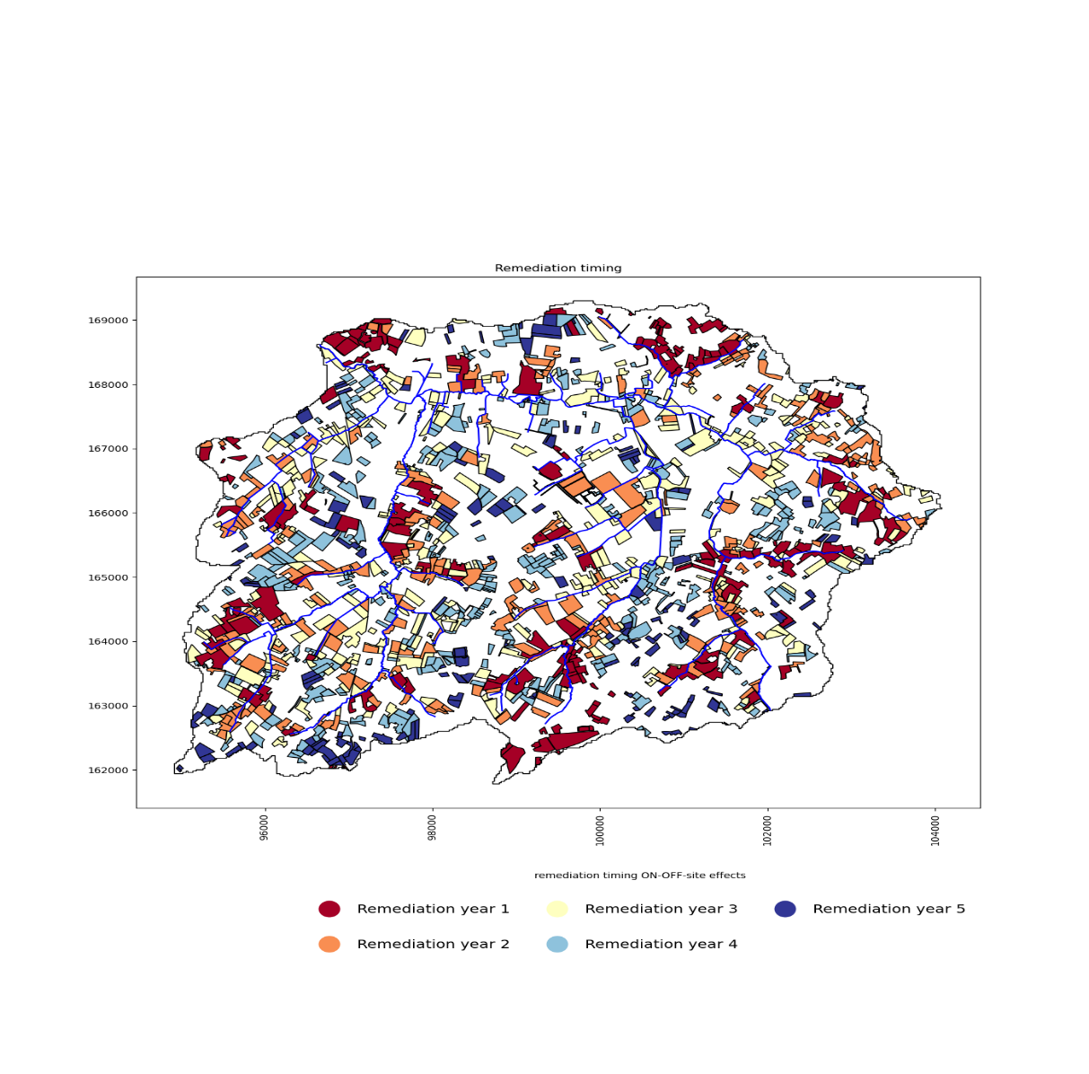

Figure 7‑13: Timing of parcel remediation timing based on the on- and off-site priorities and an annual budget constraint of 3M€, using the approach elaborated in section 7.3.6.

### Parcel priority ranking considering the minimisation of recontamination

In the previous remedial schemes, the off-site impact of a given parcel is expressed as the reduction of Cs-137 flux at the outlet of the catchment after intervention on that parcel. However, the objective of remediation can be broadened from maximizing the reduction of the Cs-137-contribution to the outlet, to also minimizing recontamination of already cleaned parcels. In Figure 7‑14, the same annual budgets as before are used, however, the off-site impact is determined by the sum of the Cs-137 flux at the outlet cell and at all already cleaned cells.

The resulting timing of remediation is different for some parcels, compared to Figure 7‑13, due to the introduction of the minimization of recontamination. The parcels to be decontaminated in the initial year are identical for both off-site receptors, however, in the following years differences occur. These differences can be explained by the model attempting to reduce the Cs-137 at the previously cleaned parcels’ cells and so minimize recontamination. It can be noticed, that parcels uphill of to the parcels remediated in year 1, are remediated faster compared to the previous remedial scheme.

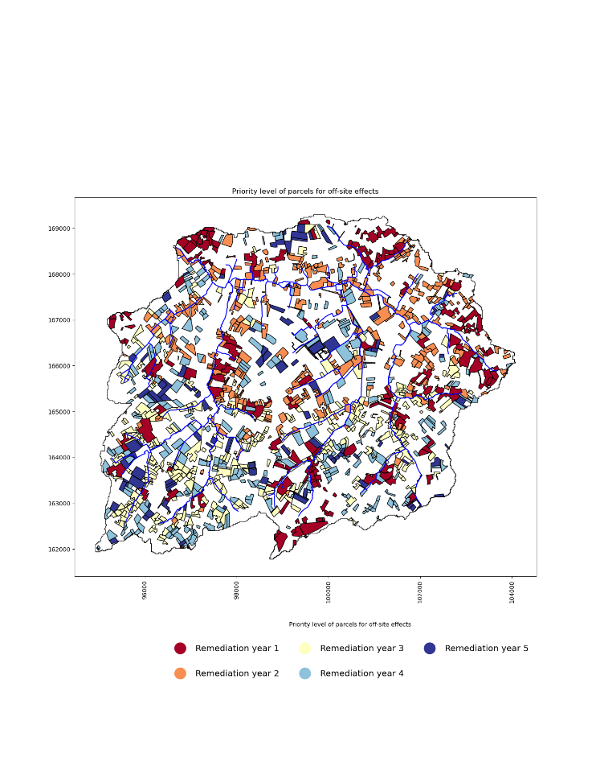

Figure 7‑14: Timing of parcel remediation timing based on the on site priorities, the off-site priorities in the presence of multiple receptors (catchment outlet and already decontaminated parcels) and an annual budget constraint of 3M€, using the approach elaborated in section 7.3.6.

## Discussion and conclusion

The priority of agricultural parcels contaminated with Cs-137 after a nuclear accident for remediation depends upon the nature of the criteria considered and upon the available financial budgets. For a case study encompassing the Maarkebeek catchment in Belgium, a hypothetical spatially variable Cs-137 deposition pattern and topsoil removal as the remediation technique. The overall remediation efforts will reduce the Cs-137 flux at the outlet by 71%, but this will be accompanied by a 111% increase in sediment quantity.

Considering only the on-site criteria of both the cost and benefit types, including the benefit criterion 'level of contamination,' results in the most severely contaminated parcels receiving the highest priority. In case modelled export of eroded soil or export of particulate Cs-137 through the outlet of the catchment is taken as the sole off-site cost criterion, parcels close to the river system are ranked higher. We demonstrate that on-site and off-site priority rankings can be weighted and combined to yield a spatial remediation scheme that considers both types of criteria. The possibility to adjust the weights for both priorities will allow the decision maker to choose the importance of on- versus off-site impacts. Further, it is important for decisionmakers to make sure, some criteria are not taken into account in both the on-site as well as the off-site criteria. Within this manuscript, the on-site criteria ‘Distance to river’ and the off-site criterion can be considered as capturing similar information. However, due to the high number of on-site criteria and the low importance of distance to river, this is not seen as a problem. The weights should be determined by the decision makers and a sensitivity analysis could elaborate more on the impacts of different settings. Currently a weighted linear combination is used for the aggregation, however, different other techniques could be implemented (see 2.4.5).

In case annual budgets are to be respected, the remediation scheme extends over multiple years and becomes spatio-temporal. Due to the natural decay of the Cs-137 contamination and due to the spatial interaction, that characterizes the flow of (contaminated) sediment towards the outlet of the catchment, the priority given to parcels for remediation according to the multi-year remediation plans differs considerably with the priority assigned in the atemporal remediation schemes. Within the first year, using the 3M€ budget, 14.7 % of the Cs-137 flux will be reduced. However, adressing remediation from the perspective of only off-site criteria, will lead to a reduction of 36.6 % or a 149% increase in Cs-137 flux reduction efficiency in the initial year compared to schemes based on only on-site criteria. However, the increase of 9 807 tons of sediments due to the remedial efforts, is a clear indicator for the need of post-remediation measures. In addition, the reduced vegetation after the decontamination interventions, will result in a large (111%) increase in sediment reaching the outlet over 5 years. The application of rapid afforestation after topsoil removal is an option to reduce this negative impact, as was suggested in chapter 6.

Within the current implementation larger parcels, with a higher Cs-137 flux contribution will be prioritized over smaller ones. Although, this is a simplification where smaller parcels could be more important based on the potential reduction per m2, however, it fits in the philosophy to intervene on larger areas at the same time to reduce the cost and increase the feasibility.

With multi-year remediation, the risk for recontamination of previously decontaminated parcels is at stake. We showed that we can build the off-site priority ranking of parcels considering not only the outlet of the catchment as the receptor of interest but also the already decontaminated parcels. In this way more parcels away from the river system receive higher priority for decontamination to take away the source of recontamination of more downstream parcels.

The building blocks of the toolbox developed to generate the optimised spatial and spatio-temporal schemes for parcel remediation are GIS, MADM (Compromise Programming and Simple Additive Weighing), a Sediment Production and Transport Model (CAMF) and a Sediment Concentration Model for Cs-137.

We acknowledge that the proposed procedure can be further extended to account for alternative remediation techniques (e.g., ploughing techniques), uncertainties in the on-site, off-site and combined priority calculations and for the need to spatially and temporally clusters of parcels and associated remediation technique for economic and pragmatic efficiency reasons.

# Conclusions and outlook

## General conclusions

In Chapter 1, six research questions were put forward, contributing to the development of a framework meant to improve the planning of the post-accident remediation of agricultural parcels contaminated with Cs-137 in terms of where, how, and when to remediate. Four foundational dimensions were used to shape the research questions and related chapters: Spatial, Temporal, Type of decision criteria, and Uncertainty.

The spatial dimension reflects the variety of geographically defined decision alternatives. First and foremost, the spatial decisions needed in soil remediation come in the form of "Where to act?" where the alternatives are potential locations (e.g., ‘parcels’) for intervention. Also, the "How to act? The question is positioned under the spatial dimension since it deals with the alternative types of potential intervention for specific locations. Another expression of the spatial dimension is the spatial (and temporal) clustering of locations for intervention to achieve economies of scale.

To rank locations according to multiple criteria, MCDA typically uses multiple on-site attributes, i.e., attributes informing about the state of the considered locations. However, due to the soil-bound, moving nature of the RC-contamination off-site criteria is also important. One is the amount of contaminated detached sediment that accumulates at some locations of interest in a hydrological catchment. Incorporating such off-site attributes requires an iterative approach to ensure that the spatial interaction (due to flow) is properly considered.

While addressing the temporal dimension in soil remediation, it was observed that most MCDA-based studies look at remediation as a decision independent of time. However, introducing periodic (e.g., annual) budget constraints (financial labour, etc.) in large-scale projects transforms the remediation planning into an issue that returns a multi-period scheme, where time is implicitly considered. Moreover, time can be explicitly incorporated into the planning by considering remedial trajectories as alternatives, through which predefined sequences of remedial actions are evaluated and ranked. Since individual remediation actions are combined in multi-period remedial trajectories, the number of such combinations can be very high. Therefore, approaches that limit computational complexity are required, especially when the number of contaminated parcels is large and the planning horizons are long.

Lastly, the inherent presence of uncertaintyin evaluating the attributes of the alternatives and in the weight setting leads to the need for extensive uncertainty analysis in decision-making. Relying only on a deterministic method without considering uncertainty will likely give the stakeholders a false sense of confidence.

Despite an extensive literature review (Chapter 2), no decision support system was found to tackle all these dimensions in planning soil remediation. With the research described in chapters 3 to 7, we aimed to contribute to conceptualizing and implementing spatio-temporal planning frameworks capable of combining on-site and off-site criteria and leading to optimized spatio-temporal remediation schemes considering uncertainty. Whereas we deal with remediation schemes in response to large-scale soil contamination with radionuclides affecting food and agriculture, we claim that the concepts and tools are generic, transferable and useful for different types of soil contamination (e.g., PFAS). Although the concepts are currently developed to deal with one contaminant, many soil contaminations are characterized by a complex set of interacting pollutants.

In the following paragraphs, a final discussion is devoted to the research questions and the lessons learned.

In the following paragraphs, a final discussion is devoted to the research questions and the lessons learned.

### MCDA as framework for soil remediation

*RQ 1: What is the current state of the art regarding multi-criteria decision-making systems used for optimizing the remediation of polluted soils?*

In Chapter 2, MCDA was found to be an applicable framework for supporting soil remediation on a local scale, i.e., for selecting optimal remedial technology for a specific site, and on a regional scale, through optimal site selection. However, four major gaps were identified in the reviewed implementations of MCDA for supporting soil remediation: (i) A lack of inclusion of social criteria, (ii) A lack of early stakeholder engagement, (iii) A mismatch between weighting and aggregation methodologies; and (iv) A lack of sensitivity analysis, within the. Although the MCDA framework is praised for including difficult-to-quantify criteria (e.g., social aspects), Chapter 2 revealed a low adoption of social indicators within the case studies. A potential reason for the low adoption is the difficulty of rating these criteria. To overcome this difficulty, a methodology to transform linguistic scorings into fuzzy numbers within ordinal qualitative scales for the evaluation of criteria or weight settings was proposed in Chapter 3. The linguistic scales are easy to use because words are more natural than numbers to represent the preferences of people (Teigen, 1988; Zimmer, 1983).

Further, the MCDA framework provides the opportunity to consider different, potentially contrasting views of stakeholders. It provides opportunities to build common belief structures and find consensus on the problem structure (Gamper and Turcanu, 2015). However, from our review, it became clear that there is still a gap between the possibility of including stakeholders and doing so in practice. The engagement of stakeholders from the start allows for taking into account specific knowledge and insights to find innovative solutions aligned with the community’s needs (Muro et al., 2012). In addition, including the local community in the decision-making process is also justified from an ethical point of view since the decisions will affect the lives of their members in the first place (Oughton, 2013).

An example of this can be found in Chapter 5, where compensation for farmers whose parcels are contaminated and hence are not productive is considered. Stakeholder engagement creates a form of ‘Buy-in’ into the project and is imperative for these stakeholders' eventual implementation and adoption of the MCDA outcome. A possible reason for the limited incorporation of stakeholders in the reviewed case studies is the difficulty of assigning preferences to criteria within complex problems like soil remediation (Promentilla et al., 2008). However, the use of the previously mentioned linguistic approach could facilitate this. Another possible reason for not including multiple stakeholders is the difficulty of achieving consensus between all the decision-making groups. In Chapter 3, a potential framework to include diverging views on the criteria weight setting was proposed using merged triangular fuzzy numbers (TFN).

In chapters 4, 5, and 7, the applied MCDA uses a distance-based aggregation method (CP). However, more complex aggregation methodologies exist and could be beneficial. The CP methodology has a compensatory nature, leading to weak sustainability. In comparison, techniques like PROMETHEE or ELECRTEE are outranking techniques and result in a strong sustainability ” (Pearce et al., 2006).

### Uncertainty within the MCDA framework

*RQ 2: What is the individual and combined effect of (i) uncertain criteria weights, (ii) uncertain criteria scores, and (iii) disagreement between decision makers on the ranking of alternative soil remediation technologies and, hence, on the decision power of that ranking?*

Although a sensitivity analysis is part of the generic MCDA workflow, Chapter 2 revealed a low adoption rate within the reviewed case studies. The need for a structured sensitivity analysis is important to understand and further investigate the impact on the ranking of the considered alternatives of uncertainty on criteria scores or weights. In Chapter 3, the impact of increasing the amount of uncertainty using TFN was studied. It became clear that the impact of uncertainty on the decision power cannot be ignored. A deterministic MCDA not considering uncertainty is likely to give a false sense of confidence in the outcome to the stakeholders. JRODOS is one of the existing DSS which do include possibilities for visualizing and communicating the uncertainty on the outcome to the decision makers (Müller et al., 2020). As expected, increasing the sources of uncertainty will lead to more fuzzy rankings and less straightforward ranking of alternatives. The incorporation of merged fuzzy numbers, due to disagreement between stakeholders, is a much more robust methodology to aggregate the views between stakeholders. We conclude that the methodology which we propose, i.c. linguistic evaluation scales and corresponding fuzzy numbers to incorporate vagueness and uncertainty in the decision process is helpful and is a way to enhance the incorporation of sensitivity analysis within the MCDA workflow to support soil remediation.

### Overcoming poor feasibility of spatially distributed remedial actions

*RQ 3: How to spatially cluster contaminated parcels to increase remediation efficiency without and with a given annual financial budget?*

Proposing spatio-temporal remedial plans with parcels as the unit of remediation results in very complex spatial and temporal patterns for remediation. This is explained by the spatial variability of the scores of the considered criteria, e.g. level of contamination distance to urban infrastructure. On the one hand, this is a clear indicator that an sDSS can be useful for decision makers to recognise the complexity of sound planning of remediation. On the other hand, it raises the question of whether the resulting optimal parcel-based remedial schedules are feasible to implement. The clustering of individual parcels into larger, homogeneous, actionable units is likely to improve feasibility and reduce the cost of remediation, especially when interventions are costly and technically challenging to perform. In Chapter 4, a spatio-temporal clustering approach under a budget constraint was presented to determine homogenous clusters of parcels with associated compromise intervention types to reduce the cost of remediation while still attaining near-to-optimal effectiveness. The clustering relies heavily on a spatio-temporal MADM considering the Parcel Priority Score (PPS) and Action Priority Score (APS) of each parcel. Therefore, the determination of these scores should be done with great care. The specific implementation choices, applicable criteria and weight setting should not only be the work of experts but it is highly suggested to take into account all stakeholders to ensure a broadly supported remediation scheme, as was suggested in Chapter 2. We used compromise programming (CP) with an Euclidean distance measure to compute PPS and APS, but other distance metrics, like the Manhattan distance, are possible. The choice of distance metric will affect the outcome, so should be regarded with care as they can impact the final ranking (Kizielewicz et al., 2021). The similarity threshold controls the allowed variation within the cluster while the cluster is growing cluster. Increasing the threshold allows for clusters with more heterogeneous attributes to be formed and results in more deviation from the optimal per-parcel solution. However, larger clusters give rise to lower operational costs, resulting in cheaper and faster remediation due to economies of scale. Hence, a trade-off between costs and optimality should be made by the decision-makers.

In Chapter 4, we made the choice to use parcels, polygons, as the unit for decision-making, as this would be more natural than grid cells to decision-makers and stakeholders. However, polygon-based entities in databases could potentially suffer from topological errors. The morphologic tessellation approach used for determining neighbouring parcels is less impacted by these topological errors, making it interesting for automation for larger regions and regions with less or lower resolution spatial data availability. The budget constraint is financial, however, constraints in labour or machinery availability can be considered in a similar way.

### Taking into account time within the remediation decision process

*RQ 4: How to optimally design temporal sequences of elementary remediation actions considering on-site criteria and a given annual budget?*

Acknowledging the complexity of setting priorities about where, how and when to allocate resources for the remediation of large numbers of contaminated parcels spread out in large territories, this dissertation attempts to incorporate all three question types in the MCDA. Chapter 4 implicitly takes into account time by introducing a budget constraint limiting the number of interventions in the landscape per period. In the next period, the decision variables change due to processes like radioactive decay, hence, the clustering of parcels, assignment of intervention type and ranking of the clusters may change. In chapter 5, time is considered in a more explicit way by introducing the concept of a remedial trajectory. A remedial trajectory is a sequence of elementary remedial actions combined in a multi-period remediation strategy. Within a trajectory, time is explicitly taken into account from the start of the decision process, resulting in a model that reconciles the remediation and economic aspects of remediation. The concept’s main novelty is its ability to find optimal multi-period sequences or trajectories of remedial actions from a limited set of predefined remedial actions, where column generation is used to extend the candidate set of the remedial trajectories while keeping the computational complexity limited. The latter is especially important in the context of large-scale nuclear disasters where a large number of parcels are contaminated, and due to the nature of the contamination and remediation practices, long planning horizons are needed. The model allows for the pursuit of different objectives: (i) minimize the cost, (ii) minimize the loss of production years, (iii) minimize the number of years till full production or (iv) minimize accumulated priority. Moreover, the methodology and size of the farmer compensation should be carefully considered because it will impact the required budget. For the Maarkebeek case study, the compensation amounted to as much as 10 % of the total remediation cost. However, when the high cultivation-specific compensation was chosen, the available budget became insufficient for the complete remediation of the watershed.

For the Maarkebeek catchment, with 1380 parcels to be remediated within a period of a maximum of 5 years, remediation not considering compensation to farmers, would cost 3 966 238 € and the catchment would be in full production after 4 years, with a cumulated loss of 1190 production years. In contrast, when no active remediation is done, it would take 90 years for the catchment to resume full agricultural production and cost 3 715 980 € in compensation to farmers alone. When column generation was used, the optimal remedial scheme resulted in 953 lost production years and the accumulated priority score was 3682, a 19.7% reduction compared to the initial solution without column generation. While the use of Integer Programming is needed to allow allocation of 1 trajectory per parcel, Linear Programming (LP) would be beneficial from many perspectives (e.g., computational efficiency). A hybrid form in which a trajectory is assigned to each parcel in the first year is needed, whereas for the following years, trajectories could be assigned to portions of parcels, which could be beneficial. Such a system would allow for a shift to more adaptive remediation schemes, in which decisions can be reviewed and adjusted later in the process after gathering more data on the alternatives in the field and consequently adapting the decision matrix for subsequent decisions.

### Off-site characteristics of remediation

*RQ 5: How to address off-site criteria in the design of remediation plans? Can the CAMF approach (Cellular Automata based heuristic for Minimizing Flow, Vanegas et al., 2008) be used to incorporate sediment loss and flow after decontamination in the where- and how-to-act questions?*

*RQ 6: How to take account of both on- and off-site criteria and an annual budget constraint in the design of spatio-temporal schemes for remediation, considering also the risk of re-contamination due to sediment flows?*

A procedure to model and reduce the off-site impacts of remediation of agricultural soil contaminated with Cs-137 was presented in Chapter 6, along with a case study covering the Niida catchment in the Fukushima province in Japan. The decontamination through topsoil removal in the Niida catchment, coordinated by the Japanese government in 2012-2014, led to a severe post-intervention increase in soil erosion and sediment delivery into the rivers. The procedure we developed makes use of the iterative optimization framework CAMF. We demonstrated the capability of the procedure to identify locations within the decontaminated zones for which covering the soil by means of mulching or rapid afforestation would have led to the highest possible reduction of sediment export at the catchment outlet. When using CAMF to spatially target afforestation, selecting the 1000 best cells (3.4% of candidate cells) would have resulted in a 15.4% decrease in the sediment flux compared to 0.8% when selected randomly. The reason for this difference in sediment reduction between spatially random and spatially targeted afforestation is a clear indicator that the effectiveness of interventions is highly location specific. Further, an iterative framework is needed to account for spatial interaction effects between cells.

In Chapter 7, a similar approach was used to determine the off-site impact of decontamination by means of topsoil removal in the Maarkebeek catchment. The framework was used to select 276 priority parcels per iteration for remediation, not cells, using the Cs-137 flux reduction at the outlet of the catchment as the maximisation objective. Topsoil removal on all 1380 parcels within the catchment is predicted to increase the sediment quantity at the outlet by 111%, showcasing the need for post-accident management intervention like rapid afforestation.

The remediation priority scheme considering either only on-site, only off-site or the combination of on- and off-site criteria are compared. The remediation scheme based on only off-site criteria would result in a reduction of 71 % in the C-137 flux at the outlet after 5 years, despite a large increase in sediment production due to the topsoil removal compared to only on-site criteria. Within the first year, using a 3M€ budget, the Cs-137 flux is 14.7% lower when considering on-site criteria only. Addressing the remediation from the off-site perspective only leads to a reduction of 36.6 %, meaning a 149% increase in Cs-137 flux reduction efficiency. We conclude that due to the spatial variability of contamination, the land cover and the spatial interaction phenomenon, the effectiveness and efficiency of interventions are highly location-specific and can benefit significantly from an optimisation framework like CAMF.

## Outlook

### Strengths and limitations of the research and perspective for future research

Throughout the chapters of this manuscript, it was shown that MCDA provides a flexible framework to address the where, how and when questions and come up with a parcel-based spatio-temporal scheme for remediation of agricultural land contaminated with Cs-137 to a level that agricultural food production is affected. A modular approach was used designing the current system making it easily adaptable to other soil-bound pollutants. The integration of all four dimensions in 1 framework is unique in the field of optimizing environmental management of soil-bound pollutants. The current framework and its components are designed for a single contaminant pollution, which can be a simplification of a real-world polluted site, which can be very complex. Decision-makers should be aware of this and more research to confirm the potential extension to multi-contaminants is needed. We showed that the MCDA framework is capable of handling the four stated dimensions of the problem: spatial, temporal, decision criteria and uncertainty. However, not all aspects have been dealt with together. Hence, further work is necessary. An overview is given in the following paragraph.

#### Decision criteria

At the foundation of the MCDA system applied in this study are the on-site decision criteria scores (PPS and APS). Both are calculated using the CP methodology, as discussed in Chapters 2 and 3. The differences found in Chapter 7 for the priority of the remediation schemes considering on-site, off-site, and on- and off-site criteria combined showed the importance of taking into account both types of criteria. However, the integration of the off-site impact in the concept of remedial trajectories is likely to be very difficult due to the iterative process that is required to deal with the spatial interaction for the off-site effects. Interventions on a specific parcel potentially impact the off-site impact of other parcels, causing changes in their off-site criteria scores. Whether IP can take this complexity into account is not clear at this point.

#### Spatial dimension

The list of elementary remedial actions considered throughout the manuscript was retrieved from reports describing the remedial efforts after the Chornobyl and Fukushima disasters. It is not excluded, however, that other remedial techniques may be more interesting in different climates. Therefore, research on other techniques should be performed considering emergency preparedness. Furthermore, the combination of multiple remedial techniques within the same year should be included, such as deep ploughing and the addition of K fertilizer. In addition, the immediate incorporation of post-decontamination measures (e.g., afforestation, semi-permanent herbaceous vegetation) within the evaluation of remedial actions could directly show the positive impact they can have. The concepts of clustering parcels into larger remedial units (as done in Chapter 4) can be further developed for trajectory-based remediation schemes (Chapter 5) by using multiple constraints in the formulation of the IP.

#### Uncertainty

Uncertainty related to on-site criteria scores was assessed in Chapter 3, but future research should consider uncertainty related to off-site criteria (Chapters 6 and 7). this will need careful investigation of possible interactions between multiple sources of uncertainty and their effect on the robustness of the MCDA. Including a Monte-Carlo simulation in determining the PPS and APS scores within the sDSS will produce stochastic maps of the optimal remedial technique instead of the current deterministic maps. Integrating the uncertainty on criteria scores into the spatio-temporal clustering approach will be challenging.

#### Temporal dimension

To fully integrate the temporal aspect into the sDSS, the current static transfer factor (TF) for determining Cs-137 concentrations in agricultural produce must be modified. Implementing a dynamic module to predict the Cs-137 TF based on the time elapsed after the accident, soil parameters, and climate will improve the dynamic aspect of the sDSS. However, it is essential to implement this without adding too much extra uncertainty to the calculated TF.

# REFERENCES

Abrams, F., Hendrickx, L., Sweeck, L., Camps, J., Cattrysse, D., Van Orshoven, J., 2022a. Accounting for Uncertainty and Disagreement in Multi-criteria Decision Making Using Triangular Fuzzy Numbers and Monte Carlo Simulation: A Case Study About Selecting Measures for Remediation of Agricultural Land After Radioactive Contamination, in: Real Life Applications of Multiple Criteria Decision Making Techniques in Fuzzy Domain. Springer Nature.

Abrams, F., Sweeck, L., Camps, J., Cattrysse, D., Van Orshoven, J., 2022b. Optimizing Remediation of Spatially Dispersed Contaminated Parcels under an Annual Budget Constraint. Int. J. Adv. Softw. 15, 188–199.

Adem Esmail, B., Geneletti, D., 2018. Multi‐criteria decision analysis for nature conservation: A review of 20 years of applications. Methods Ecol. Evol. 9, 42–53. https://doi.org/10.1111/2041-210x.12899

Agentschap Digitaal Vlaanderen, 2014. Digitaal Hoogtemodel Vlaanderen II, DTM, raster, 5 m. [WWW Document]. URL https://www.vlaanderen.be/datavindplaats/catalogus/digitaal-hoogtemodel-vlaanderen-ii-dtm-raster-5-m (accessed 8.4.23).

Alexandrescu, F., Martinát, S., Klusáček, P., Bartke, S., 2014. The Path From Passivity Toward Entrepreneurship. Organ. Environ. https://doi.org/10.1177/1086026614529436

Alvarez-Guerra, M., Canis, L., Voulvoulis, N., Viguri, J.R., Linkov, I., 2010. Prioritization of sediment management alternatives using stochastic multicriteria acceptability analysis. Sci. Total Environ. 408, 4354–4367. https://doi.org/10.1016/j.scitotenv.2010.07.016

Anderson, R., Norrman, J., Back, P.-E., Soderqvist, T., Rosen, L., 2018. What’s the point? The contribution of a sustainability view in contaminated site remediation. Sci. Total Environ. 630, 103–116. https://doi.org/10.1016/j.scitotenv.2018.02.120

Aral, M.M., 2010. Environmental modeling and health risk analysis (Acts/Risk), Environmental Modeling and Health Risk Analysis (Acts/Risk). https://doi.org/10.1007/978-90-481-8608-2

Bage, G.F., Samson, R., Sinclair-Desgagne, B., 2003. A technicoeconomic approach for the selection of a site remediation strategy - part B: Model application. Environ. Manage. 31, 69–78. https://doi.org/10.1007/s00267-002-2672-0

Bai, L., Luo, Y., Shi, D., Xie, X., Liu, L., Zhou, Y., Yan, Z., Li, F., 2015. TOPSIS-Based Screening Method of Soil Remediation Technology for Contaminated Sites and its Application. Soil Sediment Contam. 24, 386–397. https://doi.org/10.1080/15320383.2015.968915

Balasubramaniam, A., Boyle, A.R., Voulvoulis, N., 2007. Improving petroleum contaminated land remediation decision-making through the MCA weighting process. Chemosphere 66, 791–798. https://doi.org/10.1016/j.chemosphere.2006.06.039

Bardos, R.P., Thomas, H.F., Smith, J.W.N., Harries, N.D., Evans, F., Boyle, R., Howard, T., Lewis, R., Thomas, A.O., Dent, V.L., Haslam, A., 2020. Sustainability assessment framework and indicators developed by SuRF-UK for land remediation option appraisal. Remediation. https://doi.org/10.1002/rem.21668

Bates, M., Grieger, K., Trump, B., Keisler, J., Plourde, K., Linkov, I., 2016. Emerging Technologies for Environmental Remediation: Integrating Data and Judgment. Environ. Sci. Technol. 50, 349–358. https://doi.org/10.1021/acs.est.5b03005

Behling, N., Williams, M.C., Behling, T.G., Managi, S., 2019. Aftermath of Fukushima: Avoiding another major nuclear disaster. Energy Policy 126, 411–420. https://doi.org/10.1016/j.enpol.2018.11.038

Behzadian, M., Khanmohammadi Otaghsara, S., Yazdani, M., Ignatius, J., 2012. A state-of the-art survey of TOPSIS applications. Expert Syst. Appl. https://doi.org/10.1016/j.eswa.2012.05.056

Beierle, T.C., 2002. The Quality of Stakeholder-Based Decisions. Risk Anal. 22.

Beinat, E., van Drunen, M.A., Janssen, R., Nijboer, M.H., Koolenbrander, J.G.M., Okx, J.P., Schütte, A.R., 1998. The REC Decision Support System for comparing soil remediation options: A methodology based on Risk reduction, Environmental merit and Costs. NOBIS.

Belton, V., Stewart, T.J., 2002. Multiple criteria decision analysis: An integrated approach, Proceedings - International Conference on Pattern Recognition. https://doi.org/10.1007/978-1-4615-1495-4

BelV, 2017. Guidance on the application of conservative and less conservative approaches for the analysis of radiological consequences.

Betrie, G.D., Sadiq, R., Morin, K.A., Tesfamariam, S., 2013. Selection of remedial alternatives for mine sites: A multicriteria decision analysis approach. J. Environ. Manage. 119, 36–46. https://doi.org/10.1016/j.jenvman.2013.01.024

Bezama, A., Szarka, N., Wolfbauer, J., Lorber, K.E., 2007. Application of a balanced scorecard system for supporting decision-making in contaminated sites remediation. Water, Air, Soil Pollutionsoil polution 181, 3–16. https://doi.org/10.1007/s11270-006-9272-1

Bin, F., Onda, Y., Wakiyama, Y., Taniguchi, K., Hashimoto, A., Zhang, Y., 2022. Persistent impact of Fukushima decontamination on soil erosion and suspended sediment. Nat. Sustain. https://doi.org/10.1038/s41893-022-00924-6

Boardman, J., Vandaele, K., Evans, R., Foster, I.D.L., 2019. Off-site impacts of soil erosion and runoff: Why connectivity is more important than erosion rates. Soil Use Manag. 35, 245–256. https://doi.org/10.1111/sum.12496

Bonano, E.J., Apostolakis, G.E., Salter, P.F., Ghassemi, A., Jennings, S., 2000a. Application of risk assessment and decision analysis to the evaluation, ranking and selection of environmental remediation alternatives. J. Hazard. Mater. 71, 35–57. https://doi.org/10.1016/S0304-3894(99)00071-0

Bonano, E.J., Apostolakis, G.E., Salter, P.F., Ghassemi, A., Jennings, S., 2000b. Application of risk assessment and decision analysis to the evaluation, ranking and selection of environmental remediation alternatives. J. Hazard. Mater. 71, 35–57. https://doi.org/https://doi.org/10.1016/S0304-3894(99)00071-0

Bordogna, G., Fedrizzi, M., Pasi, G., 1997. A linguistic modeling of consensus in group decision making based on OWA operators. IEEE Trans. Syst. Man, Cybern. Part ASystems Humans. 27, 126–132. https://doi.org/10.1109/3468.553232

Borrelli, P., Van Oost, K., Meusburger, K., Alewell, C., Lugato, E., Panagos, P., 2018. A step towards a holistic assessment of soil degradation in Europe: Coupling on-site erosion with sediment transfer and carbon fluxes. Environ. Res. 161, 291–298. https://doi.org/10.1016/j.envres.2017.11.009

Briggs, D., 2009. Risk communication and stakeholder participation in the governance of systemic environmental health risks. Int. J. Risk Assess. Manag. 13, 195–215. https://doi.org/10.1504/ijram.2009.030696

Brook, B. W., Alonso, A., Meneley, D. A., Misak, J., Blees, T., & van Erp, J. B. (2014). Why nuclear energy is sustainable and has to be part of the energy mix. *Sustainable Materials and Technologies*, *1*. https://doi.org/10.1016/j.susmat.2014.11.001

Canadian Nuclear Safety Commission, 2013. Linear-Non-Threshold Model - Canadian Nuclear Safety Commission [WWW Document]. URL http://nuclearsafety.gc.ca/eng/resources/health/linear-non-threshold-model/index.cfm (accessed 3.6.23).

Cappuyns, V., 2016. Inclusion of social indicators in decision support tools for the selection of sustainable site remediation options. J. Environ. Manage. 184, 45–56. https://doi.org/10.1016/j.jenvman.2016.07.035

Castillo-Reyes, G., Estrella, R., Gabriels, K., Van Orshoven, J., Abrams, F., Roose, D., 2022. Selecting cells in a raster database for maximal impact intervention in the presence of spatial interaction: Computational complexity of a Multiple vs. a Single Flow Direction Method. Comput. Geosci. 7735, 0–2.

Cegan, J., Filion, A., Keisler, J., Linkov, I., 2017. Trends and applications of multi-criteria decision analysis in environmental sciences: literature review. Environ. Syst. Decis. 37, 123–133. https://doi.org/10.1007/s10669-017-9642-9

Chartin, C., Evrard, O., Laceby, J.P., Onda, Y., Ottlé, C., Lefèvre, I., Cerdan, O., 2017. The impact of typhoons on sediment connectivity: lessons learnt from contaminated coastal catchments of the Fukushima Prefecture (Japan). Earth Surf. Process. Landforms 42, 306–317. https://doi.org/10.1002/esp.4056

Chartin, C., Evrard, O., Onda, Y., Patin, J., Lefèvre, I., Ottlé, C., Ayrault, S., Lepage, H., Bonté, P., 2013. Tracking the early dispersion of contaminated sediment along rivers draining the Fukushima radioactive pollution plume. Anthropocene 1, 23–34. https://doi.org/10.1016/j.ancene.2013.07.001

Chen, S.S., Taylor, J.S., Baek, K., Khan, E., Tsang, D.C.W., Ok, Y.S., 2017. Sustainability likelihood of remediation options for metal-contaminated soil/sediment. Chemosphere 174, 421–427. https://doi.org/10.1016/j.chemosphere.2017.02.005

Chen, Y., Li, B., 2011. Dynamic multi-attribute decision making model based on triangular intuitionistic fuzzy numbers. Sci. Iran. 18, 268–274. https://doi.org/10.1016/j.scient.2011.03.022

Coenen, F., 2009. Introduction, in: Coenen, F.H.J.M. (Ed.), Public Participation and Better Environmental Decisions: The Promise and Limits of Participatory Processes for the Quality of Environmentally Related Decision-Making. Springer Netherlands, Dordrecht, pp. 1–21. https://doi.org/10.1007/978-1-4020-9325-8_1

Conrad, O., Bechtel, B., Bock, M., Dietrich, H., Fischer, E., Gerlitz, L., Wehberg, J., Wichmann, V., Böhner, J., 2015. System for Automated Geoscientific Analyses (SAGA) v. 2.1.4. Geosci. Model Dev. https://doi.org/10.5194/gmd-8-1991-2015

Danielson, M., Ekenberg, L., 2019. An improvement to swing techniques for elicitation in MCDM methods. Knowledge-Based Syst. 168, 70–79. https://doi.org/10.1016/j.knosys.2019.01.001

Dantzig, G., 1963. Linear Programming and Extensions. Princeton University Press. https://doi.org/10.1017/cbo9780511626371.009

Databank Ondergrond Vlaanderen, 2017. Digitale bodemkaart van het Vlaams Gewest: substraten [WWW Document]. 2017-06-20. URL https://www.vlaanderen.be/datavindplaats/catalogus/digitale-bodemkaart-van-het-vlaams-gewest-bodemtypes (accessed 8.4.23).

Delmas, M., Garcia-Sanchez, L., Nicoulaud-Gouin, V., Onda, Y., 2017. Improving transfer functions to describe radiocesium wash-off fluxes for the Niida River by a Bayesian approach. J. Environ. Radioact. 167, 100–109. https://doi.org/10.1016/j.jenvrad.2016.11.002

Deproost, P., Renders, D., Van de Wauw, J., Van Ransbeeck, N., Verstraeten, G., 2018. Herkalibratie van WaTEM / SEDEM met het DHMV-II als hoogte ­ model. Brussel.

Desmet, P.J.J., Govers, G., 1996. A GIS procedure for automatically calculating the USLE LS factor on topographically complex landscape units. J. Soil Water Conserv. 51, 427–433.

Desrosiers, J., Lübbecke, M.E., 2005. A Primer in Column Gerenation, in: Column Generation. pp. 1–32.

Domingues, G.F., Marcatti, G.E., dos Santos, A.G., Lorenzon, A.S., Telles, L.A. de A., de Castro, N.L.M., Barros, K.O., Gonzáles, D.G.E., de Carvalho, J.R., Gandine, S.M. da S., de Menezes, S.J.M. da C., dos Santos, A.R., Ribeiro, C.A.A.S., 2020. Optimized allocation of forest restoration zones to minimize soil losses in watersheds. J. Environ. Manage. 271. https://doi.org/10.1016/j.jenvman.2020.110923

Dong, Q., Guo, Y., 2013. Multiperiod multiattribute decision-making method based on trend incentive coefficient. Int. Trans. Oper. Res. 20, 141–152. https://doi.org/10.1111/j.1475-3995.2012.00853.x

Dosskey, M.G., 2001. Toward Quantifying Water Pollution Abatement in Response to Installing Buffers on Crop Land. Environ. Manage. 28, 577–598. https://doi.org/10.1007/s002670010245

Estrella, R., 2015. Where to Afforest ?

Estrella, R., Cattrysse, D., Orshoven, J. Van, 2016. An Integer Programming Model to Determine Land Use Trajectories for Optimizing Regionally Integrated Ecosystem Services Delivery. forest 1–26. https://doi.org/10.3390/f7020033

Estrella, R., Vanegas, P., Cattrysse, D., Orshoven, J. Van, 2014. Trading off Accuracy and Computational Efficiency of an Afforestation Site Location Method for Minimizing Sediment Yield in a River Catchment. pp. 94–100.

Evrard, O., Durand, R., Nakao, A., Laceby, J.P., Lefèvre, I., Wakiyama, Y., Hayashi, S., 2020. Impact of the 2019 typhoons on sediment source contributions and radiocesium concentrations in rivers draining the Fukushima radioactive plume, Japan. Académie des Sci. 352, 199–211. https://doi.org/10.5802/crgeos.42

Evrard, O., Laceby, J.P., Lepage, H., Onda, Y., Cerdan, O., Ayrault, S., 2015. Radiocesium transfer from hillslopes to the Pacific Ocean after the Fukushima Nuclear Power Plant accident: A review. J. Environ. Radioact. 148, 92–110. https://doi.org/10.1016/j.jenvrad.2015.06.018

Evrard, O., Laceby, J.P., Nakao, A., 2019. Effectiveness of landscape decontamination following the Fukushima nuclear accident : a review 333–350.

FANC, 2020. Jaarlijkse gemiddelde blootstelling aan ioniserende straling in België [WWW Document]. URL https://fanc.fgov.be/nl/informatiedossiers/wat-radioactiviteit-ioniserende-straling/gemiddelde-blootstelling (accessed 6.19.23).

FAO, ITPS, 2015. Status of the World’s Soil Resources (SWSR) – Main report. Rome, Italy.

FAO, WHO, 2019. Codex Alimentarius.

Fasolo, B., Bana e Costa, C.A., 2014. Tailoring value elicitation to decision makers’ numeracy and fluency: Expressing value judgments in numbers or words. Omega (United Kingdom). https://doi.org/10.1016/j.omega.2013.09.006

Fedrizzi, M., Pasi, G., 2008. Fuzzy Logic Approaches to Consensus Modelling in Group Decision Making., in: Da Ruan, Hardeman F., van der M.K. (Ed.), Intelligent Decision and Policy Making Support Systems. Springer, Berlin, Heidelberg, pp. 19–37. https://doi.org/10.1007/978-3-540-78308-4

Fennessy, M.S., Cronk, J.K., 1997. The effectiveness and restoration potential of riparian ecotones for the management of nonpoint source pollution, particularly nitrate. Crit. Rev. Environ. Sci. Technol. https://doi.org/10.1080/10643389709388502

Fesenko, S., Howard, B.J., 2012. Guidelines for remediation strategies to reduce the radiological consequences of environmental contamination 167.

Fleischmann, M., 2019. momepy: Urban Morphology Measuring Toolkit. J. Open Source Softw. 4, 1807. https://doi.org/10.21105/joss.01807

Fleischmann, M., Feliciotti, A., Romice, O., Porta, S., 2020. Morphological tessellation as a way of partitioning space: Improving consistency in urban morphology at the plot scale. Comput. Environ. Urban Syst. 80, 101441. https://doi.org/10.1016/j.compenvurbsys.2019.101441

French, S., 2002. Evaluation and Decision Models: a Critical Perspective. J. Oper. Res. Soc. 53, 809–809. https://doi.org/10.1057/palgrave.jors.2601380

Gabriels, K., 2021. Considering flood hazard and risk in spatial planning. KULeuven.

Gabriels, K., Willems, P., Van orshoven, J., 2022. An iterative runoff propagation approach to identify priority locations for land cover change minimizing downstream river flood hazard. Landsc. Urban Plan. 218. https://doi.org/10.1016/j.landurbplan.2021.104262

Gamper, C., Turcanu, C., 2015. Multi-criteria analysis: A tool for going beyond monetization? Tools Policy Formul. Actors, Capacit. Venues Eff. 121–141. https://doi.org/10.4337/9781783477043.00017

García-Lapresta, J.L., González del Pozo, R., 2019. An ordinal multi-criteria decision-making procedure under imprecise linguistic assessments. Eur. J. Oper. Res. 279, 159–167. https://doi.org/10.1016/j.ejor.2019.05.015

Geldermann, J., Spengler, T., Rentz, O., 2000. Fuzzy outranking for environmental assessment. Case study: Iron and steel making industry. Fuzzy Sets Syst. https://doi.org/10.1016/S0165-0114(99)00021-4

Gobeyn, S., Van de Wauw, J., De Vleeschouwer, N Renders, D., Van Ransbeeck, N Verstraeten, G., Deproost, P., 2021. Herziening van de neerslagerosiviteitsfactor R voor de Vlaamse erosiemodellering. 44.

Golosov, V., Konoplev, A., Wakiyama, Y., Ivanov, M., Komissarov, M., 2022. Erosion and Redeposition of Sediments and Sediment-Associated Radiocesium on River Floodplains (the Niida River Basin and the Abukuma River as an Example), Behavior of Radionuclides in the Environment III. https://doi.org/10.1007/978-981-16-6799-2_7

Gonze, M.A., Renaud, P., Korsakissok, I., Kato, H., Hinton, T.G., Mourlon, C., Simon-Cornu, M., 2014. Assessment of dry and wet atmospheric deposits of radioactive aerosols: Application to Fukushima radiocaesium fallout. Environ. Sci. Technol. https://doi.org/10.1021/es502590s

Greco, S., Ehrgott, M., Figueira, J.R., 2016. Multiple Analysis Criteria Decision State of the Art Surveys, International Series in Operations Research and Management Science.

Guillevic, J., Croüail, P., Maitre, M., Schneider, T., 2018. Decision processes/pathways. TERRITORIES: Synthesis report of CONCERT sub-subtask 9.3.3.1.

Gupta, D.K., Tiwari, S., Chatterjee, S., Walther, C., 2018. Potassium and its role in cesium transport in plants. Biologia (Bratisl). https://doi.org/10.2478/s11756-018-0110-x

Gupta, D.K., Walther, C., 2017. Impact of Cesium on Plants and the Environment, Impact of Cesium on Plants and the Environment. https://doi.org/10.1007/978-3-319-41525-3

Gurobi Optimization, L., 2020. Gurobi Optimizer Reference Manual. https//www.gurobi.com/ Doc. aufgerufen am 27.10.2020.

Hammond, E.B., Coulon, F., Hallett, S.H., Thomas, R., Hardy, D., Kingdon, A., Beriro, D.J., 2021. A critical review of decision support systems for brownfield redevelopment. Sci. Total Environ. https://doi.org/10.1016/j.scitotenv.2021.147132

Han, E., Goleman, D., Boyatzis, R., Mckee, A., 2019. First Course on Fuzzy Theory and Applications, Journal of Chemical Information and Modeling. Berlin/Heidelberg/New York.

Hardie, S.M.L., McKinley, I.G., 2014. Fukushima remediation: Status and overview of future plans. J. Environ. Radioact. 133, 75–85. https://doi.org/10.1016/j.jenvrad.2013.08.002

Hart, W.E., Laird, C., Watson, J.-P., Woodruff, D.L., 2012. Pyomo – Optimization Modeling in Python. Adv. Model. Agric. Syst.

He, L., Shao, F., Ren, L., 2020. Identifying optimal groundwater remediation strategies through a simulation-based PROMETHEE-TOPSIS approach: An application to a naphthalene-contaminated site. Hum. Ecol. Risk Assess. 26, 1550–1568. https://doi.org/10.1080/10807039.2019.1591267

Hendrickx, L.. (2021) Supporting Remediation of Agricultural Land Contaminated With Cesium-137. A Multi-criteria Decision Workflow Accounting for Uncertainties. Master's thesis, KU Leuven.

Hokkanen, J., Lahdelma, R., Salminen, P., 2000. Multicriteria decision support in a technology competition for cleaning polluted soil in Helsinki. J. Environ. Manage. 60, 339–348. https://doi.org/10.1006/jema.2000.0389

Hou, D., Al-Tabbaa, A., 2014. Sustainability: A new imperative in contaminated land remediation. Environ. Sci. Policy. https://doi.org/10.1016/j.envsci.2014.02.003

Huang, I., Keisler, J., Linkov, I., 2011. Multi-criteria decision analysis in environmental sciences: Ten years of applications and trends. Sci. Total Environ. 409, 3578–3594. https://doi.org/10.1016/j.scitotenv.2011.06.022

Huysegoms, L., Cappuyns, V., 2017. Critical review of decision support tools for sustainability assessment of site remediation options. J. Environ. Manage. 196, 278–296. https://doi.org/10.1016/j.jenvman.2017.03.002

IAEA, 2022. Power Reactor Information System (PRIS) (database) [WWW Document]. IAEA. URL https://pris.iaea.org/PRIS/home.aspx (accessed 12.19.22).

IAEA, 2021. Energy, Electricity and Nuclear Power Estimates for the Period up to 2050, Reference Data Series. INTERNATIONAL ATOMIC ENERGY AGENCY, Vienna.

IAEA, 2018. IAEA Safety Glossary: 2018 Edition.

IAEA, 2014. INES: International Nuclear and Radiological Event Scale.

IAEA, 2016. Criteria for Radionuclide Activity Concentrations for Food and Drinking Water

IAEA, 2013. Decommissioning and Remediation after a Nuclear Accident, International Experts Meeting.

IAEA, 2010. Handbook of Parameter Values for the Prediction of Radionuclide Transfer in Terrestrial and Freshwater Environments. Vienna. https://doi.org/10.1016/j.jenvrad.2010.10.004

ICRP, 2009. Application of the Commission’s Recommendations to the Protection of People Living in Long-term Contaminated Areas After a Nuclear Accident or a Radiation Emergency, Annals of the ICRP.

ICRP, 2007. The 2007 Recommendations of the International Commission on Radiological Protection. ICRP publication 103., Ann. ICRP 37 (2-4). https://doi.org/10.1016/j.icrp.2007.10.003

ICRP, 2005. ICRP Publication 99: low-dose extrapolation of radiation-related cancer risk, Annals of the ICRP.

IEA, 2022. World Energy Outlook 2022, World Energy Outlook 2022.

IEA, 2019. Nuclear Power in a Clean Energy System, Nuclear Power in a Clean Energy System. https://doi.org/10.1787/fc5f4b7e-en

Jackson, J.A., Kloeber, J.M., Ralston, B.E., Deckro, R.F., 2017. Selecting a portfolio of technologies: An application of decision analysis. Decis. Sci. 30, 93–114.

JAEA, 2015. Remediation of Contaminated Areas in the Aftermath of the Accident at the Fukushima Daiichi Nuclear Power Station: Overview, Analysis and Lessons Learned Part 1: A Report on the “Decontamination Pilot Project,” JAEA R&D Review. https://doi.org/10.11484/jaea-review-2014-051

Jarjies, A., Abbas, M., Fernandes, H.M., Wong, M., Coates, R., 2013. Prioritization methodology for the decommissioning of nuclear facilities: A study case on the Iraq former nuclear complex. J. Environ. Radioact. 119, 70–78. https://doi.org/10.1016/j.jenvrad.2012.01.001

Kandakoglu, A., Frini, A., Ben Amor, S., 2019. Multicriteria decision making for sustainable development: A systematic review. J. Multi-Criteria Decis. Anal. https://doi.org/10.1002/mcda.1682

Karatas, M., 2017. Multiattribute Decision Making Using Multiperiod Probabilistic Weighted Fuzzy Axiomatic Design. Syst. Eng. 20, 318–334. https://doi.org/10.1002/sys

Keenan, P.B., Jankowski, P., 2019. Spatial Decision Support Systems: Three decades on. Decis. Support Syst. https://doi.org/10.1016/j.dss.2018.10.010

Keeney, R.L., 1980. Siting Energy Facilities, Siting Energy Facilities. CA : Academic Press., San Diego. https://doi.org/10.1016/c2013-0-10951-8

Keeney, R.L., Raiffa, H., 1976. Decisions with multiple objectives: preferences and value tradeoffs. New York Wiley.

Kingscott, J., Weisman, R.J., 2002. Cost Evaluation for Selected Remediation Technologies. Remediat. J. 12, 99–116. https://doi.org/10.1002/rem.10028

Kirchmann, R., Van der Stricht, E., 2001. Radioecology : radioactivity and ecosystems. Liège : Fortemps.

Kitahara, H., Okura, Y., Sammori, T., Kawanami, A., 2000. Application of Universal Soil Loss Equation (USLE) to Mountainous Forests in Japan. J. For. Res. 5, 231–236. https://doi.org/10.1007/bf02767115

Kizielewicz, B., Więckowski, J., Wątrobski, J. (2021). A Study of Different Distance Metrics in the TOPSIS Method. In: Czarnowski, I., Howlett, R.J., Jain, L.C. (eds) Intelligent Decision Technologies. Smart Innovation, Systems and Technologies, vol 238. Springer, Singapore.

Konoplev, А., Kanivets, V., Zhukova, О., Germenchuk, М., Derkach, H., 2021. Mid- to long-term radiocesium wash-off from contaminated catchments at Chernobyl and Fukushima. Water Res. 188, 116514. https://doi.org/10.1016/j.watres.2020.116514

Kujlu, R., Moslemzadeh, M., Rahimi, S., Aghayani, E., Ghanbari, F., Mahdavianpour, M., 2020. Selecting the best stabilization/solidification method for the treatment of oil-contaminated soils using simple and applied best-worst multi-criteria decision-making method. Environ. Pollut. 263, 114447. https://doi.org/10.1016/j.envpol.2020.114447

Kwang, L., 2019. First course on fuzzy theory and applications, in: Advances in Soft Computing Editor-in-Chief. https://doi.org/10.5860/choice.42-5917

Lahdelma, R., Salminen, P., 2008. Multicrteria decision analyisis for choosing the remediation method for landfill based mixed ordinal and cardinal information, in: Linkov, I and Ferguson, E and Magar, V. (Ed.), REAL-TIME AND DELIBERATIVE DECISION MAKING: APPLICATION TO EMERGING STRESSORS, NATO Science for Peace and Security Series C-Environmental Security. p. 379+.

Li, D., Zhang, C., Pizzol, L., Critto, A., Zhang, H., Lv, S., Marcomini, A., 2014. Regional risk assessment approaches to land planning for industrial polluted areas in China: The Hulunbeier region case study. Environ. Int. 65, 16–32. https://doi.org/10.1016/j.envint.2013.12.004

Li, X., Li, J., Sui, H., He, L., Cao, X., Li, Y., 2018. Evaluation and determination of soil remediation schemes using a modified AHP model and its application in a contaminated coking plant. J. Hazard. Mater. 353, 300–311. https://doi.org/10.1016/j.jhazmat.2018.04.010

Likert, R., 1932. A technique for the measurement of attitudes. Arch. Psychol.

Liland, A., Goronovski, A., Navrid, S., Tkaczyk, P.-S.D., Prats German, S., Sala, R., Barbru, M., Turcanu, C., Sweeck, L., Vanhoudt, N., Abelshausen, B., 2019. D 9.70: Framework for Socio-Economic Analysis.

Lin, Y., Hoover, J., Beene, D., Erdei, E., Liu, Z., 2020. Environmental risk mapping of potential abandoned uranium mine contamination on the Navajo Nation, USA, using a GIS-based multi-criteria decision analysis approach. Environ. Sci. Pollut. Res. 27, 30542–30557. https://doi.org/10.1007/s11356-020-09257-3

Linkov, I., Satterstrom, F.K., Kiker, G., Batchelor, C., Bridges, T., Ferguson, E., 2006a. From comparative risk assessment to multi-criteria decision analysis and adaptive management: Recent developments and applications. Environ. Int. 32, 1072–1093. https://doi.org/10.1016/j.envint.2006.06.013

Linkov, I., Satterstrom, F.K., Kiker, G.A., Bridges, T.S., Benjamin, S.L., Belluck, D.A., 2006b. From optimization to adaptation: shifting paradigms in environmental management and their application to remedial decisions. Integr. Environ. Assess. Manag. 2, 92–98. https://doi.org/10.1897/1551-3793(2006)2[92:FOTASP]2.0.CO;2

Linkov, I., Varghese, A., Jamil, S., Seager, T.P., Kiker, G., Bridges, T., 2004a. Multi-Criteria Decision Analysis: A Framework for Structuring Remedial Decisions at Contaminated Sites. Comp. Risk Assess. Environ. Decis. Mak. 15–54. https://doi.org/10.1007/1-4020-2243-3_2

Linkov, I., Varghese, A., Jamil, S., Seager, T.P., Kiker, G., Bridges, T., 2004b. Multi-criteria decision analysis: A framework for structuring remedial decisions at contaminated sites, in: Linkov, I and Ramadan, A. (Ed.), Comparative Risk Assessment and Environmental Decision Making, NATO Science Series IV-Earth and Environmental Sciences. pp. 15–54.

Linkov, I., Welle, P., Loney, D., Tkachuk, A., Canis, L., Kim, J.B., Bridges, T., 2011. Use of multicriteria decision analysis to support weight of evidence evaluation. Risk Anal. 31, 1211–1225. https://doi.org/10.1111/j.1539-6924.2011.01585.x

Liu, X., Machida, M., Kurikami, H., Kitamura, A., 2019. Long-term simulations of radiocesium discharge in watershed with improved radioesium wash-off model: Applying the model to Abukuma River basin of Fukushima. J. Environ. Radioact. 203, 135–146. https://doi.org/10.1016/j.jenvrad.2019.03.001

Malczewski, J., 1999. GIS and Multicriteria Decision Analysis. https://doi.org/10.1039/c5gc01615k

Malczewski, J., Rinner, C., 2015. Multicriteria Decision Analysis in Geographic Information Science, Analysis methods. https://doi.org/10.1007/978-3-540-74757-4

Marleau Donais, F., Abi-Zeid, I., Waygood, E.O.D., Lavoie, R., 2019. A review of cost–benefit analysis and multicriteria decision analysis from the perspective of sustainable transport in project evaluation, EURO Journal on Decision Processes. https://doi.org/10.1007/s40070-019-00098-1

Martínez, L., Liu, J., Yang, J.B., Herrera, F., 2005. A multigranular hierarchical linguistic model for design evaluation based on safety and cost analysis. Int. J. Intell. Syst. 20, 1161–1194. https://doi.org/10.1002/int.20107

McCuen, R.H., Knight, Z., Cutter, A.G., 2006. Evaluation of the Nash–Sutcliffe Efficiency Index. J. Hydrol. Eng. https://doi.org/10.1061/(asce)1084-0699(2006)11:6(597)

Merz, S., Steinhauser, G., Hamada, N., 2013. Anthropogenic radionuclides in Japanese food: Environmental and legal implications. Environ. Sci. Technol. https://doi.org/10.1021/es3037498

Mettler, F.A., 2012. Medical effects and risks of exposure to ionising radiation. J. Radiol. Prot. https://doi.org/10.1088/0952-4746/32/1/N9

Ministry of the Environment goverment of Japan, 2023. Booklet to Provide Basic Information Regarding Health Effects of Radiation [WWW Document].

Mobbs, S., Orr, P., Weber, I., 2019. Strategic considerations for the sustainable remediation of nuclear installations. J. Environ. Radioact. 196, 153–163. https://doi.org/10.1016/j.jenvrad.2017.07.018

Moradpour, S., Ebrahimnejad, S., Mehdizadeh, E., Mohamadi, A., 2011. Using Hybrid Fuzzy PROMETHEE II and Fuzzy Binary Goal Programming for Risk Ranking : A Case Study of Highway Construction Projects 9, 47–55.

Müller, T., Bai, S., Raskob, W., 2020. MCDA handling uncertainties. Radioprotection 55, S181–S185. https://doi.org/10.1051/radiopro/2020030

Munda, G., 2019. Multi-criteria Evaluation in Public, in: Doumpos, M., Figueira, J., Greco, S., Zopounidis, C. (Eds.), New Perspectives in Multiple Criteria Decision Making: Innovative Applications and Case Studies. SPRINGER, Cham, pp. 297–313. https://doi.org/https://doi-org.kuleuven.e-bronnen.be/10.1007

Munda, G., 2004. Social multi-criteria evaluation: Methodological foundations and operational consequences. Eur. J. Oper. Res. 158, 662–677. https://doi.org/10.1016/S0377-2217(03)00369-2

Munro, A., 2013. The economics of nuclear decontamination: Assessing policy options for the management of land around Fukushima dai-ichi. Environ. Sci. Policy 33, 63–75. https://doi.org/10.1016/j.envsci.2013.04.008

Muro, M., Hrudey, S.E., Jude, S., Heath, L., Pollard, S., 2012. Making it real: What risk managers should know about community engagement. J. Environ. Assess. Policy Manag. 14. https://doi.org/10.1142/S146433321250010X

Naseri-Rad, M., Berndtsson, R., Persson, K.M., Nakagawa, K., 2020. INSIDE: An efficient guide for sustainable remediation practice in addressing contaminated soil and groundwater. Sci. Total Environ. 740, 139879. https://doi.org/10.1016/j.scitotenv.2020.139879

Nazari, A., Ernst, A., Dunstall, S., Bryan, B., Connor, J., Nolan, M., Stock, F., 2015. Combined aggregation and column generation for land-use trade-off optimisation. IFIP Adv. Inf. Commun. Technol. 448, 455–466.

NEA, 2021. Preparedness for Post-Accident Recovery: Lessons from Experience. Paris.

NEA, 2018. Towards an all-hazards approach to emergency preparedness and response. Paris. https://doi.org/10.1787/9789264289031-en

NEA, 2016. Stakeholder Involvement in Decision Making: A Short Guide to Issues, Approaches and Resources, Radioactive Waste Management. OECD publishing, Paris. https://doi.org/10.1787/791983ee-en

NEA, 2006. Stakeholders and radiological protection: Lessons from Chernobyl 20 Years After, Nuclear News.

NICOLE, 2013. Risk - Informed and Joint Position Statement.

NICOLE, 2012. How to implement sustainable remediation in a contaminated land project? NICOLE Sustainable remediation work group report.

Nihei, N., 2016. Monitoring Inspection for Radioactive Substances in Agricultural, Livestock, Forest and Fishery Products in Fukushima Prefecture. In: Nakanishi, T., Tanoi, K. (eds) Agricultural Implications of the Fukushima Nuclear Accident. Springer, Tokyo. https://doi-org.kuleuven.e-bronnen.be/10.1007/978-4-431-55828-6_2

NIRAS/ONDRAF, 2018. Element dependent Environmental input parameters for the miosphere model, NIROND-TR 2008-26E V3.

Nisbet, A.F., Jones, A., 2009. Generic handbook for assisting in the management of contaminated food production systems in Europe following a radiological emergency, Food Handbook.

Nordström, E.M., Eriksson, L.O., Öhman, K., 2010. Integrating multiple criteria decision analysis in participatory forest planning: Experience from a case study in northern Sweden. For. Policy Econ. https://doi.org/10.1016/j.forpol.2010.07.006

Nuttall, W.J., 2022. Nuclear Renaissance. CRC Press, Boca Raton. https://doi.org/10.1201/9781003038733

OECD, NEA, 2022. Building a Framework for Post-Nuclear Accident Recovery Preparedness: National-Level Guidance.

Ojovan, M.I., Lee, W.E., 2013. An Introduction to Nuclear Waste Immobilisation: Second Edition, An Introduction to Nuclear Waste Immobilisation: Second Edition. https://doi.org/10.1016/C2012-0-03562-4

Oltra, C., Sala, R., Germán, S., López-Asensio, S., 2019. Trust perceptions among residents surrounding nuclear power plants: A descriptive and explanatory study. Prog. Nucl. Energy. https://doi.org/10.1016/j.pnucene.2018.12.012

Onda, Y., Taniguchi, K., Yoshimura, K., Kato, H., Takahashi, J., Wakiyama, Y., Coppin, F., Smith, H., 2020. Radionuclides from the Fukushima Daiichi Nuclear Power Plant in terrestrial systems. Nat. Rev. Earth Environ. https://doi.org/10.1038/s43017-020-0099-x

ONDRAF/NIRAS, 2010. Element dependent environmental parameters for the biosphere model.

Osterwalder, L., Johnson, C.A., Yang, H., Johnston, R.B., 2014. Multi-criteria assessment of community-based fluoride-removal technologies for rural Ethiopia. Sci. Total Environ. 488–489, 532–538. https://doi.org/10.1016/j.scitotenv.2013.10.072

Oughton, D.H., 2013. Social and ethical issues in environmental remediation projects. J. Environ. Radioact. 119, 21–25. https://doi.org/10.1016/j.jenvrad.2011.08.019

Ozsahin, I., Abebe, S.T., Mok, G.S.P., 2020. A multi-criteria decision-making approach for schizophrenia treatment techniques. Arch. Psychiatry Psychother. https://doi.org/10.12740/APP/111624

Panagos, P., Borrelli, P., Meusburger, K., 2015a. A new European slope length and steepness factor (LS-factor) for modeling soil erosion by water. Geosci. 5, 117–126. https://doi.org/10.3390/geosciences5020117

Panagos, P., Borrelli, P., Poesen, J., Ballabio, C., Lugato, E., Meusburger, K., Montanarella, L., Alewell, C., 2015b. The new assessment of soil loss by water erosion in Europe. Environ. Sci. Policy 54, 438–447. https://doi.org/10.1016/j.envsci.2015.08.012

Pasi, G., Yager, R.R., 2006. Modeling the concept of majority opinion in group decision making, in: Information Sciences. https://doi.org/10.1016/j.ins.2005.07.006

Pearce, D., Atkinson, G., Mourato, S., 2006. Cost-benefit analysis and the environment: Recent developments, Cost-benefit analysis and the environment: Recent developments. Organisation for Economic Cooperation and Development (OECD). https://doi.org/10.1787/9789264010055-en

Perepelyatnikov, G., Perepelyatnikova, L., Ivanova, T., Kalynenko, L., Grytsyuk, N., Zhurba, M., Davydchuk, V., Arapis, G., 2007. Radiological efficiency of agricultural countermeasures applied in radiocontaminated fields. J. Environ. Eng. Landsc. Manag. 15, 243–252. https://doi.org/10.1080/16486897.2007.9636937

Pizzol, L., Critto, A., Agostini, P., Marcomini, A., 2011. Regional risk assessment for contaminated sites Part 2: Ranking of potentially contaminated sites. Environ. Int. 37, 1307–1320. https://doi.org/10.1016/j.envint.2011.05.010

Polat, S., Aksoy, A., Unlu, K., 2015. A Fuzzy Rule Based Remedial Priority Ranking System for Contaminated Sites. GROUNDWATER 53, 317–327. https://doi.org/10.1111/gwat.12199

Pollard, S.J.T., Brookes, A., Earl, N., Lowe, J., Kearney, T., Nathanail, C.P., 2004. Integrating decision tools for the sustainable management of land contamination. Sci. Total Environ. https://doi.org/10.1016/j.scitotenv.2003.11.017

Pölzl-Viol, C., Turcanu, C., Abelshausen, B., Van Oudheusden, M., Meskens, G., Perko, T., Duranova, T., Zeleznik, N., Liutsko, L., Cardis, E., Savu, D., 2018. Report on key challenges, best practices and recommendations for stakeholder engagement 10–99.

Prasad, K.N., Cole, W.C., Hasse, G.M., 2004. Health risks of low dose ionizing radiation in humans: a review. Exp. Biol. Med. (Maywood). 229, 378–382. https://doi.org/10.1177/153537020422900505

Promentilla, M., Furuichi, T., Ishii, K., Tanikawa, N., 2006. Evaluation of remedial countermeasures using the analytic network process. Waste Manag. 26, 1410–1421. https://doi.org/10.1016/j.wasman.2005.11.020

Promentilla, M.A.B., Furuichi, T., Ishii, K., Tanikawa, N., 2008. A fuzzy analytic network process for multi-criteria evaluation of contaminated site remedial countermeasures. J. Environ. Manage. 88, 479–495. https://doi.org/10.1016/j.jenvman.2007.03.013

Qin, X.S., Huang, G.H., Sun, W., Chakma, A., 2008. Optimization of remediation operations at petroleum-contaminated sites through a simulation-based stochastic-MCDA approach. Energy Sources, Part A Recover. Util. Environ. Eff. 30, 1300–1326. https://doi.org/10.1080/15567030801928623

Quijano, L., Beguería, S., Gaspar, L., Navas, A., 2016. Estimating erosion rates using 137Cs measurements and WATEM/SEDEM in a Mediterranean cultivated field. Catena 138, 38–51. https://doi.org/10.1016/j.catena.2015.11.009

Raskob, W., Beresford, N.A., Duranova, T., Korsakissok, I., Mathieu, A., Montero, M., Müller, T., Turcanu, C., Woda, C., 2020. CONFIDENCE: Project description and main results. Radioprotection 55, S7–S15. https://doi.org/10.1051/radiopro/2020008

Raskob, W., Gering, F., Lochard, J., Nisbet, A., Starostova, V., Tomic, B., 2011. Nuclear and Radiological Emergency Management and Rehabilitation Strategies: Towards a EU approach for decision support tools. Nucl. Eng. Des. 241, 3395–3402. https://doi.org/10.1016/j.nucengdes.2011.03.008

Renard et. al, 1997. Predicting soil erosion by water—a guide Equation, conservation planning with the Revised Universal Soil Loss (RUSLE). United States Department of Agriculture, Agricultural Research Service (USDA-ARS) Handbook No. 703.. ASAE Publ.

Ritchie, H., Roser, M., Rosado, P., 2022. Energy [WWW Document]. Publ. online OurWorldInData.org.

Rodríguez Eugenio, N., McLaughlin, M., Pennock, L., 2018. Soil Pollution: a hidden reality. ROME.

Rosen, L., Back, P.E., Soderqvist, T., Norrman, J., Brinkhoff, P., Norberg, T., Volchko, Y., Norin, M., Bergknut, M., Doberl, G., 2015. SCORE: A novel multi-criteria decision analysis approach to assessing the sustainability of contaminated land remediation. Sci. Total Environ. 511, 621–638. https://doi.org/10.1016/j.scitotenv.2014.12.058

Roy, B., 1996. Multicriteria Methodology for Decision Aiding. Kluwer, Dordrecht.

Roy, B., 1968. Classement et choix en présence de points de vue multiples: La méthode ELECTRE. Rev. d’Informatique Rech. Opérationelle 8, 57–75.

Salt, C.A., Dunsmore, M.C., 2000. Development of a spatial decision support system for post-emergency management of radioactively contaminated land. J. Environ. Manage. 58, 169–178. https://doi.org/10.1006/jema.2000.0324

Sanchez, A.L., Wright, S.M., Smolders, E., Naylor, C., Stevens, P.A., Kennedy, V.H., Dodd, B.A., Singleton, D.L., Barnett, C.L., 1999. High plant uptake of radiocesium from organic soils due to Cs mobility and low soil K content. Environ. Sci. Technol. https://doi.org/10.1021/es990058h

Scheffler, A., Roth, T., Ahlf, W., 2014. Sustainable decision making under uncertainty: A case study in dredged material management. Environ. Sci. Eur. https://doi.org/10.1186/2190-4715-26-7

Scholten, L., Schuwirth, N., Reichert, P., Lienert, J., 2015. Tackling uncertainty in multi-criteria decision analysis - An application to water supply infrastructure planning. Eur. J. Oper. Res. https://doi.org/10.1016/j.ejor.2014.09.044

Sitorus, F., Cilliers, J.J., Brito-parada, P.R., 2019. Multi-criteria decision making for the choice problem in mining and mineral processing : Applications and trends 121, 393–417. https://doi.org/10.1016/j.eswa.2018.12.001

Söderlund, M., Lusa, M., Lehto, J., Hakanen, M., Vaaranmaa, K., Lahdenperä, A.-M., 2011. Sorption of Iodine, Chlorine, Technetium and Cesium in Soil.

Søndergaard, G.L., Binning, P.J., Bondgaard, M., Bjerg, P.L., 2018. Multi-criteria assessment tool for sustainability appraisal of remediation alternatives for a contaminated site. J. Soils Sediments 18, 3334–3348. https://doi.org/10.1007/s11368-017-1805-2

Sorvari, J., Antikainen, R., Kosola, M.L., Hokkanen, P., Haavisto, T., 2009. Eco-efficiency in contaminated land management in Finland - Barriers and development needs. J. Environ. Manage. https://doi.org/10.1016/j.jenvman.2008.11.002

Sorvari, J., Seppälä, J., 2010. A decision support tool to prioritize risk management options for contaminated sites. Sci. Total Environ. 408, 1786–1799. https://doi.org/10.1016/j.scitotenv.2009.12.026

Sparrevik, M., Barton, D., Oen, A., Sehkar, N., Linkov, I., 2011. Use of Multicriteria Involvement processes to enhance transparency and stakeholder participation at Bergen Harbor, Norway. Integr. Environ. Assess. Manag. 7, 414–425. https://doi.org/10.1002/ieam.182

Staunton, S., Dumat, C., Zsolnay, A., 2002. Possible role of organic matter in radiocaesium adsorption in soils. J. Environ. Radioact. https://doi.org/10.1016/S0265-931X(01)00064-9

Steinhauser, G., Brandl, A., Johnson, T.E., 2014. Comparison of the Chernobyl and Fukushima nuclear accidents: A review of the environmental impacts. Sci. Total Environ. 470–471, 800–817. https://doi.org/10.1016/j.scitotenv.2013.10.029

Stewart, T.J., Durbach, I., 2016. Dealing with Uncertainties in MCDA, in: Multiple Analysis Criteria Decision State of the Art Surveys. pp. 476–496.

SuRF U.K, 2011. Annex 1: the SuRF-UK indicator set for sustainable remediation assess- ment, final November 2011. Contaminated Land: Applications In Real Environments. (CLAIRE).

SuRF U.K, 2010. A framework for assessing the sustainability of soil and groundwater re- mediation. Contaminated Land: Applications In Real Environments (CLAIRE).

Sweeck, L., Hakimi, N., 2022. Methodology for calculating radioactive contamination in agricultural products and ingestion doses as result of accidental atmospheric releases. SCK CEN report SCK CEN/47143083.

Taniguchi, K., Onda, Y., Smith, H.G., Blake, W., Yoshimura, K., Yamashiki, Y., Kuramoto, T., Saito, K., 2019. Transport and Redistribution of Radiocesium in Fukushima Fallout through Rivers. Environ. Sci. Technol. 53, 12339–12347. https://doi.org/10.1021/acs.est.9b02890

Tanoi, K., 2013. Behavior of radiocesium adsorbed by the leaves and stems of wheat plant during the first year after the fukushima daiichi nuclear power plant accident, in: Agricultural Implications of the Fukushima Nuclear Accident. https://doi.org/10.1007/978-4-431-54328-2_2

Tarsitano, D., Young, S.D., Crout, N.M.J., 2011. Evaluating and reducing a model of radiocaesium soil-plant uptake. J. Environ. Radioact. 102, 262–269. https://doi.org/10.1016/j.jenvrad.2010.11.017

Teigen, K.H., 1988. The language of uncertainty. Acta Psychol. (Amst). https://doi.org/10.1016/0001-6918(88)90043-1

Thokala, P., Madhavan, G., 2018. Stakeholder involvement in Multi-Criteria Decision Analysis. Cost Eff. Resour. Alloc. 16, 1–5. https://doi.org/10.1186/s12962-018-0120-0

Tian, J., Huo, Z., Ma, F., Gao, X., Wu, Y., 2019. Application and Selection of Remediation Technology for OCPs-Contaminated Sites by Decision-Making Methods. Int. J. Environ. Res. Public Health 16. https://doi.org/10.3390/ijerph16111888

Türk, E., Zwick, P.D., 2019. Optimization of land use decisions using binary integer programming: The case of Hillsborough County, Florida, USA. J. Environ. Manage. 235, 240–249. https://doi.org/10.1016/j.jenvman.2019.01.031

Ueda, S., Hasegawa, H., Kakiuchi, H., Akata, N., Ohtsuka, Y., Hisamatsu, S., 2013. Fluvial discharges of radiocaesium from watersheds contaminated by the Fukushima Dai-ichi Nuclear Power Plant accident, Japan. J. Environ. Radioact. 118, 96–104. https://doi.org/10.1016/j.jenvrad.2012.11.009

Uematsu, S., 2017. Radiocaesium Transfer To Crops in the Fukushima Affected Environments: a Soil Chemical and Plant Physiological Approach.

Ulanovsky, A., Jacob, P., Fesenko, S., Bogdevitch, I., Kashparov, V., Sanzharova, N., 2011. ReSCA: Decision support tool for remediation planning after the Chernobyl accident. Radiat. Environ. Biophys. https://doi.org/10.1007/s00411-010-0344-7

United Nations Economic Commission for Europe, 2021. Carbon Neutrality in the UNECE Region: Integrated Life-cycle Assessment of Electricity Sources UNITED NATIONS ECONOMIC COMMISSION FOR EUROPE 108.

UNSCEAR, 2023. Ansers to frequently asked questions about radiation [WWW Document]. URL https://www.unscear.org/unscear/en/areas-of-work/radiation-faq.html (accessed 8.12.23).

UNSCEAR, 2013. SCIENTIFIC ANNEX A: Levels and effects of radiation exposure due to the nuclear accident after the 2011 great east-Japan earthquake and tsunami, Andystaging.Rwdev.Org.

UNSCEAR, 2008. Sources and effects of ionizing radiation, UNSCEAR 2008 Report.

Urso, L., 2019. D9.62 – Methodology to quantify improvement. Guidance on uncertainty analysis for radioecological models Lead.

US EPA, 2020. Superfund Optimization Progress Report.

US EPA, 2012. Methodology for Understanding and Reducing a Project’s Environmental Footprint. US EPA Office of Solid Waste and Emergency Response.

US EPA, 2008. Green Remediation: Incorporating Sustainable Environmental Practices into Remediation of Contaminated Sites, USEPA Publication.

US EPA, 1988. Guidance for Conducting Remedial Investigations and Feasibility Studies Under CERCLA, EPA/540/G-89/004.

Van der linden, S., Van Valckenborgh, J., 2018. Bodembedekkingskaart (BBK), 5m resolutie [WWW Document]. URL https://download.vlaanderen.be/product/7680-bodembedekkingskaart_(bbk)_5m_resolutie_opname_2018 (accessed 8.4.23).

van Drunen, M.A., Beinat, E., Nijboer, M., Okx, J.P., 2005. Multi-objective decision-making for soil remediation problems. L. Contam. Reclam. https://doi.org/10.2462/09670513.676

Van Rompaey, A.J.J., Verstraeten, G., Van Oost, K., Govers, G., Poesen, J., 2001. Modelling mean annual sediment yield using a distributed approach. Earth Surf. Process. Landforms 26, 1221–1236. https://doi.org/10.1002/esp.275

Vanegas, P., 2010. A Spatially Explicit Approach to the Site Location Problem in Raster Maps with Application to Afforestation. KULeuven.

Vanegas, P., Cattrysse, D., Van Orshoven, J., 2012. Allocating reforestation areas for sediment flow minimization: An integer programming formulation and a heuristic solution method. Optim. Eng. https://doi.org/10.1007/s11081-011-9138-2

Vanegas, P., Cattrysse, D., Van Orshoven, J., 2008. Comparing exact and heuristic methods for site location based on multiple attributes: An afforestation application. Lect. Notes Comput. Sci. (including Subser. Lect. Notes Artif. Intell. Lect. Notes Bioinformatics) 5072 LNCS, 389–404. https://doi.org/10.1007/978-3-540-69839-5_29

Vanegas, P., Cattrysse, D., Wijffels, A., Van Orshoven, J., 2010. Finding sites meeting compactness and on- and off-site suitability criteria in raster maps, in: 2nd International Conference on Advanced Geographic Information Systems, Applications, and Services, GEOProcessing 2010. pp. 15–20. https://doi.org/10.1109/GEOProcessing.2010.10

Verstegen, J.A., Karssenberg, D., Van der Hilst, F., Faaij, A., 2012. Spatio-temporal uncertainty in Spatial Decision Support Systems: A case study of changing land availability for bioenergy crops in Mozambique. Comput. Environ. Urban Syst. https://doi.org/10.1016/j.compenvurbsys.2011.08.003

Verstraeten, G., Prosser, I.P., Fogarty, P., 2007. Predicting the spatial patterns of hillslope sediment delivery to river channels in the Murrumbidgee catchment, Australia. J. Hydrol. 334, 440–454. https://doi.org/10.1016/j.jhydrol.2006.10.025

Wainwright, J., Parsons, A.J., Cooper, J.R., Gao, P., Gillies, J.A., Mao, L., Orford, J.D., Knight, P.G., 2015. The concept of transport capacity in geomorphology. Rev. Geophys. 53, 1155–1202. https://doi.org/10.1002/2014RG000474

Wakiyama, Y., Onda, Y., Yoshimura, K., Igarashi, Y., Kato, H., 2019. Land use types control solid wash-off rate and entrainment coefficient of Fukushima-derived 137Cs, and their time dependence. J. Environ. Radioact. 210, 105990. https://doi.org/10.1016/j.jenvrad.2019.105990

Wang, W.J., Luoh, L., 2000. Simple computation for the defuzzifications of center of sum and center of gravity. J. Intell. Fuzzy Syst.

White, P.J., Broadley, M.R., 2000. Mechanisms of caesium uptake by plants. New Phytol. https://doi.org/10.1046/j.1469-8137.2000.00704.x

Wischmeier, W., Smith, D., 1978. Predicting rainfall erosion losses: a guide to conservation planning, U.S. Department of Agriculture Handbook No. 537. https://doi.org/10.1029/TR039i002p00285

Xu, Z., 2008. On multi-period multi-attribute decision making. Knowledge-Based Syst. 21, 164–171. https://doi.org/10.1016/j.knosys.2007.05.007

Yager, R.R., Filev, D.P., 1999. Induced Ordered Weighted Averaging operators. IEEE Trans. Syst. Man, Cybern. Part B Cybern. https://doi.org/10.1109/3477.752789

Yang, A.L., Huang, G.H., Qin, X.S., Fan, Y.R., 2012. Evaluation of remedial options for a benzene-contaminated site through a simulation-based fuzzy-MCDA approach. J. Hazard. Mater. 213, 421–433. https://doi.org/10.1016/j.jhazmat.2012.02.027

Yatsalo, B., Gritsyuk, S., Sullivan, T., Trump, B., Linkov, I., 2016. Multi-criteria risk management with the use of DecernsMCDA: methods and case studies. Environ. Syst. Decis. 36, 266–276. https://doi.org/10.1007/s10669-016-9598-1

Yoshimura, K., Onda, Y., Kato, H., 2015. Evaluation of radiocaesium wash-off by soil erosion from various land uses using USLE plots. J. Environ. Radioact. 139, 362–369. https://doi.org/10.1016/j.jenvrad.2014.07.019

Yumashev, D., Johnson, P., 2017. Flexible decision making in the wake of large scale nuclear emergencies: Long-term response. Eur. J. Oper. Res. 261, 368–389. https://doi.org/10.1016/j.ejor.2017.01.054

Yumashev, D., Johnson, P., Thomas, P.J., 2017. Economically optimal strategies for medium-term recovery after a major nuclear reactor accident. Process Saf. Environ. Prot. 112, 63–76. https://doi.org/10.1016/j.psep.2017.08.022

Zabeo, A., Pizzol, L., Agostini, P., Critto, A., Giove, S., Marcomini, A., 2011. Regional risk assessment for contaminated sites Part 1: Vulnerability assessment by multicriteria decision analysis. Environ. Int. 37, 1295–1306. https://doi.org/10.1016/j.envint.2011.05.005

Zadeh, L.A., 1965. Fuzzy Sets. Inf. Control 338--35. https://doi.org/10.1061/9780784413616.194

Zanaga, D., Van De Kerchove, R., De Keersmaecker, W., Souverijns, N., Brockmann, C., Quast, R., Wevers, J., Grosu, A., Paccini, A., Vergnaud, S., Cartus, O., Santoro, M., Fritz, S., Georgieva, I., Lesiv, M., Carter, S., Herold, M., Linlin, L., Tsendbazar, N., Raimoino, F., Arino, O., 2021. ESA WorldCover 10 m 2020 v100.

Zardari, N.H., Kamal, A., Sharif Monirussaman, S., Zulkifli, Y. bin, 2015. Weighting Methods and their Effects on Multi-Criteria Decision Making Model Outcomes in Water Resources Management.

Zeevaert, T., Bousher, A., Brendler, V., Hedemann Jensen, P., Nordlinder, S., 2001. Evaluation and ranking of restoration strategies for radioactively contaminated sites. J. Environ. Radioact. https://doi.org/10.1016/S0265-931X(01)00046-7

Zhang, K., Achari, G., Pei, Y., 2010. Incorporating linguistic, probabilistic, and possibilistic information in a risk-based approach for ranking contaminated sites. Integr. Environ. Assess. Manag. 6, 711–724. https://doi.org/10.1002/ieam.72

Zhang, K., Kluck, C., Achari, G., 2009. A Comparative Approach for Ranking Contaminated Sites Based on the Risk Assessment Paradigm Using Fuzzy PROMETHEE. Environ. Manage. 44, 952–967. https://doi.org/10.1007/s00267-009-9368-7

Zhu, Y.G., Smolders, E., 2000. Plant uptake of radiocaesium: A review of mechanisms, regulation and application. J. Exp. Bot. https://doi.org/10.1093/jexbot/51.351.1635

Zimmer, A.C., 1983. Verbal Vs. numerical processing of subjective probabilities. Adv. Psychol. https://doi.org/10.1016/S0166-4115(08)62198-6

# Methodology for calculating radioactive contamination in agricultural products and ingestion doses as result of accidental atmospheric releases

This annex provides a more technical overview on the radiological impact on the food chain, from an accidental atmospheric radioactive release. It provides an in-depth overview on the methodology for the calculation of radionuclide uptake in animals and plants, parameter values are provided for Cs-137 as this is the main focus of the manuscript. The methodology is based on the SCK CEN biosphere model (Sweeck and Hakimi, 2022). The following assumptions are made:

* Only root uptake of Cs-137 is considered, the deposition on aerial parts of plants, such as leaves will not be considered in the evaluation. This is according to the BelV guidance (BelV, 2017), where the destruction of first harvest of food crops after accidental release is suggested.
* Removal of radionuclides from the soil by wind erosion is not taken into account.
* It is assumed that the ingestion of food crops occurs immediately at the time of harvest.
* Losses by food preparation (mainly washing) are not considered.
* All crop roots are within the root zone soil layer, which is set at 0.15 m for pasture and 0.3 m for food crops.

**Cs-137 concentrations in agricultural products**

The ingestion of contaminated food crops as well as the ingestion of contaminated animal products (only cow meat and milk) will be considered for the ingestion dose. The concentrations in crops for human consumption are calculated for the fresh weight of edible plant parts, as consumption rates for humans refer to fresh weight, while for the feed for animal consumption, dry weight is used because animal intakes are expressed on a dry weight basis.

**Concentration in vegetation**

The contamination of the crop due to root uptake can be calculated, knowing the crop type, soil type and radionuclide, as follows;

$C_{v,root,i}=D_{i}.\frac{B_{v,i}}{P_{v}}.exp⁡(-\left({}_{l,i}+{}_{i}\right).t_{h,v})$ (A.1)

Where

*Cv,root,i* = concentration of radionuclide *i* in crop *v* from root uptake [Bq/kg];

$D_{i}$ = deposition of radionuclide i on the soil at the end of the release (Bq/m2)

*λi* = radioactive decay constant for radionuclide i [y-1]

th,v = time of harvest since deposition [y]

$B_{v,i}$ = soil-to-plant transfer factor of radionuclide *i* for food crop *v* [kg(soil)/kg(plant)]

= surface density of the root zone soil [kg/m2]

= *ρs .* *ds,v*

with

*ρs* = soil density [kg/m3]

*ds,v* = root zone depth [m]

${}_{l,i}$ = leaching rate constant for radionuclide i [y-1] and can be calculated from (A.2)

where

*Inf* = net infiltration rate [m/y]

*θs* = volumetric water content of the soil [-]

*Kd,i* = solid-liquid distribution coefficient for radionuclide *i* in the root zone soil [m3/kg]

For parameter $B_{v,i}$ (soil-to-plant transfer factor of radionuclide *i* for food crop *v*), recommended values for Cs-137 are provided in table A.1.

Table A 1: Best estimate values for the soil-to-plant transfer factors for Cs-137 (IAEA, 2010; ONDRAF/NIRAS, 2010). Values in bold are best overall estimates, due to missing data for organic specifically.

|  |  |  |  |  |  |  |  |  |
| --- | --- | --- | --- | --- | --- | --- | --- | --- |
|  | **Cereals** | **Fruit and berries** | **Leafy vegetables** | **Non leafy vegetables** | **Legumes** | **Root crops** | **Tubers** | **Pasture** |
| **[kgdw/kgdw]** | **[kgdw/kgdw]** | **[kgdw/kgdw]** | **[kgdw/kgdw]** | **[kgdw/kgdw]** | **[kgdw/kgdw]** | **[kgdw/kgdw]** | **[kgdw/kgdw]** |
| Sand | 3.9 E-02 | 2.3 E-02 | 1.2 E-01 | 3.5 E-02 | 8.7 E-02 | 6.2 E-02 | 9.3 E-02 | 2.9 E-01 |
| Loam | 2.0 E-02 | 4.4 E-02 | 7.4 E-02 | 3.3 E-02 | 2.0 E-02 | 3.0 E-02 | 3.5 E-02 | 1.9 E-01 |
| Clay | 1.1 E-02 | 4.7 E-02 | 1.8 E-02 | 9.1 E-02 | 1.3 E-02 | 2.4 E-02 | 2.5 E-02 | 1.8 E-01 |
| Organic | 4.3 E-02 | 1.4 E-02 | 2.3 E-02 | *2.1 E-02* | *4.0 E-02* | 5.9 E-02 | 5.8 E-02 | 7.6 E-01 |

For parameter *ds,v* (thickness of the root zone soil for crop *v*), values of 0.3 m (for food crops) and 0.15 m (for pasture) are used. For parameter *ρs* (bulk density of the root zone soil), *Inf* (net infiltration rate), *θs* (volumetric water content of root zone soil), *Kd,i* (solid-liquid distribution coefficient for Cs-137 in the root zone soil) values per soil type are found in table A 4.

Table A 2: model parameters (bulk density of the root zone soil, (solid-liquid distribution coefficient, net infiltration rate, volumetric water content) used for different soil types.

|  |  |  |  |  |
| --- | --- | --- | --- | --- |
|  | *ρs* | *Kd,i* | *inf* | *θs* |
| [kgdw/kgdw] | [m³/kg] | [m/y] | [-] |
| Sand | 1500 | 0.53 | 0.19 | 0.22 |
| Loam | 1420 | 0.37 | 0.19 | 0.32 |
| Clay | 1300 | 0.37 | 0.19 | 0.36 |
| Organic | 300 | 0.27 | 0.19 | 0.32 |

**Concentration in animal products**

The main transfer pathway to animals is the ingestion of contaminated feed and soil. The total radionuclide concentration in animal products can be estimated as;

$C_{k,a,i}=C_{k,a,i}^{feed}+C_{k,a,i}^{soil}$ (A.3)

where

*Ck,a,i* = concentration of radionuclide *i* in product *k* from animal *a* [Bq/kgfor meat *or*Bq/ℓ for milk];

*Cfeedk,a,i* = concentration of radionuclide *i* in product *k* from animal *a* due to ingestion of contaminated feed [Bq/kg for meat *or* Bq/ℓ for milk]

*Csoilk,a,i* = concentration of radionuclide *i* in product *k* from animal *a* due to ingestion of contaminated soil [Bq/kg for meat *or* Bq/ℓ for milk]

The dry weight content of crops is given in Table A.3 from (NIRAS/ONDRAF, 2018).

Table A 3: Crop-specific dry weight content of crops DWv [kgdw/kgfw].

|  |  |  |  |  |  |  |  |  |
| --- | --- | --- | --- | --- | --- | --- | --- | --- |
|  | **Cereals** | **Fruit and berries** | **Leafy vegetables** | **Non leafy vegetables** | **Legumes** | **Root crops** | **Tubers** | **Pasture** |
|  | 0.868 | 0.122 | 0.093 | 0.063 | 0.861 | 0.14 | 0.21 | 0.266 |

**Concentration in milk**

The equation for the concentration of radionuclides in milk is given by:

$C_{m,a,i}=\left[{(C}_{v,root,i}+C_{s,i}.\left.X_{s,a}\right).U_{v,a}\right].F_{m,a,i}$ (A.4)

where

*Cm,a, i* = concentration of radionuclide *i* in milk taken from animal *a* [Bq/ℓ]

*Cv,root,i*= concentration of radionuclide *i* in pasture from root uptake [Bq/kg]

*(Cs,i)* = concentration of radionuclide *i* in root zone soil of pasture land [Bq/kg(soil)])

*Xs,a* = ratio of soil-to-pasture intake by animal species *a* [kg(soil)/kgpasture]

*Uv,a* = daily pasture intake by animal *a* [kgpasture)/d]

*Fm,a,i* = transfer factor for milk of animal species *a* for radionuclide *i* [d/ℓ]

For parameters *Fm,a,i* (transfer factor for milk of animal species *a* for radionuclide *Cs-137*) the value of 5.2 E-03 is used.

**Concentration in meat**

The equation for the concentration of radionuclides in meat is given by:

$C_{f,a,i}=\left[{(C}_{v,root,i}+C_{s,i}.\left.X_{s,a}\right).U_{v,a}\right].F_{f,a,i}$ (A.5)

where

*Cf,a, i* = concentration of radionuclide *i* in meat taken from animal *a* [Bq/kg];

*Cv, root,i* = concentration of radionuclide *i* in pasture (cattle, goat, sheep) or maize (pigs, poultry) from root uptake [Bq/kg];

*(Cs,i)* = concentration of radionuclide *i* in root zone soil of pasture land or cereal field [Bq/kg(soil)]);

*Xs,a* = ratio of soil-to-pasture/maize intake by animal species *a* [kg(soil)/kgv];

*Uv,a* = daily pasture/maize intake by animal *a* [kgv/d]; and

*Ff,a,i*= transfer factor for meat of animal species *a* for radionuclide *i* [d/kg].

For parameters $U_{v,a}$ (daily pasture animal *a*) and *Xs,a* (ratio of soil-to-pasture/maize intake by animal species *a*), the recommended values for cattle are given in Table A.4:

Table A 4: Animal-specific parameters (Sweeck and Hakimi, 2022)

|  |  |  |  |  |
| --- | --- | --- | --- | --- |
| **Parameter** | | | **Beef cattle** | **Dairy cattle** |
| Uvg,a | Pasture intake | kgdw/day | 15 | 15 |
| Xs,a | Soil intake | kgdw,soil/kgdw,feed | 0.049 | 0.049 |

For parameters Ff,a,i (transfer factor for meat of cow for radionuclide Cs-137) the value of 1.90 E-02.

**Ingestion dose**

The total annual ingestion dose [Sv/y] to a representative person is given by:

$E_{ing,i}=E_{ing,v,i}{+E}_{ing,a,i}$ (A.6)

where

*Eing,i* = total annual effective dose from ingestion of radionuclide *i* [Sv/y]

*Eing,v,i* = annual effective dose from ingestion of food crops contaminated with radionuclide *i* [Sv/y]

*Eing,a,i* = annual effective dose from ingestion of animal-derived food products contaminated with radionuclide *i* [Sv/y]

For each pathway, the dose can be expressed as;

|  |  |
| --- | --- |
|  | (A.7) |

where

*Cp,i* = the concentration [Bq/kg] of radionuclide *i* in the product *p* (food crops, milk, meat)considered;

*Qp* = the annual intake [kg/y] of this product *p*; and

*DFing,i* = the effective ingestion dose coefficient for radionuclide *i*, corrected for short-lived progeny [Sv/y]

The annual intake of food crops for specific population groups can be found in Table A.6 and the ingestion dose factor for Cs-137 for specific population in Table A.5.

Table A 5: Ingestion dose factor DFing, Cs-137 for adults, children and infants [Sv/Bq] (Sweeck and Hakimi, 2022).

|  |  |  |  |
| --- | --- | --- | --- |
|  | adult | child | infant |
| Cs-137 | 1,3E-08 | 1E-08 | 1,2E-08 |

Table A 6: Food intake of the population [kg fw y-1] (Sweeck and Hakimi, 2022).

|  |  |  |  |  |  |  |
| --- | --- | --- | --- | --- | --- | --- |
|  | **child (0 - 1)** | **child (1 -2)** | **child (2 - 7)** | **child (7 - 12)** | **child (12 - 17)** | **adult** |
| **Crops** | 0 | 520.0 | 520.0 | 520.0 | 630.0 | 520.0 |
| leafy vegetables | 0 | 26.0 | 26.0 | 26.0 | 42.0 | 64.0 |
| fruit and berries | 0 | 114.4 | 114.4 | 114.4 | 138.6 | 114.4 |
| cereals | 0 | 124.8 | 124.8 | 124.8 | 151.2 | 124.8 |
| tubers | 0 | 185.2 | 208.5 | 208.5 | 244.0 | 174.9 |
| non-leafy veg. | 0 | 50.1 | 33.5 | 33.5 | 39.2 | 30.3 |
| root crops | 0 | 14.0 | 9.3 | 9.3 | 10.8 | 8.3 |
| legumes | 0 | 5.5 | 3.6 | 3.6 | 4.2 | 3.3 |
| Cow milk (l/y) | 330.0 | 330.0 | 330.0 | 330.0 | 400.0 | 310.0 |
| Fish | 0 | 6.9 | 6.9 | 6.9 | 16.0 | 21.0 |
| Meat | 0 | 41.0 | 41.0 | 41.0 | 65.0 | 110.0 |
| beef | 0 | 17.0 | 16.8 | 16.8 | 26.7 | 45.5 |
| goat | 0 | 0.02 | 0.03 | 0.03 | 0.04 | 0.07 |
| sheep | 0 | 3.4 | 3.4 | 3.4 | 5.3 | 9.0 |
| pork | 0 | 10.9 | 10.9 | 10.9 | 17.3 | 29.2 |
| poultry | 0 | 9.7 | 9.8 | 9.8 | 15.6 | 26.2 |

**Permissible levels of Cs-137 in food products**

Within the current framework permissible levels of Cs-137 are set to 100 Bq/kg.

# Evaluation Criteria found in site selection for supporting soil remediation

This annex provides the references to papers (Table B-1) and the found criteria per class (Table B-2 to B-7), similarly to the methodology in Chapter 2 for case studies related to site selection in soil remediation.

Table B 1: Papers used in the review of criteria for site selection support for soil poluttion.

|  |
| --- |
| Reference papers |
| Carlon, C., Pizzol, L., Critto, A., Marcomini, A., 2008. A spatial risk assessment methodology to support the remediation of contaminated land. Environ. Int. 34, 397–411. https://doi.org/10.1016/j.envint.2007.09.009 |
| Polat, S., Aksoy, A., Unlu, K., 2015. A Fuzzy Rule Based Remedial Priority Ranking System for Contaminated Sites. GROUNDWATER 53, 317–327. https://doi.org/10.1111/gwat.12199 |
| Zabeo, A., Pizzol, L., Agostini, P., Critto, A., Giove, S., Marcomini, A., 2011. Regional risk assessment for contaminated sites Part 1: Vulnerability assessment by multicriteria decision analysis. Environ. Int. 37, 1295–1306. https://doi.org/10.1016/j.envint.2011.05.005 |
| Chen, R., Xiong, Y., Li, J., Teng, Y., Chen, H., Yang, J., 2019. Comparison of multi-criteria analysis methodologies for the prioritization of arsenic-contaminated sites in the southwest of China. Environ. Sci. Pollut. Res. 26, 11781–11792. https://doi.org/10.1007/s11356-019-04642-z |
| Zhang, K., Kluck, C., Achari, G., 2009. A Comparative Approach for Ranking Contaminated Sites Based on the Risk Assessment Paradigm Using Fuzzy PROMETHEE. Environ. Manage. 44, 952–967. https://doi.org/10.1007/s00267-009-9368-7 |
| Zhang, K., Achari, G., Pei, Y., 2010. Incorporating linguistic, probabilistic, and possibilistic information in a risk-based approach for ranking contaminated sites. Integr. Environ. Assess. Manag. 6, 711–724. https://doi.org/10.1002/ieam.72 |
| Li, X., Xiao, R., Chen, W., Chang, C., Deng, Y., Xie, T., 2017. A conceptual framework for classification management of contaminated sites in Guangzhou, China. Sustain. 9, 1–13. https://doi.org/10.3390/su9030362 |
| Li, D., Zhang, C., Pizzol, L., Critto, A., Zhang, H., Lv, S., Marcomini, A., 2014. Regional risk assessment approaches to land planning for industrial polluted areas in China: The Hulunbeier region case study. Environ. Int. 65, 16–32. https://doi.org/10.1016/j.envint.2013.12.004 |
| Sam, K., Coulon, F., Prpich, G., 2017. A multi-attribute methodology for the prioritisation of oil contaminated sites in the Niger Delta. Sci. Total Environ. 579, 1323–1332. https://doi.org/10.1016/j.scitotenv.2016.11.126 |
| Jarjies, A., Abbas, M., Fernandes, H.M., Wong, M., Coates, R., 2013. Prioritization methodology for the decommissioning of nuclear facilities: A study case on the Iraq former nuclear complex. J. Environ. Radioact. 119, 70–78. https://doi.org/10.1016/j.jenvrad.2012.01.001 |
| Lin, Y., Hoover, J., Beene, D., Erdei, E., Liu, Z., 2020. Environmental risk mapping of potential abandoned uranium mine contamination on the Navajo Nation, USA, using a GIS-based multi-criteria decision analysis approach. Environ. Sci. Pollut. Res. 27, 30542–30557. https://doi.org/10.1007/s11356-020-09257-3 |

Table B 2: Distribution of the criteria over the five classes and the sub-division for the “Site location selection”.

|  |  |  |  |
| --- | --- | --- | --- |
| Criteria class | Description | Rel. occurrence [%] | Rel. occurrence [%] |
| Economic | The economic impact of the alternative, all costs and benefits that can be monetized. | 76 % | 96 % |
| Human health risk | The health risk to humans or effect on human health. | 75 % | 74 % |
| Social | The social impact is regarded on the local scale. Which effects does the alternative have on the surrounding communities. | 63 % | 59 % |
| Technical | The technical needs and impacts of a the alternative. | 83 % | 83 % |
| Environmental | The effect of the alternative on the local and regional environment. | 80 % | 100 % |

Table B 3: The relative occurrence of specific economic criteria to evaluate the alternative remediation sites (where) compared to the total number of cases for the ‘where problem statement’ (n = 13).

|  |  |  |  |
| --- | --- | --- | --- |
| Criteria | Description | indicator | Relative occurrence  [%] |
| Direct benefits of alternative | The potential economic benefits directly caused from the clean-up of the site. | GDP from the municipality | 8 % |

Table B 4: The relative occurrence of specific social criteria to evaluate the alternative remediation sites (where) compared to the total number of cases for the ‘where problem statement’ (n = 13).

|  |  |  |  |
| --- | --- | --- | --- |
| Criteria | Description | indicator | Relative occurrence  [%] |
| Local participation | What are the effects on the local community regarding to local job opportunities, resources and other local activities ? | Unemployment rate [%] | 7 % |
| Local acceptance | How acceptable was the alternative for the local communities ? It was noted that the acceptance of the local community can be improved with an open dialogue in the participation processes. | Assessment by community members [/] | 7 % |
| Cultural heritage | What impact does the remediation alternative have on cultural heritage both on site and off site of the project, due to destruction, preservation or restoration ? Does the alternative in some way impact cultural practices of the local communities ? | Cultural heritage sites in the neighbourhood and protection typology [Expert assessment] | 23 % |
| Equity | Does the remediation alternative provide fair chances (equity) for all community members, are there effects on vulnerable groups in the society ? | Percentage of vulnerable groups in the area (% V.G.) | 15 % |
| Distance to social infrastructure | How far is the remediation site situated from roads, towns farms and communities ? | Distance to urban infrastructure [m] | 54 % |
| Population density | How densely populated is the area around the remediation site ? | The population density of the region [people/km2] | 38 % |

Table B 5: The relative occurrence of specific technical criteria to evaluate the remediation sites (where) compared to the total number of cases for the ‘where problem statement’ (n = 13).

|  |  |  |  |
| --- | --- | --- | --- |
| Criteria | Description | indicator | Relative occurrence  [%] |
| Contaminant mobility | Does the site have physical properties contributing to contaminant mobility ? | Hydraulic conductivity (K) | 62 % |
| Time | Time to reach an acceptable contamination level. | Site reuse urgency [year] | 31 % |
| Area | The size of the contaminated area. | Size of the site [ha] | 31 % |
| Waste management | Does the remediation technology produce waste ? | Waste produced [tons/ha] | 15 % |
| Distance to the source | Distance to source of the pollution | Distance to the mining sites [meter] | 8 % |

Table B 6: The relative occurrence of specific human health effects criteria to evaluate the remediation sites (Where) compared to the total number of cases for the ‘where problem statement’ (n = 13).

|  |  |  |  |
| --- | --- | --- | --- |
| Criteria | Description | Indicator | Relative occurrence  [%] |
| Long term risk | The effects on human health and safety from the spreading of the contaminants from the site. | Excess Lifetime Cancer Risk (ELCR) [/] | 78 % |
| Short term risk | The effects on human health and safety of the site workers and users due to exposure on the site. | Annual effective dose [mSv/y] | 15 % |

Table B 7: The relative occurrence of specific environmental criteria to evaluate the remediation sites (Where) compared to the total number of cases for the ‘where problem statement’ (n = 13).

|  |  |  |  |
| --- | --- | --- | --- |
| Criteria | Description | Indicator | Relative occurrence  [%] |
| Exposure of living organism | Exposure of living organisms to contaminants on the polluted site (the risk to fauna and flora). | Bioconcentration Index [/] | 46 % |
| Primary non-living exposure | Toxic exposure of soil and water in the environment to the contamination, not directly of living organisms. | Ecological Toxicity Index [/] | 69 % |
| Contaminant concentration | The contaminant concentration on the site. | Concentration of the contaminant [mg/kg] | 46 % |
| Protected environmental area | The distance to or presence of protected nature reserves of the site. | Distance [m] | 38 % |
| Topography | The topography of the remediation site. | Slope [%] | 8 % |
| Land use | The specific land use type on the site. | Importance of different land use types determined by experts | 46 % |
| Distance to water (ground and surface) | The distance to ground or surface water from the polluted site. | Distance [m] | 38 % |